Liver Ultrasound session

Objective: Obtain longitudinal view of patient’s liver and gall bladder to correlate with the liver anatomy encountered during dissection of your cadaver.

Prior to session review the following resources:

Liver and Gall Bladder Camtasia Video on Sakai

Learning modules (Abdomen-Liver and Gallbladder modules) at SUSME site http://www.susme.org/learning-modules/

Within the 24-hour period just prior to the start of the US03 sessions, log onto ExamSoft and take the pre-test.

Meet in the SimLife center lobby area 15 minutes before your assigned time.

- Start US device by pressing the power button.
- Press “Preset” and select the 4C probe, “Abdomen” application and “Abdomen” preset. Exit. Confirm that the TGC controls are in the middle positions.
- Apply US coupling gel to RUQ in the subxyphoid region at the midline and right subcostal region and the probe footprint.
- Scan with probe marker pointing cephalad in the midline of the subxyphoid region and right subcostal region and identify liver. Slightly adjust direction of the probe and briefly explore longitudinal views of liver. Ask the patient to take a deep breath and hold it briefly to help bring liver and IVC into clear view.
- Scan the left lobe angling probe side to side until you obtain a view of the left lobe, caudate lobe, IVC, ligamentum venosum, and hepatic vein (Figure1).
- Gall Bladder: Scan the subcostal region on the right side approximately 7cm from the midline. Marker should be pointed toward the patient’s right shoulder for a longitudinal view of the gall bladder (Figure 2). Visualization of the gall bladder requires distention which is normally facilitated by having the patient fast. This will vary in the non-fasted patient, i.e. the standardized patient.
- Clean probe and properly replace.

You will have a total of 30 minutes so each student should take no more than 10 minutes to complete the liver and gall bladder ultrasound exam on a standardized patient.

Within the 24-hour period just following the end of the USA03 sessions, log onto ExamSoft and take the post-test.

Figure 1.
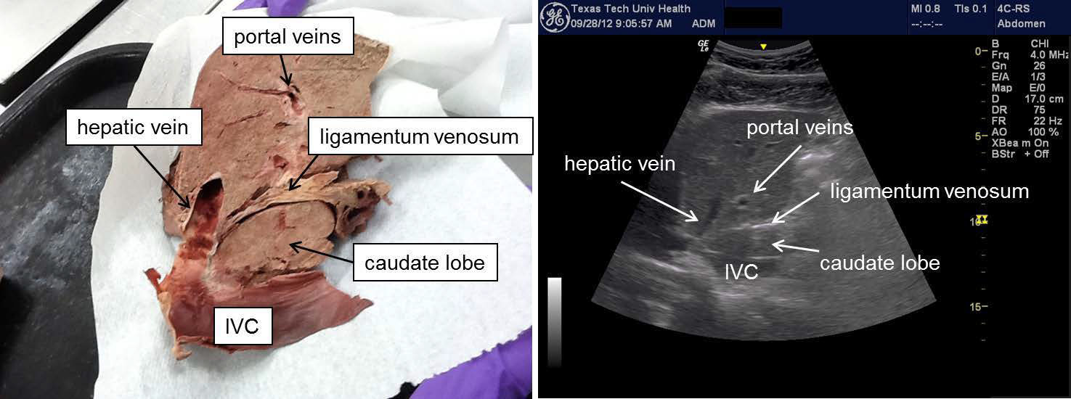

Figure 2.
