Table S1 Questionnaire’s themes and components
Themes and components | Measures
Components related to voluntary research involvement (Have you..)
Have heard about “Health research” | Yes / No
Participated or volunteered for any research project outside of academic curriculum | Yes / No
Published a research paper in a peer-reviewed journal | Yes / No
Been a first author on a published research paper | Yes / No
Self-perceived research component
Received formal research training during your undergraduate studies, beyond textbook knowledge | Yes / No
Attended workshops or seminars on research methodologies, biostatistics and research ethics | Yes / No
Attended formal training on research proposal writing, manuscript writing, and the publication process? | Yes / No
Regularly read medical journals, other than textbooks | Yes / No
Future research aspirations
Pursue a career in research in the near future | Yes / No
Interested in volunteering to gain more research experience as a graduate | Yes / No
Do you agree that undergraduate studies should emphasize more practice oriented research courses? | 5-point Likert scales (1=strongly agree and 5= strongly disagree)
Research barriers and challenges
Encountered any obstacles or challenges in your research activities | Yes / No
Received encouragement from peers and faculty or institutions | Yes / No
Procedure of research you find most challenging | statement
Reason behind your unfavorable outlook on pursuing career on research | statement

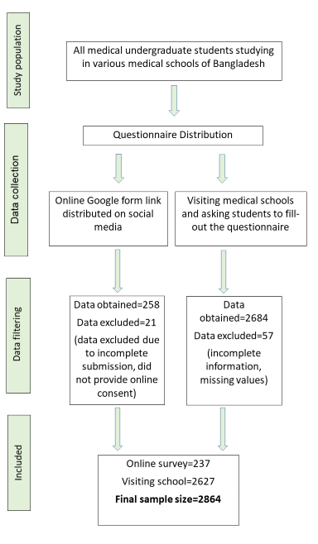

Figure S1: Flow chart for the data collection process

Table S2: Age distribution according to experiencing barriers/challenges among undergraduate medical students (n=2864)
 | Experienced barriers/challenges |  | p-value*
 | Yes  n=1304  n(%) | No  n=1560  n(%)
Age (years)
≤18 | 22(1.7) | 42(2.7) | 0.340
19-23 | 1086(83.3) | 1290(82.7) | 0.340
24-28 | 193(14.8) | 224(14.4) | 0.340
>28 | 3(0.2) | 4(0.3) | 0.340
*p-value obtained by chi-square test

