Written Knowledge Assessment

Trainee Name: Date:

For the following test questions, please answer best choice available. If you are unaware of the correct answer, choose "Do Not Know" rather than placing a random guess.
All images and videos created by author, Dr. Sahar Ahmad.

1
Attenuation of an ultrasound wave is lowest in which of the following mediums? []Water
[]Bone []Steel []Air
[]Do Not Know
2
Which of the following ratios best describes the typical ultrasound transducer’s percentage time spent emitting waves to the time spent listening for echoes? (Emitt : Listen)
[]10:90
[]30:70
[]50:50
[]70:30
[]90:10
[]Do Not Know
3
Which type of artifact is seen in this image?
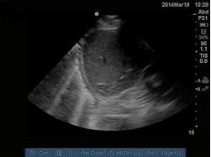
[]Reflection []Reverberation []Ring down []Doppler Shift []Nyquist limit []Do Not Know

4
The machine settings and transducer from this image are best described as:
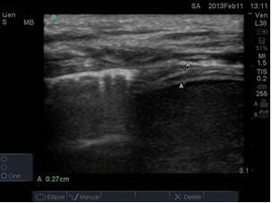
[]Linear Array, High frequency, B-Mode []Linear Array, High frequency, M- Mode []Phased Array, Low frequency, B- Mode []Phased Array, Low frequency, M- Mode []Linear Array, Low frequency, B- Mode []Phased Array, High frequency, M- mode []Do Not Know
5
Prior to starting the procedure, how would you optimize this image?
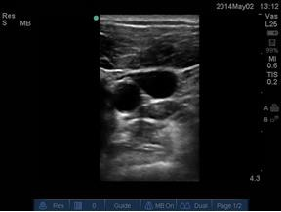
[]Reduce depth []Increase depth []Reduce gain []Increase gain
[]Rotate scan plane 90 degrees []Do Not Know

Which of the following probe maneuvers are being performed in this video: https://youtu.be/kDCViFgUjnc
[]Slide []Rotate []Angulate []Tilt
[]Do Not Know

7
Match the image obtained by this transducer position (see image).
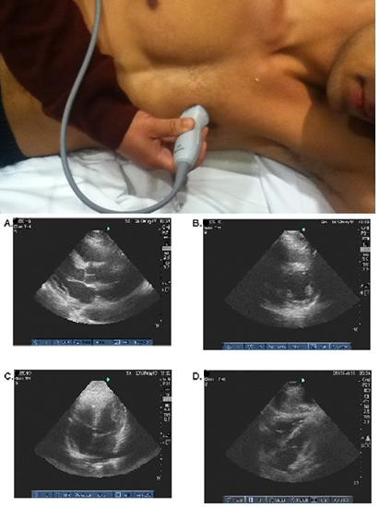
[]A
[]B
[]C
[]D
[]Do Not Know

8
Which structure is shown in this image?
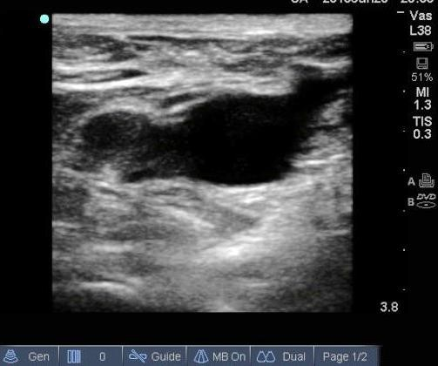
[]Internal Jugular Vein with Carotid Artery in short axis []Internal Jugular Vein in longitudinal axis
[]Common Femoral Vein with Saphenous Vein in short axis []Common Femoral Vein in longitudinal axis
[]Do Not Know

9
Identify the structure marked by the arrow:
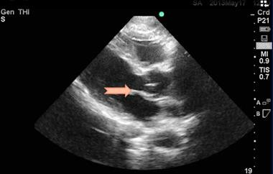
[]Anterior Leaflet of Mitral Valve []Posterior Leaflet of Mitral Valve []Right Coronary Cusp of Aortic Valve []Left Coronary Cusp of Aortic Valve []Non Coronary Cusp of Aortic Valve []Do Not Know

10
Identify the structure marked by the star:
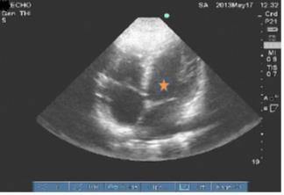
[]Left Ventricle []Right Ventricle []Left Atrium []Right Atrium []Do Not Know

11
Identify the structure marked by the arrow:
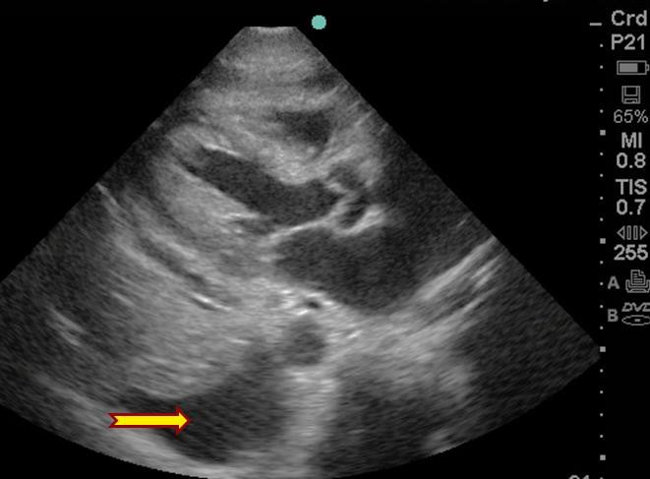
[]Pleural effusion []Pericardial effusion []Left Ventricle []Left Atrium
[]Descending thoracic Aorta []Do not know

12
Which of the following is diagnosed by this ultrasound video: https://youtu.be/7ppUaJ5UaJA
[]Complex pleural effusion []Diaphragm paradox
[]Aortic Aneurysm
[]Aortic Dissection
[]None of the above
[]Do Not Know

13
Identify this image:
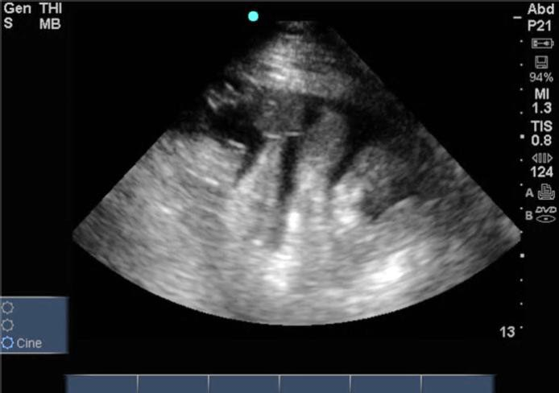
[]Liver
[]Bowel []Bladder []Kidney
[]Do Not Know

14
Identify this finding:
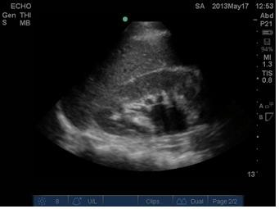
[]Liver cyst
[]Liver with ascites
[]Bowel with ascites
[]Kidney with hydronephrosis
[]Renal cyst
[]None of the above
[]Do Not Know

15
Identify the finding shown in this image:
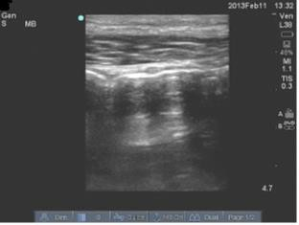
[]A-lines
[]B-lines
[]Lung Sliding
[]Reverberation artifact []None of the above
[]Do Not Know

16
This image is compatible with the following clinical diagnoses EXCEPT:
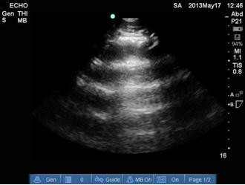
[]Acute pulmonary edema []Pulmonary Embolus []Pneumothorax
[]Right Main Stem intubation []None of the above
[]Do Not Know

17
This patient in shock, is intubated receiving 8 cc/kg Tidal Volume, is paralyzed, and in Normal Sinus Rhythm. What is the best management strategy according to this image?
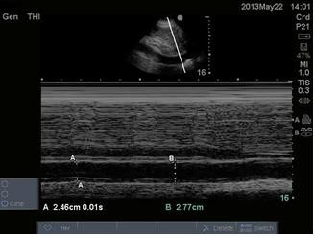
[]Start fluid resuscitation []Start vasopressor therapy []Diurese
[]All of the above

Exam Answers

- Choice 1: Water
- Choice 1: 10:90
- Choice 3: Ring Down
- Choice 1: Linear Array, High frequency, B-Mode
- Choice 1: Reduce depth
- Choice 3: Angulate
- Choice 1: A
- Choice 3: Common Femoral Vein with Saphenous Vein in short axis
- Choice 1: Anterior Leaflet of Mitral Valve
- Choice 1: Left Ventricle
- Choice 1: Pleural Effusion
- Choice 1: Complex Pleural Effusion
- Choice 2: Bowel
- Choice 4: Kidney with hydronephrosis
- Choice 4: Reverberation artifact
- Choice 1: Acute pulmonary edema
- Choice 2: Start vasopressor therapy

