Appendix A: Intervention Design Based on the PRISM Model:
Initial Design Draft and Team Review
An initial draft for designing a VTS-based program based on the PRISM model was written and shared with the educational design team for final approval. Prism Model is an open educational design framework that reflects other (humanistic) dimensions of teaching a specific skill (observation skill) and helps to design and implement interventions according to the goals within this framework and includes four educational functions: Mastering Skill, Perspective Taking, Personal Insight, and Social Advocacy.
Objective Setting and Skill Identification
In the first and second steps, with the ultimate goal of improving the observation skills of medical students, learning objectives were designed based on the first function of this model (Mastering Skill). In the third step, it was specified that:
- What skills or knowledge will students gain, and how will these skills help them become better doctors?
- For the art-based educational activities section, visual thinking strategies and visual thinking-based activities such as personal response tours, group poetry, describe-and-draw activities, and mask-making were chosen to strengthen students' observational skills.
- The reflection section considers the research team's experiences and backgrounds in this area and what artistic collaborations will be used. We proceeded to start planning educational activities using the AAMC guide (1, 2). For this purpose, we considered the educational atmosphere and culture of the Gonabad University of Medical Sciences, to what extent it can implement innovative programs in the curriculum of medical students, such as VTS-based programs, and what skills and knowledge are considered important in this institution.
The skills required for Gonabad medical students are defined based on the document of essential competencies of graduates of the general medical doctorate program, which includes:
- Clinical skills
- Communication skills
- Patient care (diagnosis, treatment, rehabilitation)
- Health promotion and prevention in the health system and the role of the physician in it
- Personal development and lifelong learning
- Professional commitment, ethics, and medical law
- Decision-making, reasoning and problem-solving skills
Improving observation skills can be categorized as patient care skills (diagnosis, treatment, and rehabilitation).

Cultural Considerations
While the essential competencies are defined in different roles, most general medical education programs are set in hospital settings and provide students with a limited view of a physician's professional life.
Benefits and Limitations of Observation Skill Training
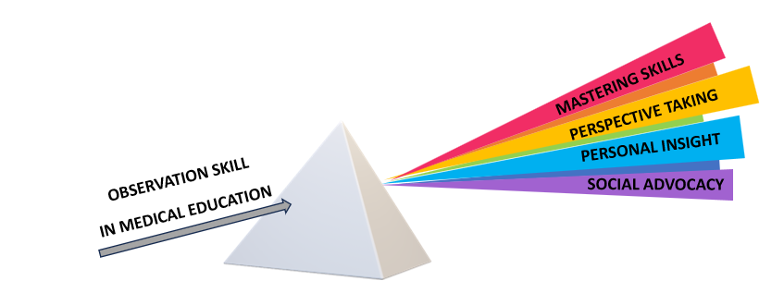
In the final step, the advantages and limitations of observation skill training were defined based on the first function (3-5).
1. AAMC. Home - Getting Started Guide Part 1. Available from: https://www.aamc.org/about-us/mission-areas/medical-education/getting-started-activities (accessed December 13, 2024).
2. AAMC. Association of American Medical Colleges. Available from: https://www.aamc.org/about-us/mission-areas/medical-education/frahme (accessed December 13, 2024).
3. Moniz T, Golafshani M, Gaspar CM, Adams NE, Haidet P, Sukhera J, et al. The Prism Model for Integrating the Arts and Humanities Into Medical Education. Academic medicine: journal of the Association of American Medical Colleges. 2021;96(8):1225.
4. Moniz T, Golafshani M, Gaspar CM, Adams NE, Haidet P, Sukhera J, et al. The prism model: advancing a theory of practice for arts and humanities in medical education. Perspectives on medical education. 2021;10(4):207-14.
5. Howley L, Gaufberg E, King BE. The fundamental role of the arts and humanities in medical education. Available from: https://store.aamc.org/the-fundamental-role-of-the-arts-and-humanities-in-medical-education.html (accessed December 13, 2024).

Appendix B: Details of the VTS-Based Course in the Intervention Group
EXPANDED VTS

Visual Thinking Activity |  |  | Visual Thinking Strategy
Duration | Description of the activity | Activity | Duration | Image Or Human Model | Description | Session
60 Min | Displayed artwork for students to consider its relevance to their current professional roles. | Personal Responses Tour and Reflection | 90 Min | 3 art images/the Power of Music by Williams Mount,1847; The Miracle of Aurelia degli Angeli. by Giovanni Battista Crespi, 1600; Of War and Other Demons by Ali Akbar Sadeghi, 1981. | Classroom discussion about art images with VTS and Group Reflection | 1
60 Min | Students in small groups create a collective poem by each writing a line in response to an image. | Group Poems and Group Discussion | 90 Min | 3 art images/Inheritance 1897 and Death in the Sickroom 1895 by Edvard Munch; The Death of Socrates by Jacques Louis David in 1787. | Classroom discussion about art images with VTS and Group Reflection | 2
60 Min | In this activity, one student describes a pre-selected art image to their partner, who then creates a drawing based on the description. Afterward, the pair discusses their experience. | Describe and Draw with Reflection | 90 Min | 3 art images/A young man stricken with tuberculosis’ TB. Harlem, 1940 by Alice Neel; The Waiting Room by George Tooker, 1959; The Anatomy Lesson of Dr. Nicolaes Tulp, 1632. | Classroom discussion about art images with VTS and Group Reflection | 3
60 Min | Students used masks to express their professional feelings about a pre-selected artwork. In the end, they described their masks. | Mask Making and self-reflection | 40 Min for a Human Model and 20 Min for a Clinical Image | human model and one clinical image/ A clinical image with skin conditions and the human model had makeup applied to simulate various skin conditions. | Classroom discussion about clinical image and human model with VTS and Group Reflection | 4

Appendix C: Details of the Observation Exercises Course in the Control Group
 | Observation Exercises
Description of the activity | Goal |  | scientific bases | Activity
A set of complex optical illusions, capable of multiple interpretations, was shown to a group of students. | This illustrates that our perceptions are frequently shaped more by beliefs than by reality. | In Classroom | perceptual psychology | “Games based on optical illusions”
Students drew a model's lines without looking at the paper, discussing the experience afterward. | Slow down, synchronize hand and eye, observe closely, and record the eye's journey. | In Classroom | concepts of motor learning and visual perception | “Blind Contour Drawing”
Students worked in pairs to quickly sketch each other's faces and then discussed the experience at the end. | To explore the relationship between facial features and overall proportions. | In Classroom | Gestalt psychology | “Focus on Face”
Students quickly sketched a person in a standing or sitting position and wrote a reflection on their observations and assumptions about the model's physical characteristics. | To improve analytical and descriptive skills, balance the observation of details with understanding the whole. | Homework | Gestalt perception | “Close Observation and Documentation”
Students engaged in the observation of quotidian occurrences, subsequently reinterpreting them through an analytical lens. | These occurrences should be viewed not as isolated incidents, but rather as chances to observe transformation. | Homework | principles of longitudinal observation and developmental psychology | "see change"

Appendix D: Pre-Test and Post-Test in Short Term:
Describe your observations of these images.
What do you see in this image?
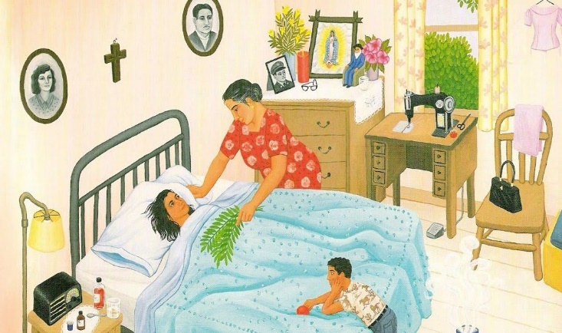 | La Curandera (faith healer) by Carmen Lomas Garza, 1989
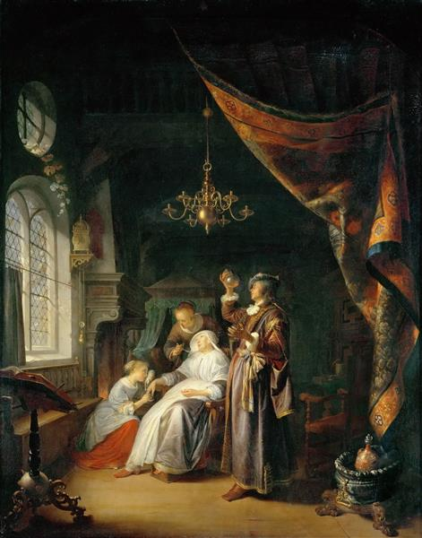 | The Dropsical Woman by Dutch artist Gerrit Dou, 1663
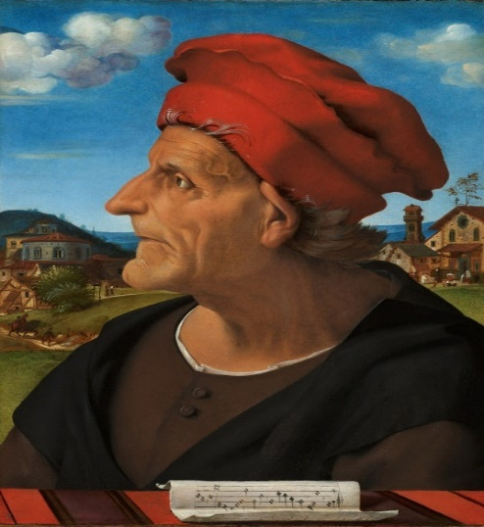 | Portrait of Francesco Giamberti (between circa 1404 and 1482), architect and musician
Appendix E: The method in a snapshot

Intervention
Group
n.44 cases

Control Group
n.45 controls

About four 2/5-hour training sessions focused on VTS with VTA:
First Session: VTS with Personal Responses Tour
Second Session: VTS with Group Poems
Third Session: VTS with Describe and Draw
Four Session: VTS with Mask Making

Clinical Exposure
1 Meeting
Controlled and random
Simultaneously
Initially, training was conducted for the control group, followed by the intervention group
First that was implemented for the control group, and subsequently for the intervention group

Simultaneously

Simultaneously

Post-Test 2

Clinical Exposure
1 Meeting
Post-Test 2

Post-Test 1

Pre-Test

Post-Test 1

four 2-hour training sessions focused on observational exercises (OE):

interactive lecture approach with:

Optical Illusions Game
Blind Contour Drawing
Focus on the Face
Homework Assignments: Close Observation and Documentation/ See Change

Pre-Test

