Supplementary material
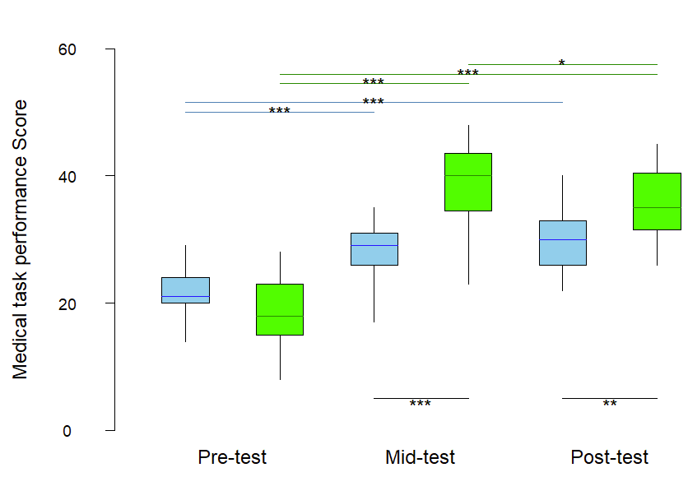
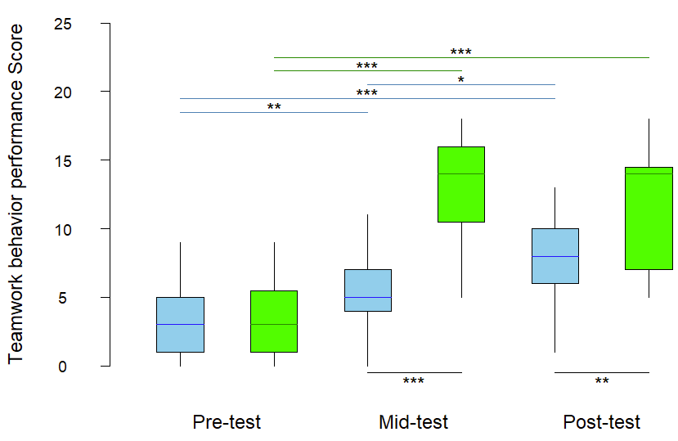
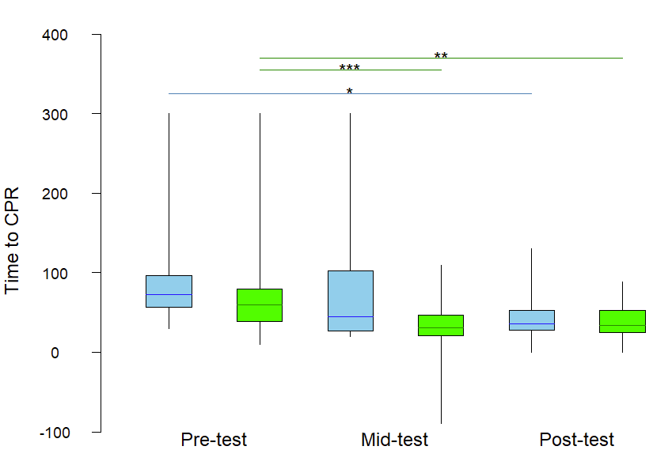
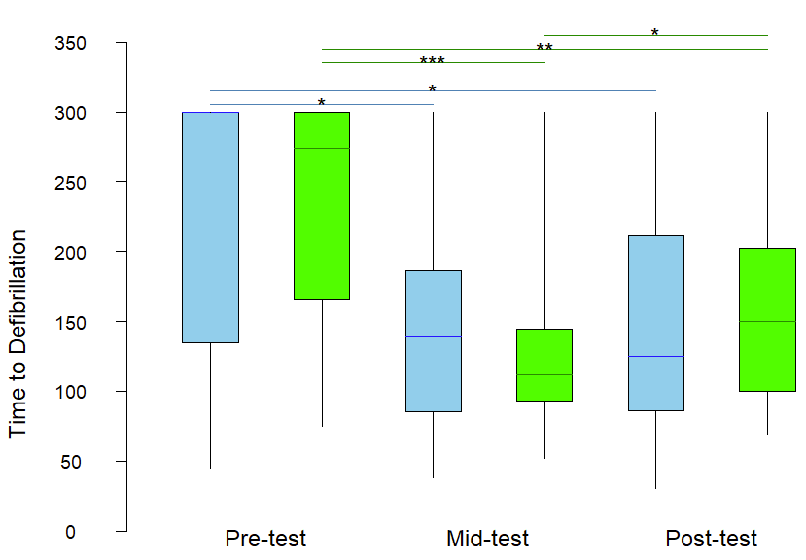
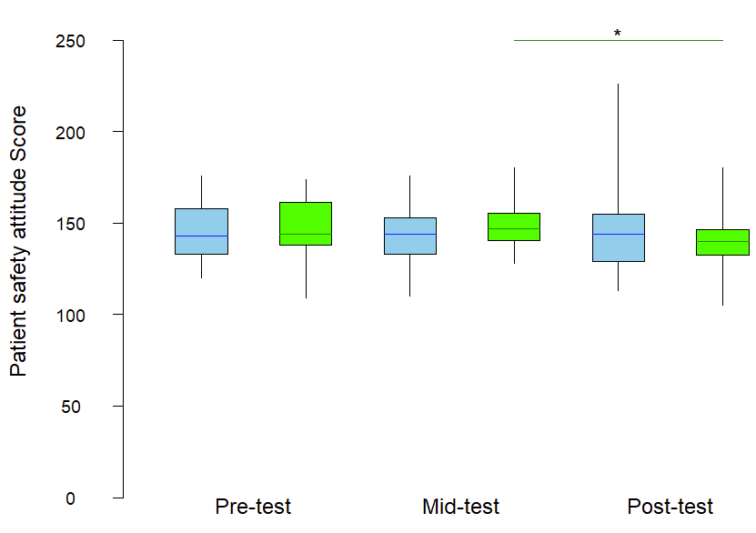

Regular low-dose group
SET-CPR group
Fig S1. A box plot is used to illustrate the learning outcomes between the two groups as well as the variations within in 6-year program medical students. (A) Medical task performance, (B) Teamwork behavior performance, (C) Patient safety attitude score, (D) Time to CPR, and (E) Time to Defibrillation.
Note: Wilcoxon test for within-group comparisons and Mann-Whitney U test for between-group comparisons at three time points: Pre-test, Mid-test, and Post-test. * p < 0.05, ** p < 0.01, *** p < 0.001, two-tailed.

