Supplementary Material
Supplementary Figure 1. Principal component analysis

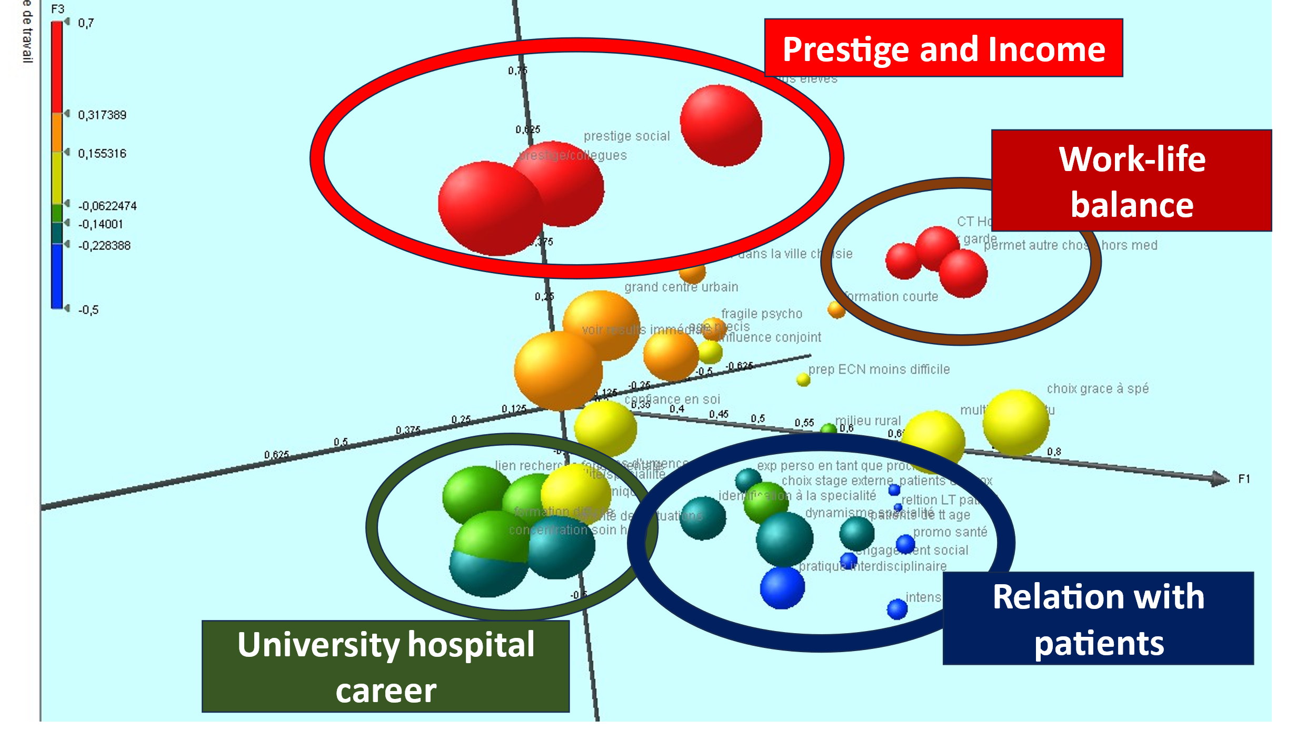

Prestige and high income | Work–life balance | Career in a university hospital | Relationship with patients
o High income  o Prestige among colleagues  o Prestige in society | o Number of on-call hours  o Duration of practice  o Ability to do something other than medicine  o Short training period | o Association with clinical research  o Association with fundamental research  o Difficult training  o Severity of cases  o Focus on hospital care  o Focus on emergency care  o Change city to obtain the specialty | o Local patients  o Long-term relationship with patients  o Experience obtained during external internships  o Experience as a relative or patient  o Identify with someone in the specialty  o Health promotion  o Social commitment  o Patients of all ages  o Dynamism of the specialty  o Interdisciplinary practice  o Intensity of relationships with patients

Supplementary Table 1.
Medical lifestyle and work–life balance: α = 0.852 | α without the item
My choice of specialty will allow me to have acceptable on-call hours | 0.746
My specialty choice will allow me to have acceptable practice hours | 0.734
My specialty choice will allow me to choose what I want to do in medicine | 0.776
My specialty choice will allow me to do other things outside of medicine | 0.738
I am ready to change my choice of specialty to remain in my chosen city (university) (*) | 0.797
My partner plays an important role in my choice of specialty (*) | 0.825
Societal orientation: α = 0.844
My specialty choice will provide me with multiple professional opportunities | 0.835
My specialty choice will allow me to focus on local patients | 0.818
My specialty choice will allow me to cultivate long-term relationships with patients | 0.813
My choice of specialty is guided by my social commitment | 0.818
I am interested in health promotion and my choice of specialty will allow me to do practice that | 0.814
My choice of specialty is guided by my personal experience as a patient or relative (*) | 0.845
My choice of specialty is guided by the intensity of my relationships with patients (*) | 0.816
My choice of specialty is guided by the search for an inter-disciplinary practice (*) | 0.841
Prestige: α = 0.792
My choice of specialty offers high income potential | 0.737
My choice of specialty will bestow me with prestige among my future colleagues | 0.697
My choice of specialty will bestow me with prestige in society | 0.703
I prefer to see immediate results from my treatments | 0.736
I identify with a doctor who works in the specialty I have chosen (*) | 0.746
My choice of specialty is guided by the image of dynamism associated with it (*) | 0.772
Work in a hospital: α = 0.789
My choice of specialty will allow me to focus on hospital care | 0.752
My choice of specialty will allow me to focus on emergency care | 0.763
I am interested in a wide range of problems experienced by patients of all ages | 0.780
I prefer to focus on a limited variety of patient problems and/or on one or more specific age group(s) of patients | 0.786
My choice of specialty will provide me with greater chances of practicing in a large urban center | 0.785
My choice of specialty will provide me with greater chances of practicing in a rural area | 0.807
My choice of specialty will allow me to have a strong association with clinical research | 0.764
My choice of specialty will allow me to have a strong association with fundamental or technological research | 0.762
My choice of specialty is guided by the severity of the clinical cases to be treated | 0.757
Medical training: α = 0.602
My choice of specialty will require a shorter residency | 0.558
My choice of specialty will require a difficult but stimulating residency | 0.590
I identify with a doctor who works in the specialty I have chosen (*) | 0.526
My choice of specialty will make preparation for the national ranking exam less difficult (*) | 0.559
The rotations that I completed had a strong influence on my choice of specialty (*) | 0.517
I feel psychologically fragile, and my choice of specialty is guided by this fragility (*) | 0.595
I feel psychologically strong, and this guides my choice of specialty (*) | 0.594
(*) These items were added to the original Wright's questionnaire.
Supplementary Table 2. Clustering of the students
 | Cluster 1 | Cluster 2
Total number of students in the cluster | 360 (64.9%) | 195 (35.1%)
Number of students whose first choice of specialty is general medicine | 78 (21.6%) | 109 (55.9%)
Number of students whose first choice of specialty is oncology | 13 (3.6%) | 1 (0.5%)
Items with significantly different score distributions in the clusters
 | Mean (*) | Mean (*) | p-value
My choice of specialty will require a shorter residency | 1.97 | 3.44 | <0.0001
My choice of specialty will allow me to focus on hospital care | 2.94 | 1.65 | <0.0001
My specialty choice will allow me to have acceptable practice hours | 3.36 | 4.35 | 0.009
My choice of specialty will require a difficult but stimulating residency | 3.08 | 1.96 | <0.0001
I am ready to change my choice of city (university) to remain in my chosen specialty | 4.09 | 3.01 | <0.0001
My choice of specialty will allow me to focus on local patients | 2.42 | 3.32 | <0.0001
I prefer to focus on a limited variety of cases and/or on one or more specific age group(s) of patients | 2.61 | 2.33 | 0.05

(*) The mean score for each item is derived from the responses to the following question: “We would like to know the extent to which you think the following factors influenced your choice of specialty. Please indicate the level of the influence of each of these factors on your choice of specialty [1 = Very unimportant, 2 = Unimportant, 3 = Neither important nor unimportant, 4 = important, 5 = Very important].”

Supplementary Table 3. Analysis of the ability of the questionnaire to predict the choice of oncology and general medicine as a specialty
 | As first choice | As second choice | As third choice
Area under the curve (Oncology) | 0.927 | 0.555 | 0.521
Arear under the curve (General medicine) | 0.951 | 0.624 | 0.544

Supplementary Table 3
 | P value | Equation
My choice of specialty will allow me to have acceptable on-call hours | 0.3922 | Y = 0.1033*X + 3.320
My choice of specialty will allow me to have acceptable practice hours | 0.9527 | Y = -0.007136*X + 3.547
My choice of specialty will allow me to choose what I want to do in medicine | 0.8161 | Y = -0.02846*X + 3.975
My choice of specialty will allow me to do other things outside of medicine | 0.8026 | Y = 0.03120*X + 3.791
My choice of specialty will provide me multiple professional opportunities | 0.5246 | Y = -0.07446*X + 3.553
My choice of specialty will allow me to focus on local patients | 0.6915 | Y = -0.04341*X + 2.465
My choice of specialty will allow me to cultivate long-term relationships with patients | 0.0380 | Y = 0.1286*X + 2.730
My choice of specialty is guided by my social commitment | 0.2323 | Y = -0.1399*X + 2.493
I am interested in health promotion and my choice of specialty will allow me to do that | 0.6326 | Y = -0.05534*X + 2.781
My choice of specialty offers high income potential | 0.1174 | Y = 0.1748*X + 2.986
My choice of specialty will bestow me with prestige among my future colleagues | 0.7381 | Y = -0.03333*X + 1.957
My choice of specialty will bestow me with prestige in society. | 0.8486 | Y = -0.01966*X + 2.046
My choice of specialty will allow me to focus on hospital care | 0.1490 | Y = -0.1517*X + 2.248
I prefer to see immediate results from my treatments | 0.0021 | Y = -0.1867*X + 2.633
My choice of specialty will allow me to focus on emergency care | <0.001 | Y = -0.2576*X + 2.389
I am interested in a wide range of problems experienced by patients of all ages | 0.5675 | Y = -0.06814*X + 3.220
I prefer to focus on a limited variety of patient problems and/or one or more specific age group(s) of patients | 0.5504 | Y = -0.05985*X + 2.261
My choice of specialty will provide me with greater chances of practicing in a large urban center | 0.6940 | Y = 0.04183*X + 2.357
My choice of specialty will provide me greater chances of practicing in a rural area | 0.3448 | Y = -0.09591*X + 2.148
My choice of specialty will require a shorter residency | 0.2562 | Y = 0.1234*X + 2.212
My choice of specialty will require a difficult but stimulating residency | 0.5633 | Y = -0.06459*X + 2.423
I identify with a doctor who works in the specialty I have chosen | 0.9547 | Y = 0.007169*X + 2.498
My choice of specialty make preparation for the national ranking exam less difficult. | 0.0023 | Y = -0.005438*X + 2.210
The rotations that I completed had a strong influence on my choice of specialty | 0.2343 | Y = 0.1538*X + 3.262
I am ready to change my choice of city (university) to remain in my chosen specialty | 0.2681 | Y = -0.1507*X + 3.352
I am ready to change my choice of specialty to remain in my chosen city (university) | 0.3763 | Y = 0.09569*X + 1.883
My partner plays an important role in my choice of specialty | 0.8560 | Y = 0.02591*X + 2.530
My choice of specialty will allow me to have a strong association with clinical research | <0.001 | Y = 0.03029*X + 1.869
My choice of specialty will allow me to have a strong association with fundamental or technological research | <0.001 | Y = 0.006971*X + 1.774
My choice of specialty is guided by my personal experience as a patient or relative | 0.3319 | Y = -0.1060*X + 2.005
My choice of specialty is guided by the severity of the clinical cases to be treated | 0.1902 | Y = -0.1508*X + 2.519
My choice of specialty is guided by the intensity of my relationships with patients | 0.9888 | Y = -0.001677*X + 3.034
My choice of specialty is guided by the image of dynamism associated with it | 0.2676 | Y = -0.1320*X + 2.944
My choice of specialty is guided by the search for an inter-disciplinary practice | 0.5884 | Y = -0.06518*X + 2.955
I feel psychologically fragile, and my choice of specialty is guided by this fragility. | 0.3941 | Y = 0.08983*X + 1.851
I feel psychologically strong, and this guides my choice of specialty | 0.6003 | Y = -0.06183*X + 2.538

