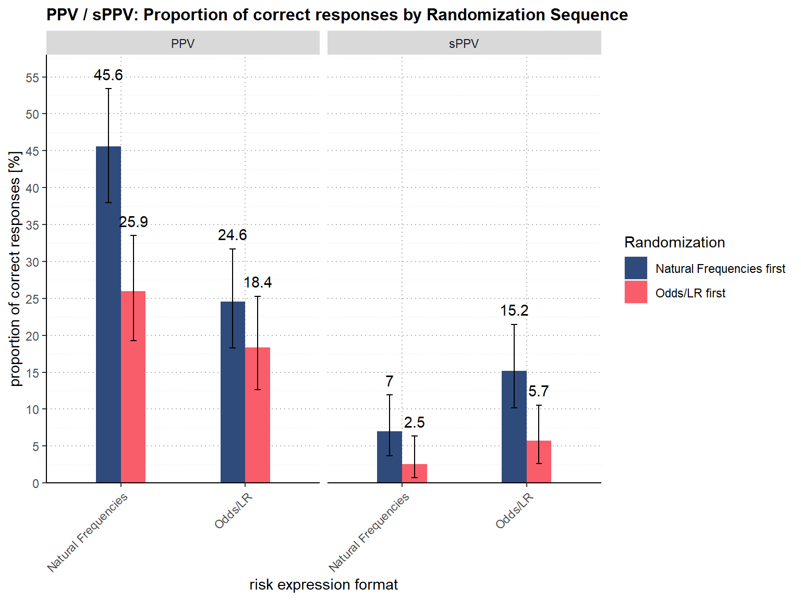
Supplementary Figure 1: Proportion of correctly calculated positive predictive values, stratified by the sequence of tasks presented
Notes. Error bars display 95% confidence intervals. The overlaid numbers indicate the proportion of correct answers in percent based on the total number of n = 329 responses.
PPV Positive Predictive Value of a single test, sPPV Positive predictive value of two sequentially positive tests, Odds/LR Odds and Likelihood Ratios

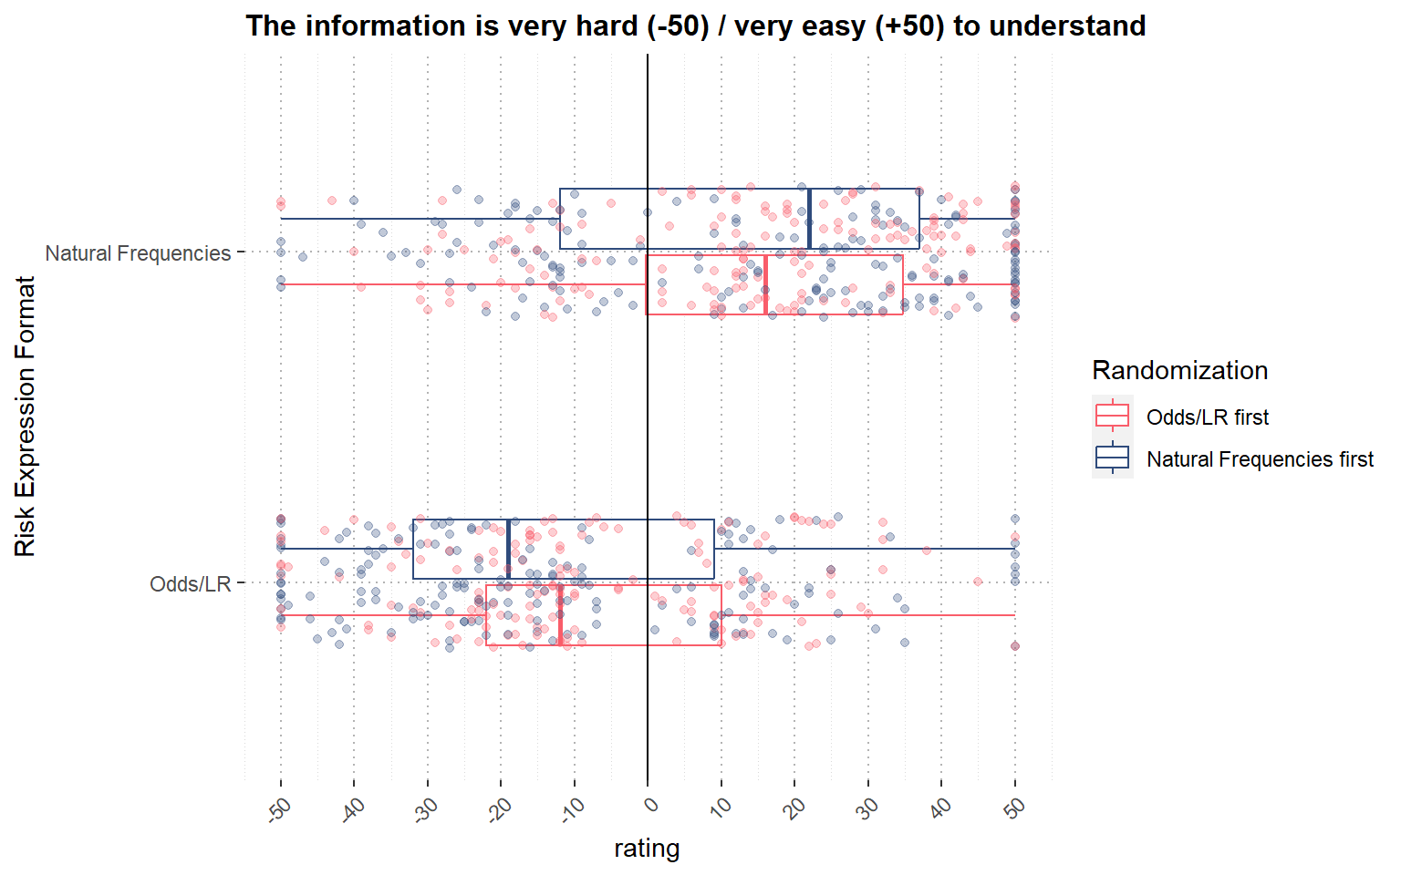
Supplementary Figure 2: Subjective comprehensibility of the test statistics by risk expression format, stratified by the sequence of tasks presented
Notes. The scatterplot displays responses from all n = 329 participants per risk expression format, accompanied by an overlaid boxplot illustrating the median, as well as the 25th and 75th percentile ratings provided by participants.
Odds/LR Odds and Likelihood Ratios

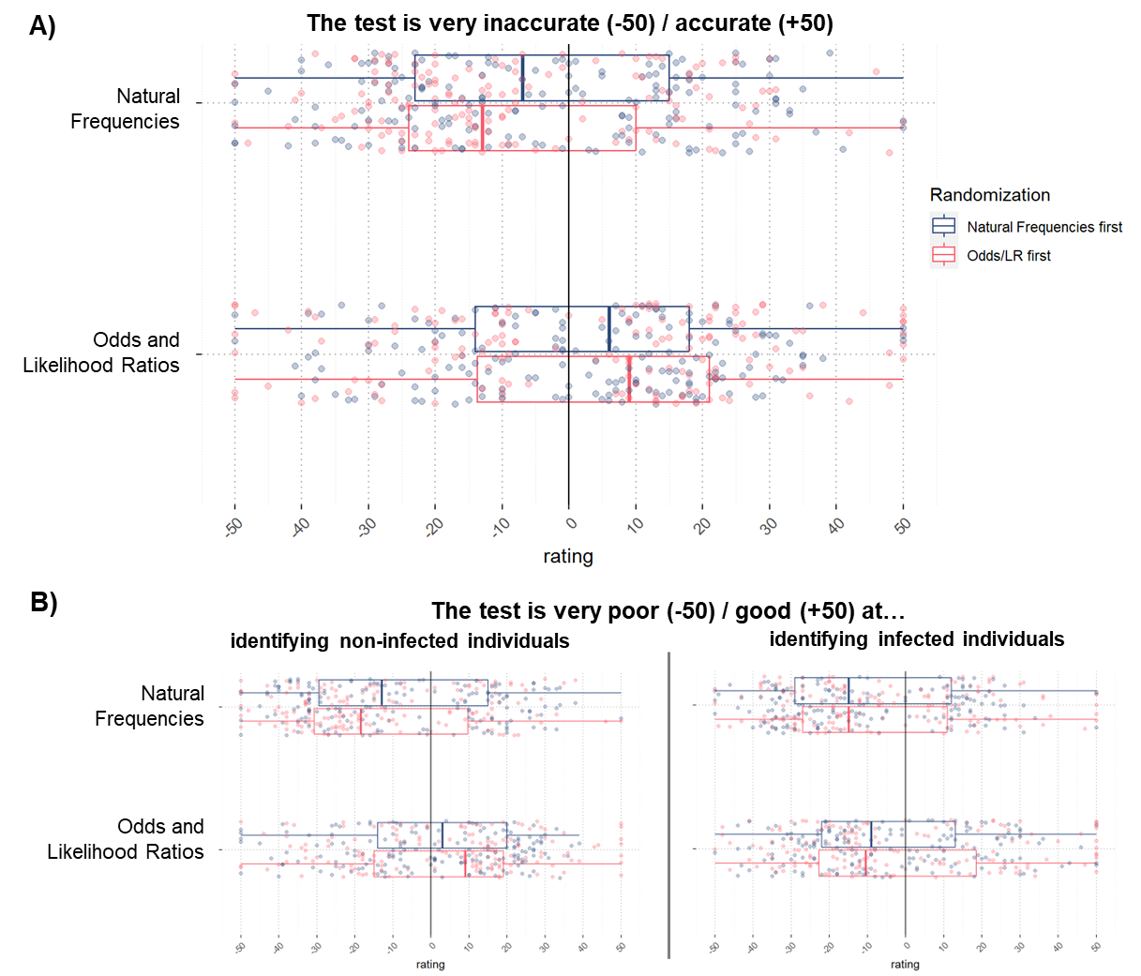
Supplementary Figure 3: Subjective evaluation of test accuracy, stratified by the sequence of tasks presented
Notes. The scatterplots display responses from all n = 329 participants per risk expression format, accompanied by overlaid boxplots illustrating the median, as well as the 25th and 75th percentile ratings provided by participants.

