Supplementary Methods
- Virtual Learning Network Platform (VLNP)
The Virtual Learning Network Platform (VLNP), developed by Nanjing Medical University (Affiliated Stomatological Hospital of Nanjing Medical University, Nanjing, China), is an advanced virtual reality simulation platform designed for orthodontic pre-clinical training. This online platform, accessible at http://211.139.109.55/virlab/index.html, creates an interactive virtual learning environment featuring diverse clinical case scenarios.
The platform enables students to engage with virtual patients, obtaining medical histories and chief complaints while practicing various clinical procedures in a simulated dental clinic environment. Through standard computer interfaces including mouse and keyboard controls, students can manipulate virtual dental instruments to perform comprehensive clinical tasks ranging from oral examinations and impression taking to bracket bonding procedures.
This system provides enhanced real-time visual feedback by comparing student performance against established professional standards in critical areas of orthodontic practice including dental crowding assessment and bracket positioning accuracy. This instant feedback mechanism enables students to better understand essential operational procedures and improve their technical skills through real-time interaction in the virtual environment.
Each student accesses VLNP through individual accounts, allowing for independent online interactive virtual simulation training curriculum. The training curriculum on VLNP is structured into three progressive components: (i) Theoretical preparation: review the requirements and predefined criteria for orthodontic practice tasks. (ii) Procedural demonstration: Step-by-step instructional videos guide students through orthodontic procedures. (iii) Practical application: Students execute procedures in the virtual environment, following the demonstrated sequence. For instance, in the fixed orthodontic appliance bonding module, students sequentially perform tooth cleaning, etching and drying, adhesive application, bracket placement, and light curing.
VLNP's unique advantages include providing unlimited practice opportunities with self-paced learning, enhancing students' understanding of operational procedures and technical proficiency via real-time interactive environment and instant feedback mechanism significantly.

- Virtual Simulation Training and Evaluation System (VSTES)
The offline preclinical training is implemented via the Virtual Simulation Training and Evaluation System (VSTES v.01, Unidraw Co. Ltd, Beijing, China). This system integrates haptic virtual reality simulation with advanced force feedback technology, creating a highly realistic training environment.
The VSTES hardware, as illustrated in Fig. S1, comprises several key components: the hardware shell, bi-manual haptic devices, observation window, touch screen for control operations, foot pedal, 3D mouse, and graphics workstation.
The VSTES hardware shell is ergonomically designed with adjustable height settings, ensuring optimal positioning for users of varying statures. This adaptability enhances user comfort during extended training sessions and accommodates different clinical scenarios.
The observation window of the VSTES serves as the primary visual interface, providing users with a clear view of the virtual operating field. By default, the virtual patient is positioned at the 12-o'clock orientation, with the 3D mouse enabling users to adjust this position as needed.
A distinctive feature of VSTES is its dual force feedback devices, which accurately simulate the tactile sensations and operational dynamics of bi-manual orthodontic procedures. This configuration allows users to experience realistic resistance and feedback during virtual treatments, closely mimicking actual clinical conditions.
The system incorporates a foot pedal interface that controls the activation state of virtual instruments. For instance, during the simulation of dental biofilm removal, users can activate the polishing cup's high-frequency vibration by depressing the foot pedal, effectively replicating the clinical process of biofilm removal. This pedal-based control mechanism provides an additional layer of operational realism within the virtual training environment.
Through this integrated hardware configuration, VSTES offers dental professionals and students an advanced platform for skill development, procedure refinement, and treatment planning in a risk-free virtual environment. The system's combination of visual, tactile, and operational feedback mechanisms creates a highly realistic training experience that bridges the gap between theoretical knowledge and practical application in orthodontics.

Supplementary Tables
Table S1. Comparison of practical orthodontic bracket bonding results reaching a plateau across six offline sessions. All students completed the offline virtual training on the VSTES via the haptic-enhanced virtual simulator, once a week for six consecutive weeks.
Items | Offline training times |  | Mean Deviation  (Post - Pre) | P value
Items | Pre | Post | Mean Deviation  (Post - Pre) | P value
Cleaning | 1st | 2nd | 0.58 | 0.095
Cleaning | 1st | 3rd | 0.96* | 0.006
Cleaning | 1st | 4th | 1.15* | 0.001
Cleaning | 1st | 5th | 0.96* | 0.006
Cleaning | 1st | 6th | 1.15* | 0.001
Cleaning | 2nd | 1st | -0.58 | 0.095
Cleaning | 2nd | 3rd | 0.38 | 0.264
Cleaning | 2nd | 4th | 0.58 | 0.095
Cleaning | 2nd | 5th | 0.38 | 0.264
Cleaning | 2nd | 6th | 0.58 | 0.095
Cleaning | 3rd | 1st | -0.96* | 0.006
Cleaning | 3rd | 2nd | -0.38 | 0.264
Cleaning | 3rd | 4th | 0.19 | 0.576
Cleaning | 3rd | 5th | 0.00 | 1.000
Cleaning | 3rd | 6th | 0.19 | 0.576
Cleaning | 4th | 1st | -1.15* | 0.001
Cleaning | 4th | 2nd | -0.58 | 0.095
Cleaning | 4th | 3rd | -0.19 | 0.576
Cleaning | 4th | 5th | -0.19 | 0.576
Cleaning | 4th | 6th | 0.00 | 1.000
Cleaning | 5th | 1st | -0.96* | 0.006
Cleaning | 5th | 2nd | -0.38 | 0.264
Cleaning | 5th | 3rd | 0.00 | 1.000
Cleaning | 5th | 4th | 0.19 | 0.576
Cleaning | 5th | 6th | 0.19 | 0.576
Cleaning | 6th | 1st | -1.15* | 0.001
Cleaning | 6th | 2nd | -0.58 | 0.095
Cleaning | 6th | 3rd | -0.19 | 0.576
Cleaning | 6th | 4th | 0.00 | 1.000
Cleaning | 6th | 5th | -0.19 | 0.576
Etching time | 1st | 2nd | 1.83* | 0.000
Etching time | 1st | 3rd | 2.21* | 0.000
Etching time | 1st | 4th | 3.46* | 0.000
Etching time | 1st | 5th | 3.37* | 0.000
Etching time | 1st | 6th | 3.65* | 0.000
Etching time | 2nd | 1st | -1.83* | 0.000
Etching time | 2nd | 3rd | 0.38 | 0.367
Etching time | 2nd | 4th | 1.63* | 0.000
Etching time | 2nd | 5th | 1.54* | 0.000
Etching time | 2nd | 6th | 1.83* | 0.000
Etching time | 3rd | 1st | -2.21* | 0.000
Etching time | 3rd | 2nd | -0.38 | 0.367
Etching time | 3rd | 4th | 1.25* | 0.004
Etching time | 3rd | 5th | 1.15* | 0.007
Etching time | 3rd | 6th | 1.44* | 0.001
Etching time | 4th | 1st | -3.46* | 0.000
Etching time | 4th | 2nd | -1.63* | 0.000
Etching time | 4th | 3rd | -1.25* | 0.004
Etching time | 4th | 5th | -0.10 | 0.821
Etching time | 4th | 6th | 0.19 | 0.651
Etching time | 5th | 1st | -3.37* | 0.000
Etching time | 5th | 2nd | -1.54* | 0.000
Etching time | 5th | 3rd | -1.15* | 0.007
Etching time | 5th | 4th | 0.10 | 0.821
Etching time | 5th | 6th | 0.29 | 0.498
Etching time | 6th | 1st | -3.65* | 0.000
Etching time | 6th | 2nd | -1.83* | 0.000
Etching time | 6th | 3rd | -1.44* | 0.001
Etching time | 6th | 4th | -0.19 | 0.651
Etching time | 6th | 5th | -0.29 | 0.498
Rinsing off acid etchant | 1st | 2nd | 0.00 | 1.000
Rinsing off acid etchant | 1st | 3rd | -0.38 | 0.503
Rinsing off acid etchant | 1st | 4th | 1.35* | 0.020
Rinsing off acid etchant | 1st | 5th | 0.58 | 0.316
Rinsing off acid etchant | 1st | 6th | 0.77 | 0.182
Rinsing off acid etchant | 2nd | 1st | 0.00 | 1.000
Rinsing off acid etchant | 2nd | 3rd | -0.38 | 0.503
Rinsing off acid etchant | 2nd | 4th | 1.35* | 0.020
Rinsing off acid etchant | 2nd | 5th | 0.58 | 0.316
Rinsing off acid etchant | 2nd | 6th | 0.77 | 0.182
Rinsing off acid etchant | 3rd | 1st | 0.38 | 0.503
Rinsing off acid etchant | 3rd | 2nd | 0.38 | 0.503
Rinsing off acid etchant | 3rd | 4th | 1.73* | 0.003
Rinsing off acid etchant | 3rd | 5th | 0.96 | 0.095
Rinsing off acid etchant | 3rd | 6th | 1.15* | 0.046
Rinsing off acid etchant | 4th | 1st | -1.35* | 0.020
Rinsing off acid etchant | 4th | 2nd | -1.35* | 0.020
Rinsing off acid etchant | 4th | 3rd | -1.73* | 0.003
Rinsing off acid etchant | 4th | 5th | -0.77 | 0.182
Rinsing off acid etchant | 4th | 6th | -0.58 | 0.316
Rinsing off acid etchant | 5th | 1st | -0.58 | 0.316
Rinsing off acid etchant | 5th | 2nd | -0.58 | 0.316
Rinsing off acid etchant | 5th | 3rd | -0.96 | 0.095
Rinsing off acid etchant | 5th | 4th | 0.77 | 0.182
Rinsing off acid etchant | 5th | 6th | 0.19 | 0.738
Rinsing off acid etchant | 6th | 1st | -0.77 | 0.182
Rinsing off acid etchant | 6th | 2nd | -0.77 | 0.182
Rinsing off acid etchant | 6th | 3rd | -1.15* | 0.046
Rinsing off acid etchant | 6th | 4th | 0.58 | 0.316
Rinsing off acid etchant | 6th | 5th | -0.19 | 0.738
Rinsing time | 1st | 2nd | 0.77* | 0.014
Rinsing time | 1st | 3rd | 0.96* | 0.002
Rinsing time | 1st | 4th | 1.15* | 0.000
Rinsing time | 1st | 5th | 1.15* | 0.000
Rinsing time | 1st | 6th | 1.15* | 0.000
Rinsing time | 2nd | 1st | -0.77* | 0.014
Rinsing time | 2nd | 3rd | 0.19 | 0.534
Rinsing time | 2nd | 4th | 0.38 | 0.214
Rinsing time | 2nd | 5th | 0.38 | 0.214
Rinsing time | 2nd | 6th | 0.38 | 0.214
Rinsing time | 3rd | 1st | -0.96* | 0.002
Rinsing time | 3rd | 2nd | -0.19 | 0.534
Rinsing time | 3rd | 4th | 0.19 | 0.534
Rinsing time | 3rd | 5th | 0.19 | 0.534
Rinsing time | 3rd | 6th | 0.19 | 0.534
Rinsing time | 4th | 1st | -1.15* | 0.000
Rinsing time | 4th | 2nd | -0.38 | 0.214
Rinsing time | 4th | 3rd | -0.19 | 0.534
Rinsing time | 4th | 5th | 0.00 | 1.000
Rinsing time | 4th | 6th | 0.00 | 1.000
Rinsing time | 5th | 1st | -1.15* | 0.000
Rinsing time | 5th | 2nd | -0.38 | 0.214
Rinsing time | 5th | 3rd | -0.19 | 0.534
Rinsing time | 5th | 4th | 0.00 | 1.000
Rinsing time | 5th | 6th | 0.00 | 1.000
Rinsing time | 6th | 1st | -1.15* | 0.000
Rinsing time | 6th | 2nd | -0.38 | 0.214
Rinsing time | 6th | 3rd | -0.19 | 0.534
Rinsing time | 6th | 4th | 0.00 | 1.000
Rinsing time | 6th | 5th | 0.00 | 1.000
Coating adhesive | 1st | 2nd | 2.31* | 0.000
Coating adhesive | 1st | 3rd | 3.46* | 0.000
Coating adhesive | 1st | 4th | 3.85* | 0.000
Coating adhesive | 1st | 5th | 3.46* | 0.000
Coating adhesive | 1st | 6th | 3.85* | 0.000
Coating adhesive | 2nd | 1st | -2.31* | 0.000
Coating adhesive | 2nd | 3rd | 1.15* | 0.015
Coating adhesive | 2nd | 4th | 1.54* | 0.001
Coating adhesive | 2nd | 5th | 1.15* | 0.015
Coating adhesive | 2nd | 6th | 1.54* | 0.001
Coating adhesive | 3rd | 1st | -3.46* | 0.000
Coating adhesive | 3rd | 2nd | -1.15* | 0.015
Coating adhesive | 3rd | 4th | 0.38 | 0.413
Coating adhesive | 3rd | 5th | 0.00 | 1.000
Coating adhesive | 3rd | 6th | 0.38 | 0.413
Coating adhesive | 4th | 1st | -3.85* | 0.000
Coating adhesive | 4th | 2nd | -1.54* | 0.001
Coating adhesive | 4th | 3rd | -0.38 | 0.413
Coating adhesive | 4th | 5th | -0.38 | 0.413
Coating adhesive | 4th | 6th | 0.00 | 1.000
Coating adhesive | 5th | 1st | -3.46* | 0.00
Coating adhesive | 5th | 2nd | -1.15* | 0.015
Coating adhesive | 5th | 3rd | 0.00 | 1.000
Coating adhesive | 5th | 4th | 0.38 | 0.413
Coating adhesive | 5th | 6th | 0.38 | 0.413
Coating adhesive | 6th | 1st | -3.85* | 0.000
Coating adhesive | 6th | 2nd | -1.54* | 0.001
Coating adhesive | 6th | 3rd | -0.38 | 0.413
Coating adhesive | 6th | 4th | 0.00 | 1.000
Coating adhesive | 6th | 5th | -0.38 | 0.413
*P < 0.05
Table S2. Scores for bracket height before and after online and offline training. Pre- and post-training bracket positions on the dental model were compared with the standard position of the MBT appliance in three dimensions: occlusal, gingival, mesial, and distal directions.
Tooth position | MBT Standard |  |  | Pre-training test score |  | Post-training test score
Tooth position | Height  ¹ | Score | Left |  | Right | Left | Right
U1 | 5 | 5 | 3.15 |  | 3.35 | 4.46* | 4.5*
U2 | 4.5 | 5 | 3 |  | 1.92 | 4.19* | 4.42*
U3 | 5 | 5 | 2.23 |  | 2.77 | 4.19* | 4.12*
U4 | 4.5 | 5 | 4.5 |  | 3.69 | 4.5 | 4.5*
U5 | 4 | 5 | 3.38 |  | 3.92 | 4.19* | 4.27
L1 | 4 | 5 | 3.31 |  | 2.12 | 3.92* | 3.81*
L2 | 4 | 5 | 2.35 |  | 3.5 | 4.38* | 4.54*
L3 | 4.5 | 5 | 2.92 |  | 4.27 | 4.85* | 4.35
L4 | 4 | 5 | 3.5 |  | 3.69 | 4.46* | 4
L5 | 3.5 | 5 | 3.46 |  | 2.62 | 3.62 | 3.62*
Total |  | 100 | 31.81 |  | 31.34 | 42.77 | 42.12
*P < 0.05

Supplementary Figures
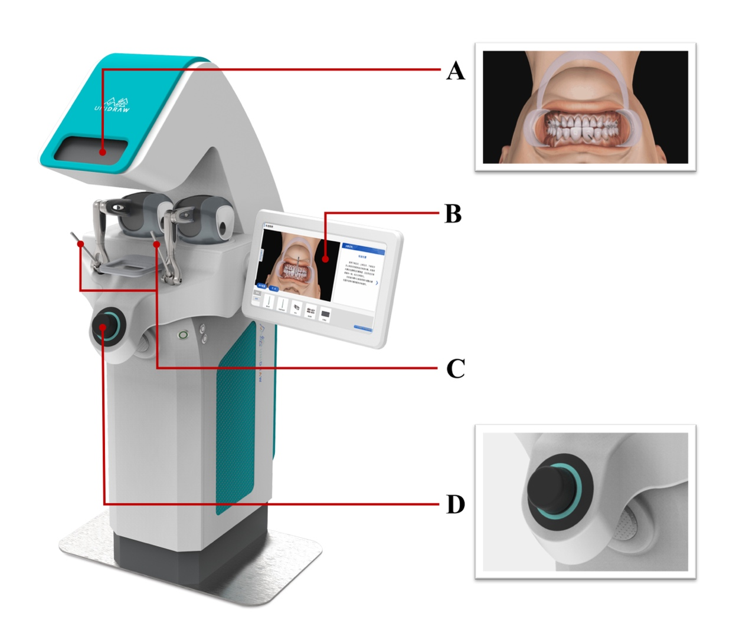
Fig. S1 The haptic-enhanced virtual instrument used in the offline training, featuring an observation window for viewing the virtual operating scene (A), a touch screen interface for control operation (B), bilateral force feedback devices for simulating the clinical bimanual operations (C), and a 3D mouse for virtual patient position adjustment (D).

