The questionnaire to measure the perspectives of medical students about their roles in university
Dear student,
We wish you ever-increasing health and success.
This questionnaire is designed to assess your perspective as a medical sciences student about playing your roles in university, which are summarized in the diagram below. Fulfilling each of the roles requires performing several tasks that are listed in the questionnaire. Please specify your opinion regarding the importance of each of the tasks, the level of opportunities available in the university and the level of your preparedness to fulfill them by choosing one of the options from None, Little, Some, Considerable, Great.

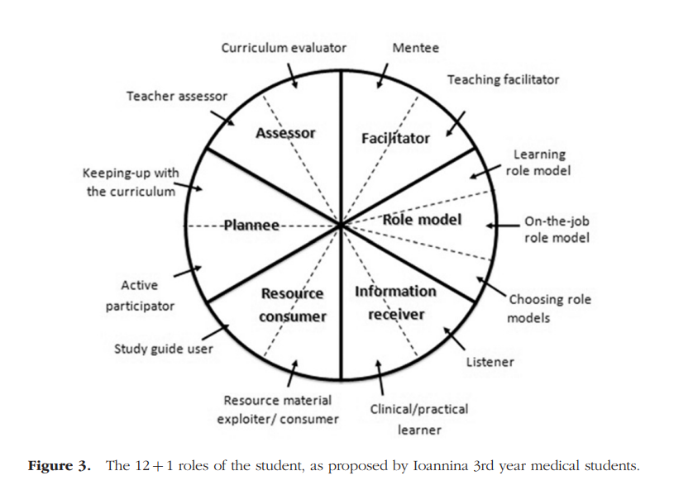
Your participation in completing this questionnaire will be greatly appreciated. It will help us in carrying out a needs assessment and planning to increase students' awareness of their roles. We hope the findings of this research will provide a supportive environment to fulfill your roles in the university. Participating in this research and completing the questionnaire is completely optional and you are free to withdraw from participation at any time. The information in the questionnaire will be kept completely confidential and completing the questionnaire will be considered as your informed consent to participate in this research.
We sincerely thank you for helping us in conducting this research by completing this questionnaire and reflecting your valuable opinions.
You can share your questions about this research with us through the e-mail address sa.ghafarifar@gmail.com.

Role** | Row | Task | Importance of the task |  |  |  |  | Level of opportunities available to play the task |  |  |  |  | Degree of readiness to play the task
Role** | Row | Task | None | Little | Some | Considerable | Great | None | Little | Some | Considerable | Great | None | Little | Some | Considerable | Great
Reflective trainee | 1 | Studying the course plans before attending classes and training sessions
Reflective trainee | 2 | Reflecting on the reasons for attending a learning session before attending
Reflective trainee | 3 | Reflecting on him/her goals for attending a learning session by reviewing the course plan
Interactive knowledge seeker | 4 | Reviewing him/her previous knowledge about the subject of the learning session before attending
Interactive knowledge seeker | 5 | Focusing on acquiring the goals intended for that session during the session
Interactive knowledge seeker | 6 | Making connections between new content and him/her previous knowledge and experience
Interactive knowledge seeker | 7 | Effective communication with patients and their companions
Active listener | 8 | Trying to find answers to the questions formed in his/her mind
Active listener | 9 | Applying his/her knowledge and information received in practice
Active listener | 10 | Assessing level of achievement of his/her learning goals at the end of the session and course
Active listener | 11 | Being a self-regulated learner based on education quality standards
Role** | Row | Task | Importance of the task |  |  |  |  | Level of opportunities available to play the task |  |  |  |  | Degree of readiness to play the task
Role** | Row | Task | None | Little | Some | Considerable | Great | None | Little | Some | Considerable | Great | None | Little | Some | Considerable | Great
Role model as student/apprentice | 12 | Observing the thought processes of teachers and peers
Role model as student/apprentice | 13 | Acting as a good role model for peers to encourage them to learn more and better
Role model as student/apprentice | 14 | Timely and accurate completion of assignments
Role model as student/apprentice | 15 | Interaction with other members of the educational or care teams
Role model as student/apprentice | 16 | Developing an individual learning plan
Role model as student/apprentice | 17 | Planning for group learning in all learning sessions and settings
Role model as student/apprentice | 18 | Practicing evidence-based learning and not blindly consuming information available on the Internet
Role model as student/apprentice | 19 | Acquiring active search skills for information and educational resources on websites
Role model as student/apprentice | 20 | The ability to critically appraisal of the available scientific sources regarding the validity, relevance, and applicability of the information
Role model as student/apprentice | 21 | Acquiring the skills of processing, analyzing and organizing the searched information
Collaborative learner | 22 | Challenging thoughts of him/herself, of classmates, of the teacher in a session
Collaborative learner | 23 | Being an active listener instead of being passive in the learning session
Collaborative learner | 24 | Interacting with teachers in order to facilitate their teaching by asking good, logical and timely questions
Collaborative learner | 25 | Criticizing teachers' teaching process, their statements and educational materials after having enough interaction with them
Collaborative learner | 26 | Providing constructive feedback to teachers in order to create motivation, interest and enthusiasm in teachers for more activity
Collaborative learner | 27 | Evaluating the written and formal curriculum
Role** | Row | Task | Importance of the task |  |  |  |  | Level of opportunities available to play the task |  |  |  |  | Degree of readiness to play the task
Role** | Row | Task | None | Little | Some | Considerable | Great | None | Little | Some | Considerable | Great | None | Little | Some | Considerable | Great
Mentee | 28 | Discussing what you have learned with your classmates
Mentee | 29 | Interacting with classmates and teaching the learned material to peers
Mentee | 30 | Active participation in peer evaluation
Assessor | 31 | Fair evaluation of teachers with the aim of helping their professional development
Assessor | 32 | Evaluating the outcomes of the predetermined learning objectives in the curriculum
Strategic and critical learner | 33 | Actively and critically choosing his/her role models
Strategic and critical learner | 34 | Reflection on learning activities and his/her own daily experiences in different contexts
Strategic and critical learner | 35 | Monitoring his/her own learning process and identifying his/her mistakes and problems
Strategic and critical learner | 36 | Evaluating his/her learning skills to identify his/her learning strengths and weaknesses
Active participator | 37 | Participation in determining the effectiveness of courses and curriculum
Active participator | 38 | Participation in evaluation of the quality standards of education in her/his school
Active participator | 39 | Participating in determining the importance, priority and weight of each course in curriculum
Active participator | 40 | Active participation in educational plannings in the university
Active participator | 41 | Participation in determining the quality standards of education in his/her school
Active participator | 42 | Cooperation with teachers in writing study guides and course plans
Active participator | 43 | Playing the role of a rational and critic consumer for educational resources produced by teachers

