S1 Appendix – Recorded Lectures:
Topic | Duration
Introduction to Ultrasonography and Pulmonary POCUS  - Basics of ultrasonography: Understanding equipment and basic principles.  - Introduction to POCUS: Role in primary care and its benefits.  - Pulmonary POCUS overview: Key concepts and scope in abdominal assessment. | 45 minutes
Demonstration of the abdominal examination in the primary care settings  - Techniques for the abdominal examination using POCUS.  - Identifying normal abdominal findings and variations; hepatobiliary, pancreas and spleen, kidneys, urethra and urinary bladder, abdominal aorta.  - Practical tips for integrating POCUS in routine primary care examinations. | 45 minutes
Abdominal physiology as demonstrated using POCUS  - Techniques for identifying large abdominal vessels, kidneys, bladder, spleen, and hepatobiliary structures using POCUS, with emphasis on pattern recognition.  - Kidney and Bladder examination.  - Specifics of pancreas examination, illustrating how pattern recognition aids in identifying normal and abnormal findings  - Hepatobiliary measurements and recognitions. | 60 minutes
Hepatobiliary and Spleen Common pathologies  - Essentials of hepatobiliary and splenic ultrasound: key anatomical landmarks and scanning techniques.  - Ultrasound identification of hepatobiliary pathologies: fatty liver and cirrhosis, gallbladder and biliary duct abnormalities.  - Spleen ultrasound: recognizing splenomegaly, cysts, splenic infract, and other common splenic conditions. | 60 minutes
Urology and Aorta Pathologies  - Fundamental urological and aortic ultrasound principles: anatomy, scanning protocols, and normal vs. pathological findings.  - Aortic ultrasound: identifying signs of aneurysms and dissections, focusing on measurement techniques and urgency criteria.  - Kidney and bladder ultrasound assesses hydronephrosis, nephrolithiasis, and other bladder pathologies. | 60 minutes
Implementation in the PCP setting - Clinical Cases from the clinic  - Case-based learning: POCUS for abdominal pain:  - Interpretation of POCUS findings in real case scenarios.  - Integrating clinical history with POCUS for accurate diagnosis.  - Enhancing diagnostic accuracy with POCUS in primary care:  - Comparative analysis of POCUS and traditional diagnostic tools.  - Case studies demonstrating improved diagnostic accuracy.  - Strategies for incorporating POCUS into clinical decision-making.  - Patient management and follow-up using POCUS findings. | 60 minutes

S2 Appendix- Abdominal Hands On Test
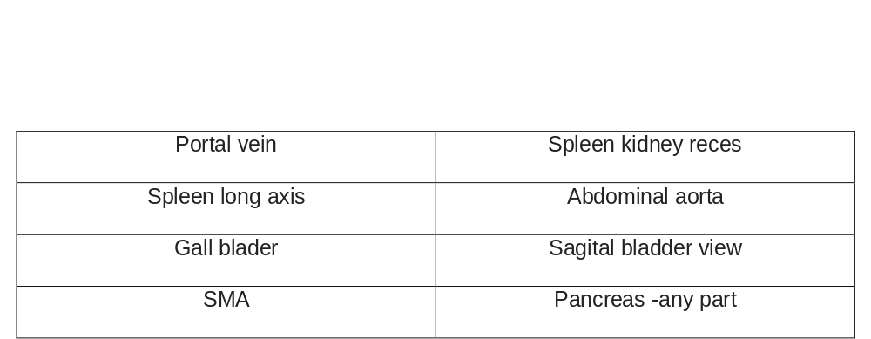
The participant will choose three POCUS windows randomly from a stack of eight POCUS windows options, as detailed below:

Test Scores:
An expert in POCUS reviewed the results, categorizing them as either correct or incorrect:
Correct- the Physician was able to demonstrate the requested POCUS window.
Incorrect- the physician couldn’t demonstrate the requested POCUS window.
The POCUS experts scored the examinees according to the following answers:
POCUS Window | Image | Description
Portal Vein | 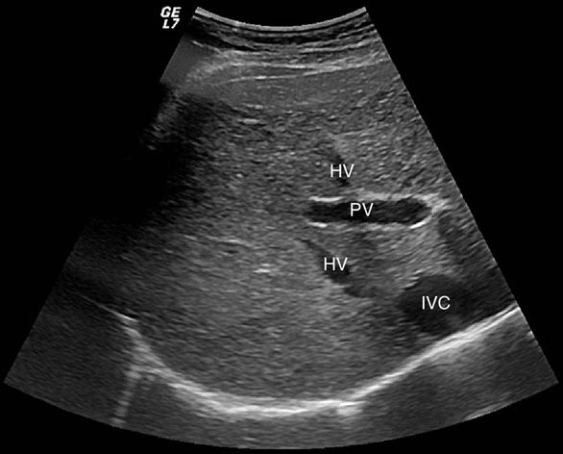 | Recognize; portal vein (PV) as it appears in the liver, differentiation, and comparison to other vessels: hepatic veins (HV) and inferior vena cava (IVC)
Spleen Long axis | 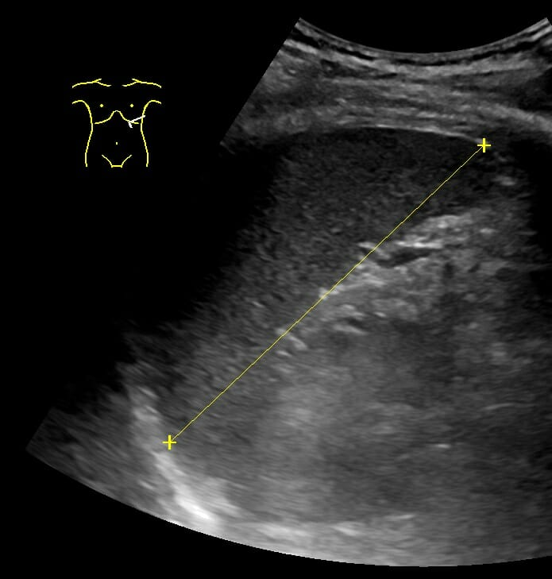 | Recognize spleen on the long axis, differentiation between lung and kidney. Measuring size using the device’s tools.
Gallbladder | 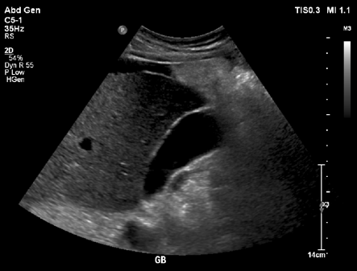 | Demonstration of gallbladder. Tilting the transducer to examine all cavities and walls.
SMA | 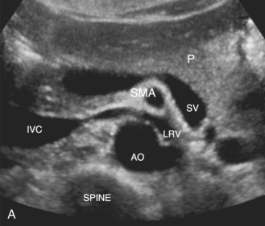 | Recognition of the SMA (superior mesenteric artery), differentiating from the Aorta (AO) inferior vena cava ( IVC). The proper demonstration includes a view of the left renal vein.
Spleen-Kidney and liver-kidney Recess | 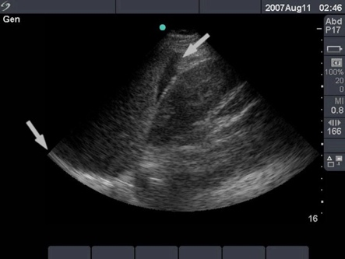 | Demonstration of the liver/spleen and the kidney. recognition of the potential recess, and possible pathologies ( as presented).
Abdominal Aorta | 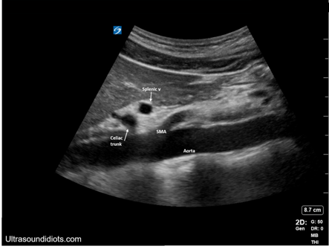 | Recognition of the abdominal aorta in short and long axis.
Bladder view | 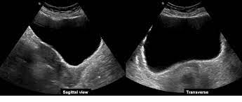 | Demonstration of the bladder in sagittal and transverse axis.
Pancreas | 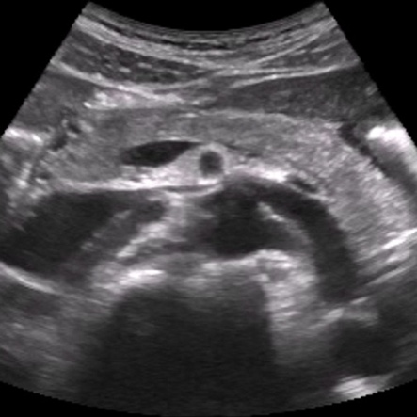 | Demonstration of the pancreas in short axis.

S3 Appendix- Pre-Intervention Questionnaire - Abdominal Course
Point of Care Ultrasound' course- Questionnaire
- To what extent do you believe incorporating POCUS (in general) into your practice will improve the care you provide to patients?
Strongly disagree/ Disagree/ Neutral/ Agree/ Strongly agree
- To what extent do you believe incorporating abdominal POCUS into your practice will improve the care you provide to patients?
Strongly disagree/ Disagree/ Neutral/ Agree/ Strongly agree
- To what extent do you agree with the following statement: A short abdominal POCUS course improves diagnostic skills?
Strongly disagree/ Disagree/ Neutral/ Agree/ Strongly agree
- To what extent do you agree with the following statement: abdominal POCUS is a diagnostic modality that primary care physicians can use to provide a more accurate and quicker diagnosis for several disease processes for the abdominal examination?
Strongly disagree/ Disagree/ Neutral/ Agree/ Strongly agree

Do you think abdominal POCUS course should be an integral part of both residents’ and specialists’ medical training?
Strongly disagree/ Disagree/ Neutral/ Agree/ Strongly agree
- Do you agree with the following statement: Short abdominal POCUS course may shorten time to diagnosis thus may reduce morbidity?
Strongly disagree/ Disagree/ Neutral/ Agree/ Strongly agree
- Do you believe this Short abdominal POCUS course will improve your ultrasound skills?
Strongly disagree/ Disagree/ Neutral/ Agree/ Strongly agree
- How comfortable do you feel with your understanding of the ultrasound machine and your ability to operate it within different clinical abdominal scenarios before this course?
Not at all/ Minimally/ Moderately/ Greatly / Extremely
- How comfortable do you feel with your understanding of the capabilities and limitations of abdominal POCUS?
Strongly disagree/ Disagree/ Neutral/ Agree/ Strongly agree
- How likely are you to integrate abdominal POCUS into your routine clinical care after the course?
Not at all/ Minimally/ Moderately/ Greatly / Extremely
- What is your frequency of Abdominal US utilization pre- POCUS course?
Not using/ Little use (up four times a month) / Reasonable use (more than once a week)/ Multiple use (every day)
- Have you ever had similar training in this field??
Yes / No

S4 Primary Care Physicians Perceptions on abdominal POCUS – Post Course
- To what extent do you believe incorporating POCUS (in general) into your practice will improve the care you provide to patients?
Strongly disagree/ Disagree/ Neutral/ Agree/ Strongly agree
- To what extent do you believe incorporating abdominal POCUS into your practice will improve the care you provide to patients?
Strongly disagree/ Disagree/ Neutral/ Agree/ Strongly agree
- To what extent do you agree with the following statement: A short abdominal POCUS course improves diagnostic skills?
Strongly disagree/ Disagree/ Neutral/ Agree/ Strongly agree
- To what extent do you agree with the following statement: POCUS is a diagnostic modality that primary care physicians can use to provide a more accurate and quicker diagnosis for several disease processes for the abdominal examination?
Strongly disagree/ Disagree/ Neutral/ Agree/ Strongly agree

Do you think abdominal POCUS course should be an integral part of both residents’ and specialists’ medical training?
Strongly disagree/ Disagree/ Neutral/ Agree/ Strongly agree
- Do you agree with the following statement: Short abdominal POCUS course may shorten time to diagnosis thus may reduce morbidity?
Strongly disagree/ Disagree/ Neutral/ Agree/ Strongly agree
- Do you believe the Short abdominal POCUS course you took improved your ultrasound skills?
Strongly disagree/ Disagree/ Neutral/ Agree/ Strongly agree
- How comfortable do you feel with your understanding of the ultrasound machine and your ability to operate it within different clinical abdominal scenarios after this course?
Not at all/ Minimally/ Moderately/ Greatly / Extremely
- How comfortable do you feel with your understanding of the capabilities and limitations of abdominal POCUS after the course?
Strongly disagree/ Disagree/ Neutral/ Agree/ Strongly agree
- How likely are you to integrate abdominal POCUS into your routine clinical care after the course?
Not at all/ Minimally/ Moderately/ Greatly / Extremely
- What is your frequency of abdominal US utilization pre- POCUS course?
Not using/ Little use (up four times a month) / Reasonable use (more than once a week)/ Multiple use (every day)

S5 Appendix Echo - Abdominal Pathology Identification Test
Question 1: Where should the transducer be placed to see this image?
1. Midaxillary to the right of the patient
2. Lower abdominal right quadrant
3. The middle of the abdomen
4. Anterior to the bladder

Question 2: What is shown in this picture?
1. A normal kidney
2. Pyelonephritis
3. Urinary tract narrowing
4. Hydronephrosis

Question 3: What is shown in this picture?
1. Seashore sign indicative of pneomathorax.
2. Focused assessment with sonography in trauma (FAST) positive
3. Acute cholangitis
4. ״Fish Tail״ sign indicative of pleural effusion.

Question 4: What is shown in this picture?
1. Normal gallbladder
2. Liver abscess
3. Gallbladder with sludge
4. Cholecystitis

Question 5: What is shown in this picture?
1. Wirsung duct expansion
2. Normal pancreatic head
3. Normal pancreatic tail
4. Bile duct

Question 6: Where should the transducer be placed to see this image?
1. Sub-Xiphoid position when the transducer is perpendicular at 90 degrees to the patient's body
2. Mid-clavicular position when the transducer is balanced at 180 degrees to the patient's body
3. Mid-axillary position when the transducer is perpendicular at 90 degrees to the patient's body
4. Sub-Xiphoid position when the transducer is perpendicular at 180 degrees to the patient's body.

Question 7: What is the structure pointed to by the orange arrow in this picture?
1. Abdominal aorta
2. Superior mesenteric artery
3. Inferior vena cava
4. Body of pancreas

Question 8: What is shown in this picture?
1. Pathological gallbladder
2. Physiological bladder
3. Pathological bladder
4. Positive FAST sign

S1 Appendix- Primary Care Physicians Perceptions Of POCUS

 | Time
Variable | T1¹ | T2¹ | p-value²
To what extent do you believe incorporating POCUS (in general) into your practice will improve the care you provide to patients? |  |  | <0.001
Strongly Disagree | 0 / 48 (0%) | 0 / 48 (0%)
Disagree | 11 / 48 (23%) | 0 / 48 (0%)
Neutral | 22 / 48 (46%) | 1 / 48 (2.1%)
Agree | 13 / 48 (27%) | 21 / 48 (44%)
Strongly Agree | 2 / 48 (4.2%) | 26 / 48 (54%)
To what extent do you believe incorporating abdominal POCUS into your practice will improve the care you provide to patients? |  |  | <0.001
Strongly Disagree | 1 / 48 (2.1%) | 0 / 48 (0%)
Disagree | 12 / 48 (25%) | 0 / 48 (0%)
Neutral | 27 / 48 (56%) | 4 / 48 (8.3%)
Agree | 7 / 48 (15%) | 20 / 48 (42%)
Strongly Agree | 1 / 48 (2.1%) | 24 / 48 (50%)
To what extent do you agree with the following statement: A short abdominal POCUS course improves diagnostic skills? |  |  | <0.001
Strongly Disagree | 0 / 48 (0%) | 0 / 48 (0%)
Disagree | 4 / 48 (8.3%) | 1 / 48 (2.1%)
Neutral | 26 / 48 (54%) | 3 / 48 (6.3%)
Agree | 16 / 48 (33%) | 26 / 48 (54%)
Strongly Agree | 2 / 48 (4.2%) | 18 / 48 (38%)
To what extent do you agree with the following statement: POCUS is a diagnostic modality that primary care physicians can use to provide a more accurate and quicker diagnosis for several disease processes for the abdominal examination? |  |  | <0.001
Strongly Disagree | 0 / 48 (0%) | 0 / 48 (0%)
Disagree | 12 / 48 (25%) | 0 / 48 (0%)
Neutral | 19 / 48 (40%) | 3 / 48 (6.3%)
Agree | 10 / 48 (21%) | 25 / 48 (52%)
Strongly Agree | 7 / 48 (15%) | 20 / 48 (42%)
Do you think abdominal POCUS course should be an integral part of both residents’ and specialists’ medical training? |  |  | <0.001
Strongly Disagree | 0 / 48 (0%) | 0 / 48 (0%)
Disagree | 0 / 48 (0%) | 0 / 48 (0%)
Neutral | 33 / 48 (69%) | 1 / 48 (2.1%)
Agree | 12 / 48 (25%) | 20 / 48 (42%)
Strongly Agree | 3 / 48 (6.3%) | 27 / 48 (56%)
Do you agree with the following statement: Short abdominal POCUS course may shorten time to diagnosis thus may reduce morbidity? |  |  | <0.001
Strongly Disagree | 2 / 48 (4.2%) | 0 / 48 (0%)
Disagree | 20 / 48 (42%) | 1 / 48 (2.1%)
Neutral | 21 / 48 (44%) | 9 / 48 (19%)
Agree | 5 / 48 (10%) | 23 / 48 (48%)
Strongly Agree | 0 / 48 (0%) | 15 / 48 (31%)
Do you believe this Short abdominal POCUS course will improve your ultrasound skills? |  |  | 0.006
Strongly Disagree | 0 / 48 (0%) | 0 / 47 (0%)
Disagree | 4 / 48 (8.3%) | 0 / 47 (0%)
Neutral | 11 / 48 (23%) | 4 / 47 (8.5%)
Agree | 19 / 48 (40%) | 22 / 47 (47%)
Strongly Agree | 14 / 48 (29%) | 21 / 47 (45%)
How comfortable do you feel with your understanding of the ultrasound machine and your ability to operate it within different clinical abdominal scenarios before this course? |  |  | <0.001
Not at all | 25 / 48 (52%) | 1 / 48 (2.1%)
Minimally | 14 / 48 (29%) | 6 / 48 (13%)
Moderately | 9 / 48 (19%) | 21 / 48 (44%)
Greatly | 0 / 48 (0%) | 18 / 48 (38%)
Extremely | 0 / 48 (0%) | 2 / 48 (4.2%)
How comfortable do you feel with your understanding of the capabilities and limitations of abdominal POCUS? |  |  | <0.001
Not at all | 15 / 48 (31%) | 0 / 48 (0%)
Minimally | 33 / 48 (69%) | 2 / 48 (4.2%)
Moderately | 0 / 48 (0%) | 18 / 48 (38%)
Greatly | 0 / 48 (0%) | 24 / 48 (50%)
Extremely | 0 / 48 (0%) | 4 / 48 (8.3%)
How likely are you to integrate abdominal POCUS into your routine clinical care after the course? |  |  | 0.005
Not at all | 0 / 48 (0%) | 0 / 48 (0%)
Minimally | 6 / 48 (13%) | 7 / 48 (15%)
Moderately | 36 / 48 (75%) | 17 / 48 (35%)
Greatly | 5 / 48 (10%) | 22 / 48 (46%)
Extremely | 1 / 48 (2.1%) | 2 / 48 (4.2%)
What is your frequency of Abdominal US utilization pre- POCUS course? |  |  | <0.001
Not using | 45 / 48 (94%) | 9 / 48 (19%)
Little use (up four times a month) | 3 / 48 (6.3%) | 18 / 48 (38%)
Reasonable use (more than once a week) | 0 / 48 (0%) | 18 / 48 (38%)
Multiple use (every day) | 0 / 48 (0%) | 3 / 48 (6.3%)
¹n / N (%)
² McNemar test

