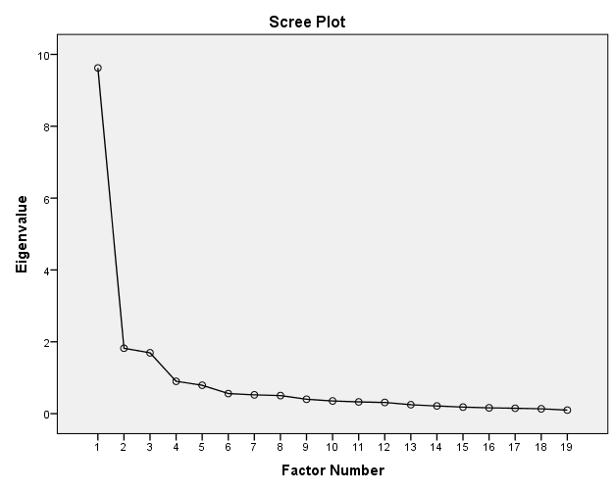

Supplementary Figure 1. Scree Plot of the Extracted Components of the Persian version of the Educational Leadership Scale for Nursing Students.

Supplementary Table 1. CVR and CVI, Subscription Values for Each Solution and Stability Test.

Item | CVR | CVI | Extraction | Corrected Item-Total Correlation | Cronbach's Alpha if Item Deleted
Q1 | 0/86 | 1/00 | .629 | .480 | .945
Q2 | 0/86 | 0/93 | .698 | .543 | .944
Q3 | 1/00 | 0/93 | .663 | .563 | .943
Q4 | 0/71 | 0/93 | .511 | .621 | .942
Q5 | 0/86 | 0/93 | .773 | .701 | .941
Q6 | 0/86 | 1/00 | .721 | .733 | .940
Q7 | 0/86 | 1/00 | .707 | .738 | .940
Q8 | 1/00 | 0/93 | .711 | .678 | .941
Q9 | 0/71 | 0/93 | .742 | .649 | .942
Q10 | 0/86 | 0/86 | .497 | .639 | .942
Q11 | 0/86 | 0/93 | .621 | .672 | .941
Q12 | 0/86 | 0/93 | .641 | .725 | .941
Q13 | 1/00 | 1/00 | .680 | .742 | .940
Q14 | 0/86 | 1/00 | .675 | .742 | .940
Q15 | 0/71 | 0/86 | .509 | .664 | .942
Q16 | 1/00 | 1/00 | .473 | .655 | .942
Q17 | 1/00 | 1/00 | .652 | .747 | .940
Q18 | 0/86 | 0/93 | .699 | .734 | .940
Q19 | 0/86 | 0/93 | .523 | .671 | .942

EDUCATIONAL LEADERSHIP SCALE FOR NURSING STUDENTS
Educational Leadership Scale For Nursing Students | Never Disagree | Disagree | Undecided | Agree | Strongly Agree
- I believe that I will serve as a professional role model for nursing profession candidates.
- I frequently keep my professional knowledge up to date.
- I follow the scientific activities in my field.
- I am eager to share my knowledge related to my field.
- I believe that learning modules related to the field should be designed to develop an interest in nursing candidates.
- I believe that educational materials should be crafted to align with the learning objectives.
- I believe that the best method should be selected to assess the training needs of nursing candidates.
- I believe that the learning progress of nursing candidates should be regularly assessed.
- I believe that the training contents should be tailored to meet the needs of the nursing profession.
- I believe that the standards of the National Core Program for Nursing should be followed when planning educational programs.
- I believe that the standards of international nursing education programs should be followed when preparing educational programs.
- I believe that nursing educational programs should be designed in a way that facilitates learning.
- I believe that technology should be utilized in vocational training.
- I believe that the most suitable assessment method should be employed in evaluating vocational training.
- I think incorporating professional ethics into nursing training is of utmost importance.
- I think learning modules should be designed in alignment with nursing professional ethics.
- I think enhancing and developing the communication skills of nursing candidates is crucial.
- I think fostering cooperative skills in nursing candidates is essential.
- I think classroom education should be conducted in a democratic environment.

