Supplemental Materials

Application of Case-Based Learning with the Symptom "Limited Mouth Opening" in Clinical Practice Teaching of Temporomandibular Joint Disorders
Pan Jiang, Haixiang Chen, Jing Li, Hangtian Zhou
Department of Stomatology, The First Affiliated Hospital of USTC, Division of Life Sciences and Medicine, University of Science and Technology of China, Hefei, Anhui, 230001, China
Corresponding Author: Pan Jiang
Email: panjiang108@163.com

Supplemental Figure 1. Teaching Evaluation Scores of the Two Groups of Residents
Supplemental Table 1. Comparison of Temporomandibular Joint Theoretical Knowledge Scores between the Two Groups
Supplemental Form 1. Temporomandibular Joint Exam Question
Supplemental Form 2. Clinical Medical History Collection Scoring Form
Supplemental Form 3. Specialty Practice assessment Form
Supplemental Form 4. Questionnaire Survey
Supplemental Figure 1. Teaching Evaluation Scores of the Two Groups of Residents

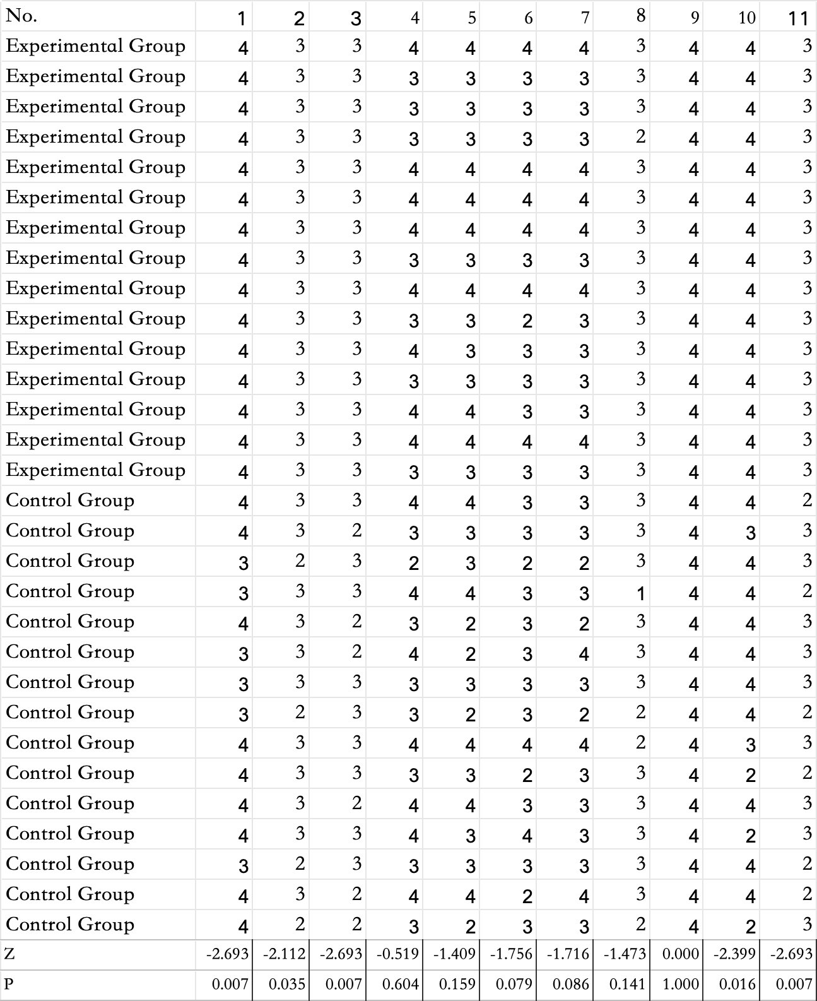
Supplemental Table 1: Comparison of Temporomandibular Joint Theoretical Knowledge Scores between the Two Groups [Score, M(IQR)]
Group | Theoretical Knowledge
Experimental Group | 58 (26)
Control Group | 55 (31)
Z-value | -0.934
P-value | 0.350

Supplemental Form 1: Temporomandibular Joint Exam Question

| 1 | A1 | The highest prevalence and consultation rates of temporomandibular disorders (TMD) occur in which age group? (2 point) |
A. 10–20 years old
B. 20–30 years old
C. 30–40 years old
D. 40–50 years old
E. 50–60 years old |
| 2 | A1 | The nerve distribution of the joint capsule does **NOT** include: (2 point) |
A. Masseteric nerve
B. Auriculotemporal nerve
C. Posterior deep temporal nerve
D. Buccal nerve |
| 3 | A1 | Which statement about inflammatory diseases is **incorrect**? (2 point) |
A. Capsulitis and synovitis are clinically easy to differentiate.
B. Tenderness in capsulitis is mainly on the lateral wall of the joint capsule.
C. Local pain occurs during joint movement.
D. Pain increases with posterior-superior joint loading during movement.
E. Joint effusion may cause mild swelling and inability to occlude posterior teeth on the same side. |
| 4 | A1 | The opening condition after disc or capsular ligament laxity is: (2 point) |
A. Normal opening range
B. Excessive opening with subluxation
C. Moderate limitation in opening
D. Clicking and subluxation
E. Mild limitation in opening |
| 5 | A1 | A patient experiences deep pain in the right joint during mouth opening and chewing, tenderness at the posterior-superior maxillary tuberosity, moderate limited opening, passive opening exceeding natural range, and deviation to the right. The most likely diagnosis is: (3 point) |
A. Right lateral pterygoid muscle hyperactivity
B. Right TMD inflammatory disease
C. Right irreducible disc anterior displacement
D. Right lateral pterygoid muscle spasm
E. Left lateral pterygoid muscle hyperactivity |
| 6 | A1 | Which is **NOT** a feature of true ankylosis? (2 point) |
A. Micrognathia
B. Reduced condylar mobility
C. Deepening of the antegonial notch
D. Elongated coronoid process
E. Loss of joint structure |
| 7 | A1 | A 26-year-old male presents with limited mouth opening and headache/tinnitus for 15 days. Examination: 1 cm opening, no joint clicking or crepitus, no trauma history, and unremarkable X-ray. The most likely diagnosis is: (3 point) |
A. Tetanus
B. Hysteria
C. Masticatory muscle spasm
D. Pterygopalatine fossa tumor
E. Infratemporal fossa tumor |
| 8 | A1 | Unilateral TMJ ankylosis may cause: (2 point) |
A. Chin deviates to the healthy side
B. Chin deviates to the affected side
C. Fullness of the healthy side
D. Narrowness of the affected side
E. Micrognathia |
| 9 | A1 | The three major symptoms of TMD do **NOT** include: (2 point) |
A. Abnormal opening range and pattern
B. Spontaneous pain in the joint or muscles in severe cases
C. Clicking, crepitus, or grating during movement
D. Pain in the joint or muscles during movement, possibly with trigger points
E. Joint locking during opening/closing |
| 10 | A1 | The most common type of masticatory muscle disorder is: (2 point) |
A. Myositis
B. Myofascial pain
C. Muscle spasm
D. Unclassified local myalgia
E. Intermittent pain |
| 11 | A1 | A patient has a crisp click in the left TMJ during initial opening and final closing, left joint pain when clenching, and multiple missing posterior teeth. X-ray shows reduced posterior joint space. The diagnosis is: (3 point) |
A. Left lateral pterygoid spasm
B. Left disc perforation
C. Left condylar destruction
D. Left disc displacement with condylar retrusion
E. Left disc displacement with condylar protrusion |
| 12 | A1 | A 12-year-old boy with childhood left ear discharge and 8-year history of limited opening. Examination: facial asymmetry, 2 mm opening, no left TMJ mobility, active right TMJ. The most likely diagnosis is: (3 point) |
A. Bilateral bony ankylosis
B. Bilateral extra-articular ankylosis
C. Left bony ankylosis
D. Left extra-articular ankylosis
E. Left bony ankylosis with right extra-articular ankylosis |
| 13 | A1 | Which statement is **inconsistent** with TMD symptoms? (2 point) |
A. Joint locking during movement
B. Abnormal opening range and pattern
C. Pain in the joint or muscles during movement
D. Spontaneous pain in severe cases
E. Clicking, crepitus, or grating during movement |
| 14 | A1 | Which is an irreversible conservative treatment for TMD? (2 point) |
A. Medication
B. Physical therapy
C. Injection therapy
D. Occlusal splint therapy
E. Orthodontic treatment |
| 15 | A1 | The condylar cartilage is composed of: (2 point) |
A. Hyaline cartilage
B. Fibrocartilage
C. Hyaline and fibrocartilage
D. None of the above |
| 16 | A1 | Which statement about masticatory muscle disorders is **incorrect**? (2 point) | A. Mainly organic changes in muscles
B. Mainly functional incoordination, hyperactivity, or spasm
C. Includes myofascial pain
D. Includes lateral pterygoid hyperactivity and spasm
E. Conservative treatment is primary |
| 17 | A1 | Childhood injury to which area may cause micrognathia? (2 point) |
A. Condylar process
B. Mandibular angle
C. Mandibular symphysis
D. Mandibular body |
| 18 | A1 | The anterior boundary of the TMJ does **NOT** include: (3 point) |
A. Superior head of the lateral pterygoid
B. Anterior temporal attachment
C. Anterior mandibular attachment
D. Inferior head of the medial pterygoid |
| 19 | A1 | The most common type of TMD is: (2 point) |
A. Masticatory muscle disorders
B. Internal derangements
C. Inflammatory joint diseases
D. Osteoarthritis
E. Ankylosis |
| 20 | A1 | A patient with left TMJ pain during opening/chewing (no spontaneous pain), moderate limited opening with left deviation, and tenderness posterior to the left condyle. Treatment should be: (3 point) |
A. 0.5% or 1% procaine injection
B. 2% procaine (2–3 ml)
C. Prednisolone 0.5–0.8 ml injection
D. Repositioning splint therapy
E. Condylectomy and disc removal |
| 21 | A1 | The connection between the lateral pterygoid muscle and the articular disc does **NOT** include: (3 point) |
A. Nodal connection
B. Tendon connection
C. End-to-end connection
D. Fibrous connection |
| 22 | A1 | The characteristic sound of disc perforation is: (3 point) |
A. Single crisp click during initial opening and final closing
B. Multiple joint crepitus sounds
C. No clicking
D. Single crisp click during final opening and initial closing
E. Multiple crisp clicks |
| 23 | A1 | Key differences between condylar neck fracture and acute disc displacement include: (3 point) |
A. Midline deviation to the affected side in unilateral fracture
B. Anterior open bite in bilateral fractures
C. Condylar tenderness and hematoma
D. Fracture line visible on X-ray
E. All of the above |
| 24 | A1 | Treatments for recurrent TMJ dislocation do **NOT** include: (3 point) |
A. Arthroscopy
B. Eminence augmentation
C. Condylectomy
D. Eminence reduction
E. Capsular tightening |
| 25 | A1 | The most common treatment for acute anterior TMJ dislocation is: (3 point) |
A. General anesthesia reduction
B. Surgical reduction
C. Intermaxillary reduction
D. Extraoral manual reduction
E. Intraoral manual reduction |
| 26 | A1 | Which method is **NOT** used for TMD diagnosis? (3 point) |
A. History taking
B. Clinical examination
C. Surgical exploration
D. Schüller and transpharyngeal X-rays
E. Arthrography |
| 27 | A1 | Which statement about TMJ imaging is **incorrect**? (3 point) |
A. X-rays show joint space changes and bone changes
B. Arthrography detects disc displacement, perforation, and attachment changes
C. MRI detects disc displacement and effusion
D. CT visualizes disc morphology
E. X-rays show condylar sclerosis, destruction, or cysts |
| 28 | A1 | Which statement about TMJ treatment is **incorrect**? (3 point) |
A. Conservative therapy is primary
B. Start with reversible methods before irreversible ones
C. Asymptomatic disc displacement requires no surgery
D. Irreducible disc displacement without limitation needs no surgery
E. Sclerosing agents are injected intra-articularly for capsular laxity |
| 29 | A1 | For lateral pterygoid spasm, use: (3 point) |
A. 0.5% or 1% procaine
B. 2% procaine
C. Prednisolone
D. 5% sodium morrhuate
E. 50% glucose |
| 30 | A2 | A 25-year-old female with typical joint clicking (now absent) and limited opening. X-ray shows condylar sclerosis and destruction. The diagnosis is: (4 point) |
A. Reducible disc displacement
B. Irreducible disc displacement
C. Osteoarthritis
D. Synovitis
E. Condylar fracture |
| 31 | A2 | A 25-year-old female with right joint clicking (now absent), limited opening, and MRI showing disc perforation. The diagnosis is: (4 point) |
A. Right reducible disc displacement
B. Left irreducible disc displacement
C. Bilateral irreducible disc displacement
D. Right osteoarthritis
E. Left osteoarthritis |
| 32 | A2 | A female with persistent dull pain triggered by cold, tenderness, mild limited opening (passively normal but painful). The diagnosis is: (4 point) |
A. Lateral pterygoid hyperactivity
B. Lateral pterygoid spasm
C. Myofascial pain
D. Reducible disc displacement
E. Irreducible disc displacement |
| 33 | X | Clinical features of fibrous TMJ ankylosis include: (5 point) |
A. Joint pain
B. Progressive limited opening
C. Complete inability to open
D. Limited lateral movement
E. Reduced condylar mobility |
| 34 | X | Treatments for TMJ synovitis include: (5 point) |
A. Both conservative and surgical treatments are ineffective
B. Conservative therapy first
C. Medication, rest, injections, and joint lavage
D. Splint therapy for disc displacement or osteoarthritis
E. Surgical intervention for all cases |
| 35 | X | Radiographic features of TMJ ankylosis include: (5 point) |
A. Irregular bone destruction in the condyle and fossa
B. Loss of joint space in bony ankylosis
C. Condyle and eminence fused into a bony mass
D. "T"-shaped fusion of the ramus and zygomatic arch
E. Blurred joint space in fibrous ankylosis |
| 36 | X | Features of intermaxillary contracture include: (5 point) |
A. Limited mouth opening
B. Trauma or infection-related
C. Caused by high-dose radiation
D. Facial scars or fibrous bands
E. Surgical treatment is primary |
| 37 | X | Clinical signs of acute anterior TMJ dislocation include: (5 point) |
A. Inability to close the mouth
B. Anterior open bite with midline deviation
C. Posterior crossbite
D. Clear speech
E. Drooling and shortened lower face |
| 38 | X | Facial characteristics of TMJ ankylosis include: (5 point) |
A. Flattened affected side
B. Chin deviation to the healthy side
C. Deep antegonial notch
D. Bird-face deformity
E. Facial asymmetry |
| 39 | X | Pathological features of recurrent TMJ dislocation include: (5 point) |
A. Lax joint capsule and ligaments
B. Shallow glenoid fossa
C. Condylar and eminence hypertrophy
D. Masticatory muscle dysfunction
E. Increased synovial fluid |

---
**Note:** Questions marked "X" are multiple-select (choose all that apply).

Supplemental Form 2: Clinical Medical History Collection Scoring Form
Clinical Medical History Items | score | Specific score
Duration of the chief complaint symptoms | 2
Affected area | 2
Specific nature of the symptoms | 2
Presence of accompanying symptoms | 2
Presence of triggering factors | 2
Presence of systemic symptoms | 1
Treatment history | 3
History of toothache | 2
Previous history of joint clicking, pain, or limited mouth opening | 3
History of betel nut chewing | 1
History of trauma or surgery | 1
History of orthodontic treatment | 1
Family history | 1
General medical history | 1
Next steps for examination | 4
Preliminary diagnosis | 4
Diagnostic basis | 5
Treatment plan | 3
Total | 40

Supplemental Form 3: Specialty Practice assessments
Specialty Practice Items | score | Specific score
Facial symmetry | 1
Active mouth opening degree and pattern | 1
Passive mouth opening examination | 1
Joint clicking and noises | 1
Consistency of joint movement | 1
Tenderness in joint and muscle areas | 1
Range of mandibular protrusion and lateral movements | 1
Intraoral occlusal relationship | 1
Impacted third molar in upper and lower jaws | 1
Oral mucosa and muscles | 1
MRI reading:  TMJ disc reducible anterior displacement | 2
MRI reading:  TMJ disc non-reducible anterior displacement | 2
MRI reading:  Joint disc degeneration | 2
MRI reading:  Synovial chondromatosis | 2
MRI reading:  Arthritis | 2
Total | 20

Supplemental Form 4: Questionnaire Survey
- In the teaching of temporomandibular joint (TMJ) disorders, are you satisfied with the "case discussion" teaching method?
A. Very satisfied
B. Satisfied
C. Neutral
D. Dissatisfied
- During the rotation in the TMJ specialty department, is clinical teaching helpful in increasing your literature reading volume?
A. Very helpful
B. Neutral
C. Not helpful
- Is the case discussion of TMJ disorders helpful in expanding your clinical thinking?
A. Very helpful
B. Neutral
C. Not helpful
- Can you list diseases with the clinical manifestation of "limited mouth opening" and explain the key points for differential diagnosis?
A. Can list more than 5
B. Can list 3-5
C. Can list 1-2
D. Unclear
- Can you list diseases with the clinical manifestation of "joint pain" and explain the key points for differential diagnosis?
A. Can list more than 5
B. Can list 3-5
C. Can list 1-2
D. Unclear
- Can you list diseases with the clinical manifestation of "clicking during mouth opening" and explain the key points for differential diagnosis?
A. Can list more than 5
B. Can list 3-5
C. Can list 1-2
D. Unclear
- Can you list diseases with the clinical manifestation of "mandibular deviation" and explain the key points for differential diagnosis?
A. Can list more than 5
B. Can list 3-5
C. Can list 1-2
D. Unclear
- Does the teaching of TMJ disorders significantly reduce your misdiagnosis rate in clinical practice (for TMJ disorders)?
A. Improved diagnostic accuracy
B. Neutral
C. No help
- Does the teaching model of TMJ disorders motivate your learning initiative?
A. Very satisfied
B. Satisfied
C. Neutral
D. Dissatisfied
- Does the teaching model of TMJ disorders enhance team collaboration and improve comprehensive analytical skills?
A. Very satisfied
B. Satisfied
C. Neutral
D. Dissatisfied
- Does the teaching model of TMJ disorders improve your ability to write medical records?
A. Very helpful
B. Neutral
C. Not helpful

