Table S1 – Risk of bias in randomized trials (ROB2)
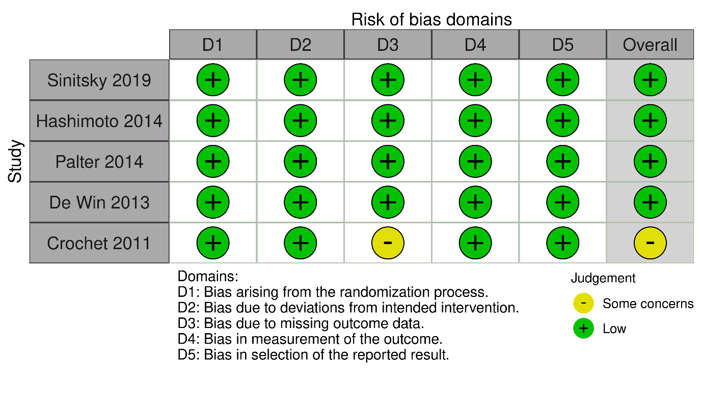
Table S2 – Risk of bias in observational studies (ROBINS-E)
