Supplementary Table (S1): Exploratory factor analysis and factor loadings (EFA) for DASS
 | Pattern Matrix |  |  | Structure Matrix |  |  | Communalities
Item number | Factor 1 | Factor 2 | Factor 3 | Factor 1 | Factor 2 | Factor 3 | Communalities
Q2 | 0.791 | 0.130 | 0.524 | 0.767 | 0.541 | 0.740 | 0.652
Q4 | 0.942 | 0.188 | 0.060 | 0.851 | 0.458 | 0.504 | 0.746
Q7 | 0.908 | 0.074 | 0.179 | 0.857 | 0.597 | 0.357 | 0.759
Q9 | 0.963 | 0.184 | 0.391 | 0.809 | 0.361 | 0.367 | 0.813
Q15 | 0.455 | 0.273 | 0.199 | 0.746 | 0.657 | 0.567 | 0.632
Q19 | 0.714 | 0.232 | 0.342 | 0.874 | 0.287 | 0.519 | 0.721
Q20 | 0.824 | 0.102 | 0.379 | 0.831 | 0.390 | 0.453 | 0.736
Q1 | 0.285 | 0.561 | 0.008 | 0.650 | 0.745 | 0.386 | 0.600
Q6 | 0.478 | 0.503 | 0.177 | 0.711 | 0.743 | 0.299 | 0.661
Q8 | 0.013 | 0.857 | 0.009 | 0.582 | 0.869 | 0.376 | 0.755
Q11 | 0.372 | 0.789 | 0.270 | 0.613 | 0.884 | 0.281 | 0.750
Q12 | 0.203 | 0.914 | 0.131 | 0.472 | 0.835 | 0.403 | 0.720
Q14 | 0.304 | 0.541 | 0.119 | 0.794 | 0.722 | 0.542 | 0.711
Q18 | 0.362 | 0.629 | 0.445 | 0.635 | 0.780 | 0.392 | 0.691
Q3 | 0.197 | 0.809 | 0.141 | 0.652 | 0.880 | 0.309 | 0.796
Q5 | 0.021 | 0.758 | 0.202 | 0.633 | 0.857 | 0.532 | 0.770
Q10 | 0.570 | 0.789 | 0.273 | 0.580 | 0.779 | 0.627 | 0.668
Q13 | 0.445 | 0.851 | 0.031 | 0.561 | 0.894 | 0.459 | 0.743
Q16 | 0.432 | 0.721 | 0.076 | 0.654 | 0.835 | 0.533 | 0.742
Q17 | 0.173 | 0.642 | 0.378 | 0.490 | 0.760 | 0.693 | 0.728
Q21 | 0.107 | 0.561 | 0.199 | 0.523 | 0.778 | 0.548 | 0.568
 |  | Kaiser-Meyer-Olkin Measure of Sampling Adequacy = 0.927
The boldface indicates salient (> 0.30) loading

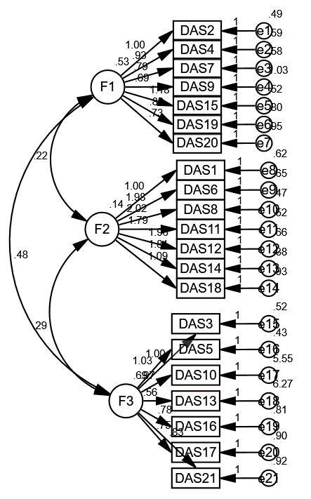
Supplementary Figure (1): CFA confirmatory factor analysis by Structure Equation Modeling for DASS
Model fit parameters CFI; IFI; RMSEA (0.963; 0.983; 0.075).
CFI = Comparative fit index; IFI = incremental fit index;
and RMSEA = Root Mean Square Error of Approximation.
Model χ²; significance 3.227 (0.001)

F1: Anxiety
F2: Stress
F3: Depression

Supplementary Table (S2): Cronbac's Alpha for DASS
Item number | Cronbach's Alpha if Item Deleted
Anxiety | 0.813
Q2 | 0.773
Q4 | 0.789
Q7 | 0.810
Q9 | 0.797
Q15 | 0.779
Q19 | 0.772
Q20 | 0.795
Stress | 0.804
Q1 | 0.705
Q6 | 0.763
Q8 | 0.747
Q11 | 0.762
Q12 | 0.772
Q14 | 0.762
Q18 | 0.728
Depression | 0.884
Q3 | 0.874
Q5 | 0.867
Q10 | 0.864
Q13 | 0.862
Q16 | 0.865
Q17 | 0.864
Q21 | 0.873
Overall DASS | 0.902

Supplementary Table (S3): (Item to scale correlation) for DASS
Item number | Pearson Correlation
Anxiety
Q2 | 0.519*
Q4 | 0.673*
Q7 | 0.537*
Q9 | 0.635*
Q15 | 0.580*
Q19 | 0.519*
Q20 | 0.790*
Stress
Q1 | 0.570*
Q6 | 0.590*
Q8 | 0.529*
Q11 | 0.518*
Q12 | 0.549*
Q14 | 0.691*
Q18 | 0.756*
Depression
Q3 | 0.761*
Q5 | 0.597*
Q10 | 0.521*
Q13 | 0.603*
Q16 | 0.529*
Q17 | 0.611*
Q21 | 0.805*

Supplementary Table (S4):Exploratory factor analysis and factor loadings (EFA) for Self-efficacy scale
Item number | Pattern Matrix |  | Structure Matrix |  | Communalities
Item number | Factor 1 | Factor 2 | Factor 1 | Factor 2 | Communalities
Q1 | 0.853 | 0.001 | 0.852 | 0.526 | 0.726
Q2 | 0.815 | 0.111 | 0.910 | 0.540 | 0.891
Q3 | 0.876 | 0.041 | 0.902 | 0.583 | 0.814
Q4 | 0.890 | 0.069 | 0.933 | 0.619 | 0.873
Q5 | 0.189 | 0.796 | 0.681 | 0.913 | 0.855
Q6 | 0.903 | 0.061 | 0.941 | 0.619 | 0.887
Q7 | 0.797 | 0.030 | 0.778 | 0.463 | 0.606
Q8 | 0.955 | 0.045 | 0.927 | 0.545 | 0.861
Q9 | 0.904 | 0.029 | 0.886 | 0.530 | 0.786
Q10 | 0.915 | 0.039 | 0.939 | 0.605 | 0.883
Kaiser-Meyer-Olkin Measure of Sampling Adequacy = 0.956
The boldface indicates salient (> 0.30) loading

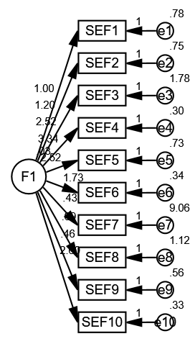
Supplementary Figure (2): CFA confirmatory factor analysis by Structure Equation Modeling for Self-efficacy scale
Model fit parameters CFI; IFI; RMSEA (0.948; 0.956; 0.077).
CFI = Comparative fit index; IFI = incremental fit index;
and RMSEA = Root Mean Square Error of Approximation.
Model χ²; significance 3.939 (0.001)

Supplementary Table (S5):Cronbac's Alpha for Self-efficacy scale
Item number | Cronbach's Alpha if Item Deleted
Q1 | 0.802
Q2 | 0.811
Q3 | 0.783
Q4 | 0.794
Q5 | 0.803
Q6 | 0.793
Q7 | 0.814
Q8 | 0.801
Q9 | 0.815
Q10 | 0.782
Self-efficacy scale | 0.817

Supplementary Table (S6): (Item to scale correlation) for Self-efficacy scale
Item number | Pearson Correlation
Q1 | 0.586*
Q2 | 0.511*
Q3 | 0.742*
Q4 | 0.669*
Q5 | 0.597*
Q6 | 0.669*
Q7 | 0.543*
Q8 | 0.612*
Q9 | 0.667*
Q10 | 0.748*

Supplementary Table (S7):Exploratory factor analysis and factor loadings (EFA) for Student advising and counseling survey
Item number | Pattern Matrix |  | Structure Matrix |  | Communalities
Item number | Factor 1 | Factor 2 | Factor 1 | Factor 2 | Communalities
Q1 | 0.922 | 0.055 | 0.962 | 0.736 | 0.927
Q2 | 0.875 | 0.104 | 0.952 | 0.751 | 0.912
Q3 | 0.973 | 0.002 | 0.940 | 0.756 | 0.917
Q4 | 0.943 | 0.016 | 0.955 | 0.713 | 0.913
Q5 | 0.913 | 0.060 | 0.958 | 0.735 | 0.919
Q6 | 0.826 | 0.540 | 0.921 | 0.760 | 0.921
Q7 | 0.918 | 0.041 | 0.948 | 0.719 | 0.899
Q8 | 0.917 | 0.037 | 0.944 | 0.714 | 0.892
Q9 | 0.922 | 0.055 | 0.962 | 0.736 | 0.927
Q10 | 0.875 | 0.104 | 0.952 | 0.751 | 0.912
Kaiser-Meyer-Olkin Measure of Sampling Adequacy = 0.986
The boldface indicates salient (> 0.30) loading

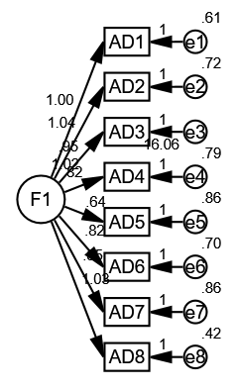
Supplementary Figure (S3): CFA confirmatory factor analysis by Structure Equation Modeling for Student advising and counseling survey
Model fit parameters CFI; IFI; RMSEA (0.973; 0.944; 0.089).
CFI = Comparative fit index; IFI = incremental fit index;
and RMSEA = Root Mean Square Error of Approximation.
Model χ²; significance 2.961 (0.001)

Supplementary Table (S8): Cronbac's Alpha for Student advising survey
Item number | Cronbach's Alpha if Item Deleted
Q1 | 0.843
Q2 | 0.835
Q3 | 0.841
Q4 | 0.852
Q5 | 0.856
Q6 | 0.855
Q7 | 0.856
Q8 | 0.847
Q9 | 0.843
Q10 | 0.835
Student advising and counseling survey | 0.869

Supplementary Table (S9): (Item to scale correlation) for Student advising survey
Item number | Pearson Correlation
Q1 | 0.877*
Q2 | 0.682*
Q3 | 0.569*
Q4 | 0.699*
Q5 | 0.760*
Q6 | 0.503*
Q7 | 0.657*
Q8 | 0.736*
Q9 | 0.877*
Q10 | 0.682*

