Supplemental Appendices
Supplemental Digital Appendix 1. Breakdown of institutional enrollment numbers for MD-PhD and MD-MSc trainees across Canada
 | MD-PhD |  | MD-MSc
Institution | 2020-2021 | 2021-2022 | 2020-2021 | 2021-2022
University of Alberta | 11 | 12 | N/A | N/A
University of British Columbia | 31 | 29 | N/A | N/A
University of Calgary | 30 | 24 | 25 | 24
University of Manitoba | 1 | 4 | 0 | 3
McGill University | 20 | 23 | N/A | N/A
McMaster University | 17 | 21 | N/A | N/A
University of Ottawa | 22 | 20 | N/A | N/A
Queens University | 20 | 20 | N/A | N/A
University of Toronto | 69 | 61 | 26 | 28
Western University | 21 | 24 | N/A | N/A
*N/A denotes that the specific institution does not have a formalized MD-MSc program.

Supplemental Digital Appendix 2. Frequency of top five mentorship needs per marginalised identity group
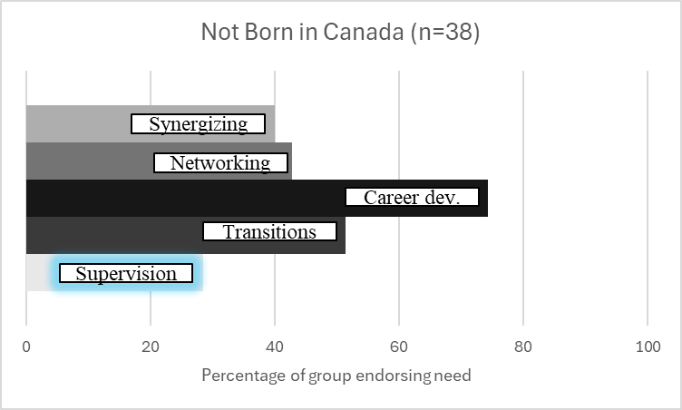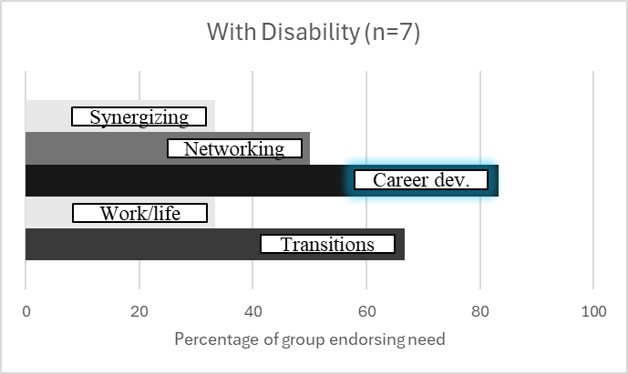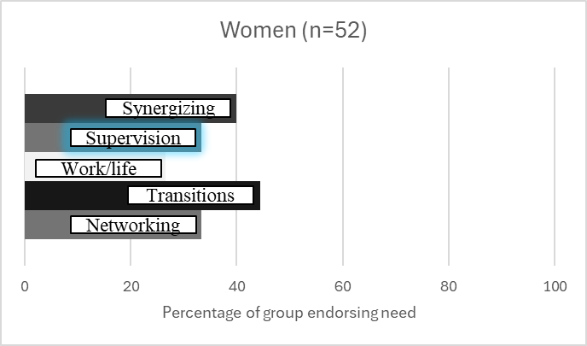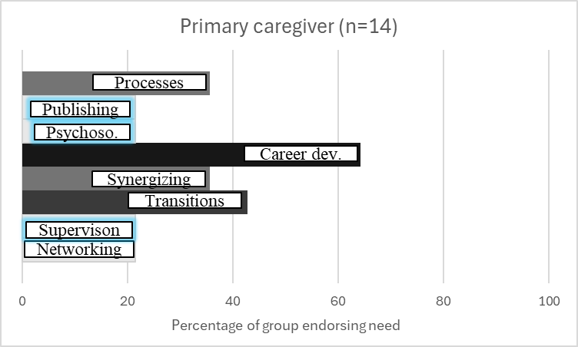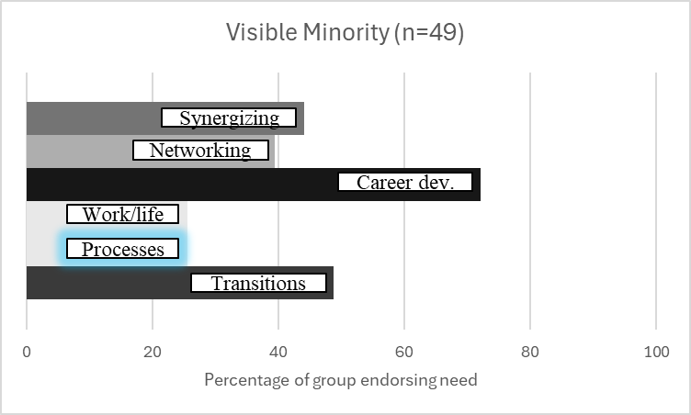
Abbreviations: Supervision: Choosing a research supervisor and maintaining a good relationship; Publishing: writing and presentations; Transitions: transitions in training; Processes: navigating institutional processes; Work/life: work/life balance; Career dev.: career planning and development; Psychoso.: Psychosocial support; Synergizing: synergizing clinical and research interests.

