Supplementary Table S1.Post-course questionnaire content.
Question | Answer
Q1. How difficult do you find the dermatology and venereology course? | 5-point Likert scale: 1 = very easy, 5 = very difficult
Q2. What are the main barriers you encountered while learning this course? | Q2_A. Fragmented knowledge structure  Q2_B. Numerous clinical images with high memory load  Q2_C. Lack of access to typical clinical cases  Q2_D. Lack of authoritative learning resources  Q2_E. Fast-paced lectures that are hard to follow  Q2_F. Limited interaction and feedback  Q2_G. Lack of periodic assessments and practice
Q3. To what extent do you agree that the current teaching model helped alleviate these learning difficulties? | 5-point Likert scale:1 = Strongly disagree, 5 = Strongly agree,5 = Very satisfied
Q4. How satisfied are you with the overall design of the course? | 5-point Likert scale: 1 = Very dissatisfied
Q5_A–D. [Experimental group only] How satisfied are you with each of the following instructional components? | Q5_A. Scenario-based simulation  Q5_B. Group discussion  Q5_C. Teacher-facilitated Q&A  Q5_D. Theoretical lecture  (5-point Likert scale: 1 = Very dissatisfied, 5 = Very satisfied)
Q6. To what extent do you agree that the teaching model helped you master the core knowledge? | 5-point Likert scale: 1 = Strongly disagree, 5 = Strongly agree
Q7. To what extent do you agree that the teaching model stimulated your interest in learning? | 5-point Likert scale: 1 = Strongly disagree, 5 = Strongly agree
Q8. To what extent do you agree that the teaching model improved your classroom engagement? | 5-point Likert scale: 1 = Strongly disagree, 5 = Strongly agree
Q9_A–D. How much improvement do you feel in the following core competencies after this course? | (5-point Likert scale: 1 = Not at all, 2 = Slight improvement, 3 = Moderate improvement, 4 = Substantial improvement, 5 = Very substantial improvement)  Q9_A. Clinical reasoning  Q9_B. Autonomous learning  Q9_C. Teamwork skills  Q9_D. Doctor–patient communication
Q10. Do you think this teaching model is suitable for other clinical subjects? | 5-point Likert scale: 1 = Strongly disagree, 5 = Strongly agree
Supplementary Table S2. Baseline test scores between groups.
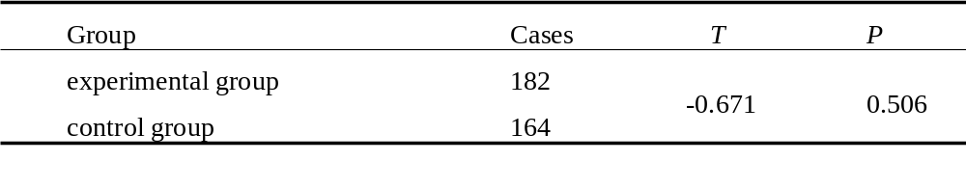
Supplementary Table S3. Student ratings of course difficulty
Supplementary Figure S1.Q10 responses between Sim+LBL and LBL groups.
Supplementary Figure S2.SHAP beeswarm plot of the top seven predictors.
