CONTENTS
Supplementary Table 1 1
Supplementary Table 2 4
Supplementary Table 3. Risk assessment of included studies. 4
Supplementary Table 4 6
Theoretical knowledge examination scores 6
Practical skills examination scores 8
Learning interest 10
Clinical thinking 11
Communication and expression ability 12
Self-directed learning ability 12
Supplementary Figure 1 Inconsistency test 13
Supplementary Figure 2 16
Supplementary Figure 3 Funnel plot 19
Supplementary Figure 4 23

Supplementary Table 1 PRISMA 2020 checklist
Section and Topic | Item # | Checklist item | Location where item is reported
TITLE
Title | 1 | Identify the report as a systematic review. | Page 1
ABSTRACT
Abstract | 2 | See the PRISMA 2020 for Abstracts checklist. | Page 2
INTRODUCTION
Rationale | 3 | Describe the rationale for the review in the context of existing knowledge. | Page 3
Objectives | 4 | Provide an explicit statement of the objective(s) or question(s) the review addresses. | Page 4
METHODS
Eligibility criteria | 5 | Specify the inclusion and exclusion criteria for the review and how studies were grouped for the syntheses. | Sup page 5
Information sources | 6 | Specify all databases, registers, websites, organisations, reference lists and other sources searched or consulted to identify studies. Specify the date when each source was last searched or consulted. | Page 5
Search strategy | 7 | Present the full search strategies for all databases, registers and websites, including any filters and limits used. | Sup page 5-6
Selection process | 8 | Specify the methods used to decide whether a study met the inclusion criteria of the review, including how many reviewers screened each record and each report retrieved, whether they worked independently, and if applicable, details of automation tools used in the process. | Page 7
Data collection process | 9 | Specify the methods used to collect data from reports, including how many reviewers collected data from each report, whether they worked independently, any processes for obtaining or confirming data from study investigators, and if applicable, details of automation tools used in the process. | Page 7-8
Data items | 10a | List and define all outcomes for which data were sought. Specify whether all results that were compatible with each outcome domain in each study were sought (e.g. for all measures, time points, analyses), and if not, the methods used to decide which results to collect. | Page 7
Data items | 10b | List and define all other variables for which data were sought (e.g. participant and intervention characteristics, funding sources). Describe any assumptions made about any missing or unclear information. | Page 7
Study risk of bias assessment | 11 | Specify the methods used to assess risk of bias in the included studies, including details of the tool(s) used, how many reviewers assessed each study and whether they worked independently, and if applicable, details of automation tools used in the process. | Page 7
Effect measures | 12 | Specify for each outcome the effect measure(s) (e.g. risk ratio, mean difference) used in the synthesis or presentation of results. | Page 7
Synthesis methods | 13a | Describe the processes used to decide which studies were eligible for each synthesis (e.g. tabulating the study intervention characteristics and comparing against the planned groups for each synthesis (item #5)). | Page 7-8
Synthesis methods | 13b | Describe any methods required to prepare the data for presentation or synthesis, such as handling of missing summary statistics, or data conversions. | Page 7-8
Synthesis methods | 13c | Describe any methods used to tabulate or visually display results of individual studies and syntheses. | Page 7-8
Synthesis methods | 13d | Describe any methods used to synthesize results and provide a rationale for the choice(s). If meta-analysis was performed, describe the model(s), method(s) to identify the presence and extent of statistical heterogeneity, and software package(s) used. | Page 7-8
Synthesis methods | 13e | Describe any methods used to explore possible causes of heterogeneity among study results (e.g. subgroup analysis, meta-regression). | Page 7-8
Synthesis methods | 13f | Describe any sensitivity analyses conducted to assess robustness of the synthesized results. | Page 8
Reporting bias assessment | 14 | Describe any methods used to assess risk of bias due to missing results in a synthesis (arising from reporting biases). | Page 8
Certainty assessment | 15 | Describe any methods used to assess certainty (or confidence) in the body of evidence for an outcome. | NULL
RESULTS
Study selection | 16a | Describe the results of the search and selection process, from the number of records identified in the search to the number of studies included in the review, ideally using a flow diagram. | Page 9
Study selection | 16b | Cite studies that might appear to meet the inclusion criteria, but which were excluded, and explain why they were excluded. | Sup page 10-21
Study characteristics | 17 | Cite each included study and present its characteristics. | Page 9
Risk of bias in studies | 18 | Present assessments of risk of bias for each included study. | Page 9
Results of individual studies | 19 | For all outcomes, present, for each study: (a) summary statistics for each group (where appropriate) and (b) an effect estimate and its precision (e.g. confidence/credible interval), ideally using structured tables or plots. | Sup page 42-53
Results of syntheses | 20a | For each synthesis, briefly summarise the characteristics and risk of bias among contributing studies. | Page 9
Results of syntheses | 20b | Present results of all statistical syntheses conducted. If meta-analysis was done, present for each the summary estimate and its precision (e.g. confidence/credible interval) and measures of statistical heterogeneity. If comparing groups, describe the direction of the effect. | Page 10-12
Results of syntheses | 20c | Present results of all investigations of possible causes of heterogeneity among study results. | Page 10-12
Results of syntheses | 20d | Present results of all sensitivity analyses conducted to assess the robustness of the synthesized results. | Page 10-12
Reporting biases | 21 | Present assessments of risk of bias due to missing results (arising from reporting biases) for each synthesis assessed. | NULL
Certainty of evidence | 22 | Present assessments of certainty (or confidence) in the body of evidence for each outcome assessed. | NULL
DISCUSSION
Discussion | 23a | Provide a general interpretation of the results in the context of other evidence. | Page 13
Discussion | 23b | Discuss any limitations of the evidence included in the review. | Page 15
Discussion | 23c | Discuss any limitations of the review processes used. | Page 15
Discussion | 23d | Discuss implications of the results for practice, policy, and future research. | Page 13-15
OTHER INFORMATION
Registration and protocol | 24a | Provide registration information for the review, including register name and registration number, or state that the review was not registered. | Page 2
Registration and protocol | 24b | Indicate where the review protocol can be accessed, or state that a protocol was not prepared. | Page 2
Registration and protocol | 24c | Describe and explain any amendments to information provided at registration or in the protocol. | Page 2
Support | 25 | Describe sources of financial or non-financial support for the review, and the role of the funders or sponsors in the review. | Page 16
Competing interests | 26 | Declare any competing interests of review authors. | Page 17
Availability of data, code and other materials | 27 | Report which of the following are publicly available and where they can be found: template data collection forms; data extracted from included studies; data used for all analyses; analytic code; any other materials used in the review. | Page 6-7

Supplementary Table 2
certainty in effect estimates | specific meanings
High certainty | We are very confident that the true effect lies close to that of  the estimate of the effect.
Moderate certainty  Low certainty  Very low certainty | We are moderately confident in the effect estimate; the true effect is likely to be close to the estimate of the effect, but there is a possibility that it is substantially different.  Our confidence in the effect estimate is limited; the true effect may be substantially different from the estimate of the effect.  We have very little confidence in the effect estimate; the true effect is likely to be substantially different from the estimate of effect.

Supplementary Table 3. Risk assessment of included studies.
Studies | Random sequence generation | Allocation concealment | Blinding | Incomplete outcome | Selective report | Other bias
Zhao ZN | Low risk | Unclear | Unclear | Low risk | Low risk | Unclear
Li JY | Unclear | Unclear | Unclear | Low risk | Low risk | Low risk
Yang F | Unclear | Unclear | Unclear | Low risk | Low risk | Low risk
Hu Y | Unclear | Unclear | Unclear | Low risk | Low risk | Low risk
Wang Q | Unclear | Unclear | Unclear | Low risk | Low risk | Low risk
Duan XL | Unclear | Unclear | Unclear | Low risk | Low risk | Low risk
Song HJ | Unclear | Unclear | Unclear | Low risk | Low risk | Low risk
Wang XS | Unclear | Unclear | Unclear | Low risk | Low risk | Low risk
Li LM | Unclear | Unclear | Unclear | Low risk | Low risk | Low risk
Wu M | Unclear | Unclear | Unclear | Low risk | Low risk | Low risk
Liu YJ | Unclear | Unclear | Unclear | Low risk | Low risk | Unclear
Zhang L | Unclear | Unclear | Unclear | Low risk | Low risk | Low risk
Ma HY | Unclear | Unclear | Unclear | Low risk | Low risk | Low risk
Liu CL | Unclear | Unclear | Unclear | Low risk | Low risk | Unclear
Shao C | Unclear | Unclear | Unclear | Low risk | Low risk | Low risk
He X | Low risk | Unclear | Unclear | Low risk | Low risk | Low risk
Xu H | Unclear | Unclear | Unclear | Low risk | Low risk | Low risk
Guo WT | Unclear | Unclear | Unclear | Low risk | Low risk | Low risk
Liu D | Low risk | Unclear | Unclear | Low risk | Low risk | Low risk
Zhang X | Unclear | Unclear | Unclear | Low risk | Low risk | Low risk
Yu XH | Low risk | Unclear | Unclear | Low risk | Low risk | Low risk
Wu K | Low risk | Unclear | Unclear | Low risk | Low risk | Low risk
Liu W | Low risk | Unclear | Unclear | Low risk | Low risk | Low risk
Zhou Y | Low risk | Unclear | Unclear | Low risk | Low risk | Low risk
Fan LH | Unclear | Unclear | Unclear | Low risk | Low risk | Unclear
Zhang | Unclear | Unclear | Unclear | Low risk | Low risk | Low risk
Ni JT | Low risk | Unclear | Unclear | Low risk | Low risk | Low risk
Nie H | Low risk | Unclear | Unclear | Low risk | Low risk | Low risk
Sun M | Low risk | Unclear | Unclear | Low risk | Low risk | Low risk
Feng XD | Low risk | Unclear | Unclear | Low risk | Low risk | Low risk
Feng S | Low risk | Low risk | Low risk | Low risk | Low risk | Low risk
Han GS | Unclear | Unclear | Unclear | Low risk | Low risk | Low risk
Ma C | Unclear | Unclear | Unclear | Low risk | Low risk | Low risk
Wu AM | Low risk | Unclear | Unclear | Low risk | Low risk | Low risk
He X | Low risk | Unclear | Unclear | Low risk | Low risk | Low risk
Liu CY | Low risk | Unclear | Unclear | Low risk | Low risk | Unclear
Guo ZP | Unclear | Unclear | Unclear | Low risk | Low risk | Low risk
Liu K | Low risk | Unclear | Unclear | Low risk | Low risk | Low risk
Zhu JJ | Unclear | Unclear | Unclear | Low risk | Low risk | Low risk
Kang L | Unclear | Unclear | Unclear | Low risk | Low risk | Low risk
Chen WK | Unclear | Unclear | Unclear | Low risk | Low risk | Low risk
Lei TR | Unclear | Unclear | Unclear | Low risk | Low risk | Low risk
Li J | Unclear | Unclear | Unclear | Low risk | Low risk | Low risk
Chen L | High risk | Unclear | Unclear | Low risk | Low risk | Low risk
Huang X | Unclear | Unclear | Unclear | Low risk | Low risk | Unclear
Huang | Unclear | Unclear | Unclear | Low risk | Low risk | Unclear
Tan BT | Low risk | Unclear | Unclear | Low risk | Low risk | Low risk
Zhang KX | Low risk | Unclear | Unclear | Low risk | Low risk | Low risk
Cheng B | Low risk | Unclear | Unclear | Low risk | Low risk | Low risk
Yang Y | Low risk | Unclear | Unclear | Low risk | Low risk | Low risk

Supplementary Table 4

Theoretical knowledge examination scores
 | Direct estimate |  | Indirect estimate |  | Network estimate
Comparison | MD(95%CI) | Certainty | MD(95%CI) | Certainty | MD(95%CI) | Certainty
PACS-CBL vs. 3D-PBL | — | — | — | Moderate  +++○ | 4.09 (2.30, 5.87) | Moderate  +++○
PACS-CBL vs. 3D-CBL | — | — | — | — | 5.7 (3.80, 7.59) | Very Low  +○○○
PACS-CBL vs. PBL-CBL | — | — | — | — | 6.1 (4.15, 8.06) | Very Low  +○○○
PACS-CBL vs. MDT-CBL | — | — | — | — | 7.1 (3.85, 10.37) | Very Low  +○○○
PACS-CBL vs. PACS-PBL | — | — | — | — | 7.91 (5.90, 9.93) | Very Low  +○○○
PACS-CBL vs. PBL-TBL | — | — | — | — | 7.53 (5.58, 9.46) | Very Low  +○○○
PACS-CBL vs. PBL | 10.0 (3.40, 17.0) | low  ++○○ | — | — | 10 (8.35, 11.65) | low  ++○○
PACS-CBL vs. CBL | — | — | — | — | 8.98 (7.13, 10.83) | Very Low  +○○○
PACS-CBL vs. LBL | — | — | — | low  ++○○ | 13.53 (11.83, 15.23) | low  ++○○
3D-PBL vs. 3D-CBL | — | — | — | low  ++○○ | 1.61 (0.49, 2.73) | low  ++○○
3D-PBL vs. PBL-CBL | — | — | — | low  ++○○ | 2.01 (0.79, 3.23) | low  ++○○
3D-PBL vs. MDT-CBL | — | — | — | low  ++○○ | 3.01 (0.13, 5.9) | low  ++○○
3D-PBL vs. PACS-PBL | — | — | — | High  ++++ | 3.83 (2.52, 5.12) | High  ++++
3D-PBL vs. PBL-TBL | — | — | — | low  ++○○ | 3.44 (2.24, 4.65) | low  ++○○
3D-PBL vs. PBL | 6.0 (3.4, 8.6) | Moderate  +++○ | -0.79 (-7.7, 6.2) | High  ++++ | 5.91 (5.21, 6.61) | High  ++++
3D-PBL vs. CBL | — | — | — | Moderate  +++○ | 4.89 (3.84, 5.94) | Moderate  +++○
3D-PBL vs. LBL | 7.1 (3.8, 10) | High  ++++ | 11.0 (6.80, 15.00) | Moderate  +++○ | 9.44 (8.69, 10.19) | High  ++++
3D-CBL vs. PBL-CBL | — | — | — | low  ++○○ | 0.4 (-0.87, 1.67) | low  ++○○
3D-CBL vs. MDT-CBL | — | — | — | low  ++○○ | 1.4 (-1.5, 4.3) | low  ++○○
3D-CBL vs. PACS-PBL | — | — | — | low  ++○○ | 2.21 (0.86, 3.56) | low  ++○○
3D-CBL vs. PBL-TBL | — | — | — | low  ++○○ | 1.83 (0.56, 3.08) | low  ++○○
3D-CBL vs. PBL | — | — | — | low  ++○○ | 4.3 (3.36, 5.24) | low  ++○○
3D-CBL vs. CBL | 6.9 (3.0, 11.0) | High  ++++ | — | low  ++○○ | 3.28 (2.49, 4.07) | High  ++++
3D-CBL vs. LBL | 2.0 (-4.6, 8.5) | low  ++○○ | 19.0 (13.0, 26.0) | Moderate  +++○ | 7.83 (6.99, 8.66) | Moderate  +++○
PBL-CBL vs. MDT-CBL | — | — | — | low  ++○○ | 1.00 (-1.94, 3.94) | low  ++○○
PBL-CBL vs. PACS-PBL | — | — | — | low  ++○○ | 1.81 (0.37, 3.25) | low  ++○○
PBL-CBL vs. PBL-TBL | — | — | — | low  ++○○ | 1.43 (0.07, 2.77) | low  ++○○
PBL-CBL vs. PBL | — | — | — | low  ++○○ | 3.9 (2.84, 4.96) | low  ++○○
PBL-CBL vs. CBL | — | — | — | low  ++○○ | 2.88 (1.68, 4.08) | low  ++○○
PBL-CBL vs. LBL | 6.5 (3.9, 9.1) | low  ++○○ | — | — | 7.43 (6.46, 8.39) | low  ++○○
MDT-CBL vs. PACS-PBL | — | — | — | low  ++○○ | 0.82 (-2.15, 3.77) | low  ++○○
MDT-CBL vs. PBL-TBL | — | — | — | low  ++○○ | 0.43 (-2.5, 3.36) | low  ++○○
MDT-CBL vs. PBL | — | — | — | low  ++○○ | 2.9 (0.09, 5.71) | low  ++○○
MDT-CBL vs. CBL | — | — | — | low  ++○○ | 1.89 (-0.99, 4.76) | low  ++○○
MDT-CBL vs. LBL | 6.4 (-0.5, 13.0) | low  ++○○ | — | — | 6.43 (3.66, 9.21) | low  ++○○
PACS-PBL vs. PBL-TBL | — | — | — | low  ++○○ | -0.38 (-1.82, 1.05) | low  ++○○
PACS-PBL vs. PBL | — | — | — | High  ++++ | 2.09 (0.93, 3.24) | High  ++++
PACS-PBL vs. CBL | — | — | — | Moderate  +++○ | 1.07 (-0.22, 2.36) | Moderate  +++○
PACS-PBL vs. LBL | 5.5 (1.7, 9.4) | High  ++++ | — | — | 5.62 (4.54, 6.68) | High  ++++
PBL-TBL vs. PBL | — | — | — | low  ++○○ | 2.47 (1.43, 3.51) | low  ++○○
PBL-TBL vs. CBL | — | — | — | low  ++○○ | 1.45 (0.27, 2.65) | low  ++○○
PBL-TBL vs. LBL | 6.0 (-0.44, 12.0) | low  ++○○ | — | — | 6 (5.06, 6.94) | low  ++○○
PBL vs. CBL | — | — | — | Moderate  +++○ | -1.02 (-1.87, -0.17) | Moderate  +++○
PBL vs. LBL | 3.7 (2.1, 5.3) | Moderate  +++○ | — | Moderate  +++○ | 3.53 (3.09, 3.97) | Moderate  +++○
CBL vs. LBL | 9.1 (5.9, 12) | High  ++++ | — | Moderate  +++○ | 4.55 (3.82, 5.27) | High  ++++

Practical skills examination scores
 | Direct estimate |  | Indirect estimate |  | Network estimate
Comparison | MD(95%CI) | Certainty | MD(95%CI) | Certainty | MD(95%CI) | Certainty
PACS-CBL vs. 3D-PBL | — | — | — | low  ++○○ | 10.97 (9.55, 12.4) | low  ++○○
PACS-CBL vs. 3D-CBL | — | — | — | — | 11.51 (9.66, 13.36) | Very Low  +○○○
PACS-CBL vs. PBL-CBL | — | — | — | — | 11.39 (9.65, 13.12) | Very Low  +○○○
PACS-CBL vs. MDT-CBL | — | — | — | — | 11.81 (7.84, 15.83) | Very Low  +○○○
PACS-CBL vs. PACS-PBL | — | — | — | — | 11.93 (10.18, 13.69) | Very Low  +○○○
PACS-CBL vs. PBL | 15.0 (7.8, 22.0) | low  ++○○ | — | — | 14.8 (13.49, 16.12) | low  ++○○
PACS-CBL vs. CBL | — | — | — | — | 16.9 (15.08, 18.7) | Very Low  +○○○
PACS-CBL vs. LBL | — | — | — | low  ++○○ | 18.81 (17.46, 20.16) | low  ++○○
3D-PBL vs. 3D-CBL | — | — | — | low  ++○○ | 0.54 (-0.82, 1.9) | low  ++○○
3D-PBL vs. PBL-CBL | — | — | — | High  ++++ | 0.42 (-0.77, 1.61) | High  ++++
3D-PBL vs. MDT-CBL | — | — | — | low  ++○○ | 0.84 (-2.94, 4.64) | low  ++○○
3D-PBL vs. PACS-PBL | — | — | — | High  ++++ | 0.96 ( -0.27, 2.2) | High  ++++
3D-PBL vs. PBL | 8.8 (5.8, 12.0) | High  ++++ | -20. (-29, -12) | High  ++++ | 3.83 (3.28, 4.38) | High  ++++
3D-PBL vs. CBL | — | — | — | low  ++○○ | 5.92 (4.63, 7.22) | low  ++○○
3D-PBL vs. LBL | 6.0 (2.7, 9.3) | High  ++++ | 26.0 (20.0, 33.0) | High  ++++ | 7.84 (7.34, 8.35) | High  ++++
3D-CBL vs. PBL-CBL | — | — | — | low  ++○○ | -0.12 (-1.78, 1.53) | low  ++○○
3D-CBL vs. MDT-CBL | — | — | — | low  ++○○ | 0.3 (-3.64, 4.27) | low  ++○○
3D-CBL vs. PACS-PBL | — | — | — | low  ++○○ | 0.42 ( -1.26, 2.12) | low  ++○○
3D-CBL vs. PBL | — | — | — | low  ++○○ | 3.29 (1.99, 4.59) | low  ++○○
3D-CBL vs. CBL | 5.6 ( 0.51, 11.0) | High  ++++ | — | low  ++○○ | 5.39 (4.75, 6.02) | High  ++++
3D-CBL vs. LBL | 7.3 (0.025, 14.0) | low  ++○○ | 8.2 (-9.8, 26.0) | low  ++○○ | 7.3 (6.05, 8.56) | low  ++○○
PBL-CBL vs. MDT-CBL | — | — | — | low  ++○○ | 0.43 (-3.47, 4.34) | low  ++○○
PBL-CBL vs. PACS-PBL | — | — | — | High  ++++ | 0.55 ( -1.01, 2.1) | High  ++++
PBL-CBL vs. PBL | — | — | — | High  ++++ | 3.41 (2.29, 4.54) | High  ++++
PBL-CBL vs. CBL | — | — | — | low  ++○○ | 5.51 (3.9, 7.12) | low  ++○○
PBL-CBL vs. LBL | 5.9 (2.2, 9.5) | High  ++++ | — | — | 7.42 (6.35, 8.5) | High  ++++
MDT-CBL vs. PACS-PBL | — | — | — | low  ++○○ | 0.12 ( -3.82, 4.05) | low  ++○○
MDT-CBL vs. PBL | — | — | — | low  ++○○ | 2.99 (-0.79, 6.75) | low  ++○○
MDT-CBL vs. CBL | — | — | — | low  ++○○ | 5.09 (1.13, 9.01) | low  ++○○
MDT-CBL vs. LBL | 7.0 (-0.77, 15.0) | low  ++○○ | — | — | 7 (3.23, 10.75) | low  ++○○
PACS-PBL vs. PBL | — | — | — | High  ++++ | 2.86 (1.69, 4.03) | High  ++++
PACS-PBL vs. CBL | — | — | — | low  ++○○ | 4.96 (3.32, 6.6) | low  ++○○
PACS-PBL vs. LBL | 6.6 (1.5, 12.0) | High  ++++ | — | — | 6.88 (5.75, 8) | High  ++++
PBL vs. CBL | — | — | — | High  ++++ | 2.1 (0.86, 3.33) | High  ++++
PBL vs. LBL | 5.8 (3.9, 7.8) | High  ++++ | — | High  ++++ | 4.01 (3.69, 4.34) | High  ++++
CBL vs. LBL | 1.9 (-5.1, 8.9) | low  ++○○ | 0.69 (-21.0, 22.0) | low  ++○○ | 1.92 (0.73, 3.11) | low  ++○○

Learning interest
 | Direct estimate |  | Indirect estimate |  | Network estimate
Comparison | MD(95%CI) | Certainty | MD(95%CI) | Certainty | MD(95%CI) | Certainty
3D-PBL vs. 3D-CBL | — | — | — | low  ++○○ | 0.17 (-0.27, 0.61) | low  ++○○
3D-PBL vs. PBL-CBL | — | — | — | low  ++○○ | -0.51 (-1.43, 0.41) | low  ++○○
3D-PBL vs. MDT-CBL | — | — | — | low  ++○○ | -2.14 (-3.71, -0.56) | low  ++○○
3D-PBL vs. PBL | 1.1 (-2.7, 5.0,) | Moderate  +++○ | 2.6 (-0.93, 6.2, ) | Moderate  +++○ | 0.36 (0, 0.71) | Moderate  +++○
3D-PBL vs. CBL | — | — | — | High  ++++ | 1.11 (0.69, 1.53) | High  ++++
3D-PBL vs. LBL | 5.5 (2.2, 9.5) | High  ++++ | 3.2 (-0.57, 7.0) | Moderate  +++○ | 1.88 (1.53, 2.24) | High  ++++
3D-CBL vs. PBL-CBL | — | — | — | low  ++○○ | -0.68 (-1.57, 0.21) | low  ++○○
3D-CBL vs. MDT-CBL | — | — | — | low  ++○○ | -2.31 (-3.87, -0.75) | low  ++○○
3D-CBL vs. PBL | — | — | — | low  ++○○ | 0.18 (-0.16, 0.53) | low  ++○○
3D-CBL vs. CBL | 1.1 (-2.0, 4.3) | High  ++++ | 0.89 ( -2.6, 4.4) | low  ++○○ | 0.94 (0.76, 1.12) | High  ++++
3D-CBL vs. LBL | 1.7 ( -3.8, 7.2) | low  ++○○ | — | High  ++++ | 1.71 (1.45, 1.97) | High  ++++
PBL-CBL vs. MDT-CBL | — | — | — | low  ++○○ | -1.63 (-3.39, 0.12) | low  ++○○
PBL-CBL vs. PBL | — | — | — | low  ++○○ | 0.87 (-0.01, 1.75) | low  ++○○
PBL-CBL vs. CBL | — | — | — | low  ++○○ | 1.62 (0.74, 2.5) | low  ++○○
PBL-CBL vs. LBL | 2.4 (-3.1, 7.9) | low  ++○○ | — | — | 2.39 (1.54, 3.24) | low  ++○○
MDT-CBL vs. PBL | — | — | — | low  ++○○ | 2.5 (0.94, 4.04) | low  ++○○
MDT-CBL vs. CBL | — | — | — | low  ++○○ | 3.25 (1.69, 4.8) | low  ++○○
MDT-CBL vs. LBL | 4.0 (-1.6, 9.7) | low  ++○○ | — | — | 4.02 (2.49, 5.56) | low  ++○○
PBL vs. CBL | — | — | — | Moderate  +++○ | 0.75 (0.43, 1.07) | Moderate  +++○
PBL vs. LBL | 1.6 (-2.3, 5.5) | Moderate  +++○ | 3.1 (-0.46, 6.6) | Moderate  +++○ | 1.53 (1.3, 1.75) | Moderate  +++○
CBL vs. LBL | 1.1 ( -2.0, 4.3) | High  ++++ | 0.85 (-2.7, 4.4) | low  ++○○ | 0.77 (0.54, 1) | High  ++++

Clinical thinking
 | Direct estimate |  | Indirect estimate |  | Network estimate
Comparison | MD(95%CI) | Certainty | MD(95%CI) | Certainty | MD(95%CI) | Certainty
3D-PBL vs. 3D-CBL | — | — | — | — | -0.76 (-1.34, -0.18) | Very Low  +○○○
3D-PBL vs. MDT-CBL | — | — | — | low  ++○○ | -1.18 (-2.84, 0.48) | low  ++○○
3D-PBL vs. PBL | 4.2 (-0.19, 8.9) | High  ++++ | 3.3 (-3.0, 9.6) | Moderate  +++○ | 0.08 (-0.07, 0.24) | High  ++++
3D-PBL vs. CBL | — | — | — | Moderate  +++○ | 0.95 (0.61, 1.28) | Moderate  +++○
3D-PBL vs. LBL | 3.9 (0.044, 8.1) | High  ++++ | 7.6 (0.37, 15.0) | Moderate  +++○ | 1.82 (1.67, 1.96) | High  ++++
3D-CBL vs. MDT-CBL | — | — | — | — | -0.42 (-2.17, 1.33) | Very Low  +○○○
3D-CBL vs. PBL | — | — | — | — | 0.85 (0.27, 1.42) | Very Low  +○○○
3D-CBL vs. CBL | 1.7 (-6.0, 9.5) | low  ++○○ | — | — | 1.71 (1.23, 2.19) | low  ++○○
3D-CBL vs. LBL | — | — | — | low  ++○○ | 2.58 (2.01, 3.14) | low  ++○○
MDT-CBL vs. PBL | — | — | — | low  ++○○ | 1.27 (-0.4, 2.92) | low  ++○○
MDT-CBL vs. CBL | — | — | — | low  ++○○ | 2.13 (0.44, 3.81) | low  ++○○
MDT-CBL vs. LBL | 3. (-4.9, 11.) | low  ++○○ | — | — | 3 (1.34, 4.65) | low  ++○○
PBL vs. CBL | — | — | — | Moderate  +++○ | 0.86 (0.55, 1.18) | Moderate  +++○
PBL vs. LBL | 1.4 (-2.5, 5.3) | Moderate  +++○ | -0.81 (-7.9, 6.2) | low  ++○○ | 1.73 (1.65, 1.82) | Moderate  +++○
CBL vs. LBL | 1.1 (-3.4, 5.6) | Moderate  +++○ | — | — | 0.87 (0.57, 1.17) | Moderate  +++○

Communication and expression ability
 | Direct estimate |  | Indirect estimate |  | Network estimate
Comparison | MD(95%CI) | Certainty | MD(95%CI) | Certainty | MD(95%CI) | Certainty
3D-PBL vs. 3D-CBL | — | — | — | low  ++○○ | 1.98 (0.72, 3.23) | low  ++○○
3D-PBL vs. PBL | 1.7 (-5.3, 8.6) | low  ++○○ | 4.4 (-0.75, 9.6) | Moderate  +++○ | 2.77 (1.63, 3.92) | Moderate  +++○
3D-PBL vs. CBL | — | — | — | low  ++○○ | 3.35 (2.11, 4.59) | low  ++○○
3D-PBL vs. LBL | 7.6 (2.2, 13.0) | High  ++++ | 3.2 (-2.3, 8.8) | low  ++○○ | 3.61 (2.43, 4.78) | High  ++++
3D-CBL vs. PBL | — | — | — | low  ++○○ | 0.79 (0.25, 1.34) | low  ++○○
3D-CBL vs. CBL | 1.5 (-5.5, 8.3) | low  ++○○ | 1.3 (- 4.6, 7.1) | low  ++○○ | 1.38 (0.99, 1.77) | low  ++○○
3D-CBL vs. LBL | 1.5 (-5.5, 8.5) | low  ++○○ | 1.7 (-4.1, 7.5) | low  ++○○ | 1.63 (1.2, 2.06) | low  ++○○
PBL vs. CBL | — | — | — | low  ++○○ | 0.58 (0.06, 1.1) | low  ++○○
PBL vs. LBL | 1.1 (-3.8, 6.1) | Moderate  +++○ | 2.5 (-2.3, 7.4) | low  ++○○ | 0.83 (0.5, 1.17) | Moderate  +++○
CBL vs. LBL | 0.34 (-6.7, 7.3) | low  ++○○ | 0.18 (-5.7, 6.1) | low  ++○○ | 0.25 (-0.14, 0.65) | low  ++○○

Self-directed learning ability
 | Direct estimate |  | Indirect estimate |  | Network estimate
Comparison | MD(95%CI) | Certainty | MD(95%CI) | Certainty | MD(95%CI) | Certainty
3D-PBL vs. PBL-CBL | — | — | — | low  ++○○ | 5.83 (3.68, 7.99) | low  ++○○
3D-PBL vs. MDT-CBL | — | — | — | low  ++○○ | 3.43 (0.69, 6.17) | low  ++○○
3D-PBL vs. PACS-PBL | — | — | — | low  ++○○ | 5.44 (3.41, 7.50) | low  ++○○
3D-PBL vs. PBL | 7.7 (0.57, 15.0) | low  ++○○ | 6.4 (1.3, 11.0) | low  ++○○ | 6.64 (4.56, 8.74) | low  ++○○
3D-PBL vs. LBL | 8.1 (3.1, 14.0) | High  ++++ | 8.8 (3.9, 14.0) | low  ++○○ | 8.40 (6.42, 10.40) | High  ++++
PBL-CBL vs. MDT-CBL | — | — | — | low  ++○○ | -2.40 (-4.48, -0.33) | low  ++○○
PBL-CBL vs. PACS-PBL | — | — | — | low  ++○○ | -0.38 (-1.35, 0.58) | low  ++○○
PBL-CBL vs. PBL | — | — | — | low  ++○○ | 0.81 (-0.50, 2.12) | low  ++○○
PBL-CBL vs. LBL | 2.6 (-4.2, 9.2) | low  ++○○ | — | — | 2.57 (1.72, 3.42) | low  ++○○
MDT-CBL vs. PACS-PBL | — | — | — | low  ++○○ | 2.02 (0.08, 3.97) | low  ++○○
MDT-CBL vs. PBL | — | — | — | low  ++○○ | 3.22 (1.07, 5.37) | low  ++○○
MDT-CBL vs. LBL | 5.0 (-1.8, 12.0) | low  ++○○ | — | — | 4.97 (3.09, 6.88) | low  ++○○
PACS-PBL vs. PBL | — | — | — | low  ++○○ | 1.20 (0.11, 2.29) | low  ++○○
PACS-PBL vs. LBL | 3.2 (-1.5, 8.0) | low  ++○○ | — | — | 2.95 (2.50, 3.41) | low  ++○○
PBL vs. LBL | 1.8 (-5.1, 8.5) | low  ++○○ | 1.5 (-3.2, 6.2) | low  ++○○ | 1.76 (0.77, 2.75) | low  ++○○

Supplementary Figure 1 Inconsistency test
Theoretical knowledge examination scores.
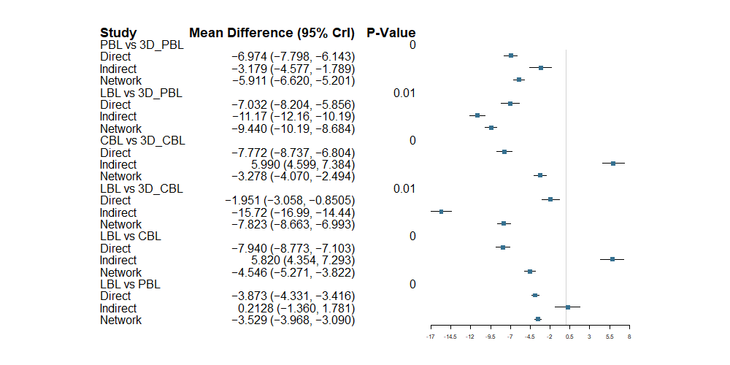
Practical skills examination scores.
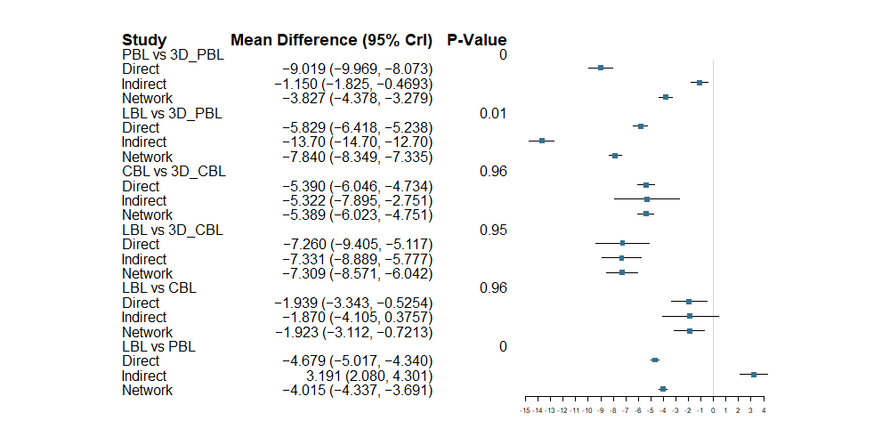
Learning interest
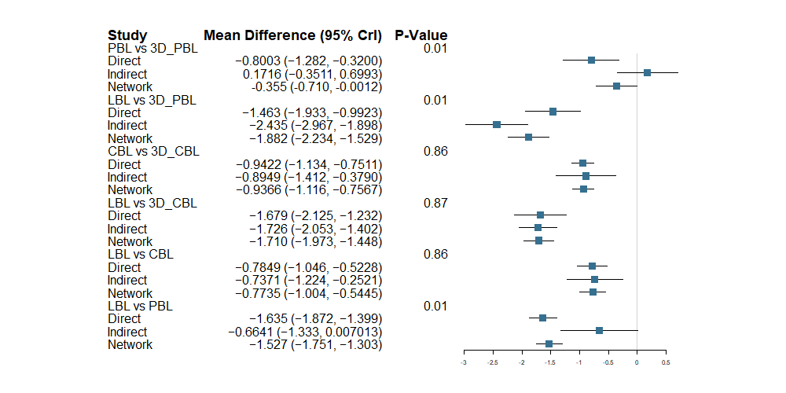
Clinical thinking
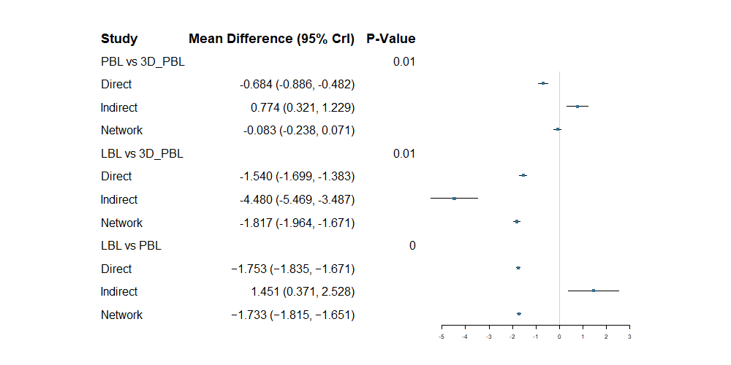
Communication and expression ability.
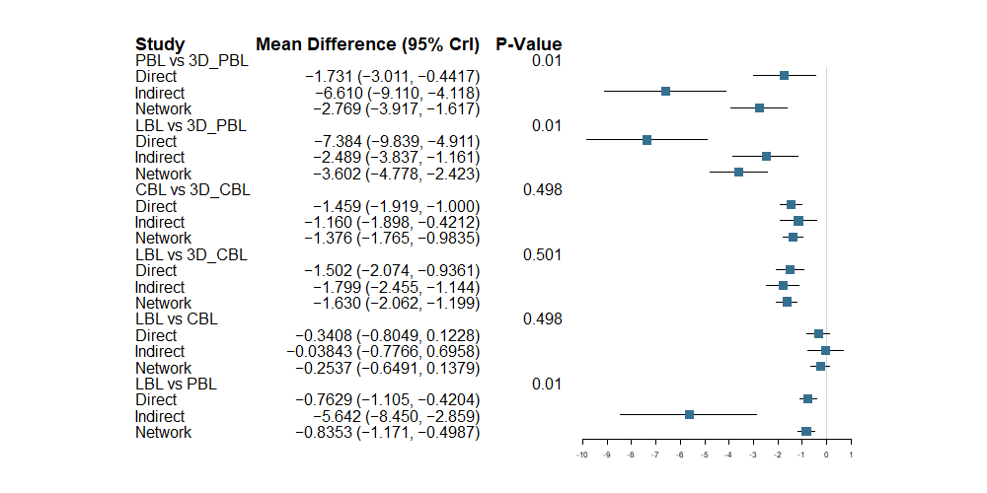
Self-directed learning ability.
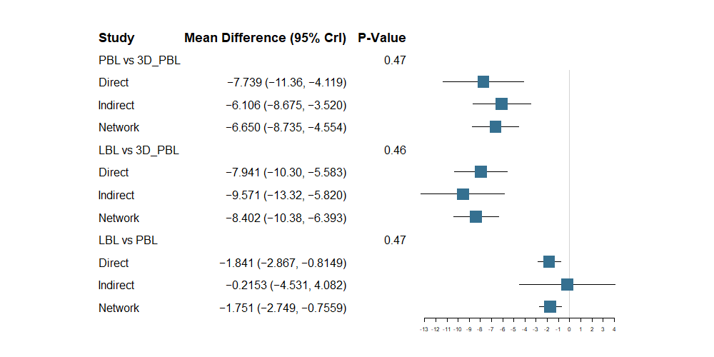

Supplementary Figure 2
A

B

c

D

E

F

Supplementary Figure 3 Funnel plot
A
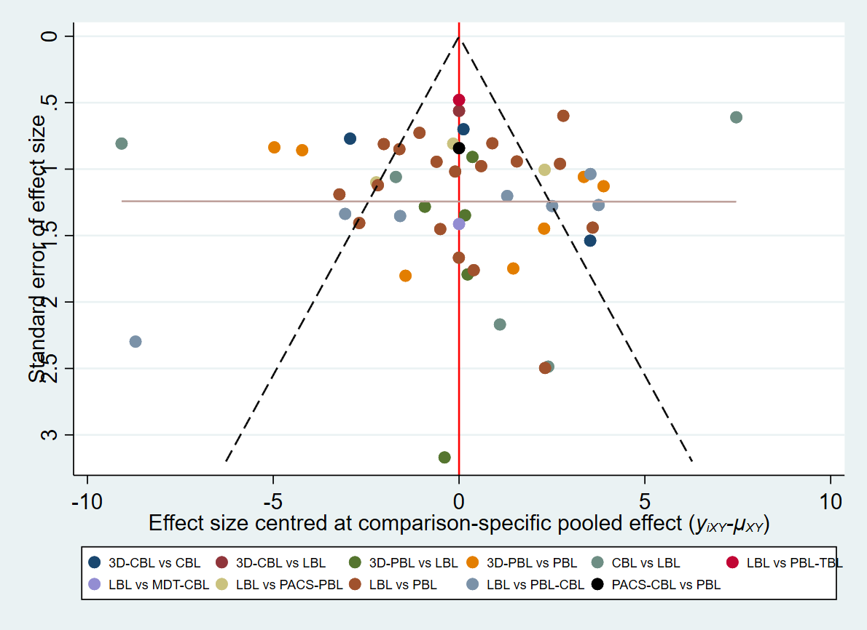
B
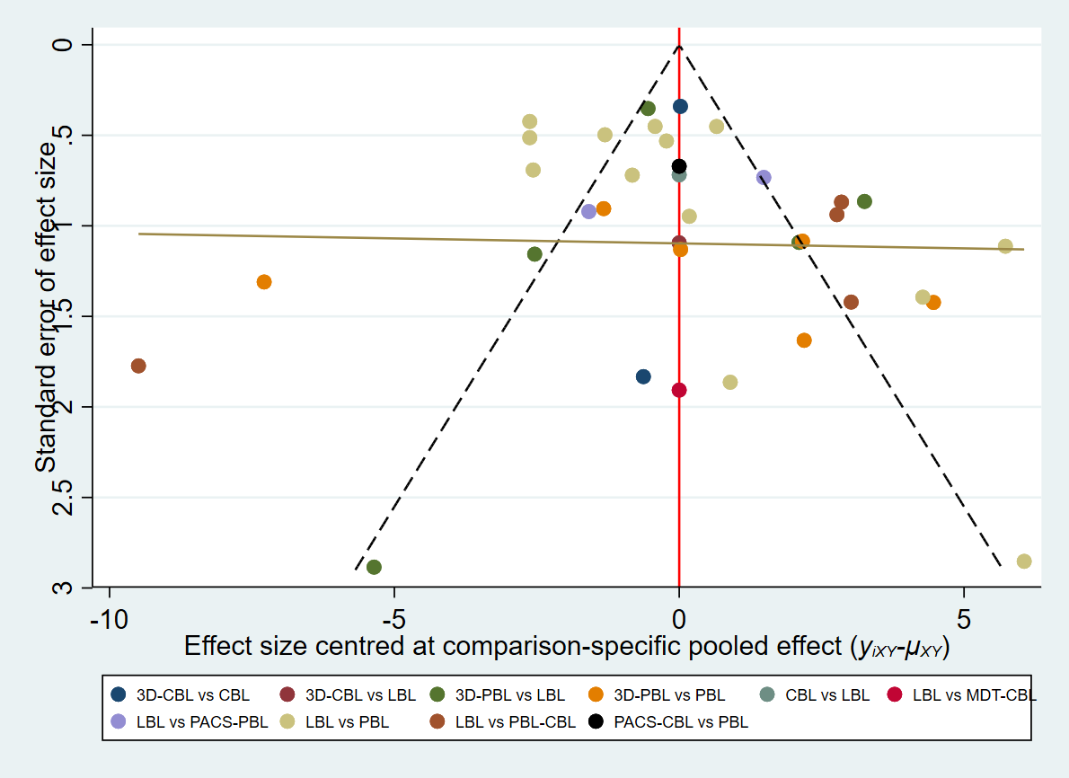
C
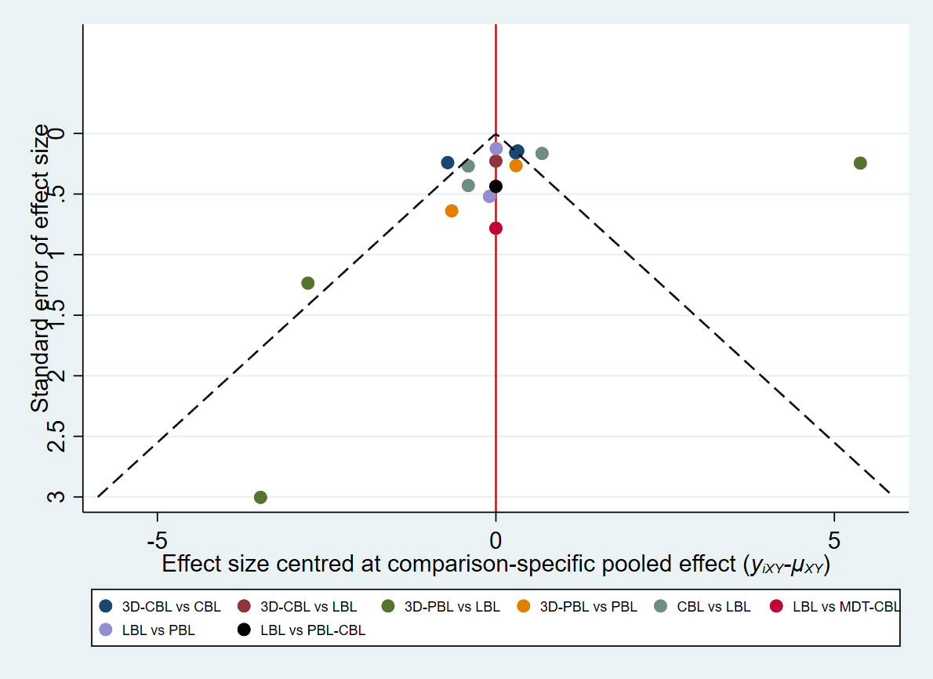
D
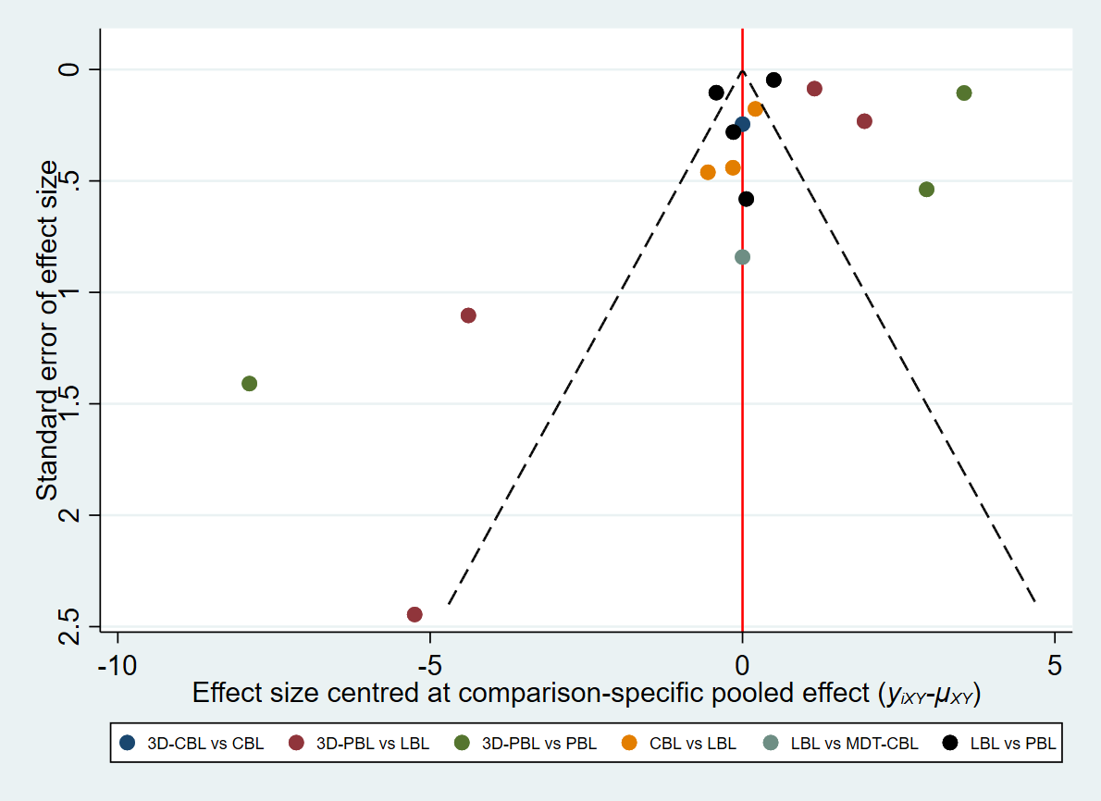

E
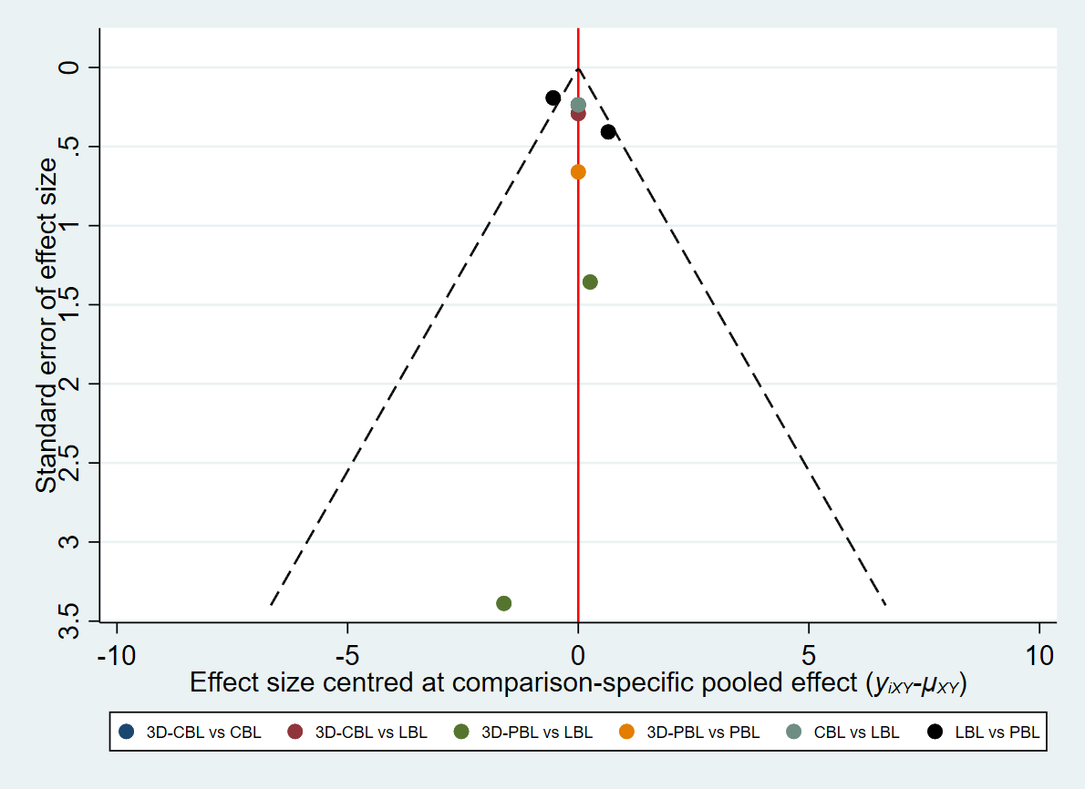
F
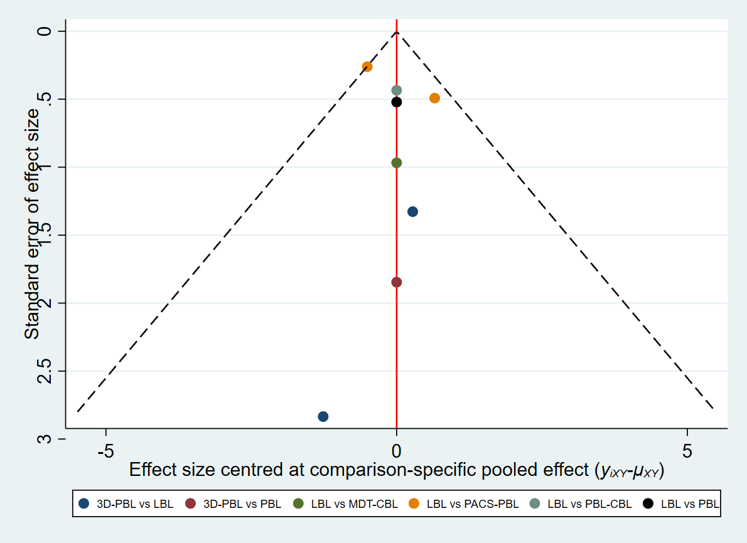

Supplementary Figure 4
