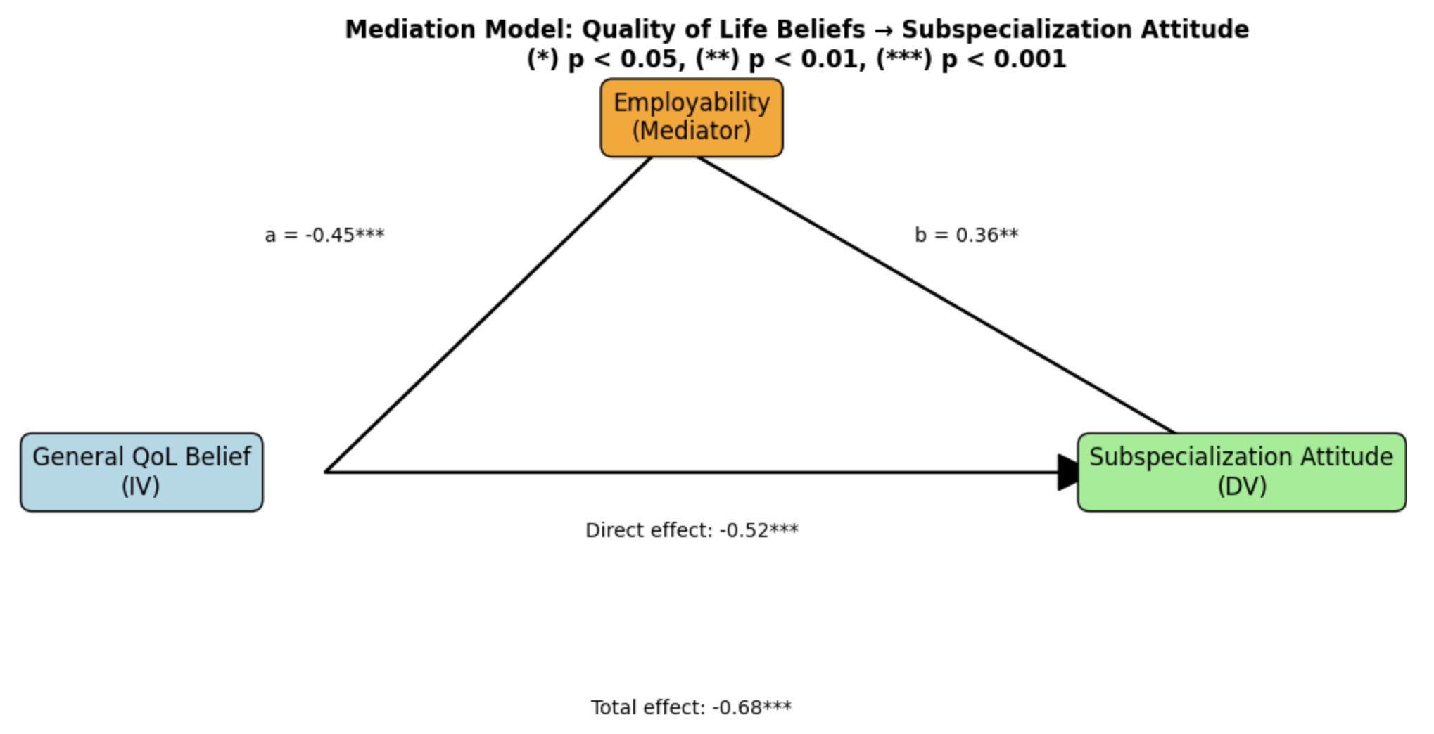
Figure S2: Simple mediation model of the relationship between belief in quality of life (QoL) in general pediatrics and attitude toward subspecialization, through the mediator of perceived employability. The path coefficients (c, c', a, b) are shown, indicating that perceived employability acts as a partial mediator. *p < 0.05, ** p < 0.01, *** p < 0.001.

