Supplementary Figure S1.
Longitudinal model-estimated coefficients with 95% confidence intervals for professionalism, resilience, leadership, and well-being constructs across academic years in Direct Entry Medicine (DEM) and Graduate Entry Medicine (GEM) cohorts. Analyses were based on a longitudinal completer sample of 146 students (95 DEM and 51 GEM) who participated in all annual assessments.
Panels depict: (a) Professionalism-self-(DEM); (b) Professionalism-others-(DEM); (c) Professionalism-self-(GEM); (d) Professionalism-others-(GEM); (e) Resilience (BRS)-DEM; (f) Resilience (BRS)-GEM; (g) Leadership (personal qualities)-DEM; (h) Leadership (personal qualities)-GEM; (i) Leadership (working with others)-DEM; (j) Leadership (working with others)-GEM; (k) EPOCH Engagement-DEM; (l) EPOCH Engagement-GEM; (m) EPOCH Perseverance-DEM; (n) EPOCH Perseverance-GEM; (o) EPOCH Optimism-DEM; (p) EPOCH Optimism-GEM; (q) EPOCH Connectedness-DEM; (r) EPOCH Connectedness-GEM; (s) EPOCH Happiness-DEM; (t) EPOCH Happiness-GEM.

( a) (b)
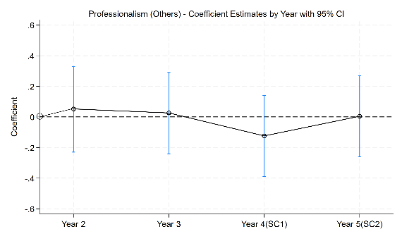
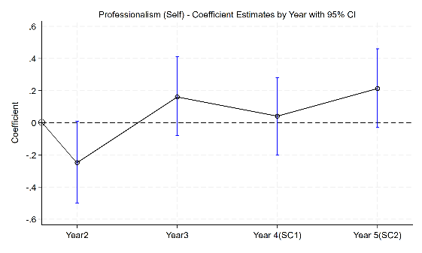

(c ) (d)
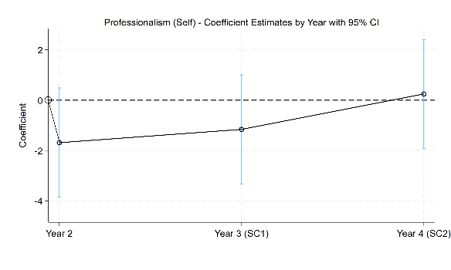
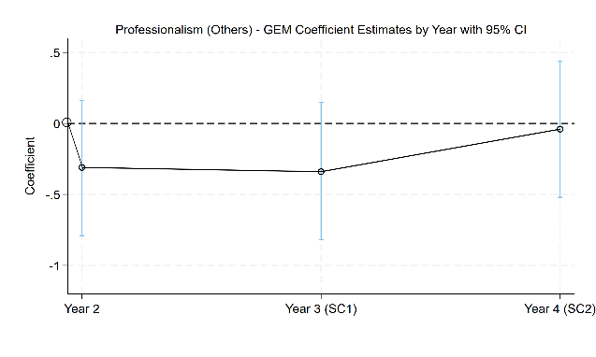

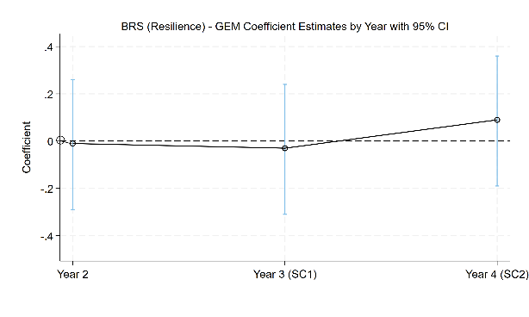
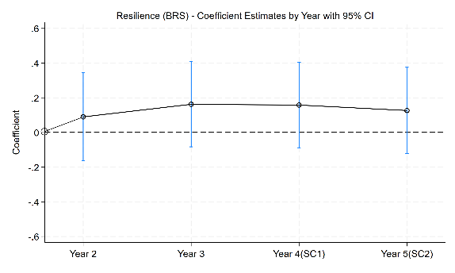
(e) (f)

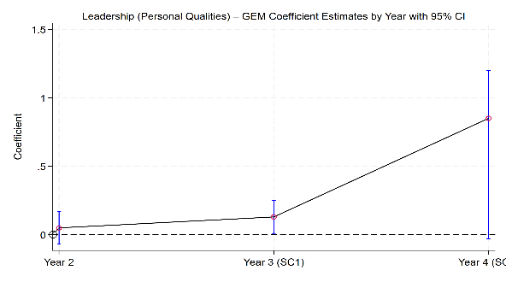
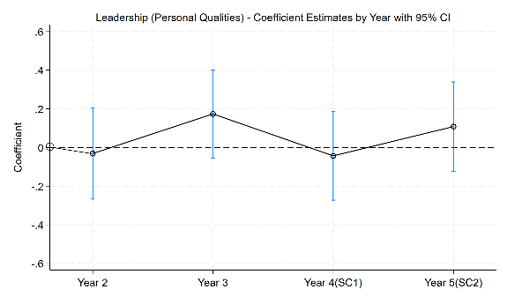
(g) (h)

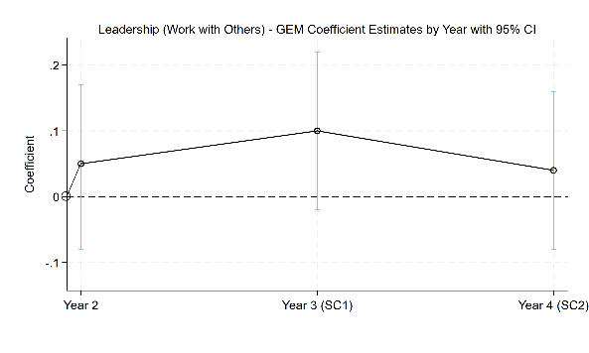
- (j)
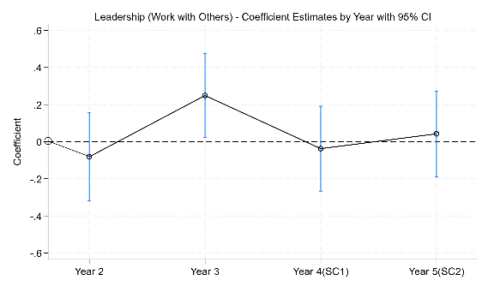

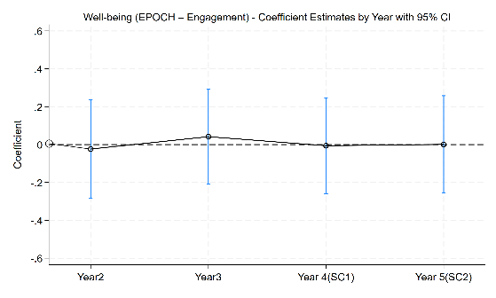
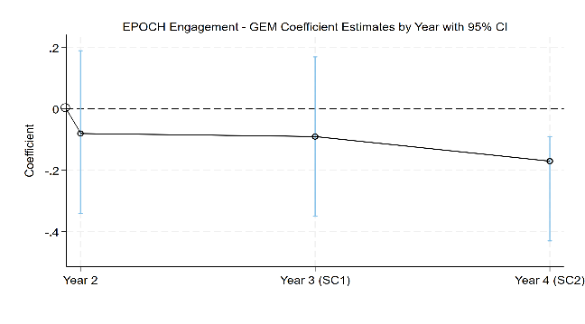
(k) (l)

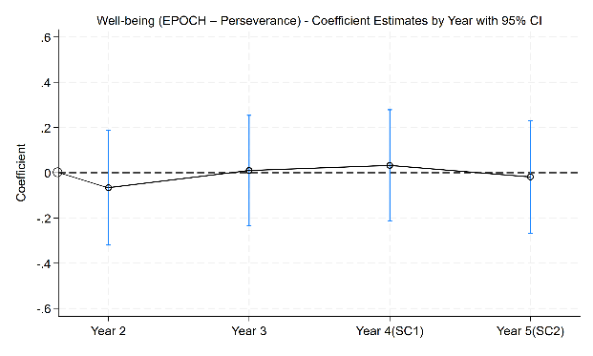
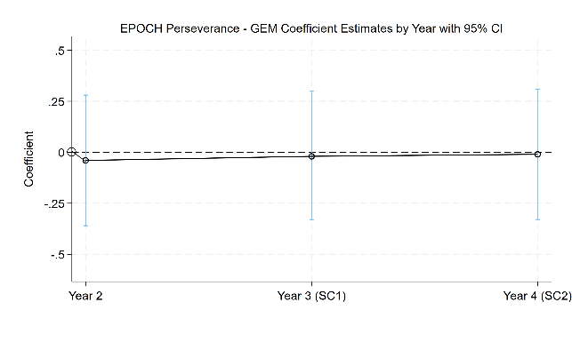
(m) (n)

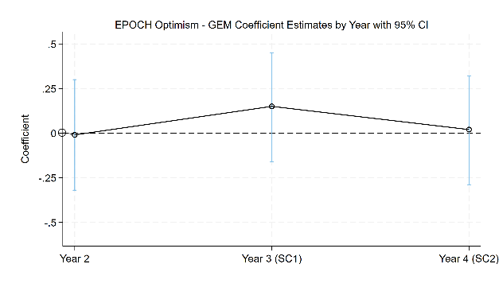
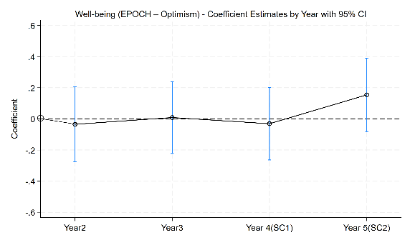
(o) (p)

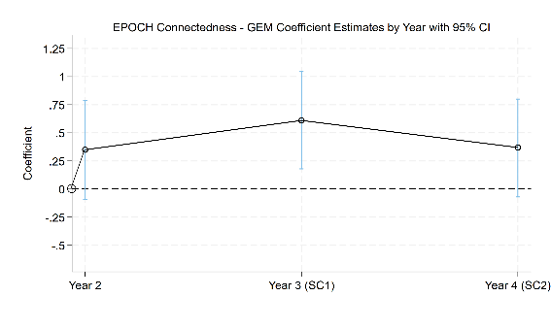
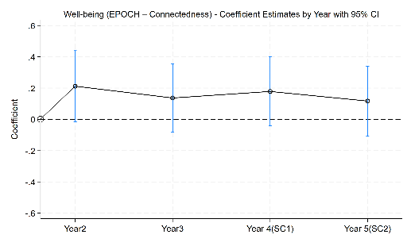
(q) (r)

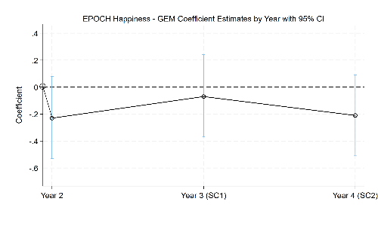
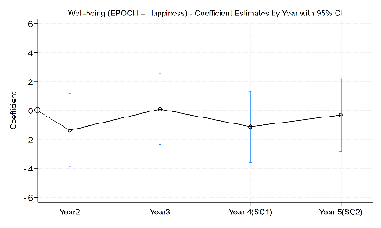
(s) (t)

