Physical therapists' ability to interpret radiographs

Please read the following information carefully.
Purpose of the study: This study aims to evaluate the skills of Physical therapists in interpreting different radiological cases.
You are eligible to participate in this survey if you meet the following criteria: physical therapy certificate holder
Do I have to take part? Your participation in this study is voluntary and you can withdraw at any time.
Risks of being a participant: There are no foreseeable risks of being a participant in an online survey. This survey will not ask you about any identity. The data collected will be used for research purposes only, and may be presented at academic conferences or published in scientific journals
Benefits of being a participant: You may not receive direct benefit from participating in this study, but we anticipate the study findings will help us to better understand the current knowledge of physical therapists in evaluating radiographs.
Time expected to complete this survey: 3 to 5 minutes
Ethical approval number: UT-505-313-2025
Privacy & confidentiality: Your privacy will be maintained at all times, and you will not be identified and your data will be securely stored. If you have any questions about this research, please contact Researchers at salamrani@ut.edu.sa. or aaalharbi@ut.edu.sa.

Do you agree to participate in this study? *
- Yes
- No

General information
Please select your gender*
- Male
- Female
Please select your age group *
- 22-29
- 30-39
- 40-49
- 50-59
- 60 and above
Please select the region that you work in.*
- Northern region
- Southern region
- Central region
- Eastern region
- Western region
Please select the type of health care facility you work in.*
- Public hospital/ centers/ clinics
- University hospital/centers/ clinics
- Private hospital /centers/ clinics
- Other:
Please select your years of clinical experience. *
- Less than one year
- 1 – 5 years
- 6 – 10 years
- 11 – 20 years
- More than 20 years
Please select your highest earned academic degree. *
- Diploma
- Bachelor Degree
- Doctor of Physical Therapy (DPT)
- Master Degree
- Doctoral (PhD) Degree
Please select your area of specialization in physical therapy.*
- General
- Orthopedic
- Neurological
- Pediatric
- Geriatric
- Sports
- Other:

Radiological assessment
How often do you contribute in radiological interpretation?*
- Always
- Often
- Sometimes
- Rarely
- Never
How did you learn /know about radiological interpretation? (*Multiple responses are possible.)*
- Academic education
- Scientific conference
- Workshop
- Lecture or seminar
- Academic paper
- Book
- I did not learn/know about radiological interpretation
- Other:
From your perspective, what are the factors that may limit the ability to conduct radiological interpretations effectively?*
- Insufficient education and training
- Insufficient access to advanced imaging technology
- Poor communication or collaboration among team members
- Inadequate time for interpretation (limited staffing/ heavy workload)
- Technical issues with imaging systems (e.g. Poor image quality)
Do you think physiotherapists should interpret radiographs as part of their practice/job?*
- Strongly agree
- Agree
- Neutral
- Disagree
- Strongly disagree
Are you interested in radiological interpretations?*
- Yes
- No
Would you be interested in attending a lecture or hands-on seminar about radiological interpretation?*
- Yes
- No
Image interpretation
What type of medical imaging modality is used this in image?*

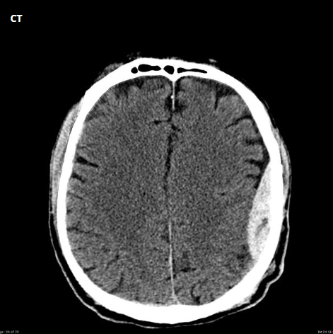

- X-ray
- Ultrasound
- CT scan
- MRI
- I don't know
Based on the provided image of the brain, what is the likely diagnosis?*
- Normal brain
- Brain tumor
- Ischemic stroke
- Epidural hematoma
- Subdural hematoma
- I don't know

What type of medical imaging modality is used this in image?
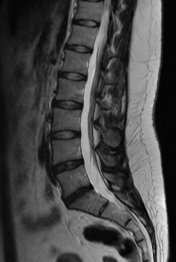
- X-ray
- Ultrasound
- CT scan
- MRI
- I don't know
Based on the provided image of spine, what is the likely diagnosis?*
- Normal lumbar spine
- Degenerative disc disease
- Lumbar spine herniation
- Spinal stenosis
- I don't know.

What type of medical imaging modality is used in this image?*
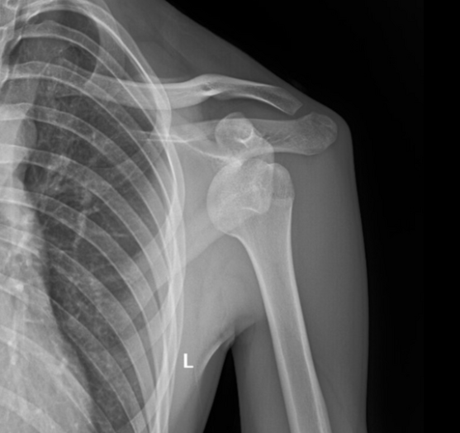
- X-ray
- Ultrasound
- CT scan
- MRI
- I don't know
Based on the provided image of shoulder, what is the likely diagnosis? *
- Normal shoulder
- Anterior shoulder dislocation
- Posterior shoulder dislocation
- Transverse fracture of humeral neck
- I don't know

What type of medical imaging modality is used this in image?*
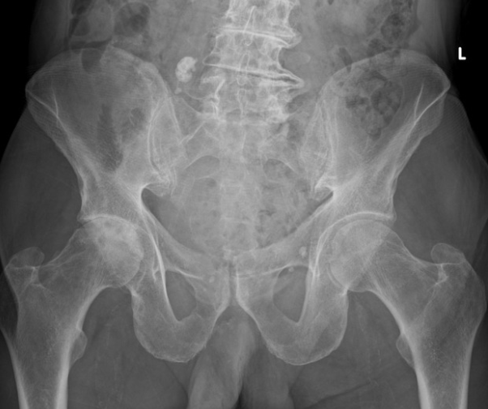

- X-ray
- Ultrasound
- CT scan
- MRI
- I don't know
Based on the provided image of pelvis, what is the likely diagnosis?*
- Normal hip joint
- Acetabular fracture
- Developmental dysplasia of the hip
- Hip osteoarthritis
- I don't know

What type of medical imaging modality is used this in image?*
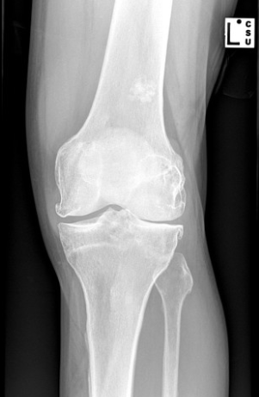
- X-ray
- Ultrasound
- CT scan
- MRI
- I don't know

Based on the provided image of knee, what is the likely diagnosis?*
- Normal knee
- Joint dislocation
- Patellar fracture
- Bone thinning (osteopenia)
- Knee osteoarthritis
- I don't know

What type of medical imaging modality is used this in image?*

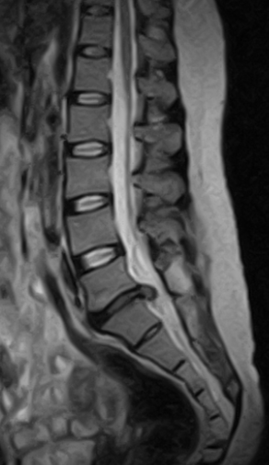
- X-ray
- Ultrasound
- CT scan
- MRI
- I don't know
Based on the provided image of spine, what is the likely diagnosis?*
- Normal lumbar spine
- Lumbar disc herniation
- Lumbar disc degeneration
- Spinal stenosis
- I don't know

What type of medical imaging modality is used this in image?*
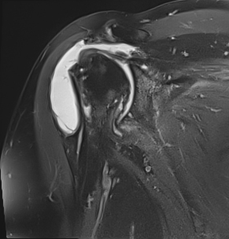
- X-ray
- Ultrasound
- CT scan
- MRI
- I don't know
Based on the provided image of shoulder, what is the likely diagnosis?*
- Normal shoulder
- Calcific tendinitis.
- Adhesive capsulitis.
- Rotator cuff tears
- I don't know

What type of medical imaging modality is used this in image?*
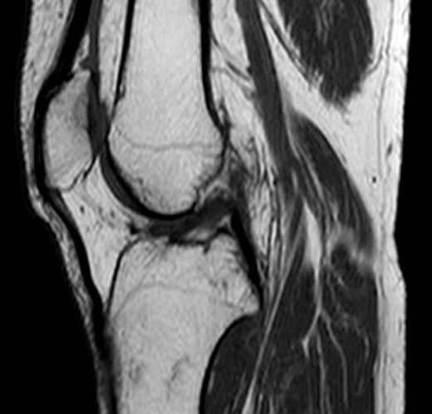
- X-ray
- Ultrasound
- CT scan
- MRI
- I don't know
Based on the provided image of Knee, what is the likely diagnosis?*
- Normal knee
- ACL tear
- PCL tear
- Meniscal tear
- I don't know

What type of medical imaging modality is used this in image?*
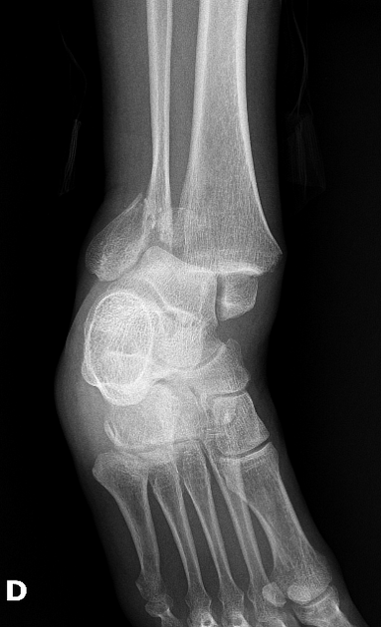
- X-ray
- Ultrasound
- CT scan
- MRI
- I don't know

Based on the provided image of Ankle, what is the likely diagnosis?*
- Normal Ankle
- Bimallolar Ankle fracture
- Lateral Ankle sprain
- Ankle osteoarthritis
- I don't know

What type of medical imaging modality is used this in image?*
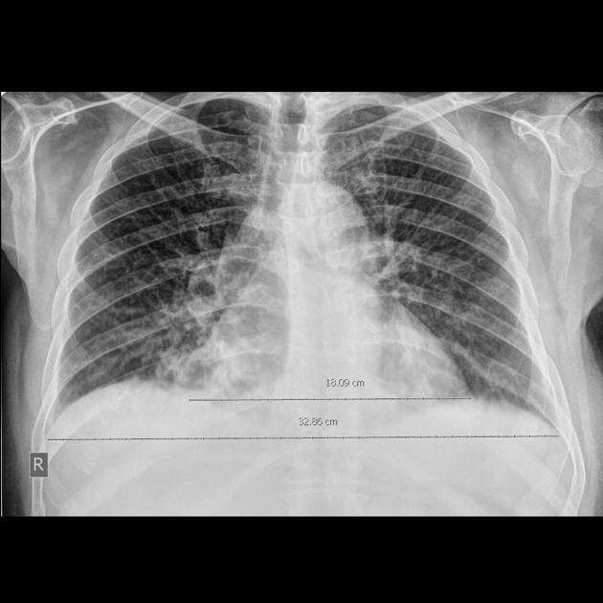
- X-ray
- Ultrasound
- CT scan
- MRI
- I don't know
Based on the provided image of Chest, what is the likely diagnosis?*
- Normal Chest
- Pneumonia
- Tuberculosis
- Pleural effusion
- I don't know

