Methods
Data extraction
In studies that present multiple related outcome indicators derived from the same participant cohort, such as theoretical examination scores categorized by the skeletal and internal organ systems, or clinical skills scores segmented into diagnostic reasoning, doctor-patient communication, and history-taking ability, each outcome indicator is treated as an independent unit of analysis and is included in the meta-analysis. The sample size corresponding to each independent outcome indicator is directly obtained from the original study. For example, if a study involves 120 participants and provides theoretical score results for both the skeletal and internal organ systems, these results are incorporated into the meta-analysis as two separate units of analysis, with a sample size of 120 for each outcome indicator. To prevent unit-of-analysis errors arising from multiple outcome data within the same cohort, we assign distinct labels to each outcome domain in the forest plot and results table. This labeling, such as “Sakelaris 2025 (Pulmonary)” and “Sakelaris 2025 (Cardiovascular),” ensures that readers can clearly differentiate between the analyses. This approach guarantees the comprehensive utilization of all pertinent outcome data related to the research question, thereby facilitating a thorough evaluation of the various dimensions of the intervention effect. To avoid overestimation of the overall sample size, while different outcome indicators from the same cohort were treated as independent units for meta-analysis, the total number of unique participants was counted only once in the summary of baseline characteristics and the reporting of combined effect sizes, irrespective of the number of outcome indicators or analytical units involved. In our study, to rule out duplicate participants, a comprehensive detection strategy was employed that integrated cross-verification of four key dimensions: protocol registration information (e.g., study objectives, design details), ethical approval numbers (unique identifiers for ethical review), basic characteristics of included participants (e.g., age, academic year, medical specialty), and participant source information (e.g., affiliated medical schools, clinical training bases), ensuring thorough identification of potential data overlap from previous occurrences.

Sensitivity analysis
Table 1 Sensitivity analysis procedures and measures
Node | Problems that need to be solved | Measures
Literature search and screening | Does the search process affect the results?  Are there omissions? | Engage in multiple preliminary searches, refining the search strategy with professional guidance based on the outcomes of these searches to develop the final search strategy. Throughout the search process, rigorously adhere to the established search strategy for literature retrieval to ensure the comprehensiveness of the search records and to maintain the integrity of the research findings.
Inclusion and exclusion of studies | 1.Characteristics of participants: Does the composition of the study population, including variables such as educational levels, knowledge reserves, countries of origin, and gender, affect the outcomes?  2.Characteristics of the intervention: Does the integration of specific intervention methods influence the outcomes of the research? For instance, do variations in Gen AI, such as the choice of Gen AI affect the results? Furthermore, how does the precision of GenAI contribute to these outcomes? Do these parameters associated with GenAI significantly impact the research findings?  3.Characteristics of the Comparison: Does the intervention strategy employed by the control group influence the results? For instance, conventional educational approaches often incorporate various PBL or CBL, alongside multiple lectures and PowerPoint presentations. Do these distinct control interventions have an effect on the results?  4.Characteristics of the outcome: Do variations in outcome indicators, including diverse scoring criteria, evaluation methodologies, and assessment content for theoretical examinations, practical skills evaluations, and composite scores, influence the results?  5.Study design: Did the type of studies included in the research affect the results? For example, should crossover design studies be included? Should the inclusion of studies be strictly limited by methodology? | During the inclusion and exclusion process, it is imperative to adhere rigorously to the pre-established protocol to ensure that this procedure does not compromise the integrity of the research findings. The specific inclusion and exclusion criteria are outlined as follows:  Eligibility Criteria  The inclusion criteria were based on the pre-established PICOS framework. 1) P: only studies exclusively featuring medical undergraduates as the primary research cohort were included. In cases where participant samples combined undergraduates with other groups (e.g., residents, postgraduate students), inclusion was contingent upon medical undergraduates comprising at least 80% of the total sample. 2) I: Only those studies that used Gen AI as an intervention for the experimental group were included in the study; 3) C: Studies that used traditional teaching methods ( such as lectures, PBL, CBL images, videos, and another, etc.) were included; 4) O: Theoretical tests, clinical skills tests, learner satisfaction, accuracy, and learning time were considered as outcomes; 5) S: only controlled studies was included, and if it is a crossover design, only the data from the first phase was included.  Exclusion Criteria  The exclusion criteria were as follows: 1) Studies involving non-undergraduate medical students such as medical residents, standardized training students, and surgeons were excluded, and those subjects were not only; 2) Intervention methods other than GenAI are excluded; 3) Those non-controlled studies were also excluded.  Prior to formal screening, 20 representative studies were selected for a pilot screening by two independent reviewers. Consistency checking during literature screening was performed using Cohen’s Kappa coefficient, which measures the agreement between two reviewers in classifying 20 pre-screened articles as “included" or “excluded”. The calculation formula is $κ=\frac{P_{o}−P_{e}}{1−P_{e}}$, where: P₀ (observed agreement rate) refers to the proportion of articles for which the two reviewers reached identical judgments relative to the total number of articles (20). It is calculated as $P_{o}=\frac{a+d}{20}×100\%$, with $a$ representing the number of articles both reviewers classified as “included” and $d$ representing the number of articles both reviewers classified as “excluded”; P_{e} (expected agreement rate) denotes the theoretical agreement rate under the assumption of random judgment. It is calculated as $P_{e}=\frac{\left(a+b\right)\left(a+c\right)+\left(c+d\right)\left(b+d\right)}{{20}^{2}}$, where $b$ is the number of articles classified as “included” by Reviewer 1 but “excluded” by Reviewer 2, and $c$ is the number of articles classified as “excluded” by Reviewer 1 but “included” by Reviewer 2. Formal screening was initiated only when consistency of the observations($P_{o}$) reaches 95% or the $κ$ value reached over 0.80. Discrepancies between reviewers were resolved through discussions with a third-party adjudicator, ensuring the reliability of the screening process.
Data extraction | When and how should missing data be handled? | During data extraction stage, data extraction followed a two-step validation process: two authors extracted data using a preformulated extraction table independently, and a third author checked the results. For data presented in graphical formats, GetData2.0 software were used for data extraction by two authors independently. Since all the data in this study were continuous data, the intraclass correlation coefficient (ICC) was used to evaluate the consistency of the data extracted by the two researchers. The data is officially extracted only when the consistency of the data extracted by two authors is ≥95%. This protocol minimized extraction errors and ensured data accuracy. If missing data was detected, the original author was contacted via email to obtain the missing data.
Data Analysis | 1.Should fixed-effect or random-effects methods be used for the analysis?  2.For continuous outcomes, where several scales have assessed the same dimension, should results be analysed as a standardized mean difference across all scales or as mean differences individually for each scale? | According to the results of the I² statistic and Chi square test, the random effects model or the fixed effects model is selected to evaluate the effect size. If the I² statistic is greater than 50% and the result of Chi square test is P < 0.1, it is considered to have significant heterogeneity.  Stata software (version 15.0) was employed to re-evaluate the effect size following the exclusion of individual studies. This process involved determining whether the exclusion led to significant changes in the results. A significant change would indicate that the excluded study had a substantial impact on the findings, whereas the absence of change would suggest robustness. The analysis revealed that the exclusion of any single study did not result in significant alterations to the results, thereby confirming their robustness
Interpretation of Results | How to interpretation the results? | In accordance with the Cochrane criteria, an absolute standardized mean difference (SMD) value of approximately 0.2-0.5 signifies a small effect size, a value around 0.5-0.8 denotes a moderate effect size, and a value of more than 0.8 indicates a large effect size.

Figure S1 Forest plot of sensitivity analysis evaluating the impact of the 80% medical undergraduate sample proportion criterion
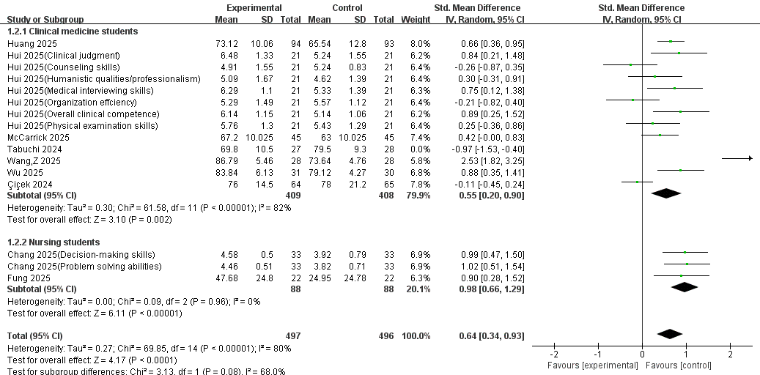
This figure compares the pooled effect sizes of the meta-analysis before and after excluding the only study with a medical undergraduate proportion of approximately 80%. The solid diamond represents the original pooled effect size (inclusive of all studies), while the dashed diamond represents the pooled effect size after exclusion of the non-100% proportion study. No substantial differences were observed in the direction and statistical significance of the pooled effect sizes between the two analyses, confirming that the 80% inclusion criterion did not affect the robustness of the final results.

