Appendix 4: Detailed Results of Meta-Regression Analyses
1. Meta-regression for basic knowledge (clinical medical students)
Covariates: Country of subjects, intervention of experimental/control group, grade, follow-up days, outcome type, role of GenAI, major, study type, sample size
Multicollinearity: No covariates were excluded, but moderate collinearity was observed. Remaining covariates: Country of subjects’ origin (VIF = 5.01), study type (VIF = 17.34), intervention measures for experimental group (VIF = 5.43), intervention measures for control group (VIF = 3.12), grade (VIF = 6.81), study quality (VIF = 29.95), follow-up duration (VIF = 3.61), sample size (VIF = 8.30), outcome type (VIF = 3.50), role of GenAI (VIF = 8.86), major (VIF = 1.92); mean VIF = 8.53 (moderate collinearity, with study quality and study type showing elevated VIF values)
Model fit (metareg, REML): Adjusted R² = 25.12%; residual I² = 90.08%, τ² = 0.4596
Overall significance: F(11, 9) = 1.61, P = 0.2419 (covariates collectively not statistically significant)
Significant individual covariates:
Study type (regression coefficient = -3.575, P = 0.030)
Non-significant covariates:
Country of subjects’ origin (P = 0.128), intervention measures for experimental group (P = 0.814), intervention measures for control group (P = 0.273), grade (P = 0.420), study quality (P = 0.373), follow-up days (P = 0.847), sample size (P = 0.229), outcome type (P = 0.226), role of GenAI (P = 0.187), major (P = 0.526)
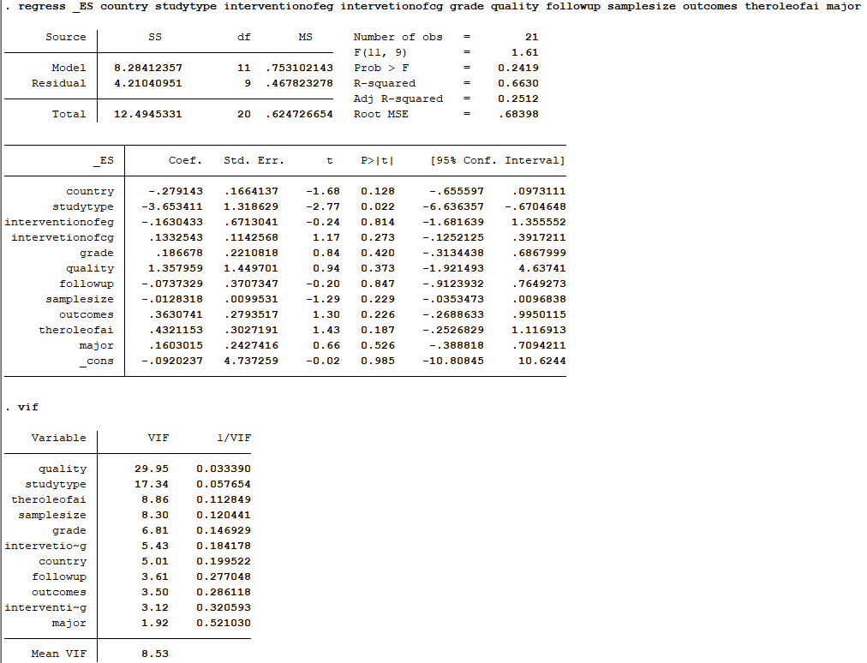Figure S1 The results of the collinearity analysis of confounding variables regarding the impact of GenAI on basic knowledge of undergraduate medical students.
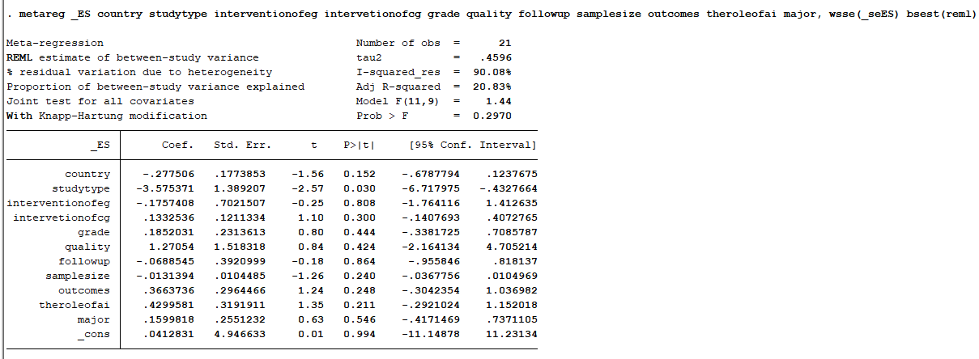
Figure S2 The results of the meta-regression analysis on the impact of GenAI on basic knowledge of undergraduate medical students
2. Meta-regression for clinical skills (clinical medicine students)
Initial covariates: Country of subjects' origin, sample size, grade, intervention measures for experimental group, intervention measures for control group, role of GenAI in the teaching process, outcome type, follow-up duration, major
Multicollinearity diagnosis and covariate selection: The initial model including all nine covariates exhibited severe multicollinearity (mean VIF = 132.79), with the role of GenAI in the teaching process (VIF = 509.97), intervention measures for experimental group (VIF = 180.72), intervention measures for control group (VIF = 116.97), and grade (VIF = 99.48) showing extreme variance inflation. After sequentially removing covariates with VIF exceeding acceptable thresholds, the role of GenAI in the teaching process was first excluded due to near-perfect collinearity with intervention measures for experimental group. In the second-step model, major was excluded owing to persistent high VIF (86.50). The final model retained seven covariates: country of subjects' origin (VIF = 2.99), sample size (VIF = 1.68), grade (VIF = 12.70), intervention measures for experimental group (VIF = 34.25), intervention measures for control group (VIF = 8.19), outcome type (VIF = 9.70), and follow-up duration (VIF = 2.15), with improved collinearity (mean VIF = 25.16). Given the exploratory nature of this analysis and the limited number of studies (n = 15), all seven covariates were retained in the final model to avoid overfitting while preserving potentially relevant moderators.
Model fit (metareg, REML with Knapp-Hartung modification): Adjusted R² = 75.59%; residual I² = 66.90%; τ² = 0.1966
Overall significance: F(7, 7) = 5.03, P = 0.0245 (covariates collectively statistically significant)
Significant individual covariates:
Country of subjects’ origin (regression coefficient = -0.748, P = 0.001)
Outcome type (regression coefficient = 0.615, P = 0.009)
Sample size (regression coefficient = 0.012, P = 0.022)
Grade (regression coefficient = 0.287, P = 0.026)
Non-significant covariates:
Intervention measures for experimental group (P = 0.883), intervention measures for control group (P = 0.803), follow-up duration (P = 0.436)
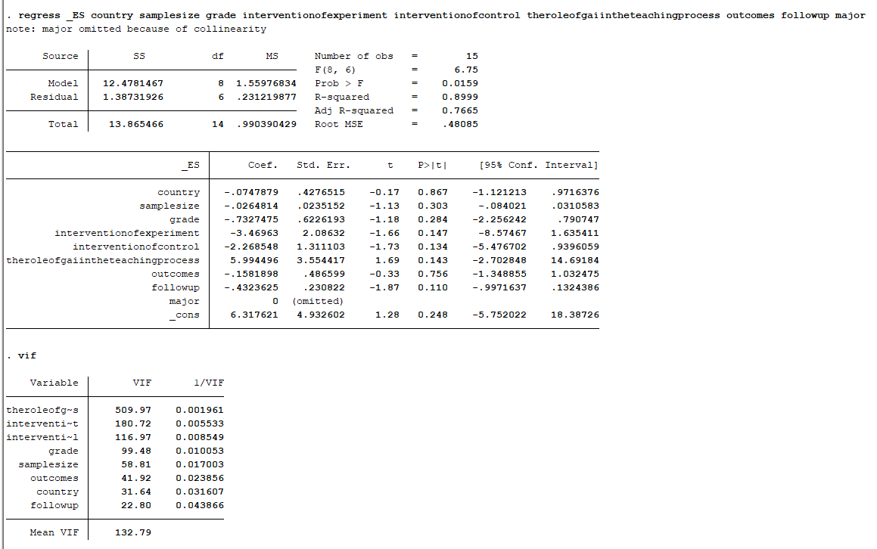
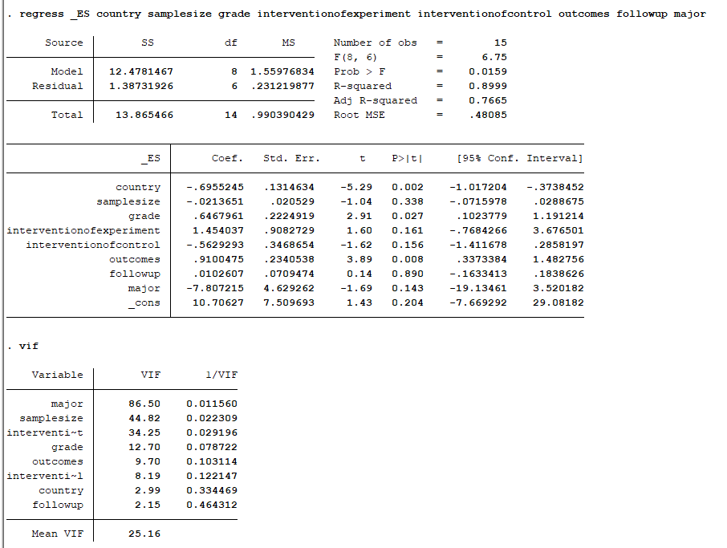
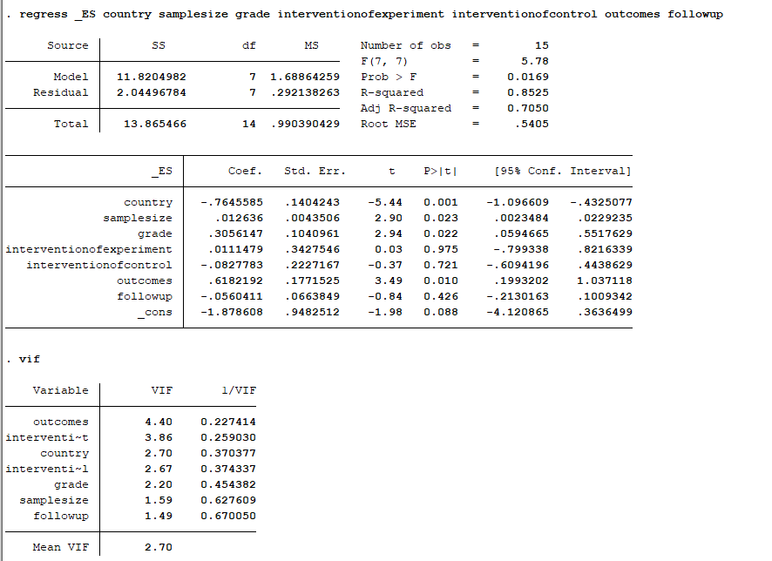
Figure S3 The results of the collinearity analysis of confounding variables regarding the impact of GenAI on clinical skills of undergraduate medical students.
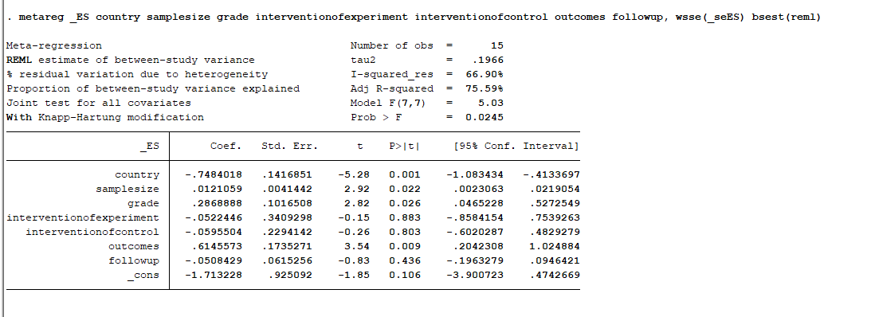
Figure S4 The results of the meta-regression analysis on the impact of GenAI on clinical skill of undergraduate medical students

