This supplementary file presents a comparison of the pooled effect estimates from our initial analysis and the updated analysis (search up to April 24, 2026). For knowledge acquisition among clinical medicine students, no new studies were identified in the updated search; the pooled effect therefore remained unchanged. However, a more detailed leave-one-out sensitivity analysis conducted during this revision, which included manual removal of each individual study, identified Bhatia 2024 as an influential study, the removal of which rendered the previously non-significant effect statistically significant. For clinical skills among clinical medicine students, the inclusion of seven newly published studies, most notably Briones-Zamora 2026, which assessed fine procedural suturing skill, attenuated the previously significant pooled effect to non-significance. All other outcomes (knowledge among nursing students, clinical skills among nursing students, and academic writing) remained unchanged.
Supplementary Table S1. Comparison of pooled effect estimates before and after the updated literature search.
Outcome | Initial analysis | Updated analysis (search up to April 24, 2026) | Direction of change | Key sensitivity finding
Knowledge (clinical medicine students) | SMD = 0.22, 95% CI: -0.13 to 0.56, P = 0.22, I² = 92%, random-effects | SMD = 0.22, 95% CI: -0.13 to 0.56, P = 0.22, I² = 92%, random-effects | Unchanged | Removal of Bhatia 2024 (SMD = -1.85) restored significance: SMD = 0.32, 95% CI: 0.05 to 0.59, P = 0.02
Knowledge (nursing students) |  | SMD = 1.11, 95% CI: 0.54 to 1.69, P = 0.0002, I² = 76%, random-effects | Unchanged | —
Clinical skills (clinical medicine students) | SMD = 0.44, 95% CI: 0.06 to 0.82, P = 0.02, I² = 86%, random-effects | SMD = 0.25, 95% CI: -0.11 to 0.60, P = 0.18, I² = 88%, random-effects | Significant → Non-significant | Removal of Briones-Zamora 2026 (SMD = -1.94) restored significance: SMD = 0.40, 95% CI: 0.04 to 0.76, P =0.03
Clinical skills (nursing students) | SMD = 0.98, 95% CI: 0.66 to 1.29, P < 0.001, I² = 0%, random-effects | SMD = 0.98, 95% CI: 0.66 to 1.29, P < 0.001, I² = 0%, random-effects | Unchanged | —
Academic writing | Significant benefit (P < 0.001) | Significant benefit (P < 0.001) | Unchanged | —
Abbreviations: SMD, standardized mean difference; CI, confidence interval.
Supplementary Figure S1. Forest plots comparing pooled effect estimates for clinical skills among clinical medicine students before and after the April 24, 2026 search update
(A)Forest plot based on the initial search , showing a significant benefit of GenAI for basic knowledge of nursing students(SMD = 0.65, P = 0.0007). (B) Forest plot based on the initial search , showing a significant benefit of GenAI for basic knowledge of nursing students(SMD = 1.11, P = 0.0002). (C)Forest plot based on the initial search , showing a significant benefit of GenAI (SMD = 0.44, P = 0.02). (D) Forest plot after the updated search (up to April 24, 2026), showing a non-significant overall effect (SMD = 0.25, P = 0.18). The newly included Briones-Zamora 2026 (arrow), which assessed fine procedural suturing skill and favored video-based instruction (SMD = −1.94), was the primary driver of this attenuation.

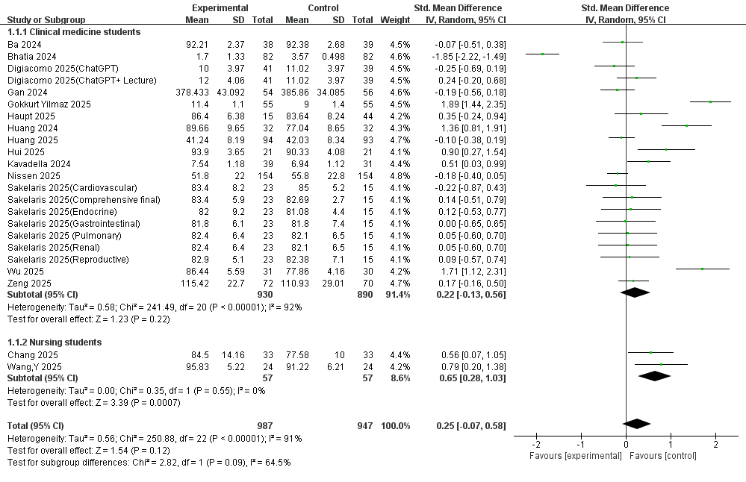
Figure S1(A) Forest plot based on the initial search , showing a significant benefit of GenAI for basic knowledge of nursing students(SMD = 0.65, P = 0.0007)
Figure S1(B) Forest plot based on the initial search , showing a significant benefit of GenAI for basic knowledge of nursing students(SMD = 1.11, P = 0.0002)

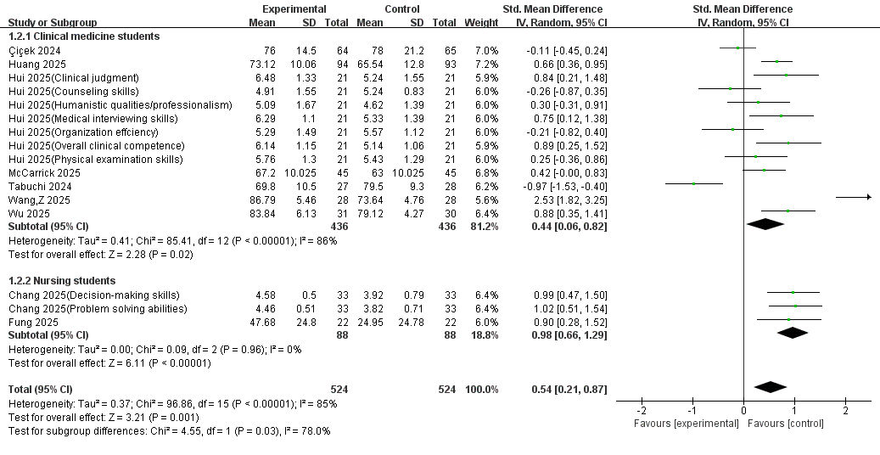
Figure S1(C) Forest plot based on the initial search , showing a significant benefit of GenAI (SMD = 0.44, P = 0.02)
Figure S1(D) Forest plot after the updated search (up to April 24, 2026), showing a non-significant overall effect (SMD = 0.25, P = 0.18)

Supplementary Table S2. Newly identified studies included in the updated analysis for clinical skills
Study | Publication year | Study design | Participants | Intervention | Comparator | Outcome type | SMD
Briones-Zamora 2026 | 2026 | Quasi-experimental | 33 third-year medical students | ChatGPT-guided instruction | Video-based instruction | Fine procedural skill (endocrine suture) | -1.94
Saloojee 2026 | 2026 | RCT | 73 final-year medical students | ChatGPT | without any digital aids | Clinical skills/clinical performance scores | -0.16
Salimi 2026 | 2026 | quasi-experimental research | 91 third to sixth academic semesters nursing students | ChatGPT | escape rooms (ERs), Control | Knowledge exam scores/arterial blood gas interpretation scale (ABGIS) | 1.91 and 1.25

