Contents
Supplementary Table 1 – PRISMA 2020 Abstract Checklist | 1
Supplementary Table 2 – PRISMA 2020 Checklist | 2
Supplementary Table 3 – Detailed Search Strategies for All Databases and Registers | 5
Supplementary Figure 1 – Risk of Bias Traffic-Light Plot for Non-Randomized Studies Assessed Using ROBINS-I. | 6
Supplementary Figure 2 – Domain-Level Summary of Risk of Bias for Non-Randomized Studies Using ROBINS-I. | 7
Supplementary Figure 3 – Risk of Bias Traffic-Light Plot for Randomized Controlled Trials Assessed Using RoB-2. | 7
Supplementary Figure 4 – Domain-Level Summary of Risk of Bias for Randomized Controlled Trials Using RoB-2 | 8

Supplementary Table 1 PRSIMA 2020 Abstract Check List
Section and Topic | Item # | Checklist item | Reported (Yes/No)
TITLE
Title | 1 | Identify the report as a systematic review. | Yes
BACKGROUND
Objectives | 2 | Provide an explicit statement of the main objective(s) or question(s) the review addresses. | Yes
METHODS
Eligibility criteria | 3 | Specify the inclusion and exclusion criteria for the review. | Yes
Information sources | 4 | Specify the information sources (e.g. databases, registers) used to identify studies and the date when each was last searched. | Yes
Risk of bias | 5 | Specify the methods used to assess risk of bias in the included studies. | Yes
Synthesis of results | 6 | Specify the methods used to present and synthesise results. | Yes
RESULTS
Included studies | 7 | Give the total number of included studies and participants and summarise relevant characteristics of studies. | Yes
Synthesis of results | 8 | Present results for main outcomes, preferably indicating the number of included studies and participants for each. If meta-analysis was done, report the summary estimate and confidence/credible interval. If comparing groups, indicate the direction of the effect (i.e. which group is favoured). | Yes
DISCUSSION
Limitations of evidence | 9 | Provide a brief summary of the limitations of the evidence included in the review (e.g. study risk of bias, inconsistency and imprecision). | Yes
Interpretation | 10 | Provide a general interpretation of the results and important implications.
OTHER
Funding | 11 | Specify the primary source of funding for the review. | Yes
Registration | 12 | Provide the register name and registration number. | Yes

Supplementary Table 2 PRISMA 2020 Check List
Section and Topic | Item # | Checklist item | Location where item is reported
TITLE
Title | 1 | Identify the report as a systematic review. | Page 1 (Title Page)
ABSTRACT
Abstract | 2 | See the PRISMA 2020 for Abstracts checklist. | Supplementary Table 1
INTRODUCTION
Rationale | 3 | Describe the rationale for the review in the context of existing knowledge. | Page 4 – 5 (Introduction section)
Objectives | 4 | Provide an explicit statement of the objective(s) or question(s) the review addresses. | Page 4 – 5 (Introduction section)
METHODS
Eligibility criteria | 5 | Specify the inclusion and exclusion criteria for the review and how studies were grouped for the syntheses. | Page 6 – 13 (Material and Methods Section)
Information sources | 6 | Specify all databases, registers, websites, organisations, reference lists and other sources searched or consulted to identify studies. Specify the date when each source was last searched or consulted. | Page 6 – 13 (Material and Methods Section)
Search strategy | 7 | Present the full search strategies for all databases, registers and websites, including any filters and limits used. | Page 6 – 13 (Material and Methods Section)
Selection process | 8 | Specify the methods used to decide whether a study met the inclusion criteria of the review, including how many reviewers screened each record and each report retrieved, whether they worked independently, and if applicable, details of automation tools used in the process. | Page 6 – 13 (Material and Methods Section)
Data collection process | 9 | Specify the methods used to collect data from reports, including how many reviewers collected data from each report, whether they worked independently, any processes for obtaining or confirming data from study investigators, and if applicable, details of automation tools used in the process. | Page 6 – 13 (Material and Methods Section)
Data items | 10a | List and define all outcomes for which data were sought. Specify whether all results that were compatible with each outcome domain in each study were sought (e.g. for all measures, time points, analyses), and if not, the methods used to decide which results to collect. | Page 6 – 13 (Material and Methods Section)
Data items | 10b | List and define all other variables for which data were sought (e.g. participant and intervention characteristics, funding sources). Describe any assumptions made about any missing or unclear information. | Page 6 – 13 (Material and Methods Section)
Study risk of bias assessment | 11 | Specify the methods used to assess risk of bias in the included studies, including details of the tool(s) used, how many reviewers assessed each study and whether they worked independently, and if applicable, details of automation tools used in the process. | Page 6 – 13 (Material and Methods Section)
Effect measures | 12 | Specify for each outcome the effect measure(s) (e.g. risk ratio, mean difference) used in the synthesis or presentation of results. | Page 6 – 13 (Material and Methods Section)
Synthesis methods | 13a | Describe the processes used to decide which studies were eligible for each synthesis (e.g. tabulating the study intervention characteristics and comparing against the planned groups for each synthesis (item #5)). | Page 6 – 13 (Material and Methods Section)
Synthesis methods | 13b | Describe any methods required to prepare the data for presentation or synthesis, such as handling of missing summary statistics, or data conversions. | Page 6 – 13 (Material and Methods Section)
Synthesis methods | 13c | Describe any methods used to tabulate or visually display results of individual studies and syntheses. | Page 6 – 13 (Material and Methods Section)
Synthesis methods | 13d | Describe any methods used to synthesize results and provide a rationale for the choice(s). If meta-analysis was performed, describe the model(s), method(s) to identify the presence and extent of statistical heterogeneity, and software package(s) used. | Page 6 – 13 (Material and Methods Section)
Synthesis methods | 13e | Describe any methods used to explore possible causes of heterogeneity among study results (e.g. subgroup analysis, meta-regression). | Page 6 – 13 (Material and Methods Section)
Synthesis methods | 13f | Describe any sensitivity analyses conducted to assess robustness of the synthesized results. | Page 6 – 13 (Material and Methods Section)
Reporting bias assessment | 14 | Describe any methods used to assess risk of bias due to missing results in a synthesis (arising from reporting biases). | Page 6 – 13 (Material and Methods Section)
Certainty assessment | 15 | Describe any methods used to assess certainty (or confidence) in the body of evidence for an outcome. | Page 6 – 13 (Material and Methods Section)
RESULTS
Study selection | 16a | Describe the results of the search and selection process, from the number of records identified in the search to the number of studies included in the review, ideally using a flow diagram. | Page 14 – 26 (Results Section)
Study selection | 16b | Cite studies that might appear to meet the inclusion criteria, but which were excluded, and explain why they were excluded. | Page 14 – 26 (Results Section)
Study characteristics | 17 | Cite each included study and present its characteristics. | Page 14 – 26 (Results Section)
Risk of bias in studies | 18 | Present assessments of risk of bias for each included study. | Page 14 – 26 (Results Section)
Results of individual studies | 19 | For all outcomes, present, for each study: (a) summary statistics for each group (where appropriate) and (b) an effect estimate and its precision (e.g. confidence/credible interval), ideally using structured tables or plots. | Page 14 – 26 (Results Section)
Results of syntheses | 20a | For each synthesis, briefly summarise the characteristics and risk of bias among contributing studies. | Page 14 – 26 (Results Section)
Results of syntheses | 20b | Present results of all statistical syntheses conducted. If meta-analysis was done, present for each the summary estimate and its precision (e.g. confidence/credible interval) and measures of statistical heterogeneity. If comparing groups, describe the direction of the effect. | Page 14 – 26 (Results Section)
Results of syntheses | 20c | Present results of all investigations of possible causes of heterogeneity among study results. | Page 14 – 26 (Results Section)
Results of syntheses | 20d | Present results of all sensitivity analyses conducted to assess the robustness of the synthesized results. | Page 14 – 26 (Results Section)
Reporting biases | 21 | Present assessments of risk of bias due to missing results (arising from reporting biases) for each synthesis assessed. | Page 14 – 26 (Results Section)
Certainty of evidence | 22 | Present assessments of certainty (or confidence) in the body of evidence for each outcome assessed. | Page 14 – 26 (Results Section)
DISCUSSION
Discussion | 23a | Provide a general interpretation of the results in the context of other evidence. | Page 27 – 30 (Discussion Section)
Discussion | 23b | Discuss any limitations of the evidence included in the review. | Page 27 – 30 (Discussion Section)
Discussion | 23c | Discuss any limitations of the review processes used. | Page 27 – 30 (Discussion Section)
Discussion | 23d | Discuss implications of the results for practice, policy, and future research. | Page 27 – 30 (Discussion Section)
OTHER INFORMATION
Registration and protocol | 24a | Provide registration information for the review, including register name and registration number, or state that the review was not registered. | Page 6 – 7 (Material and Methods section)
Registration and protocol | 24b | Indicate where the review protocol can be accessed, or state that a protocol was not prepared. | Page 6 – 7 (Material and Methods section)
Registration and protocol | 24c | Describe and explain any amendments to information provided at registration or in the protocol. | Page 6 – 7 (Material and Methods section)
Support | 25 | Describe sources of financial or non-financial support for the review, and the role of the funders or sponsors in the review.
Competing interests | 26 | Declare any competing interests of review authors. | Page 30 (After conclusion section)
Availability of data, code and other materials | 27 | Report which of the following are publicly available and where they can be found: template data collection forms; data extracted from included studies; data used for all analyses; analytic code; any other materials used in the review. | Page 30 (After conclusion section)

From: Page MJ, McKenzie JE, Bossuyt PM, Boutron I, Hoffmann TC, Mulrow CD, et al. The PRISMA 2020 statement: an updated guideline for reporting systematic reviews. BMJ 2021;372:n71. doi: 10.1136/bmj.n71. This work is licensed under CC BY 4.0. To view a copy of this license, visit https://creativecommons.org/licenses/by/4.0/

Search Strategies

Supplementary Table 3. Detailed Search Strategies for All Databases and Registers
PUBMED
("General Surgery"[Mesh] OR "Surgeons"[Mesh] OR surgeon* OR "general surgery" OR "surgical trainee*" OR "surgical resident*" OR "surgical registrar*" OR "surgical consultant*")
AND
("Simulation Training"[Mesh] OR "Patient Simulation"[Mesh] OR simulation OR "simulation-based training" OR "simulation-based education" OR "simulated scenario*" OR "high-fidelity simulation")
AND
("Leadership"[Mesh] OR leadership OR "leadership development" OR "non-technical skills" OR "Nontechnical Skills"[Mesh] OR "crisis resource management" OR "Crisis Resource Management"[Mesh] OR teamwork OR communication OR "decision making" OR "situational awareness")
EMBASE
1. 'general surgery'/exp OR 'surgical trainee'/exp OR 'surgeon'/exp
2. 'simulation training'/exp OR 'simulation-based learning' OR 'simulated scenario' OR 'simulation-based education'
3. 'leadership'/exp OR 'leadership development' OR 'nontechnical skills' OR 'crisis resource management' OR 'teamwork'/exp OR 'communication'/exp
4. 1 AND 2 AND 3
5. limit 4 to english language
COCHRANE
(general surgery OR surgical trainee OR surgeon)
AND
(simulation OR "simulation-based" OR "simulated scenario" OR "simulation-based education")
AND
(leadership OR "crisis resource management" OR "non-technical skills" OR teamwork OR communication OR "decision making")
SCOPUS
(TITLE-ABS-KEY("general surgery" OR "surgical trainee*" OR "surgical resident*" OR "surgeon*"))
AND
(TITLE-ABS-KEY("simulation training" OR "simulation-based learning" OR "simulation-based education" OR "simulated scenario"))
AND
(TITLE-ABS-KEY("leadership" OR "leadership development" OR "non-technical skills" OR "crisis resource management" OR "situational awareness" OR "decision-making" OR "teamwork" OR "communication"))
AND (LIMIT-TO(LANGUAGE, "English"))
MEDLINE
1. exp General Surgery/ OR surgeons/ OR surgical trainees.mp.
2. exp Simulation Training/ OR simulation-based education.mp. OR simulated scenario.mp.
3. exp Leadership/ OR leadership development.mp. OR crisis resource management.mp. OR non-technical skills.mp. OR teamwork.mp.
4. 1 AND 2 AND 3
5. limit 4 to english language

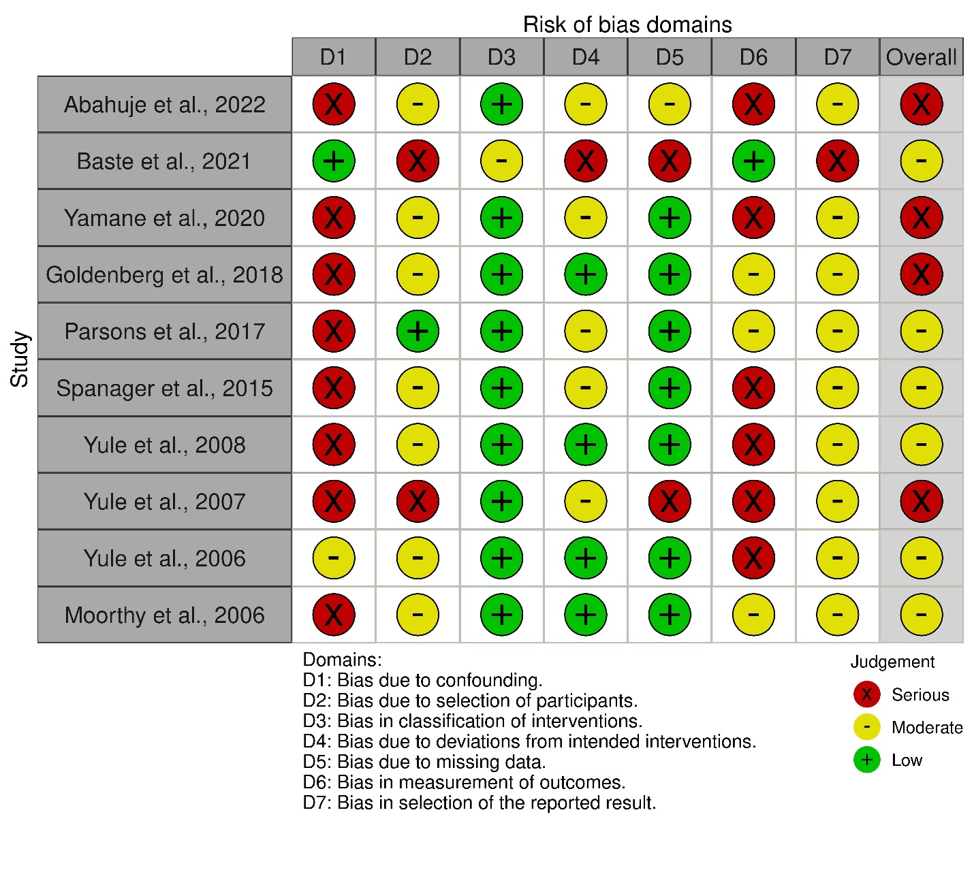
Supplementary Figure 1: Risk of Bias Traffic-Light Plot for Non-Randomized Studies Assessed Using ROBINS-I.
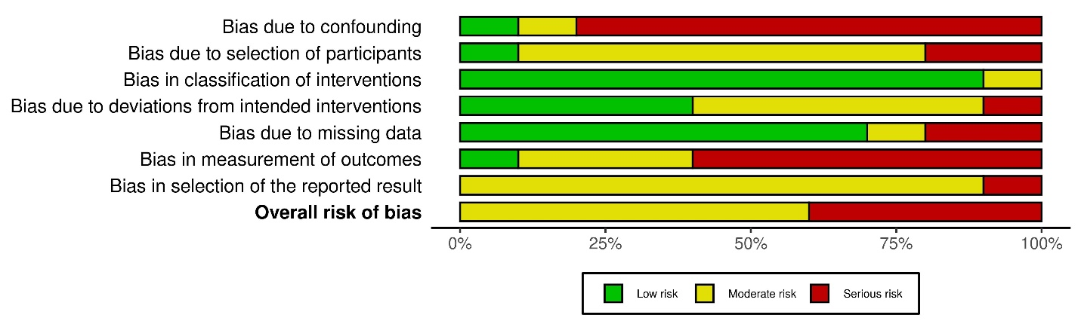
Supplementary Figure 2: Domain-Level Summary of Risk of Bias for Non-Randomized Studies Using ROBINS-I.
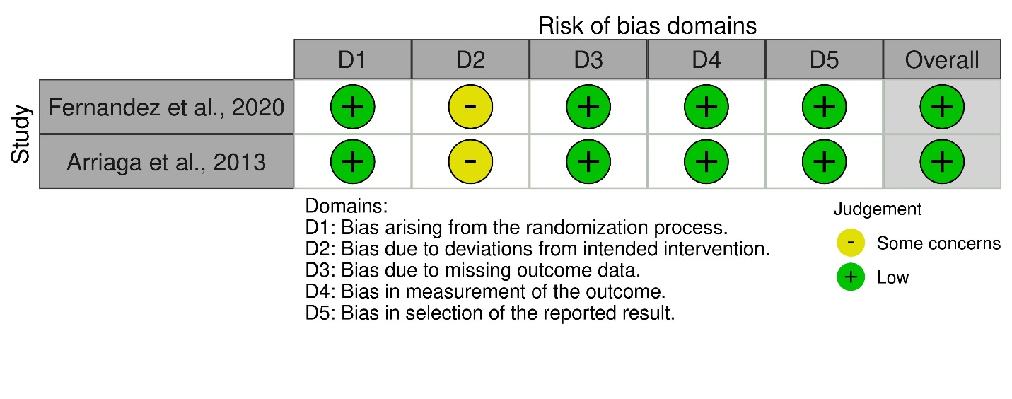
Supplementary Figure 3: Risk of Bias Traffic-Light Plot for Randomized Controlled Trials Assessed Using RoB-2.
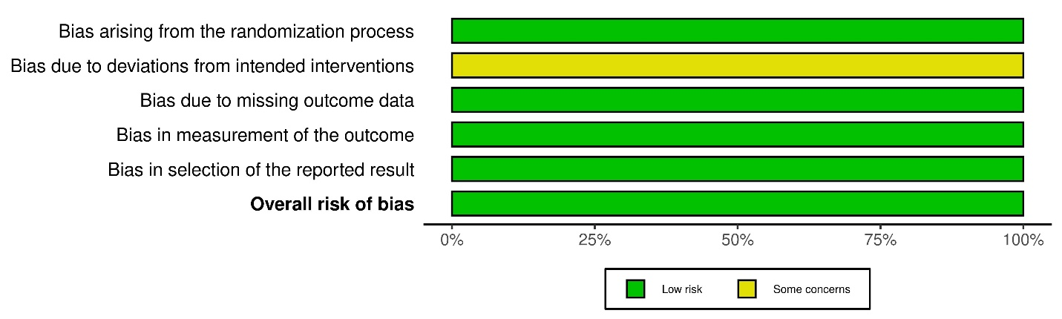
Supplementary Figure 4: Domain-Level Summary of Risk of Bias for Randomized Controlled Trials Using RoB-2

