Section 1: Case Summary

Scenario Title: | Hypercalcemia of Malignancy/ GOC Conversation
Keywords: | Hypercalcemia, malignancy, palliative care, oncologic emergencies
Brief Description of Case: | 67yo M with PMH presents for confusion, fatigue, and nausea and is found to have hypercalcemia from new diagnosis of advanced malignancy. Symptoms improve after being given intravenous hydration.

Goals and Objectives
Educational Goal: | Recognize and manage hypercalcemia in the cancer patient
Objectives: | - Create a wide differential diagnosis for altered mental status  - Recognize signs and symptoms of hypercalcemia  - Initiate treatment for hypercalcemia of malignancy  - Deliver bad news in a patient with advanced malignancy  - Perform an empathic GOC conversation with a surrogate decision maker

Learners, Setting and Personnel
Target Learners: | ☒ Junior Learners |  | ☒ Senior Learners |  | ☐ Staff
Target Learners: | ☐ Physicians | ☐ Nurses |  | ☐ RTs | ☐ Inter-professional
Target Learners: | ☐ Other Learners:
Location: | ☒ Sim Lab |  | ☐ In Situ |  | ☐ Other:
Recommended Number of Facilitators: | Instructors: 2
Recommended Number of Facilitators: | Sim Actors:2
Recommended Number of Facilitators: | Sim Techs: 1

Section 2A: Initial Patient Information

- Patient Chart
Patient Name: Miguel Rodriguez |  |  |  | Age: 67 | Gender: M | Weight: 75 kg
Presenting complaint: Confusion, nausea, fatigue
Temp: 38.5 | HR: 130 | BP: 88/62 |  | RR: 28 | O₂Sat: 93% | FiO₂:RA
Cap glucose: 150 |  |  |  | GCS: (E V M ) 13
Triage note:

67 yo M w/ HTN, DM, HLD, COPDr presents to ED with wife for 4 days of worsening fatigue, confusion, nausea, and poor PO intake.

Allergies: NKDA
Past Medical History:  - HTN  - DM  - HLD |  |  | Current Medications:  - Losartan 100 mg QD  - Hydrochlorothiazide 25 mg QD  - Lipitor 40 mg QD  - Metformin 1000 mg BID

Section 2B: Extra Patient Information

A. Further History
Include any relevant history not included in triage note above. What information will only be given to learners if they ask? Who will provide this information (mannequin’s voice, sim actors, SP, etc.)?

Patient’s wife will be at bedside and provide additional history. Per patient’s wife, patient gradually stopped eating and has been drinking less fluids over the past 4-5 days. He also seems “out of it” and would appear to not know the date or appears a lot more forgetful than usual. At baseline, patient is typically A+Ox3 and performs all IADLs independently. Review of systems remarkable for poor appetite, fatigue, nausea, constipation, and confusion. ROS otherwise negative. Wife notes that husband had been feelingunwell for a few weeks but really declined in the last few days . pt is stubborn and refused to go to doctor but now things are so bad that wife was able to get him to the doctor..
B. Physical Exam
List any pertinent positive and negative findings
Cardio: tachycardic, regular rhythm, no M/R/G | Neuro: A+Ox2 (oriented to person and place only), grossly non-focal
Resp: mild diffuse wheezing, decreased bs at right base | Head & Neck: supple, no tenderness
Abdo: soft, nontender, no rebound, guarding, rigidity | MSK/skin: no rash, purpura, or ecchymosis
Other: dry mucus membranes

Section 3: Technical Requirements/Room Vision

A. Patient
☒ Mannequin (specify type and whether infant/child/adult): adult
☐ Standardized Patient
☐ Task Trainer
☐ Hybrid
B. Special Equipment Required
IV fluids

C. Required Medications
Normal saline, bisphosphonates

D. Moulage
None

E. Monitors at Case Onset
☐ Patient on monitor with vitals displayed
☒ Patient not yet on monitor
F. Patient Reactions and Exam
Include any relevant physical exam findings that require mannequin programming or cues from patient
(e.g. – abnormal breath sounds, moaning when RUQ palpated, etc.) May be helpful to frame in ABCDE format.

A – protecting airway, moaning, confused
B – wheezing in all lung fields, decreased BS at right base
C – tachycardic, no hemorrhage
D – follows some commands, opens eyes to verbal stimuli
E – no signs of trauma, no wounds

Section 4: Sim Actor and Standardized Patients

Sim Actor and Standardized Patient Roles and Scripts
Role | Description of role, expected behavior, and key moments to intervene/prompt learners. Include any script required (including conveying patient information if patient is unable)
Family member:  wife | “I’m not sure what’s going on with him. He was fine just the other week, but now he just seems confused. He also doesn’t want to eat his dinner and just plays with his food, which is weird because he loves my cooking.”

Section 5: Scenario Progression

Scenario States, Modifiers and Triggers
Patient State/Vitals | Patient Status | Learner Actions, Modifiers & Triggers to Move to Next State |  | Facilitator Notes
1. Baseline State  Rhythm: sinus tachycardia  HR: 130  BP: 88/60  RR: 28  O₂SAT:93 %  T: 38.5ºC  GCS: 12 | Confused, dehydrated, appears weak, ill appearing  moaning | Expected Learner Actions  ☐ Send labs  ☐ Obtain FSG  ☐ Obtain EKG  ☐ Send urine  ☐ Attempt to obtain head CT  ☐ Place patient on supplemental oxygen  ☐ | Modifiers  Changes to patient condition based on learner action  - tachycardia will gradually improve after IVF started  -  Triggers  For progression to next state  -  - | If residents ask for head CT, tell them they are unavailable due to a prolonged break.  CXR will show R sided pleural effusion, tumor, bony metastasis
2.  Rhythm: Sinus tachycardia  HR: 115  BP: 90/60  RR: 28  O₂SAT:93%  T: 38.5ºC  GCS: 12 | Stable  no improvement of mental status | Expected Learner Actions  ☐ Reassess volume status  ☐ Reattempt to obtain head CT  ☐ Obtain CXR  ☐ Start bisphosphonates IV  ☐ Admit to telemetry  ☐ Discontinue HCTZ | Modifiers  - pt’s oxygen saturation will improve if placed on supplemental oxygen but his work of breathing will still be increased  -  -  Triggers  -  - | Only provide additional labs like PTH or PTHrP if specifically requested by residents  Can have patient go to CT scan quickly if residents insist. The CTH will show metastasis.  CXR will show R sided pleural effusion, tumor, bony metastasis
3.  Rhythm: normal sinus  HR: 101  BP: 100/65  RR: 28  O₂SAT:95 %  T: 37ºC  GCS: 14 | Stable | Expected Learner Actions  ☐ Explain lab results to wife  ☐ Explain that hypercalcemia indicates poor prognosis  ☐  ☐  ☐ | Modifiers  -  -  -  Triggers  - Wife will ask about lab results  - Wife will ask what this means regarding prognosis | Wife will prompt team to discuss GOC– want to know what the diagnosis is what the prognosis is can the pt be cured  what are our options?

Appendix A: Laboratory Results

CBC  WBC 11.5  Hgb 12  Plt 150  Lytes  Na 146  K 3.4  Cl 110  HCO₃ 21  AG 16  Urea 15  Cr 1.1  Glucose 150  Extended Lytes  Ca 15.5 mg/dL  Mg 1.5  PO₄ 2.2  Albumin 3.5  TSH wnl  Intact PTH 8 pg/mL (ref: 10 – 65 pg/mL)  PTHrP 10 pmol/L (ref: < or = 4.2 pmol/L)  1,25 (OH)₂D 60 ng/mL (ref: 50 – 70 ng/mL)  VBG  pH 7.41  pCO₂ 38  pO₂ 40  HCO₃ 22  Lactate 1.9 | Cardiac/Coags  Trop wnl  D-dimer wnl  INR wnl  aPTT wnl  Biliary  AST wnl  ALT wnl  GGT wnl  ALP 150  Bili wnl  Lipase wnl  Tox  EtOH neg  ASA neg  Tylenol neg  Dig level neg  Osmols wnl

Appendix B: ECGs, X-rays, Ultrasounds and Pictures

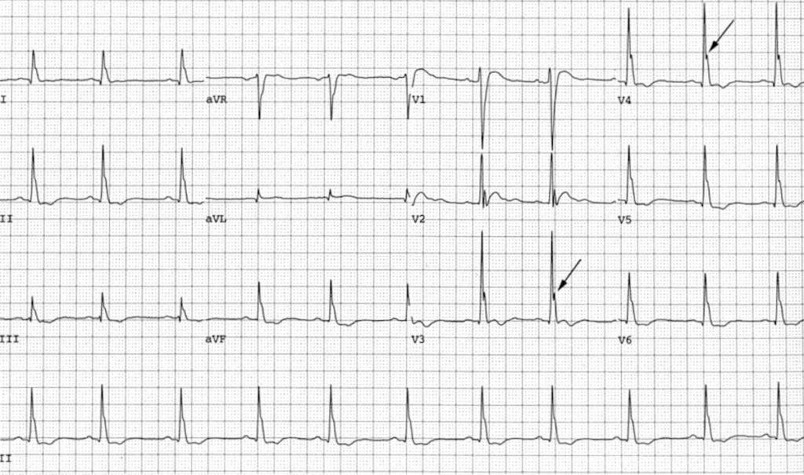

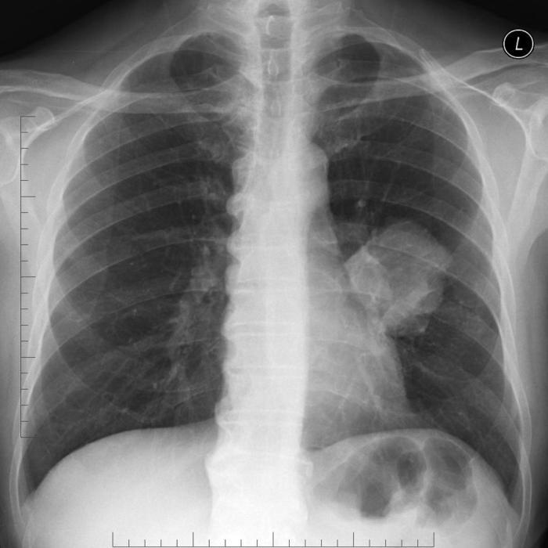

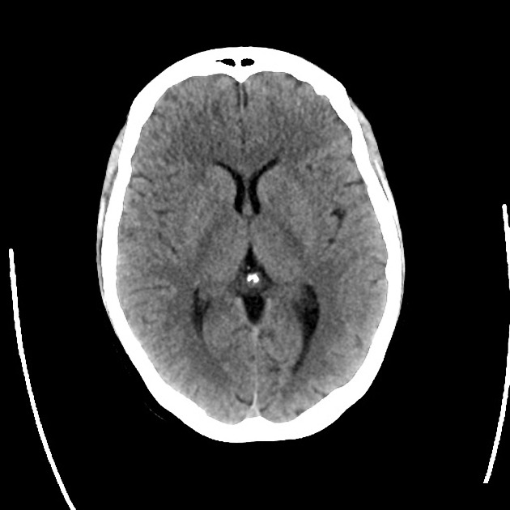

SP Case Notes
Goals of Care Conversations: Hypercalcemia of Malignancy
Patient Name and DOB | Christopher Walker, 67 yo M  SP will play role of patient’s wife, Laura Walker
Opening Statement/  Chief Complaint | “My husband hasn’t been his normal self”
“Tell Me More About It” | “He just seems out of it. He’s been slowly looking more confused over the last three months, it started with small things like forgetting to feed the dog. I noticed a few past due bills over the last month or so which is very unlike him, he’s normally on top of paying things on time.It got worse over the last week; he’s so tired, he won’t get out of bed. He’s also confused, he keeps calling out for our son but our son hasn’t lived with us in 20 years. He’d be so embarrassed if I told you this but he started wetting the bed this week as well, which he never does”
Demeanor/ Physicality | Concerned but calm, open body language towards providers
History of Present Illness | 67yo Male, current smoker, history of COPD, presents for confusion, fatigue, and nausea and is found to have hypercalcemia  You will be at the bedside and provide additional history. Your spouse gradually stopped eating and has been drinking less fluids over the past 4-5 days. He also seems “out of it” and does not know the date and appears a lot more forgetful than usual. At baseline, he is typically alert and oriented to person, place, and time and performs all activities of daily living independently. Review of systems remarkable for poor appetite, weight loss, fatigue, nausea, constipation, and confusion..
Past Medical Hx | Hypertension, Diabetes Mellitus , Hyperlipidemia COPD
Past Surgical Hx | L knee arthroplasty, Hernia repair
Allergies | Penicillin
Medications | Ipratropium/Albuterol inhaler, Metformin, Losartan, Lipitor, HCTZ
Over the Counter/ Vitamins & Supplements
Social Hx | 30 Pack per day smoker, still smokes
Family Medical Hx | Breast Cancer in maternal aunt, father with heart disease
ROS/Physical Findings | BP: 88/62 HR: 130 SpO2: 93% RR: 28 Temp: 38.5  General: Confused, older appearing man, ill appearing  Head eyes ear nose throat: dry mucous membranes  Cardio: Tachycardia  Pulmonary: Mild diffuse wheezing, Decreased lung sounds at Right lung base  Abdomen: Soft Nontender  Extremities: No edema
Props/ Moulage
SP Special instructions | You have noticed your spouse’s decline for months, but they were stubborn and refused to come to the doctor. “he’s so stubborn! He didn’t want to leave home, I made the decision because he was so out of it”  Initial labs will show hypercalcemia, medical workup will reveal metastatic cancer (likely lung cancer secondary to his long smoking history). He will also have fluid buildup at his right lung (secondary to the cancer). After learning about the cancer/hypercalcemia:  “Is this because I’ve been feeding him too much milk?”  “Is he going to die? How long does he have to live?”  “What do we do next?”  The medical team should ask you what your spouse’s wishes would be in terms of advanced life support (intubation/breathing machine, chest compressions, life sustaining medications etc). Your spouse is too sick and out of it to be able to make these decisions.  One of the main objectives of this case is for the team to have a goals of care conversation with you. If they do not prompt you to have this discussion you should bring it up “how likely is it that they make it out of this okay; what options do I have in terms of helping them” if they bring up intubation you can ask if its painful, if he will ever breathe on his own again”  You should be extremely against any thoughts of him dying at first, the medical team should be able to give her reassurance that they are focused on his symptoms and his pain, the medical team should be gentle and caring towards you. Eventually, you will decide that you want everything but intubation because “he had a brother who was on life support after a bad car accident, he said he never wanted that to happen to him if it came down to it”
Door Chart

Section 1: Case Summary

Scenario Title: | Metastatic Spinal Cord Compression
Keywords: | Aortic dissection, chest pain, back pain, extremity weakness, oncologic emergencies, spinal cord compression, hypertensive emergency
Brief Description of Case: | 52 yo F w/ PMH poorly controlled HTN and recently diagnosed breast cancer here for chest pain, back pain, and left upper and lower extremity weakness and numbness. Patient presents markedly hypertensive, uncomfortable, and appears to initially have an aortic dissection. However, further imaging will reveal she has metastatic disease to the spine, causing her neurologic deficit. Patient will not have an aortic dissection but will show evidence of metastatic disease to the lower cervical/upper thoracic spine. Radiation oncology will be consulted for emergent radiation therapy.

Goals and Objectives
Educational Goal: | Identify and treat metastatic spinal cord compression in a cancer patient
Objectives: | - Recognize life-threatening causes of chest and back pain  - Treat hypertensive emergency  - Order appropriate labs and imaging in a patient with concerning chest and back pain  - Advocate for patients and escalate issues to hospital administration quickly*  - Recognize metastatic spinal cord compression as a potential cause of back pain in the cancer patient  - Consult radiation oncology immediately upon diagnosis of metastatic spinal cord compression  *optional

Learners, Setting and Personnel
Target Learners: | ☒ Junior Learners |  | ☒ Senior Learners |  | ☐ Staff
Target Learners: | ☐ Physicians | ☐ Nurses |  | ☐ RTs | ☐ Inter-professional
Target Learners: | ☐ Other Learners:
Location: | ☒ Sim Lab |  | ☐ In Situ |  | ☐ Other:
Recommended Number of Facilitators: | Instructors: 2
Recommended Number of Facilitators: | Sim Actors:2
Recommended Number of Facilitators: | Sim Techs: 1

Section 2A: Initial Patient Information

- Patient Chart
Patient Name: Melissa Grodskaya |  |  |  | Age: 52 | Gender: Female | Weight: 65kg
Presenting complaint: chest and back pain
Temp: 98.7 | HR: 110 | BP: 220/150 |  | RR: 26 | O₂Sat: 98% | FiO₂:RA
Cap glucose: 100 |  |  |  | GCS: (E V M ) 15
Triage note:
52 yo F w/ recently diagnosed breast cancer and HTN here for severe chest and back pain x 2 days. Patient also complaining of worsening left hand weakness, left arm numbness, and feeling more clumsy than usual including several trips without falling. Reports compliance with blood pressure medications.
Allergies: NKDA
Past Medical History:  - HTN  - Breast Cancer (diagnosed 3 weeks ago; one round of chemotherapy) |  |  | Current Medications:  - Lisinopril 40 mg daily  - Amlodipine 10 mg daily  - Naproxen 250 mg BID

Section 2B: Extra Patient Information

A. Further History
Include any relevant history not included in triage note above. What information will only be given to learners if they ask? Who will provide this information (mannequin’s voice, sim actors, SP, etc.)?

Patient reports severe, worsening left-sided chest pain, non-exertional, non-pleuritic that radiates to her upper back worse with twisting movements and raising her arm. Has tried taking Tylenol and motrin without any relief. Also noted that over the past several days her left hand gradually felt weak and has trouble grasping objects. Also reports numbness to her left upper extremity that’s been worsening. Increasing clumsiness, dropping objects, feels like she is always tripping lately. No trauma or falls. No urinary retention, incontinence, saddle anesthesia, hx of IVDU. ROS positive for occasional SOB, anxiety, lightheadedness, nausea, but no vomiting. ROS otherwise negative. Recently diagnosed with breast cancer and underwent first round of chemotherapy about 2 weeks ago with pending mastectomy and radiation. No history of toxic habits.
B. Physical Exam
List any pertinent positive and negative findings
Cardio: Tachycardic, regular rhythm, no murmurs, rubs, or gallops | Neuro: CNII-XII intact, PERRL, EOMI  3/5 grip strength left hand, 4/5 LUE flexion/extension  5/5 right hand, 5/5 RUE, 4/5 LLE dorsiflexion  Slow but steady gait, no dysmetria w/ FTN. Normal rapid alternating movements.
Resp: clear bilateral breath sounds | Head & Neck: supple, no tenderness
Abdo: soft, nontender. Non-distended, no rebound, guarding, rigidity. No CVAT. No pulsatile mass. | MSK/skin: no rash, purpura, or ecchymosis. +Mild left upper thoracic tenderness to palpation. No midline cervical, thoracic, or lumbar spine tenderness to palpation. No step offs.
General: Uncomfortable, grimacing, writhing around in pain, mildly diaphoretic
Section 3: Technical Requirements/Room Vision

A. Patient
☒ Mannequin (specify type and whether infant/child/adult): adult
☐ Standardized Patient
☐ Task Trainer
☐ Hybrid
B. Special Equipment Required
IV pump, manual BP cuff

C. Required Medications
Esmolol or other IV antihypertensive, morphine or other opioid, Zofran or other antiemetic

D. Moulage
None

E. Monitors at Case Onset
☐ Patient on monitor with vitals displayed
☒ Patient not yet on monitor
F. Patient Reactions and Exam
Include any relevant physical exam findings that require mannequin programming or cues from patient
(e.g. – abnormal breath sounds, moaning when RUQ palpated, etc.) May be helpful to frame in ABCDE format.

A – airway intact, speaking full sentences
B – clear bilateral breath sounds, no increased work of breathing
C – symmetric distal pulses, extremities well perfused
D – PERRL, A+OX3, decreased sensation to light touch LUE, 3/5 grip strength left hand, 4/5 LUE flexion/extension, 4/5 LLE dorsiflexion
E – no trauma, ecchymosis

Section 4: Sim Actor and Standardized Patients

Sim Actor and Standardized Patient Roles and Scripts
Concerned Family Member | This person is a close family member of the patient.  After learning about concern for aortic dissection: “I just started supporting her/him through this breast cancer journey, we just started chemo, surgery is up next, but this back pain and high blood pressure was so sudden. I always get her/him to take their medication and on time, every time. How can this? We’re doing all the things the doctors said to do.”  After learning about metastases to the spine: “I just don't understand, breast cancer and now this? Our family doesn’t deserve this.”  The patient has always been so independent in their life, living on their own, traveling the world and things of that nature, will that continue to be the case? “Will they be able to live independently still?”  “How much time do we have left?”

Section 5: Scenario Progression

Scenario States, Modifiers and Triggers
Patient State/Vitals | Patient Status | Learner Actions, Modifiers & Triggers to Move to Next State |  | Facilitator Notes
1. Baseline State  Rhythm: sinus tachycardia  HR: 110  BP: 220/150  RR: 26  O₂SAT:98 %  T: 37ºC  GCS: 15 | Uncomfortable, crying, writhing around in pain | Expected Learner Actions  ☐ Start IV esmolol or other beta blocker  ☐ Obtain EKG  ☐ Call for STAT CTA of chest  ☐ Pain medication  ☐ Talk to radiology tech regarding emergent need for scan  ☐ Escalate to attending or administrator if rad tech pushes back  ☐ | Modifiers  Changes to patient condition based on learner action  - if no IV beta blocker started, patient will continue to have a rising BP  - if pain medication not given, BP will continue to be relatively high despite IV antihypertensive  Triggers  For progression to next state  - Blood pressure and heart rate will decrease after starting an appropriate dose of IV beta blocker  - CT scan will be done once the senior attending or department chair is contacted | Radiology tech can give push back about not having creatinine back and will request a note be written in the chart first.  After note is written, radiology tech will then continue to push back and say there are too many “STAT” patients that are ahead of this one and refuses to accept patient*  *optional
2.  Rhythm: normal sinus  HR: 70  BP: 150/90  RR: 20  O₂SAT: 98%  T: 37ºC  GCS: 15 | Will complain of nausea and started to vomit | Expected Learner Actions  ☐ Give antiemetic  ☐  ☐  ☐  ☐ | Modifiers  - if antiemetics aren’t given, patient will start to aspirate on vomit  -  -  Triggers  - ask for preliminary read CTA from radiologist  - | Preliminary read from radiologist will say no findings aortic dissection, but there will be evidence of bony metastasis in the cervical/thoracic vertebrae with possible surrounding edema. Only give this prelim read if requested. Learners may opt to just look at the CT scan themselves.
3.  Rhythm: normal sinus  HR: 65  BP: 145/85  RR: 20  O₂SAT:98 %  T: 37ºC  GCS: 15 | Patient still complaining of severe pain. Will be distressed by the persistent numbness and weakness in arm and demand an explanation | Expected Learner Actions  ☐ Give additional pain medications  ☐Consult neurosurgery, radiation oncology  ☐give IV dexamethasone  ☐arrange for MRI spine  ☐feed patient if they are hungry | Modifiers  - if pain medication isn’t given, BP rises again despite antihypertensive therapy on board  - time permitting, patient will start to get impatient, tell the care team they are hungry and vociferously demand food  -  Triggers  - if food is not given, patient threatens to leave during evaluation  - | Patient will have mild improvement in pain, but will still be uncomfortable and have persistent left hand weakness. MRI results will not be available. Patient can eat.

Appendix A: Laboratory Results

CBC  WBC 12  Hgb 11  Plt 150  Lytes  Na 140  K 3.9  Cl 110  HCO₃ 24  AG 10  Urea 20  Cr 0.9  Glucose 150  Extended Lytes  Ca 10  Mg 1.9  PO₄ 3  Albumin 3.8  TSH wnl  VBG  pH 7.49  pCO₂ 39  pO₂ 40  HCO₃ 22  Lactate 1.7 | Cardiac/Coags  Trop neg x 1  D-dimer wnl  INR wnl  aPTT wnl  Biliary  AST wnl  ALT wnl  GGT wnl  ALP wnl  Bili wnl  Lipase wnl  Tox  EtOH neg  ASA neg  Tylenol neg  Dig level neg  Osmols wnl  Other  B-HCG negative

Appendix B: ECGs, X-rays, Ultrasounds and Pictures

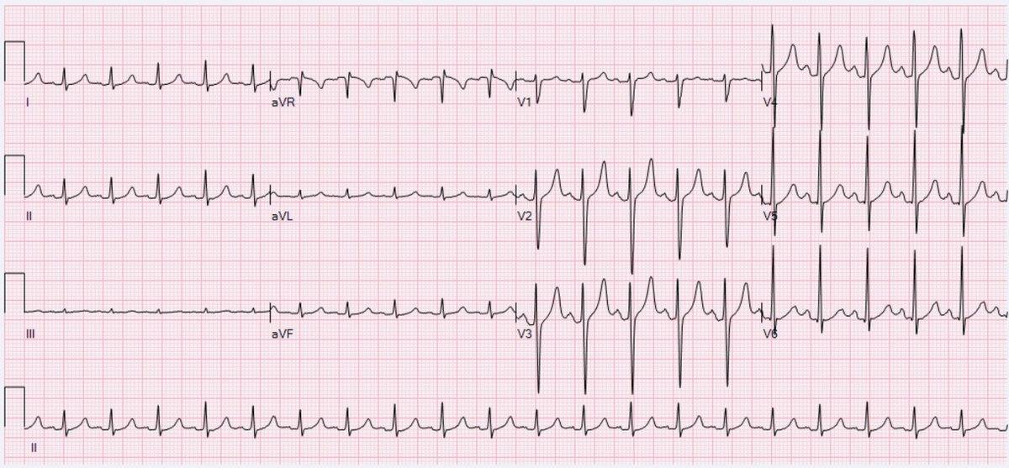

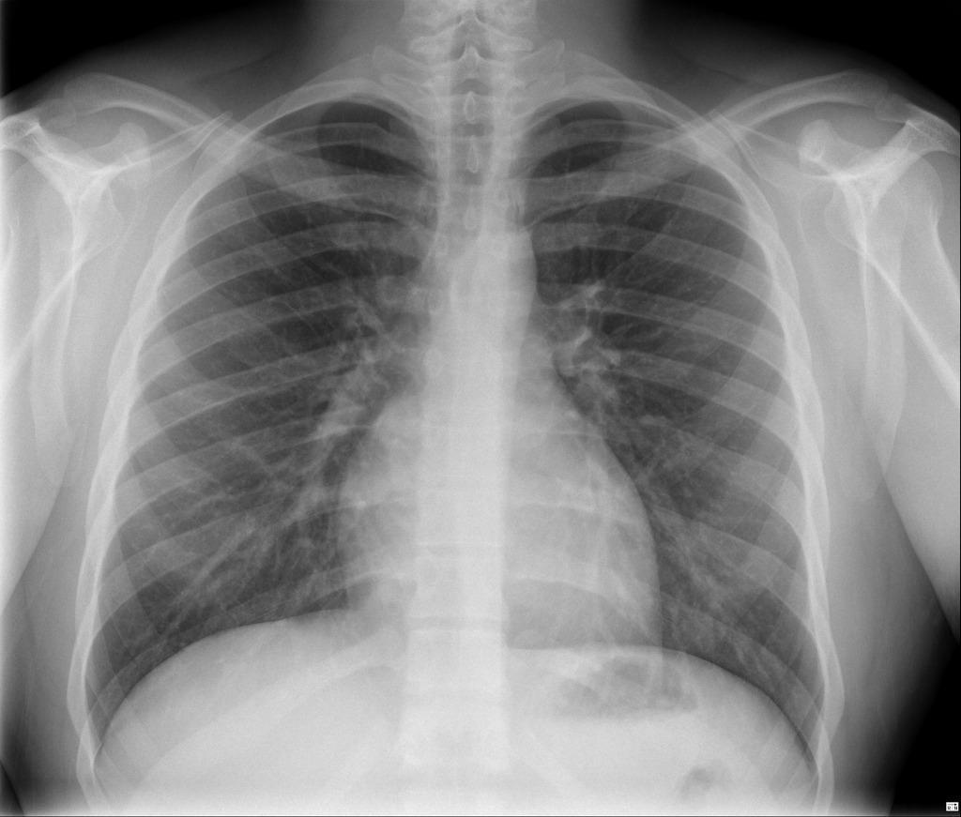

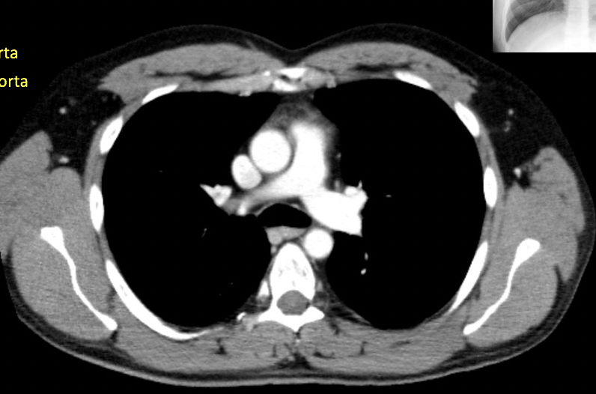

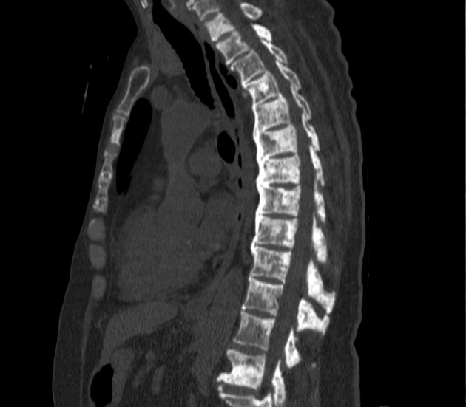

SP Case Notes
Goals of Care Conversations: Metastatic Spinal Cord Compression
Patient Name and DOB | Melissa Grodskaya, 52 yo F  SP will play role of patient’s close family member, Jay Wayne Jenkins
Opening Statement/  Chief Complaint | “My cousin isn’t feeling that well.”
“Tell Me More About It” | “I just started supporting her/him through this breast cancer journey, we just started chemo, surgery is up next, but this back pain and high blood pressure was so sudden. I always get her/him to take their medication and on time, every time. How can this?  We’re doing all the things the doctors said to do.”
Demeanor/ Physicality | Concerned but calm, open body language towards providers
History of Present Illness | 52 yo F w/ PMH poorly controlled HTN and recently diagnosed breast cancer here for chest pain, back pain, and left upper and lower extremity weakness and numbness. Patient presents markedly hypertensive, uncomfortable, and appears to initially have an aortic dissection. However, further imaging will reveal she has metastatic disease to the spine, causing her neurologic deficit. Patient will not have an aortic dissection but will show evidence of metastatic disease to the lower cervical/upper thoracic spine.
Past Medical Hx | Hypertension, Breast Cancer (Diagnosed 3W ago, 1 round of chemotherapy so far)
Past Surgical Hx | TBD
Allergies | NKDA
Medications | Lisinopril 40mg, Amlodipine 10mg, Naproxen 250mg BID
Over the Counter/ Vitamins & Supplements | Psyllium Husk 6 capsules daily (3.12g)
Social Hx | Teacher for 30 years, no toxic habits
Family Medical Hx | Unremarkable
ROS/Physical Findings | BP: 220/150 HR: 110 SpO2: 98% RR: 26 Temp: 98.7  General: Uncomfortable, grimacing, writhing around in pain, mildly diaphoretic  Card: Tachycardic, regular rhythm, no murmurs, rubs, or  Gallops  Resp: clear bilateral breath sounds  Abd: soft, nontender. Non-distended, no rebound,  guarding, rigidity. No CVAT. No pulsatile mass.  Head & Neck: supple, no tenderness  MSK/Skin: no rash, purpura, or ecchymosis. +Mild left  upper thoracic tenderness to palpation. No midline cervical,  thoracic, or lumbar spine tenderness to palpation. No step  offs.  Neuro: CNII-XII intact, PERRL, EOMI  3/5 grip strength left hand, 4/5 LUE flexion/extension  5/5 right hand, 5/5 RUE, 4/5 LLE dorsiflexion  Slow but steady gait, no dysmetria w/ FTN. Normal rapid  alternating movements.
Props/ Moulage
SP Special instructions | You have noticed that your family member is not only struggling to cope with a recent breast cancer diagnosis and the initial round of chemo plus surgical planning, but they are now having very high blood pressure and weakness.  You and your family member are exacerbated by this next bump in the road.  Initial workup will suggest that there is an acute life-threatening cause of chest and back pain in the setting of high blood pressure, aortic dissection. “I just started supporting her/him through this breast cancer journey, we just started chemo, surgery is up next, but this back pain and high blood pressure was so sudden. I always get her/him to take their medication and on time, every time. How can this? We’re doing all the things the doctors said to do.”  After learning about metastases to the spine which are found on the CT chest-abdomen-pelvis scan: “I just don’t understand, breast cancer and now this? Our family doesn’t deserve this.”  Not realizing metastases means the patient’s breast cancer is terminal:  After realizing that their loved one is much sicker than originally diagnosed: “Melissa has always been so independent in their life, living on their own, traveling the world and things of that nature, will that continue to be the case? Will they be able to live independently still?”  One of the main objectives of this case is for the team to have a goals of care conversation with you. If they do not prompt you to have this discussion you should bring it up “How likely is it that they make it out of this okay? How much time do we have left?”  You should be extremely against any thoughts of the patient dying at first, the medical team should be able to give her reassurance that they are focused on symptoms, the medical team should be gentle and caring towards you. Eventually, you will help the patient decide that they want the highest quality of life for the time they have left.

Section 1: Case Summary

Scenario Title: | End of Life Symptom Management
Keywords: | Oncology, pain management, end of life symptom management
Brief Description of Case: | 78 yo F w/ recently diagnosed pancreatic cancer who recently received palliative chemotherapy presents for acute generalized weakness, decreased appetite, and dyspnea. Patient will be neutropenic and will require multiple pressors, but will remain hypotensive despite aggressive intervention. Family will later opt for a palliative extubation while in ED.

Goals and Objectives
Educational Goal: | recognize the active dying process, manage symptoms at end of life, perform a palliative extubation
Objectives:  (Medical and CRM) | - Recognize the active dying process and understand when further medical intervention is futile  - Manage symptoms at the end of life using appropriate medications  - Communicate effectively with other team members  - Communicate bad news effectively to family members  - Perform palliative extubation
EPAs Assessed:

Learners, Setting and Personnel
Target Learners: | ☒ Junior Learners |  | ☒ Senior Learners |  | ☐ Staff
Target Learners: | ☐ Physicians | ☐ Nurses |  | ☐ RTs | ☐ Inter-professional
Target Learners: | ☐ Other Learners:
Location: | ☒ Sim Lab |  | ☐ In Situ |  | ☐ Other:
Recommended Number of Facilitators: | Instructors: 2
Recommended Number of Facilitators: | Sim Actors:2
Recommended Number of Facilitators: | Sim Techs: 1

Section 2A: Initial Patient Information

- Patient Chart
Patient Name: Akosua Obduwale |  |  |  | Age: 78 | Gender: F | Weight:64 kg
Presenting complaint: Weakness and shortness of breath
Temp: 39 C | HR: 115 | BP: 90/50 |  | RR: 38 | O₂Sat: 93% | FiO₂: 60%
Cap glucose: 120 |  |  |  | GCS: (E2 V2 M4 ) 8
Sign Out Note:
78 yo F w/ recently diagnosed pancreatic cancer who received palliative chemotherapy 3 days ago presents for acute generalized weakness, confusion, decreased appetite, and dyspnea. Patient initially presented hypotensive, tachycardic, tachypneic with increased work of breathing, altered mental status, and was febrile. Patient was started on peripheral levophed, received 2 L IVF, vancomycin and cefepime, and intubated. Central line was placed and levophed now at 30 mcg/min and has continued to require escalating doses within the past hour. As per daughter and son-in-law on the phone, patient is to remain full code. Patient went into vtach arrest, shocked once, and received 1 amp of calcium, ROSC achieved. CCM consulted and was rejected to the MICU due to poor prognosis. Family just arrived

Allergies: NKDA
Past Medical History:  Stage 4 Pancreatic Adenocarcinoma  HTN  HLD |  |  | Current Medications:  Lisinopril 40 mg daily  Simvastatin 20 mg daily

Section 2B: Extra Patient Information

A. Further History
Include any relevant history not included in triage note above. What information will only be given to learners if they ask? Who will provide this information (mannequin’s voice, sim actors, SP, etc.)?

Prior to cancer diagnosis a few weeks ago, patient was active, completely independent with all ADLs, and “vibrant.” Patient would travel frequently, visit friends, and cook. While never explicitly addressing code status in the past, patient would often say how she would not want to suffer and hopes she dies at home with family peacefully.
B. Physical Exam
List any pertinent positive and negative findings
Cardio: Tachycardic, regular, no murmurs | Neuro: Obtunded, withdraws to pain only
Resp: bilateral mechanical breath sounds | Head & Neck: supple, no tenderness
Abdo: soft, mild epigastric and RUQ tenderness, +hepatomegaly. no rebound, guarding. | MSK/skin: no rash, purpura, or ecchymosis, diffuse 2+ pitting edema BUE and BLE
Other:

Section 3: Technical Requirements/Room Vision

A. Patient
☒ Mannequin (specify type and whether infant/child/adult): adult
☐ Standardized Patient
☐ Task Trainer
☐ Hybrid
B. Special Equipment Required
intubation equipment, ventilator, suction

C. Required Medications
RSI medications, vasopressors

D. Moulage
None

E. Monitors at Case Onset
☐x Patient on monitor with vitals displayed
Patient not yet on monitor
F. Patient Reactions and Exam
Include any relevant physical exam findings that require mannequin programming or cues from patient
(e.g. – abnormal breath sounds, moaning when RUQ palpated, etc.) May be helpful to frame in ABCDE format.

A - intubated on a ventilator
B - adequate ventilation
C - tachycardic, no hemorrhage, weak peripheral pulses
D - obtunded, no sedation, withdraws to pain only
E - no signs of trauma

Section 4: Sim Actor and Standardized Patients

Sim Actor and Standardized Patient Roles and Scripts
Role | Description of role, expected behavior, and key moments to intervene/prompt learners. Include any script required (including conveying patient information if patient is unable)
Daughter | Daughter will be visibly upset, intermittently crying, pacing back and forth.  You will be near the patient. If the team does not update you, request that you have an update. Be firm, but not aggressive.  Once you see them try additional resuscitation efforts with no effect, they should warn you that she is actively dying.  If they do not warn you, ask “Is she going to die soon?”  Make note of her grimacing and secretions and say something like “It looks like she’s suffering. She wouldn’t want to go through this. Please no more CPR.”  Request that the patient is extubated.  If they do not attempt to manage her symptoms during the terminal extubation, cry more and start asking the team “Please help her. She looks so uncomfortable!”  If they do not set expectations prior to the extubation, hysterically ask, “What is happening!? Why is she making those noises!? Please make it stop!”
Section 5: Scenario Progression

Scenario States, Modifiers and Triggers
Patient State/Vitals | Patient Status | Learner Actions, Modifiers & Triggers to Move to Next State |  | Facilitator Notes
- Asysolic arrest | as soon as case starts and team has introduced themselves to the family the patient will code | Expected Learner Actions  - CPR  - BVM  - Epix1 | Modifiers  - will get ROSC after 1 round | family will be at bedside watching the code and this will push them to make pt DNR and extubate her
2.  Rhythm: sinus tach  HR: 140  BP: 60/40  RR: 45  O₂SAT: 90 %  T: 37ºC  GCS: 3 | Pt grimacing, becoming more tachypneic, overbreathing the vent, increased secretions  Daughter will be crying. Will voluntarily make pt DNR. | Expected Learner Actions  ☐ adjust vent settings  ☐ alert family of worsening clinical status and inform them that death is likely imminent  ☐ have family nearby  ☐ | Modifiers  - Blood pressure will improve for several minutes but will continue to decrease.  - Brief improvement in pulse ox, but will downtrend despite max vent support  -  Triggers  -  - | If family members are nearby, they will not be disruptive. They will just seem sad and anxious.
3. Actively Dying  Rhythm: sinus  HR: 40  BP: 50/30  RR: 40  O₂SAT: 60 %  T: 37ºC  GCS: 3 | Daughter will request that pt be extubated and to be made comfortable.  Pt will continue to grimace, have copious secretions, and have increased work of breathing | Expected Learner Actions  ☐ allow family to be at bedside, provide emotional support  ☐inform family that death will happen very soon  ☐ prepare family for what to expect during and after extubation  ☐ give opioids and/or benzos for dyspnea; titrate up for symptoms  ☐ give atropine for secretions | Modifiers  - if learners do not prepare family, they will become upset and start crying more hysterically  - if learners prepares family and comforts them, they will seem sad but will show gratitude  Triggers  - if extubated, pt will progressively become bradycardic until asystole  - if opioid or benzo dose not increased or titrated up, pt will grimace and appear more uncomfortable (restless, more accessory muscle use) | nurse will have to cue standardized patient about signs of resp distress once extubated.

Appendix A: Laboratory Results

CBC  WBC 30k  Hgb 10.1  Plt 125  Lytes  Na 131  K 5.9  Cl 111  HCO₃ ₁₈  AG 20  Urea 20  Cr 2.1  Glucose 110  Extended Lytes  Ca 8  Mg 1.6  PO₄ ₃  Albumin 3.5  TSH wnl  VBG  pH 7.15 → 7.0  pCO₂ ₃₂  pO₂ ₄₀  HCO₃ ₂₀  Lactate 7→ repeat 15 | Cardiac/Coags  Trop 0.20  D-dimer 0.5  INR wnl  aPTT wnl  Biliary  AST 140  ALT 150  GGT wnl  ALP 120  Bili wnl  Lipase wnl  Tox:  EtOH neg  ASA neg  Tylenol neg  Dig level neg  Osmols neg  Other  B-HCG neg

SP Case Notes
Palliative Extubation Case

Encounter timing (including warning times) | 10-15 minutes
Post-encounter timing (including warning times) | 45 minutes
Feedback details: (i.e. no feedback; timing; faculty & student; SP & student; faculty & SP with student) | Faculty, student, SP

Patient Name and DOB | Sarah Obduwale is the 55 year old daughter of the medical pt Akosua Obduwale aged 88 DOB 3/18/35
Opening Statement/  Chief Complaint | “I'm here because I was told my mother is very sick and may not have much time left.”
“Tell Me More About It” | “I just spoke to her yesterday. She had chemo a few days ago but she was in good spirits. And then this morning she just didn’t sound right? Very confused and weak. So I asked a friend to go check on her. Now the doctors are saying she might die?”
Demeanor/ Physicality | Worried, tearful, anxious, pacing
History of Present Illness | Your mother has been in and out of the hospital for the last few weeks. She was diagnosed with pancreatic cancer w. lung metastasis about 8 weeks ago. She has been receiving palliative chemotherapy, last dose was 3 days ago. Today she was acutely weak, confused, short of breath and had loss of appetite. you called a friend to go check on her and the friend found your mother to be ill appearing and called the ambulance. You immediately got into the car to start driving since you live far away.
Past Medical Hx | Stage 4 Pancreatic Adenocarcinoma  HTN  HLD  preDM
Past Surgical Hx | None
Allergies | none
Medications | Lisinopril 40 mg daily  Simvastatin 20 mg daily  Metformin 1000 mg daily
Over the Counter/ Vitamins & Supplements | None
Social Hx | Smoking: never  Alcohol:socially
Family Medical Hx | Parents: blood pressure (dad), diabetes(mom), heart disease(dad)  Siblings: blood pressure (brother)  Children:
ROS/Physical Findings
Props/ Moulage | SP should have hand written med list,
SP Special instructions | You are at the patient’s bedside tearful. You have not yet received an update from the medical team. If the team does not update you, then ask for one. Be firm but not aggressive. You will be very upset at the news of your mother’s grave illness, but you are even more upset by your mother’s apparent suffering. You and your mother never explicitly discussed her advanced directives but you’ve heard her say on multiple occasions that when her time comes she does not want to suffer. She would rather die at home surrounded by family. She often shared that she’s lived a long and beautiful life and she is ready to meet the Lord.  You will watch in horror as you see the team begin resuscitative measures when she loses pulses. While measures are ongoing, they should warn you that she is actively dying. If they do not say anything, you should ask “is she going to die?”  Make note of her grimacing and secretions. Share that she is suffering and never would have wanted this. Tearfully request that there be no more CPR should she lose pulses again. Request that the patient be extubated.  During the extubation, she will begin to have labored breathing and appear to be in distress. The team should warn you of this. If they do not warn you, you should become hysterical and ask “what is happening?! Why is she making those noises! What have you done to her?! Make it stop!”  If they do not attempt to make her symptoms better you should become even more tearful and beg them to help her. “Please! She is suffering even more now!Help her!”

Section 1: Case Summary

Scenario Title: | Septic Shock in the demented patient
Keywords: | Septic Shock, resuscitation, , palliative care, surrogate decision maker
Brief Description of Case: | Older male with poor cognitive status presents in septic shock necessitating pressors/intubation should family want that.

Goals and Objectives
Educational Goal: | Understand and manage legal/ethical issues in regards to surrogate decision makers
Objectives:  (Medical and CRM) | - Inquire about and manage complexities in surrogate decision makers  - Understand the order of surrogate decision makers  - Manage septic shock
EPAs Assessed:

Learners, Setting and Personnel
Target Learners: | ☒ Junior Learners |  | ☒ Senior Learners |  | ☐ Staff
Target Learners: | ☐ Physicians | ☐ Nurses |  | ☐ RTs | ☐ Inter-professional
Target Learners: | ☐ Other Learners:
Location: | ☒ Sim Lab |  | ☐ In Situ |  | ☐ Other:
Recommended Number of Facilitators: | Instructors:
Recommended Number of Facilitators: | Sim Actors: 2
Recommended Number of Facilitators: | Sim Techs: 2

Section 2A: Initial Patient Information

- Patient Chart
Patient Name: Jake F.S. Farm |  |  |  | Age: 63 | Gender: M | Weight:70kg
Presenting complaint: AMS
Temp: 39C | HR: 135 | BP: 80/40 |  | RR: 24 | O₂Sat: 92% | FiO₂:RA
Cap glucose: 48 |  |  |  | GCS:
Triage note:
63M BIBEMS from NH for AMS x1day

Allergies: penicillin (rash)
Past Medical History:  CVA (residual right sided weakness)  dementia (baseline ao2, conversant, pleasant)  HTN  HLD  DM |  |  | Current Medications:  ASA  Plavix  atorvastatin  metoprolol  metformin

Section 2B: Extra Patient Information

A. Further History
Include any relevant history not included in triage note above. What information will only be given to learners if they ask? Who will provide this information (mannequin’s voice, sim actors, SP, etc.)?

63M hx dementia cva htn hld dm presents from NH for AMS. History is obtained from daughter who visits patient regularly and saw patient yesterday at baseline complaining of abd pain today confused and decreased responsiveness. There is no formal HCP, daughter is very involved, son is less involved. Learners will only know of son if they ask about additional family members.
B. Physical Exam
List any pertinent positive and negative findings
Cardio: tachycardic | Neuro: moaning, right sided weak from prior stroke not following commands
Resp: bilateral breath sounds | Head & Neck: n/a
Abdo: soft, ttp rlq | MSK/skin: warm, clammy
Other:
Section 3: Technical Requirements/Room Vision

A. Patient
☒ Mannequin adult
☐ Standardized Patient
☐ Task Trainer
☐ Hybrid
B. Special Equipment Required
Intubation equipment,

C. Required Medications
RSI medications, IVF antibiotics

D. Moulage
E. Monitors at Case Onset
☐ Patient on monitor with vitals displayed
☐ Patient not yet on monitor

F. Patient Reactions and Exam
Pt will be in septic shock from perforated gastric ulcer. Pt will have poor mental status and may require intubation.

A – moaning, audible secretions.
B – tachypnic, symmetric breaths
C – tachycardic, thready pulses
D – moaning, right side weak at baseline, not following commands
E – no rashes

Section 4: Sim Actor and Standardized Patients

Sim Actor and Standardized Patient Roles and Scripts
Role | Description of role, expected behavior, and key moments to intervene/prompt learners. Include any script required (including conveying patient information if patient is unable)
Family member(s) | Daughter: very involved in fathers care visits him in the nursing home everyday. Angry at brother who lives farther away from NH and thus doesn’t visit as much. Sees herself as the medical decision maker BUT there is no health care proxy form signed. Wants everything done for the patient. Will arrive with patient and be the primary history provider for the team. Patient was complaining fo some abd pain yesterday the nursing home said it was gas pain and today pt was confused and vomiting in the nursing home so she demanded they send him to ER. Reports patients baseline as pleasant but confused, needs assistance with most ADLs. Will be very concerned and frantic about father want to know whats wrong want to know what can be done to help father. Will not endorse that her brother is around unless specifically asked.  “what is wrong with my father”  “please do everything to help him”  “hes so strong he is a survivor hes overcome so much”  Son: very caring and realistic about his father but works a lot of hours and doesn’t live as close as his sister and thus doesn’t visit as much. would prefer father to be comfortable and not have invasive interventions performed on his dad. Will be available in case quickly if team asks initial sibling about other siblings, or will arrive as team is setting up for invasive measures (central line vs intubation) and demand that they stop—want to understand what is going on with dad and realistically how the patient would do with these invasive measures vs without. Will state that dad never wanted to be reliant on machines to live life and is concerned about putting him on a breathing tube will argue with sister about what to do unless team is able to have a calm cool collected conversation about the acuity of the patients condition. Will ultimately agree with sister on aggressive measures given an acute decompensation.  “Dad wouldn’t want to be on a machine for the rest of his life”  “what is the chances that he comes off the tube”  “will he survive if we don’t do these things”

Section 5: Scenario Progression

Scenario States, Modifiers and Triggers
Patient State/Vitals | Patient Status | Learner Actions, Modifiers & Triggers to Move to Next State |  | Facilitator Notes
1. Baseline State  HR: 135  BP: 80/40  RR: 24  O₂SAT:92 %  T: 39ºC  GCS: | Pt is moaning, in mild resp distress | Expected Learner Actions  ☐ place IV, send sepsis labs  ☐ start broad spec abx, ivf  ☐ get history form daughter who is at bedside  ☐ RUSH exam:  ☐ finger stick  ☐  ☐ | Modifiers  Changes to patient condition based on learner action  - IVF will minimally improve BP  - mental status will not improve  Triggers  For progression to next state  - once pressors are started can move to stage 2  - | Nurse can prompt for labs/finger stick if team does not order
2.  Rhythm:  HR: 120  BP:100/60  RR: 28  O₂SAT: 95%  T:39 ºC  GCS: | Still moaning still in resp distress but now more hemodynamically stable | Expected Learner Actions  ☐ send pt for CT  ☐  ☐  ☐  ☐ | Modifiers  - once returns from CT resp status will decline and pt will need intubation  -  -  Triggers  -  - | Son will enter the case as team is prepping to intubate. Will get call from radiology that pt has a perforated gastric ulcer as prepping to intubate. Will need to discuss with family what is going on and guide through a family discussion on interventions as son does not want invasive measures but will give in once explained what is happening.
3.  HR: 120  BP:110/70  RR: vent  O₂SAT: 100%  T:39 ºC  GCS: | intubated | Expected Learner Actions  ☐ call surgery for disposition  ☐  ☐  ☐  ☐ | Modifiers  -  -  -  Triggers  -  -
4. |  | Expected Learner Actions  ☐  ☐  ☐  ☐  ☐ | Modifiers  -  -  -  Triggers  -  -

Appendix A: Laboratory Results

CBC  WBC 27  Hgb 11  Plt 400  Lytes  Na 127  K 5.2  Cl 100  HCO₃ 14  AG 20  Urea 50  Cr 1.5  Glucose 48  VBG  pH 7.22  pCO₂ 26  pO₂  HCO₃ 11  Lactate 5 | Cardiac/Coags  Trop 0.33  INR 1.1  Biliary  AST 45  ALT 48  Bili 1  Lipase <20  Tox  EtOH  ASA  Tylenol  Dig level  Osmols

Appendix B: ECGs, X-rays, Ultrasounds and Pictures

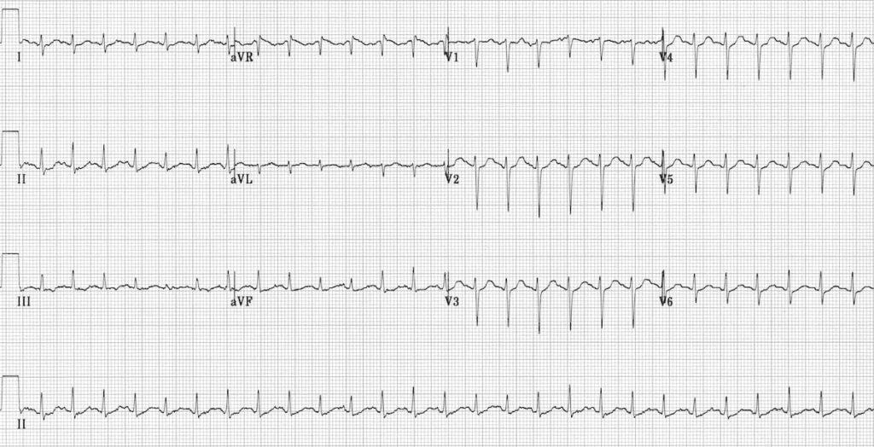

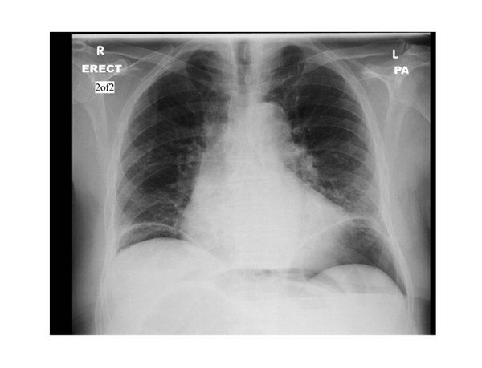

SP Case Notes
Kelly Farm – Advanced Directives

Patient Name and DOB | Kelly Farm is the 35 year old daughter of the medical pt Jake Farm aged 63
Opening Statement/  Chief Complaint | “My dad hasn’t been himself the last day, something is wrong”
“Tell Me More About It” | “He has been in the nursing home since his stroke, I visit him every day after work. Yesterday I went to see him and he was complaining of some stomach pains above his belly button and then I got a call from the nursing home today that he seemed confused. I told them to send him to the hospital and I would meet himhere. Hes normally so lively talking nonstop this just isn’t him. He looks like he is in pain.”
Demeanor/ Physicality | Worried, nervous, anxious, pacing
History of Present Illness | Your father suffered a severe stroke one year ago which cause right sided weakness and caused him to go into a nursing home. He has had such a positive outlook on everything and makes the most of every day. You visit him everyday, having dinner, watching tv, playing games. On and off the last few days he had seemed uncomfortable after dinner but he never complains so you let it be. Yesterday he started complaining of the pain and you got worried but the nurses assured you everything was ok. Dad didn’t eat his whole dinner which worried you as well but he had no fevers no nausea or vomiting. Today while getting ready to go to work you received a call from the NH that your dad was more sleepy that usual and seemed confused and had been vomiting. You asked to speak to him and he sounded unwell and you asked thqt they send him to the hospital
Past Medical Hx | Stroke last year- residual right sided weakness  Dementia: diagnosed four years ago, baseline ao2, conversant pleasant  High blood pressure: diagnosed 20 years ago  High cholesterol: diagnosed 20 yaers ago  Diabetes: Diagnosed 10 years ago
Past Surgical Hx | None
Allergies | none
Medications | Metoprolol 25mg (blood pressure) in AM, PM  Aspirin 81mg (stroke prevention) in AM  Plavix75mg (stroke prevention) in AM  atorvastatin (cholesterol)in AM  metformin (diabetes)in AM
Over the Counter/ Vitamins & Supplements | multivitamin
Social Hx | Smoking:10 pack year smoking history  Alcohol:socially
Family Medical Hx | Parents: blood pressure (dad), diabetes(mom), heart disease(dad)  Siblings: blood pressure (brother)  Children:
ROS/Physical Findings
Props/ Moulage | SP should have hand written med list,
SP Special instructions | You are very involved in your fathers care and you visit him every day at the nursing home. You consider yourself his sole caretaker – your mother passed away some time ago and your brother lives farther away and has less flexibility in his job and doesn’t come visit as much. You resent your brother and are angry that he isn’t as involved. You see yourself as the medical decision maker BUT THERE IS NO HEALTH CARE PROXY FORM SIGNED (which means any advanced care directives would need to be agreed upon by you and your sibling)  You will want everything to be done for your dad, he has been so strong since his stroke and you think he can survive anything. You will be the primary history provider as your dad is confused and will be unable to speak for himself.  If asked specific questions about your dads functional status: he is normally conversant, happy, but needs assistance with bathing, dressing, eating, preparing food and most other activities of daily living.  You will be very concerned and frantic about your dad and what to know whats wrong with him and know what needs to be done to make him better. YOU WILL NOT MENTION YOUR BROTHER UNLESS SPECIFICALLY ASKED  “what is wrong with my dad?”  “please do everything to help him”  “he is so strong, he has overcome so much already, you have to do whatever needs to be done”  At some point in the case your brother will show up and he will not want invasive measures performed on your dad. At first you will be angry with him “you never cared about dad now you just want to let him die”He is coming from a good place of not wanting dad to suffer and you will soften if he is given an opportunity to explain himself. “Dad never wantd to be dependent on machines to live” you will come together and start asking thoughtful questions about how likely it is that dad would be reliant on machines if invasive measures were done. “how likely is he to survive with vs without these interventions” and eventually you will agree together to proceed with central line/intubation/surgery

SP Case Notes
Brandon Farm – Advanced Directives

Patient Name and DOB | Brandon Farm is the 31 year old son of the medical pt Jake Farm aged 63
Opening Statement/  Chief Complaint | “n/a”
“Tell Me More About It” | n/a
Demeanor/ Physicality | Frustrated, logical, realistic,
History of Present Illness
Past Medical Hx | Stroke last year- residual right sided weakness  Dementia: diagnosed four years ago, baseline ao2, conversant pleasant  High blood pressure: diagnosed 20 years ago  High cholesterol: diagnosed 20 yaers ago  Diabetes: Diagnosed 10 years ago
Past Surgical Hx | None
Allergies | none
Medications | Metoprolol 25mg (blood pressure) in AM, PM  Aspirin 81mg (stroke prevention) in AM  Plavix75mg (stroke prevention) in AM  atorvastatin (cholesterol)in AM  metformin (diabetes)in AM
Over the Counter/ Vitamins & Supplements | multivitamin
Social Hx | Smoking:10 pack year smoking history  Alcohol:socially
Family Medical Hx | Parents: blood pressure (dad), diabetes(mom), heart disease(dad)  Siblings: blood pressure (brother)  Children:
ROS/Physical Findings
Props/ Moulage | SP should have hand written med list,
SP Special instructions | You will arrive partway through the case. Either you will show up shortly after the team asks about additional family and your sister mentions you, or just as the team is setting up for an invasive procedure (central line or intubation)  If you arrive as team is preparing for invasive measures you will be more angry than if your sister mentions you.  “Heywhaty are you doing to my dad. Stop”  As your sister yells at you you will remain calmer and not rise to her level—you will stop her and want to understand firt what is going on with your dad and understand what would happen to him without invasive measures vs with them because your dad had relayed to you that he would not want to be reliant on machines for the rest of his life and you are worried that if you proceed with invasive measures that would be the outcome.  “what are the chances he could come off the breathing machine”  “how likely is he to survive if we don’t do these things”  eventually you will agree together to proceed with central line/intubation/surgery IF AND ONLY IF the team is able to calm your sister down and lead a thoughtful and clear family meeting in the moment

Section 1: Case Summary

Scenario Title: | Necrotizing Pancratitis- Pain Management
Keywords: | Palliative care, pain management, pancreatitis, abdominal compartment syndrome, ARDS
Brief Description of Case: | 60 yo F w/ PMH ETOH abuse, alcoholic cirrhosis, HTN, DM here for 2 days of severe diffuse abdominal pain, nausea/vomiting, and generalized weakness. Pt develops necrotizing pancreatitis, becomes hypotensive despite fluids resuscitation. Pt also develops ARDS as well as abdominal compartment syndrome.

Goals and Objectives
Educational Goal:
Objectives:  (Medical and CRM) | - Identify pancreatitis and its various etiologies  - Appropriately resuscitate patients  - Recognize signs and symptoms of abdominal compartment syndrome  - Provide appropriate and adequate pain management
EPAs Assessed:

Learners, Setting and Personnel
Target Learners: | ☒ Junior Learners |  | ☒ Senior Learners |  | ☐ Staff
Target Learners: | ☐ Physicians | ☐ Nurses |  | ☐ RTs | ☐ Inter-professional
Target Learners: | ☐ Other Learners:
Location: | ☒ Sim Lab |  | ☐ In Situ |  | ☐ Other:
Recommended Number of Facilitators: | Instructors: 2
Recommended Number of Facilitators: | Sim Actors:2
Recommended Number of Facilitators: | Sim Techs: 1

Section 2A: Initial Patient Information

- Patient Chart
Patient Name: Geraldina Ramos |  |  |  | Age: 60 | Gender: F | Weight: 75kg
Presenting complaint: Weakness, abdominal pain, nausea/vomiting
Temp: 99.9F | HR: 120 | BP: 148/90 |  | RR: 20 | O₂Sat: 95% | FiO₂:RA
Cap glucose: 130 |  |  |  | GCS: (E V M ) 15
Sign out
60 yo F w/ PMH EtOH abuse (last drink 4 hours ago), cirrhosis, HCC, DM, HTN and no PSH came to ED about 6 or so hours ago for 2 days of severe abdominal pain, nausea/vomiting (NBNB). not relieved with home pain medications . Lipase is very elevated. Has received 3L IVF so far and morphine 4 mg IV x 2 with improvement in pain. Just received CT scan. Follow up the read. She looks fine, maybe a little tachy, but could probably go to floors. I would keep going giving her more fluids. Her LV function looks fine. If she does get worse, may need CCM consult for dispo.

Allergies: Ibuprofen
Past Medical History:  ETOH abuse HCC  Cirrhosis  DM  HTN  pancreatitis |  |  | Current Medications:  Losartan 100 mg  Metformin 1000 mg BID  morphine ER 90mg BID

Section 2B: Extra Patient Information

A. Further History
Include any relevant history not included in triage note above. What information will only be given to learners if they ask? Who will provide this information (mannequin’s voice, sim actors, SP, etc.)?

SP at bedside as history giver and advocate.
B. Physical Exam
List any pertinent positive and negative findings
Cardio: Tachycardic, regular rhythm. No M/R/G. | Neuro: A+Ox3, follows commands, grossly non-focal
Resp: bilateral breath sounds; slightly diminished at bases | Head & Neck: supple, no tenderness
Abdo: Very firm, diffusely tender especially over epigastric region. No rebound, guarding. No CVAT. | MSK/skin: no rash, purpura, or ecchymosis  2+ BUE and BLE pitting edema
Other:

Section 3: Technical Requirements/Room Vision

A. Patient
☒ Mannequin (specify type and whether infant/child/adult): adult
☐ Standardized Patient
☐ Task Trainer
☐ Hybrid
B. Special Equipment Required
Intubation equipment, ventilator

C. Required Medications
RSI medications, vasopressors, ACLS drugs

D. Moulage
None

E. Monitors at Case Onset
☐ Patient on monitor with vitals displayed
☒ Patient not yet on monitor
F. Patient Reactions and Exam
Include any relevant physical exam findings that require mannequin programming or cues from patient
(e.g. – abnormal breath sounds, moaning when RUQ palpated, etc.) May be helpful to frame in ABCDE format.

Airway – protecting airway
Breathing – bilateral breath sounds 🡪 eventually develops crackles
Circulation – tachycardic🡪 worsens and becomes hypotensive
Disability – initially A+Ox3 🡪 becomes altered
Exposure – no ecchymoses or signs of trauma

Section 4: Sim Actor and Standardized Patients

Sim Actor and Standardized Patient Roles and Scripts
Role | Description of role, expected behavior, and key moments to intervene/prompt learners. Include any script required (including conveying patient information if patient is unable)
Family member:  Son | Son will call for an update. ***Entire conversation will occur via phone***  “What is going on with my mother?”  “Why is surgery going to see her?”  If intubation or GOC are brought up:  “I don’t think she would want that! She said she would rather die than be placed on a machine. But I’m not sure what to do.”  “Will she ever come off the vent?”  “Being able to spend time with her family and friends was super important for her. She loved to sing and dance bachata. If she couldn’t do those things, I don’t think she would feel like life is worth living.”  If no GOC discussion held:  Son will be upset. Crying, begging to be allowed in. He will ask questions about details of her care, prognosis, treatment, etc.

Section 5: Scenario Progression

Scenario States, Modifiers and Triggers
Patient State/Vitals | Patient Status | Learner Actions, Modifiers & Triggers to Move to Next State |  | Facilitator Notes
1. Baseline State  Rhythm: sinus tachycardia  HR: 120  BP: 148/90  RR: 22  O₂SAT:98 %  T: 37ºC  GCS: 15 | Uncomfortable, complaining of persistent abdominal pain and nausea | Expected Learner Actions  ☐ Give additional analgesics and antiemetics  ☐ Give additional IVF  ☐ Repeat abdominal exam  ☐ Consult general surgery  ☐ Start heparin gtt  ☐  ☐ | Modifiers  Changes to patient condition based on learner action  -  -  Triggers  For progression to next state  - RN will say warn team that pt made 150 cc’s of urine  - Radiology will call for prelim read of CT scan | Radiology will call and report necrotizing pancreatitis and SMV occlusive thrombus.  General surgery will evaluate patient and say not concerned for abdominal compartment syndrome. Does say to board pt to SICU, but no beds available.
2.  Rhythm: sinus tachycardia  HR: 145  BP: 150/94  RR:35  O₂SAT: 92%  T: 37ºC  GCS: 15 | Complaining of worsening shortness of breath and worsening abdominal pain and distension | Expected Learner Actions  ☐ Obtain repeat CXR, consider intubation  ☐ Place supplemental O2  ☐ Pain management  ☐ Update general surgery consult  ☐ Discuss GOC with patient and son | Modifiers  - If gives more IVF, pt will become more tachypneic and hypoxic  -  -  Triggers  - RN will be concerned about worsening abdominal distension  - Son will call and demand an update* see script above
3.  Rhythm: sinus tachycardia  HR: 162  BP: 88/62  RR: 42  O₂SAT: 82 %  T: 37ºC  GCS: 11 (E3V3M5) | Mental status worsens and more tachypneic.  Abdominal distension significantly worse. | Expected Learner Actions  ☐ Start vasopressors  ☐ Intubate patient  ☐ Adjust vent settings for ARDS  ☐ Start appropriate sedation after intubation  ☐ Call general surgery stat to update them if not already done  ☐ Obtain CCM consult for dispo | Modifiers  - If pt is intubated prior to starting pressors, pt will code  Triggers  - After intubation, surgery will come back to check on patient.  - *If time allows, if pt not adequately sedated, pt will buck the vent, become more hypotensive and code. | General surgery will eventually return and perform bedside ex-lap on pt. BP will improve and pressor requirement will decrease. Case will end after ex-lap.

Appendix A: Laboratory Results

**See attached images below for pertinent labs.

CBC  WBC  Hgb  Plt  Lytes  Na  K  Cl  HCO₃  AG  Urea  Cr  Glucose  Extended Lytes  Ca  Mg  PO₄  Albumin  TSH  VBG  pH  pCO₂  pO₂  HCO₃  Lactate | Cardiac/Coags  Trop  D-dimer  INR  aPTT  Biliary  AST  ALT  GGT  ALP  Bili  Lipase  Tox  EtOH  ASA  Tylenol  Dig level  Osmols  Other  B-HCG

Appendix B: ECGs, X-rays, Ultrasounds and Pictures

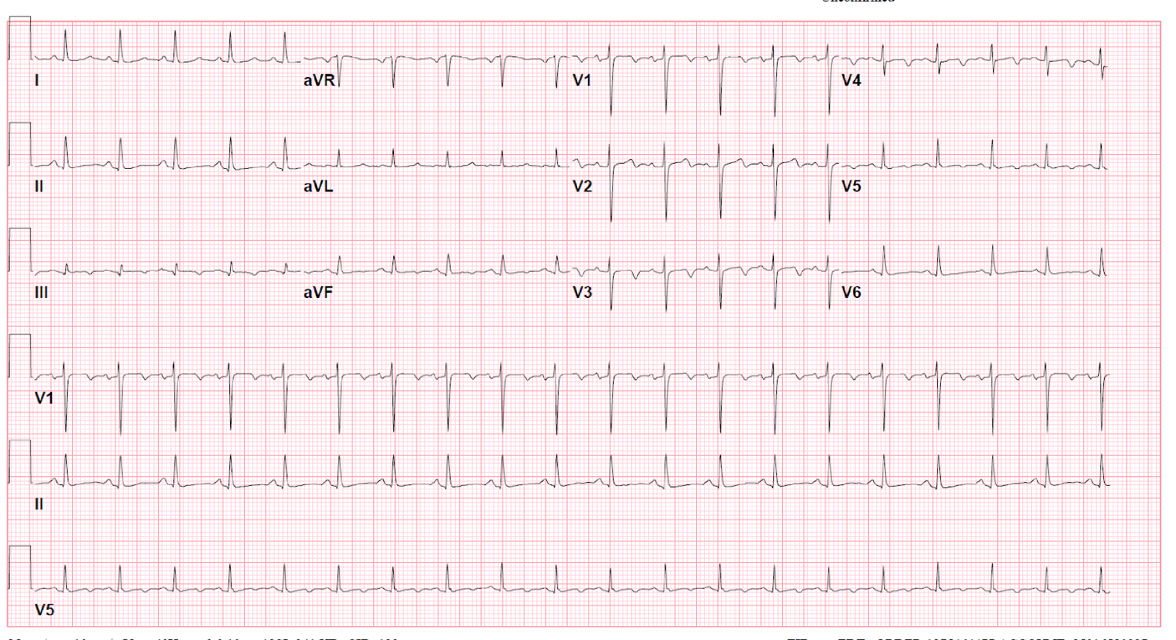

FIRST CXR

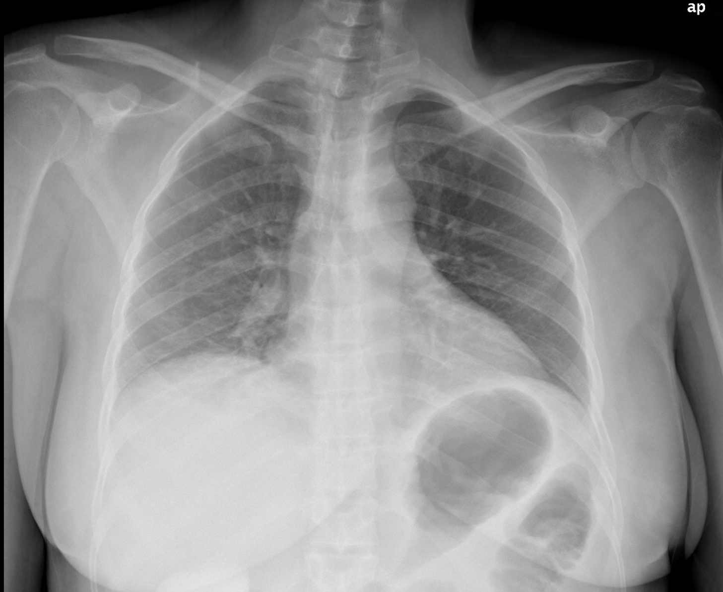

SECOND CXR
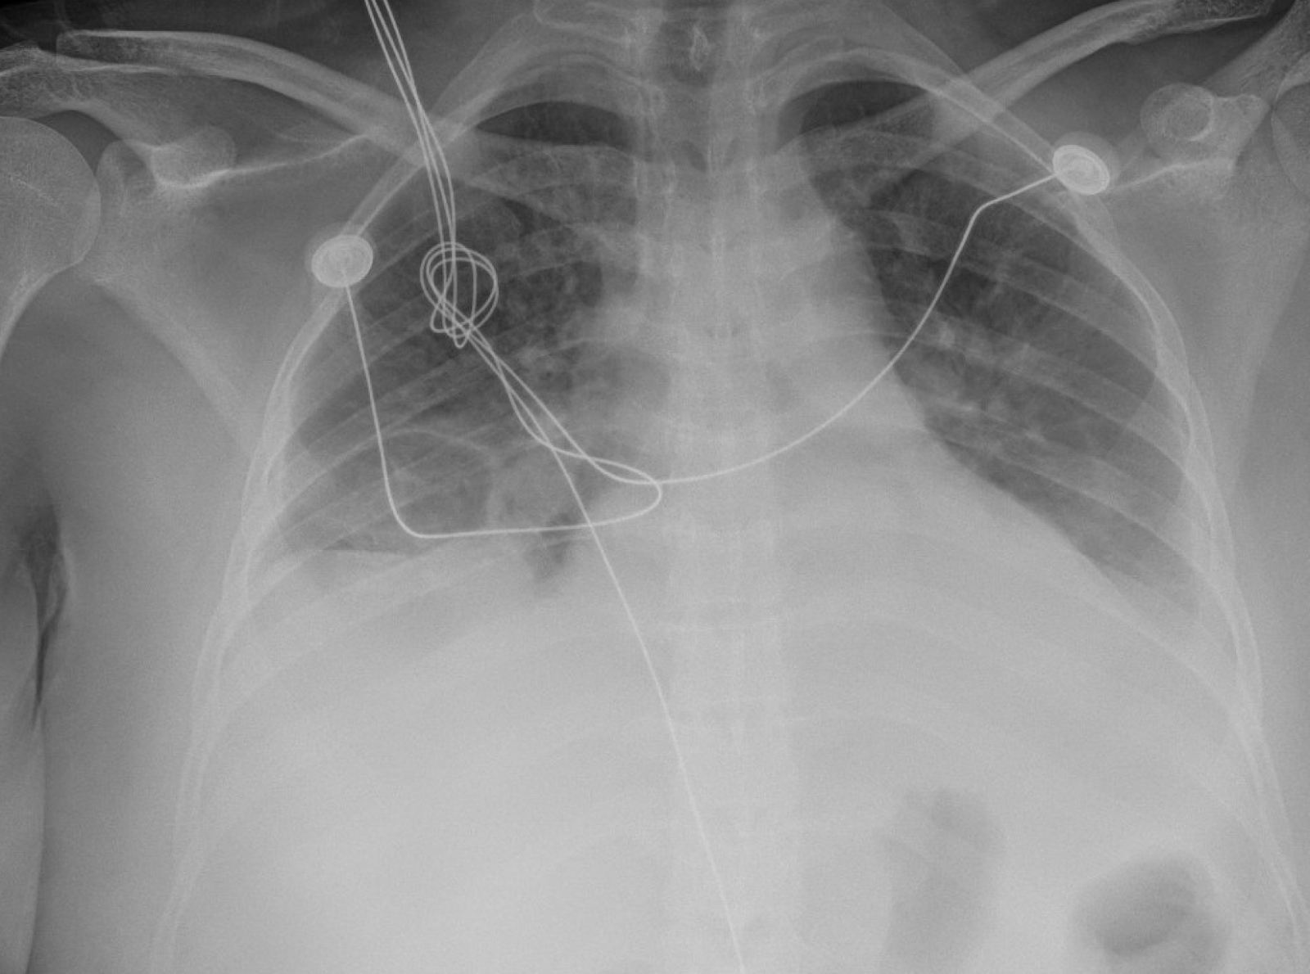

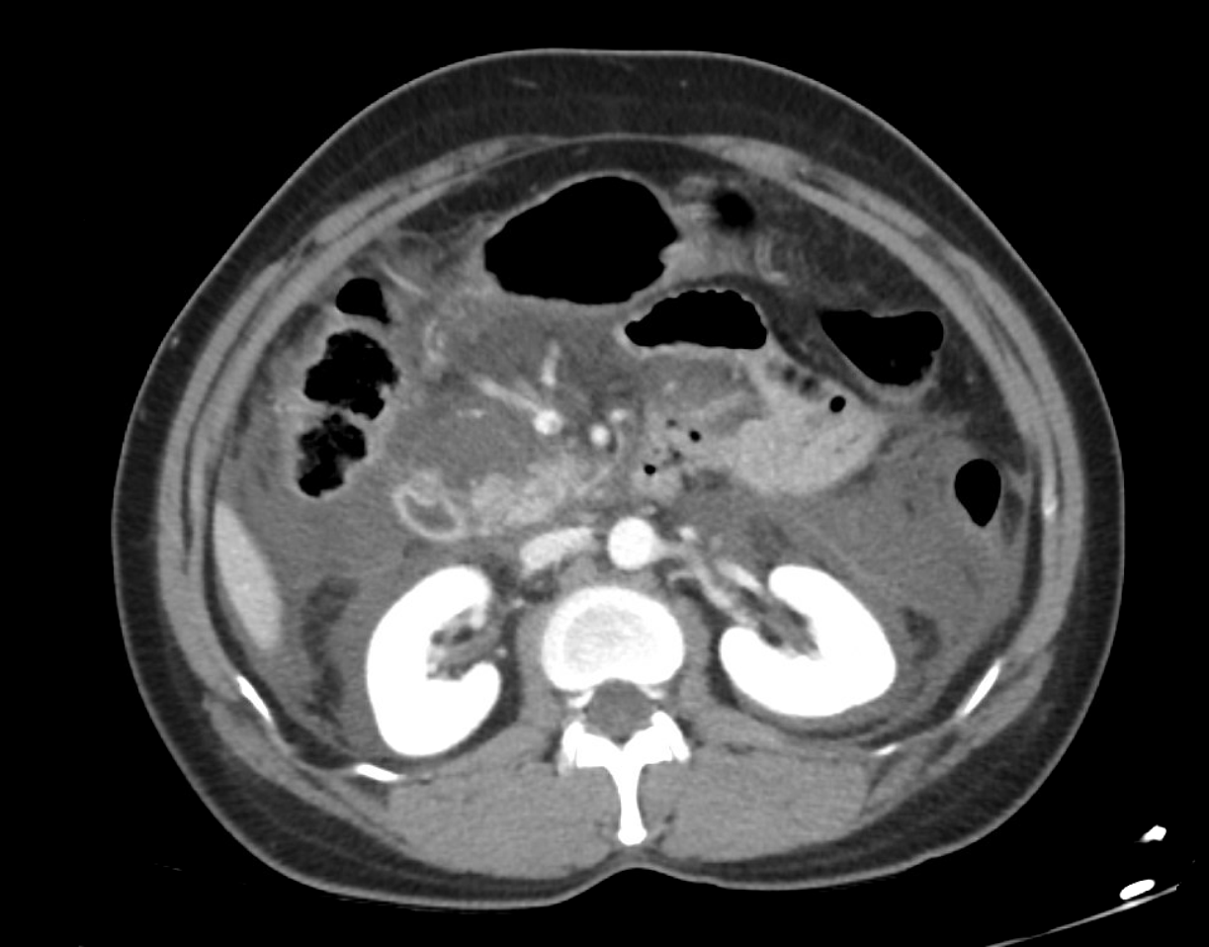
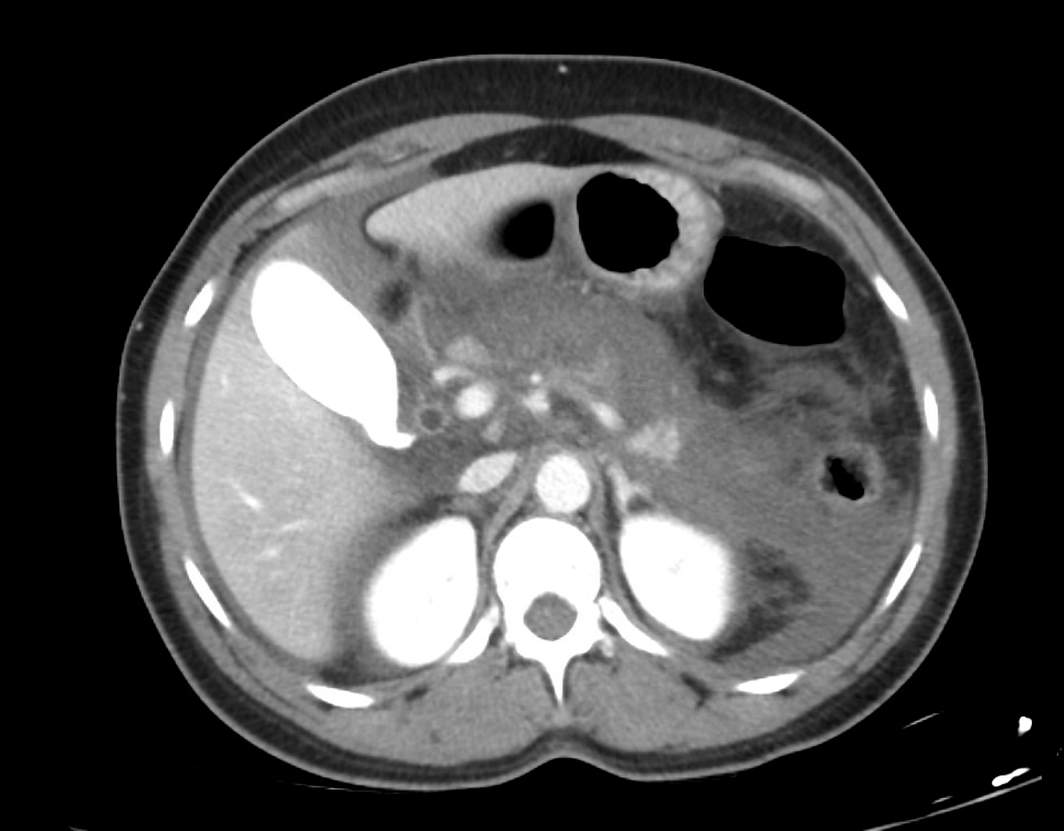
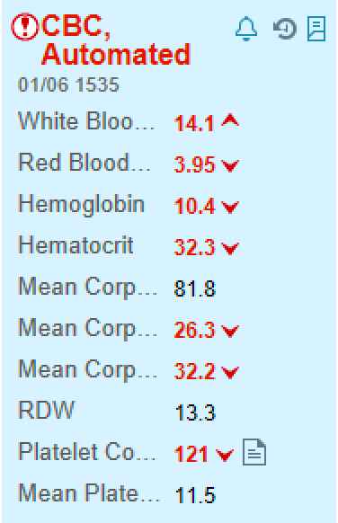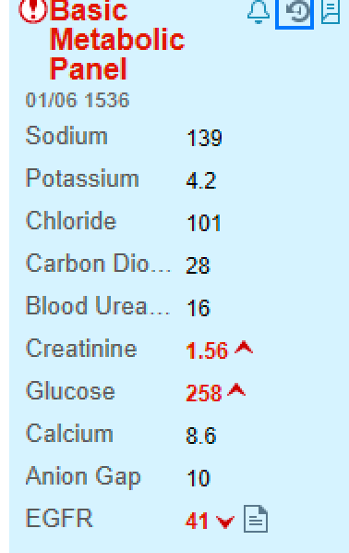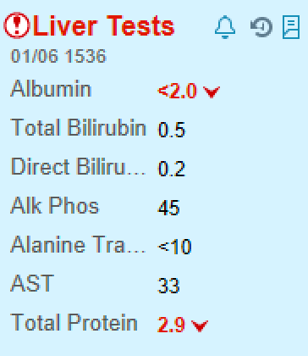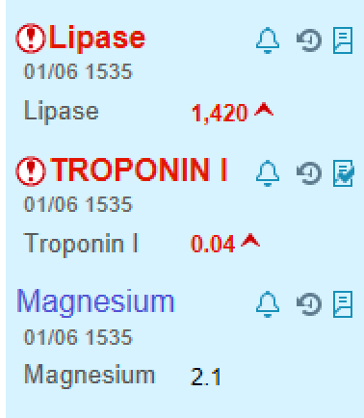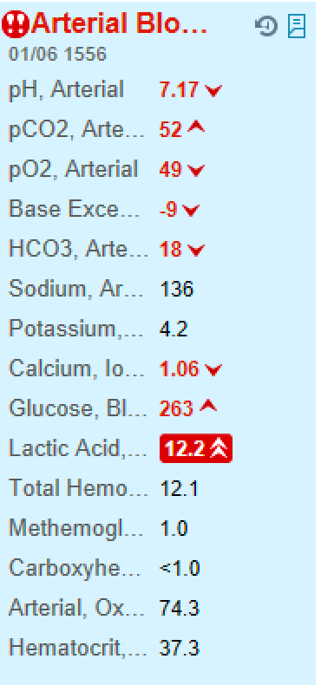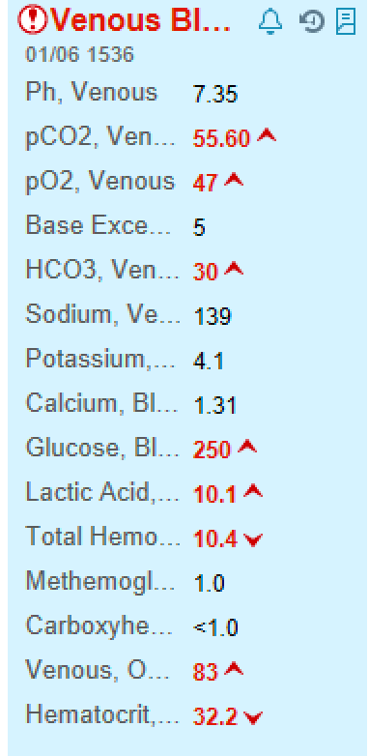

SP Case
Pain management

Patient Name and DOB | Daniel Ramos is the 32 year old son of 60 year old patient Geraldina Ramos 4/24/63
Opening Statement/  Chief Complaint | “I'm here because I was told my mother is very sick and I want to make sure her pain is taken seriously.
“Tell Me More About It” | “I know my mom has a drinking problem and it’s made her liver sick and now she has cancer. But she’s a really sweet lady who minimizes her pain so I have to advocate for her”
Demeanor/ Physicality | anxious , frustrated but redirectable
History of Present Illness | Your mother has been in and out of the hospital for the last few weeks. She was diagnosed with liver cancer with bone metastasis several months ago. She takes a lot of opiates at home for pain control. She still struggles with her drinking sometimes. She had a few drinks yesterday when the pain became overwhelming and began vomiting more and complaining of worsening abdominal pain overnight. You called the ambulance and came right away
Past Medical Hx | Alcohol abuse  Cirrhosis with progression to hepatocellular carcinoma with bone metastasis  Recurrent pancreatitis  High blood pressure  Diabetes
Past Surgical Hx | None
Allergies | none
Medications | Losartan 100 mg daily (for blood pressure)  Metformin 1000 mg BID (for diabetes)  Morphine 90mg BID (for cancer pain)
Over the Counter/ Vitamins & Supplements | None
Social Hx | Smoking: never  Alcohol: almost daily drinker
Family Medical Hx | Parents: blood pressure (dad), diabetes(mom), heart disease(dad)  Siblings: blood pressure (brother)  Children:
ROS/Physical Findings
Props/ Moulage | SP should have hand written med list,
SP Special instructions | You are at the patient’s bedside upset. You have not yet received an update from the medical team and your mom’s pain is getting worse. If the team does not update you, then ask for one. Be sharp but not aggressive. You will be very upset at your mother’s pain not being addressed and irritated that you don’t know her disposition (admit versus discharge).  You don’t understand why she needs to see the surgeons or critical care teams. She has had pancreatitis many times and she has never been this sick. You make note that her stomach is much more distended than it was when you came in.  You become very concerned as her pain worsens and seems to have trouble breathing. You never explicitly discussed her advanced directives but you’ve heard her say that she would rather die than be placed on a machine. “Being able to spend time with her family and friends was super important for her. She loved to sing and dance bachata. If she couldn’t do those things, I don’t think she would feel like life is worth living. But I don’t know. We thought she had more time so we never talked seriously about this”  You will watch in horror as you see her pain and vital signs worsen. You are worried about the level of pain that she is in and if she will make it through this illness. You should become panicked when they make mention that she may need to be intubated. If you are not addressed and no goals of care discussion is had, you should become angry and demand to be spoken with.  After the intubation, you are very concerned about her prognosis, next steps of her care, and her level of suffering. You are worried that intubation may not have been the right choice for her. You make note of her abdominal distension and also her grimacing in pain.
Door Chart | PATIENT NAME: Geraldina Ramos  DOB: 4/24/63  Rhythm: sinus tach  HR: 120  BP: 148/90  RR: 20  O₂SAT: 95 %  T: 99.9ºF  GCS: 15  60 yo F w/ PMH EtOH abuse (last drink 4 hours ago), cirrhosis, c/b HCC w/ mets to bone, DM, HTN and no PSH came to ED about 6 or so hours ago for 2 days of severe abdominal pain, nausea/vomiting (NBNB). Lipase is very elevated. Has received 3L IVF so far and morphine 4 mg IV x 2 with improvement in pain. Just received CT scan. Follow up the read. She looks fine, maybe a little tachy, but could probably go to floors. I would keep going giving her more fluids. Her LV function looks fine. If she does get worse, may need CCM consult for dispo.  You are to:  - Stabilize the patient  - Discuss goals of care with the son

Section 1: Case Summary

Scenario Title: | Uncontrolled Cancer Pain/ Hospice Care
Keywords: | Oncology, pain management, chronic pain, fall, hospice
Brief Description of Case: | 55-year-old female with a history of active breast cancer with bone mets, nephrolithiasis. Her breast cancer and metastases have been progressively worsening despite treatment, and she recently moved to hospice where she is on regular PRN opioid pain control. Pt is very short of breath and cannot provide much additional history. Hospice staff note she had a mechanical witnessed fall two days ago and has been experiencing worsening right sided chest and flank pain and shortness of breath since. Her usual PRN oral opiate regimen as well as ibuprofen have not provided her relief.

Goals and Objectives
Educational Goal: | Diagnose life-threatening intrathoracic pathology, treat pain effectively, GOC discussions
Objectives:  (Medical and CRM) | - Create wide differential diagnosis in acute flank, chest pain, shortness of breath  - Select medication class that matches a patient’s pain type and pattern  - Recognize potential adverse effects of opioid therapy  - Effectively communicate with family member of an incapacitated patient in order to ascertain medical hx, allergies, and code status  - Discuss goals of care, consent, risks and benefits of emergent treatment and procedures
EPAs Assessed:

Learners, Setting and Personnel
Target Learners: | ☒ Junior Learners |  | ☒ Senior Learners |  | ☐ Staff
Target Learners: | ☐ Physicians | ☐ Nurses |  | ☐ RTs | ☐ Inter-professional
Target Learners: | ☐ Other Learners:
Location: | ☒ Sim Lab |  | ☐ In Situ |  | ☐ Other:
Recommended Number of Facilitators: | Instructors: 2
Recommended Number of Facilitators: | Sim Actors: 1
Recommended Number of Facilitators: | Sim Techs: 1

Section 2A: Initial Patient Information

- Patient Chart
Patient Name: Melissa Wilson |  |  |  | Age: 55 | Gender: F | Weight: 75 kg
Presenting complaint: flank pain, shortness of breath
Temp: 98.3 | HR: 108 | BP: 105/60 |  | RR: 26 | O₂Sat: 92% | FiO₂:RA
Cap glucose: 92 |  |  |  | GCS: (E V M ) 15
Triage note:

55 y/o F with breast cancer presenting from hospice with sob, flank pain

Allergies: None
Past Medical History:  - Breast cancer s/p chemotherapy  - Nephrolithiasis |  |  | Current Medications:  - Oxycodone-acetaminophen 2 tablets (5-325) PRN every 6 hours  - Ibuprofen 400 mg every 8 hours  - Docusate, senna

Section 2B: Extra Patient Information

A. Further History
Include any relevant history not included in triage note above. What information will only be given to learners if they ask? Who will provide this information (mannequin’s voice, sim actors, SP, etc.)?

55 year-old Female presenting from hospice with one day of worsening right-sided chest and flank pain associated with worsening shortness of breath. She experienced a mechanical trip and fall yesterday without LOC or head strike, witnessed by hospice staff with immediate return to baseline and no change in mental status. Patient has been taking her PRN percoset and ibuprofen with only minimal relief of her symptoms. Her husband noted worsening symptoms and when she was unable to speak in complete sentences they made the decision to come to the ED. The patient is able to shake her head yes or no to questions but can only provide one-word responses intermittently, and her husband provides additional history. She points to her right flank and chest when asked about pain and endorses shortness of breath. They deny fever/chills, other chest pain, abdominal pain, nausea or vomiting, change to bowel habits, urinary symptoms, or confusion.

B. Physical Exam
List any pertinent positive and negative findings
Gen: female who appears older than stated age in moderate distress, grimacing, and uncomfortable
Cardio: Tachycardic, regular, no M/R/G | Neuro: Non-focal, A+Ox3
Resp: diminished breath sounds R mid to lower chest anteriorly and posteriorly, tachypneic | Head & Neck: supple, no tenderness
Abd: soft, non-tender, non-distended. No CVA tenderness | MSK/skin: ecchymosis to R flank

Section 3: Technical Requirements/Room Vision

A. Patient
☒ Mannequin (specify type and whether infant/child/adult): adult
☐ Standardized Patient
☐ Task Trainer
☐ Hybrid
B. Special Equipment Required
- Chest tube kit
- Ultrasound

C. Required Medications
- Lidocaine
- IV fentanyl, morphine, ketamine

D. Moulage
N/a

E. Monitors at Case Onset
☐ Patient on monitor with vitals displayed
☒ Patient not yet on monitor
F. Patient Reactions and Exam
Include any relevant physical exam findings that require mannequin programming or cues from patient
(e.g. – abnormal breath sounds, moaning when RUQ palpated, etc.)

A – patient speaking with one-word responses
B – diminished breath sounds R mid and lower fields
C – slightly tachycardic, no m/r/g
D – AEx4, GCS 15
E – ecchymosis and tenderness to R chest and flank, no spinal tenderness or step-offs, no other obvious injuries

Section 4: Sim Actor and Standardized Patients

Sim Actor and Standardized Patient Roles and Scripts
Role | Description of role, expected behavior, and key moments to intervene/prompt learners. Include any script required (including conveying patient information if patient is unable)
Pt’s husband | The patient will be too uncomfortable and tachypneic, and she will convey that she wants decisions to be made by her husband. Husband (Mr Wilson) will be stressed and emotional, as pt recently placed in hospice and she is in significant pain after the fall.  - Must ask learners about options for pain medication  - Prompt learners to provide basic explanation of hemothorax  - Prompt learners to discuss chest tube placement if they do not prompt, risks and benefits  - Prompt discussion of DNR/DNI status - pt is in hospice and DNR but husband can be hesitant regarding DNI if she worsens

Section 5: Scenario Progression

Scenario States, Modifiers and Triggers
Patient State/Vitals | Patient Status | Learner Actions, Modifiers & Triggers to Move to Next State |  | Facilitator Notes
1. Baseline State  Rhythm: sinus tach  HR: 105  BP: 105/60  RR: 26  O₂SAT: 92 %  T: 36.8 ºC  GCS: 15 | Uncomfortable, moaning and intermittently groaning, alert and speaking only intermittently | Expected Learner Actions  ☐ IV/monitor  ☐ history from patient  ☐ history from husband  ☐ perform primary survey and physical exam  ☐ O2 via NC  ☐ may try to give pain medications  ☐ perform FAST or RUSH exam  ☐ portable CXR | Modifiers  Changes to patient condition based on learner action  - pt will vomit if PO medications given  Triggers  For progression to next state  - FAST (+) or cxr showing hemothorax  - | FAST/RUSH exam will show hemothorax R sided. Patient cannot tolerate anything PO and will vomit if given any tablet.
2.  Rhythm: sinus tach  HR: 115  BP: 93/55  RR: 22  O₂SAT: 98 % (on NC)  T: 37ºC  GCS: 14 | Will appear weak and close her eyes | Expected Learner Actions  ☐ 2nd IV if not already established  ☐ start IVF bolus  ☐ transfuse at least 1 U uncrossed PRBC via rapid transfuser (ask pt’s husband about giving blood before)  ☐ ensure 2nd type and screen is sent and order more blood | Modifiers  - if 2nd type and screen not sent, blood bank will not release blood products  - BP will drop, HR elevate, pt will become more somnolent if no RBC given  Triggers  - blood pressure, HR will improve after blood transfusion | Husband should ask why patient begins looking worse, more unstable vitals
3.  Rhythm: sinus  HR: 95  BP: 110/60  RR: 20  O₂SAT: 98 %  T: 37ºC  GCS: 15 | Patient will still complain of pain | Expected Learner Actions  ☐ give pain meds (IV fentanyl, ketamine)  ☐ set up for chest tube (kit, pleur-evac, lido, scalpel, tube, sterile gown, drapes, gloves, etc., see below)  ☐ perform chest tube  ☐ call for CXR to confirm  ☐ discuss with trauma surgery, oncology for dispo  ☐ | Modifiers  - after discussion, husband and pt will be amenable to chest tube placement  - if lido not given pre chest tube, pt will yell in pain  Triggers  - Successful placement of chest tube  - Discussion of dispo with consults | Discuss chest tube placement with pt’s husband - discuss risks and benefits, pt’s wishes

Appendix A: Laboratory Results

CBC  WBC 15  Hgb 7.0 (11 from 5 days ago)  Plt 225  Lytes  Na 145  K 3.9  Cl 110  HCO₃ 18  AG 12  Urea 20  Cr 0.8  Glucose 110  Extended Lytes  Ca 9  Mg 1.7  PO₄ 3  Albumin 3.2  TSH wnl  VBG  pH 7.40  pCO₂ 42  pO₂ 40  HCO₃ 20  Lactate 2.5 | Cardiac/Coags  Trop wnl  D-dimer elevated  INR wnl  aPTT wnl  Biliary  AST wnl  ALT wnl  GGT wnl  ALP wnl  Bili wnl  Lipase wnl  Tox  EtOH wnl  ASA wnl  Tylenol wnl  Dig level wnl  Osmols wnl  Other  B-HCG neg

Appendix B: ECGs, X-rays, Ultrasounds and Pictures

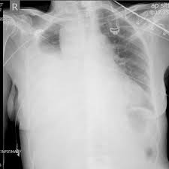

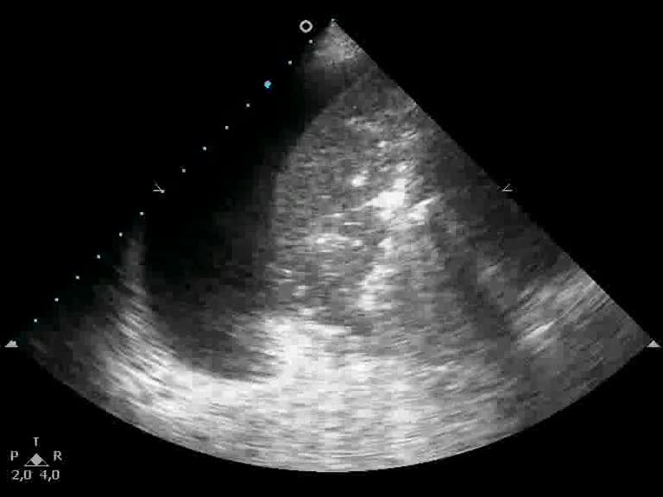

RUQ Ultrasound

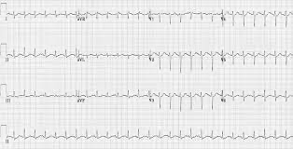

SP Script
Hospice Case

Patient Name and DOB | Benjamin Wilson is the 58 year old husband of patient Melissa Wilson, age 55
Opening Statement/  Chief Complaint | “My chest hurts and I can’t breathe”
“Tell Me More About It” | The patient is too short of breath and in too much discomfort to be able to answer. She defers history to you, her husband, as she is only able to shake her head yes or no to questions.  “My wife has been in hospice care for the past few weeks as her breast cancer has become advanced and not treatable, but has been stable for the past couple weeks. She tripped getting out of bed yesterday and fell to the ground but afterward seemed to be back to her baseline. She’s been taking her regular pain medications but today she couldn’t breathe and was in so much distress I couldn’t bear to see her continue to suffer and we had to come to the ER”
Demeanor/ Physicality | Worried, nervous, anxious
History of Present Illness | As mentioned, your wife has been in hospice for the past few weeks due to advanced breast cancer. She has been weak and tired but has been managing her pain well with her home Percoset and ibuprofen. Ms Wilson points to her right flank and chest when asked where the pain is. Besides the fall and worsening pain and shortness of breath today there have not been other falls, trauma, or other symptoms.
Past Medical Hx | Advanced metastatic breast cancer: diagnosed 3 months ago  Nephrolithiasis (kidney stone): many years ago
Past Surgical Hx | None
Allergies | none
Medications | Percoset (oxycodone-acetaminophen) 5-325mg, 2 tablets every 6 hours as needed (for pain)  Ibuprofen 600mg, every 6 hours as needed (for pain)  Docusate, senna daily (for constipation)
Over the Counter/ Vitamins & Supplements | None
Social Hx | Smoking: distant history, none in past 30 years  Alcohol: none
Family Medical Hx | Parents: blood pressure (father), breast cancer (mother and grandmother), heart disease (father)  Siblings: none  Children: none
ROS/Physical Findings | No fevers, vomiting, altered mental status, diarrhea, other traumatic injury, or new weakness  Female who appears older than stated age in distress, grimacing, uncomfortable, breathing quickly  Bruising to R flank and chest
Props/ Moulage | SP should have hand-written med list
SP Special instructions | You are very involved in your wife’s care and you have been staying with her in the hospice facility for the past couple weeks.  You both came to the difficult decision to place her in hospice recently but as her disease has now progressed rapidly and she has only been in hospice a couple weeks it has been difficult accepting that she will die soon.  You will be very concerned about pain control for your wife, and if none is provided you will become more distressed and insist on urgent treatment. You will ask which medications are being given  You have spoken extensively with your wife about her goals of care, and while she is DNR/DNI and under hospice care you are both amenable to treatment for situations like this, including a chest tube that would need to be placed emergently in this situation  Your main concern is reducing suffering and pain for your wife. You discuss with the ER doctors about the potential risks and benefits of placing a chest tube emergently. It is a difficult decision to make as they are often quite uncomfortable and requires a stay in the hospital (specifically the Surgical Intensive Care Unit) , but it will help her breathing and ultimately you will want to proceed with it.  You and the doctors discussed with Ms Wilson about the procedure, as she is in distress but still understands what is going on and can make a joint decision  “Please help her”  “What is going on? Why is she breathing so quickly?”  “What is a hemathorax? What will happen if it’s not treated?”  “Will the procedure cause her significant pain?”  “What does this mean in terms of staying in the hospital and her hospice care?”

Section 1: Case Summary

Scenario Title: | Pregnant Traumatic Arrest: Delivering Bad News
Keywords: | Obstetric Emergencies, Traumatic Arrest, Hemopneumothorax
Brief Description of Case: | 23F G1P0 @ 32 weeks pregnant brought in front triage by boyfriend for “not acting right.” Patient will be found to be altered with multiple signs of trauma all over body. Patient will initially be tachycardic, tachypneic, and hypotensive due to hemorrhagic shock. e-FAST will show a large left hemopneumothorax, and shortly afterwards patient will lose pulses. Team will start compressions (with lateral uterine displacement), and place a left sided chest tube. Patient will remain pulseless despite a chest tube and team will perform perimortem c-section. Patient will lose pulses again and will not be able to be resuscitated. Neonate will survive if resuscitated appropriately.  the ED team will break bad news to the boyfriend using SPIKES mnemonic. Further history taking will reflect patient fell down outside stairs while raining heavy

Goals and Objectives
Educational Goal: | Recognize and manage traumatic injuries in the obstetrics patient
Objectives: | - Create a wide differential diagnosis for traumatic injuries in obstetric patients  - Recognize signs and symptoms of hemothorax, and cardiac arrest  - Initiate appropriate trauma resuscitation in an obstetric patient  - Appropriately preform CPR in a pregnant patient, by laterally displacing the uterus during compressions  - Appropriately place chest tube in a pregnant patient  - Resuscitate a neonate  - Deliver bad news to family members using spikes/remap method

Learners, Setting and Personnel
Target Learners: | ☒ Junior Learners |  | ☒ Senior Learners |  |  | ☐ Staff
Target Learners: | ☐ Physicians | ☐ Nurses |  | ☐ RTs | ☐ Inter-professional
Target Learners: | ☐ Other Learners:
Location: | ☒ Sim Lab |  | ☐ In Situ |  |  | ☐ Other:
Recommended Number of Facilitators: | Instructors: 2
Recommended Number of Facilitators: | Sim Actors:2
Recommended Number of Facilitators: | Sim Techs: 1

Section 2A: Initial Patient Information

A. Patient Chart
Patient Name: Jeanine Marcus |  |  |  | Age: 23 | Gender: F | Weight: 70 kg
Presenting complaint: Confusion, SOB, Cough
Temp: 98.5 | HR: 126 | BP: 84/52 |  | RR: 24 | O₂Sat: 89% | FiO₂:RA
Cap gluco se: 98 |  |  |  | GCS: (E V M ) 2-3-4 = 9
Triage note:

23F G1P0 @ 32 weeks pregnant brought in front triage by boyfriend for “not acting right.” Bruising noted to face, made surgical notification on arrival.

Allergies: NKDA
Past Medical History:  - None |  |  | Current Medications:  - Pre-Natal Vitamins

Section 2B: Extra Patient Information

A. Further History
Include any relevant history not included in triage note above. What information will only be given to learners if they ask? Who will provide this information (mannequin’s voice, sim actors, SP, etc.)?

The patient will be brought in by the boyfriend. Ms. Marcus is an otherwise healthy 23 year old female, who is 38 weeks pregnant. The boyfriend brought the patient in this afternoon because he noticed that the patient wasn’t acting right. Upon being pressed further, he will relay that earlier this morning the patient fell down a flight of stairs. After falling, she was unresponsive. Boyfriend immediately decided to bring her to the hospital.

Boyfriend will be anxious, fearful when answering questions about events, though at the end of the case he will blame himself for the outcome as he was insisting they visit his elderly mother who lives in a dated building with a long set of stairs leading to the entrance. Patient/boyfriend live in a housing project in the Bronx wil large exterior stairs leading to the adjacent street. He will be

POBHx: G1P0, so far uncomplicated pregnancy, has had some prenatal care though has missed her last 2 visits.

B. Physical Exam
List any pertinent positive and negative findings
Cardio: Tachycardic, regular rhythm, no M/R/G | Neuro: Confused though able to state name, anisocoria, withdraws to pain, unable to follow commands
Resp: tachypneic, decreased breath sounds on the right, flail chest on the right | Head & Neck: Battle sign, peri-orbital ecchymosis, anisocoria, frontal contusion, abrasions over chin
Abdo: patch of ecchymosis over abdomen, firm, diffusely tender | MSK/skin: multiple ecchymotic lesions over trunk/extremities in various stages of healing
GU: No vaginal bleeding, no evidence of external trauma
Other: POCUS: L sided hemo-pneumothorax, + peritoneal free fluid, no pericardial effusion, +IUP with fetal movements, and fetal tachycardia

Section 3: Technical Requirements/Room Vision

A. Patient
☒ Mannequin (specify type and whether infant/child/adult) Adult Pregnant Mannequin, Infant Mannequin
☐ Standardized Patient
☐ Task Trainer
☐ Hybrid
B. Special Equipment Required
Chest tube/kit/chest wall model
Suction tubing and pleurevac
Intubation equipment

C. Required Medications
ACLS medications, RSI medications

D. Moulage
Bruising on mannequin
E. Monitors at Case Onset
☐ Patient on monitor with vitals displayed
☒ Patient not yet on monitor
F. Patient Reactions and Exam
Include any relevant physical exam findings that require mannequin programming or cues from patient
A – intact, protecting airway
B – decreased breath sounds in the left, tachypneic, hypoxic, trachea deviated to right
C – tachycardic, hypotensive,
D – Anisocoria, GCS 2E-3V-4M (9),
E – Multiple signs of trauma: L sided flail chest, bruising to face/trunk/extremities, abrasions to chin, no active bleeding

Section 4: Sim Actor and Standardized Patients

Sim Actor and Standardized Patient Roles and Scripts
Role | Description of role, expected behavior, and key moments to intervene/prompt learners. Include any script required (including conveying patient information if patient is unable)
Family member:  Boyfriend | Anxious, fearful, in distress. Earlier that day, boyfriend and patient were in an argument over his mother’s role in the child’s life. Mother was abusive to boyfriend, boyfriend wanted her involved regardless. Patient tired of the argument and decided to leave, she exited through the back of the building in a hurry. Weather was moderate rain, boyfriend was behind her yelling at her to come back. She slipped down the and fell down approx 12 steps, body stopped at a landing. Boyfriend will feel guilty, blame himself  - Will answer questions angrily  - Will be able to answer questions accurately, closely involved with pregnancy, went to every OB appointment  - Prototype type A, attempts to control everything only leading girlfriends death (motivation)

Section 5: Scenario Progression

Scenario States, Modifiers and Triggers
Patient State/Vitals | Patient Status | Learner Actions, Modifiers & Triggers to Move to Next State |  | Facilitator Notes
1. Baseline State  Rhythm: sinus tachycardia  HR: 126  BP: 84/52  RR: 30  O₂SAT:89 %  T: 98.5ºC  GCS: 9 | Thrashing around stretcher. Confused, tachypneic, hypoxic | Expected Learner Actions  ☐ Initiate Trauma resuscitation/Assess ABCs  ☐ Place on monitor  ☐ IV Access  ☐ Supplemental O2  ☐ e-FAST exam  ☐ Call for portable CXR  ☐ Transfuse Blood (MTP)  ☐ Analgesia  ☐ Perform needle thoracostomy  ☐ Set up and place chest right sided chest tube  ☐ Call trauma surgery  ☐ Call OB | Modifiers  Changes to patient condition based on learner action  - hypoxia will improve modestly with supplemental O2, chest tube placement  -Tachycardia will improve with transfusion, or chest tube placement  -hypotension will improve modestly with blood transfusion or chest tube  -  Triggers  For progression to next state  - Upon doing eFAST exam which shows the L sided hemothorax, and free fluid in abdomen the patient will become pulseless  - | eFAST will be positive for absent lung sliding on the left and fluid from hemothorax. eFAST will also be positive in RUQ.  OB and surgery will not come because they are busy on another case.
2.  Rhythm: PEA  HR: 0  BP: 0/0  RR: 0  O₂SAT: 70%  T: 37ºC  GCS: 3 | Patient goes into PEA arrest | Expected Learner Actions  ☐ Start ACLS  ☐ Intubate patient  ☐ Place chest tube  ☐ Perform perimortem c-section | Modifiers  - despite maximal therapy patient will not survive cardiac arrest. If the team starts perimortem within first few minutes of code neonate will survive  Triggers  -  - | If the fetus dies, the team will then have to deliver bad news to the baby’s father.
3. Rhythm: NSR  HR: 79  BP: 80/40  RR: 26  O₂SAT: 70%  T: 37ºC  GCS: 3  Neonate:  HR: 90  BP: 60/30  RR: 30  O2 SAT: 70% |  | ☐ Resuscitate neonate  ☐ Call peds and NICU  ☐ Deliver bad news to partner that mother and/or baby died  ☐ Call social work | Modifiers  - Neonate HR and sat will improve with PPV | Pregnant patient will not survive. Ideally, baby will survive.  Case will end when NICU and peds show up.

Appendix A: Laboratory Results

CBC  WBC 15  Hgb 7.3  Plt 150  Lytes  Na 146  K 3.8  Cl 110  HCO₃ 20  AG 16  Urea 32  Cr 1.2  Glucose 145  ABG  pH 7.44  pCO₂ 34  pO₂ 45  Lactate 1.9  COVID: Negative  Flu A: Negative  Flu B: Negative | Cardiac/Coags  Trop wnl  D-dimer 23  INR wnl  aPTT wnl  Biliary  AST 74  ALT 96  ALP 150  Bili 1.0  Lipase 34  Type and Screen  A+

Appendix B: ECGs, X-rays, Ultrasounds and Pictures

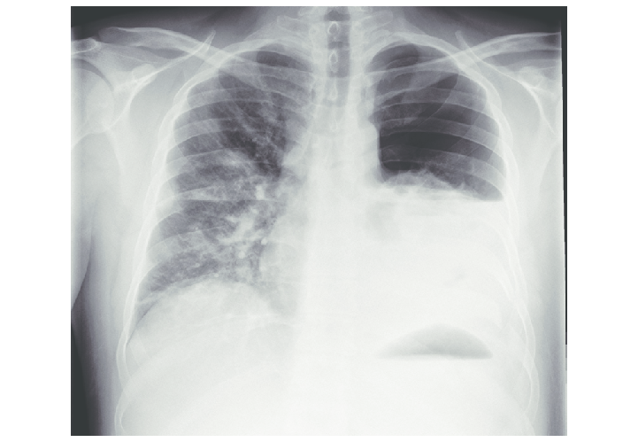

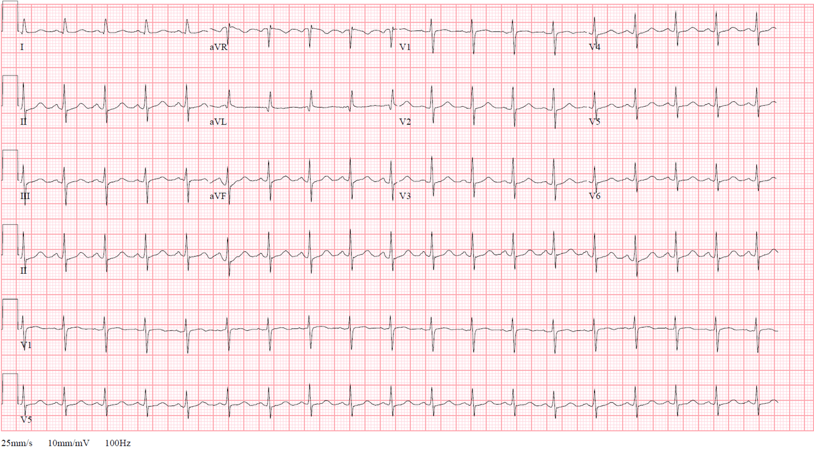

SP Case
Delivering Bad News
Patient Name and DOB | Patient is Maria Carmine, 23 yo F, SP will play roll of partner, Anthony Mondell, 25 yo M
Opening Statement/  Chief Complaint | “Help my fiance!”
“Tell Me More About It” | “We were arguing and she rushed down the stairs and fell”
Demeanor/ Physicality | Anxious, exasperated, fearful, crying
History of Present Illness | 23F hx distant appendectomy, currently G1 at 34 weeks. Had multiple episodes of vaginal bleeding early in pregnancy which resolved, uncomplicated course since then. Sonograms unremarkable up to this point
Past Medical Hx | Pt without relevant medical hx
Past Surgical Hx | Appendectomy at 10 years of age
Allergies | sulfa
Medications | None
Over the Counter/ Vitamins & Supplements | Prenatals
Social Hx | Pt and fiance had known each other for 4 years, and were very excited to become pregnant. Pt stopped using marijuana after becoming pregnant. Both families supportive in couple’s progress
Family Medical Hx | Breast Cancer in maternal aunt, father with heart disease
ROS/Physical Findings | N/A
Props/ Moulage | Ecchymosis over Left flank (FAST will be positive, rib fracture lacerating spleen causing hemorrhagic shock)
SP Special instructions | Earlier that day, boyfriend and patient were in an argument over his mother’s role in the child’s life. Mother was abusive to boyfriend, boyfriend wanted her involved regardless. Patient tired of the argument and decided to leave, she exited through the back of the building in a hurry. Weather was moderate rain, boyfriend was behind her yelling at her to come back. She slipped down and fell down approx 12 steps, body stopped at a landing. Fiance will feel guilty, blame himself  - Will answer questions angrily, “what does this have to do with my fiance??” “Don’t you already have all this in her chart??”  - Will be able to answer questions accurately, closely involved with pregnancy, went to every OB appointment- “She’s exactly 34 weeks by ultrasound, she’s had the diabetes test which was normal, all of her blood pressures have been normal”  - Prototype type A, “why is this happening to me?”  “What do you mean you had to cut her open??”  “Do you know what you’re doing?”  Medical team will attempt to save the mother, but will be unsuccessful. The baby will be saved.
Door Chart

