Supplementary

1. Supplementary Methods 3
1.1 Rationale for 35-Minute Completion Time Threshold 3
1.2 Application of Exclusion Criteria 3
1.3 Question Development Protocols 3
1.3.1 Common Elements Across Both Protocols 4
1.3.2 AI-Gen Protocol 4
1.3.2.1 General Principles 4
1.3.2.2 Step 1: Initial Question Generation Using ChatGPT-4 4
1.3.2.3 Step 2: Quality Review by Question Writer 5
1.3.2.4 Step 3A: Cross-Verification Using Google Gemini v1.5 Flash 5
1.3.2.5 Step 3B: Confidence Verification 5
1.3.2.6 Step 4: Decision Point and Documentation 6
1.3.3 Student-gen Protocol 6
1.3.3.1 General Principles 6
1.3.3.2 Step 1: Question Development 6
1.3.3.3 Step 2: Peer Review Process 6
1.3.3.4 Step 3: Time Documentation 7
1.4 Curricular Alignment and Content-Related Validity Evidence 7
1.5 Statistical Analysis 7
1.5.1 General analytic approach 7
1.5.2 Feasibility analysis 7
1.5.3 Acceptability analysis 7
1.5.4 Item Quality Measures analysis 8
1.5.5 Validity and subgroup analyses 8
1.5.6 Self-Perceived Educational Impact 8
1.6 Survey Instruments 9
1.6.1 Pre-Exam Survey 9
1.6.1.1 Demographic and Academic Variables 9
1.6.1.2 Self-Efficacy and Learning Strategy Assessment 9
1.6.2 Post-Exam Survey 9
2. Supplementary Per-Protocol (PP) Results 10
2.1 Acceptability Measures 11
2.2 Item Quality Measures 11
2.2.1 Item Discrimination (DI): 11
2.2.2 Distractor Efficiency (DE) 12
2.3 Validity Measures 12
2.3.1 Mean Exam Scores 12
2.3.2 Subgroup Analysis: Performance by Undergraduate Academic Background 13
2.3.3 Subgroup Analysis: Performance by Curricular Theme 13
2.3.4 Subgroup Analysis: Performance by Gender 13
2.4 Self-Perceived Educational Impact 14
3. Supplementary Intention-to-treat (ITT) Results 14
3.1 Subgroup Analysis: Performance by Undergraduate Academic Background 14
3.2 Subgroup Analysis: Performance by Curricular Theme 14
3.3 Subgroup Analysis: Performance by Gender 14
4. Supplementary Tables 15
Table S1. Baseline Characteristics of the students in the PP population 15
Table S2. Item discrimination index categories for AI-generated and Student-generated MCQs in the PP and ITT populations 17
Table S3. Student acceptability ratings for AI-generated versus Student-generated examinations in the PP population 18
Table S4. Curricular theme performance for AI-gen and Student-gen examinations in the PP and ITT populations, with Bonferroni-adjusted p-values. 19
Table S5. Characteristics and performance of participants excluded from the PP analysis 21
Table S6. Baseline characteristics of participants retained versus excluded from the per-protocol analysis 23
5. Supplementary Figures 25
Figure S1. Distribution of examination completion times. 25
Figure S2. Time required per MCQ by exam generation protocol. 26
Figure S3. Distribution of item discrimination index (DI) values by exam generation protocol in the PP population. 27
Figure S4. Distribution of distractor efficiency (DE) values by exam generation protocol in the PP population. 28
Figure S5. Distribution of student performance by exam generation protocol in the PP population. 29
Figure S6.1. Performance by undergraduate academic background in the PP population. 30
Figure S6.2. Performance by undergraduate academic background in the ITT population. 31
Figure S7.1. Performance by curricular theme in the PP population. 32
Figure S7.2. Performance by curricular theme in the ITT population. 33
Figure S8.1. Performance by gender in the PP population. 34
Figure S8.2. Performance by gender in the ITT population. 35
Figure S9. Comparison of PP and ITT DI distributions. 36
Figure S10. Comparison of DI for PP and ITT populations. 37
Figure S11. Acceptability metrics for PP population. 38
6. Sample Paired AI-Gen and Student-gen MCQs 39
7. Supplementary References 40

1. Supplementary Methods

1.1 Rationale for 35-Minute Completion Time Threshold
Both examination versions consisted of 112 case-based single-best-answer multiple-choice questions (MCQs), each requiring evaluation of clinical vignettes and five answer options. Based on comparable examinations administered at the University of British Columbia Faculty of Medicine, we estimated a reasonable completion time of approximately three hours for thoughtful engagement with this question format and quantity. However, recognizing that individual reading speeds, clinical reasoning efficiency, and test-taking strategies vary among students, we set the minimum threshold at 35 minutes—substantially below the expected completion time—to exclude only the most extreme cases of disengagement while retaining participants with faster but still meaningful completion patterns. Thirty-five minutes was chosen as a threshold to account for 5 minutes for pre- and post-exam survey completion and 30 minutes for actual exam time.
The appropriateness of the 35-minute threshold was validated through post-hoc analysis of actual completion times. Among all participants who submitted examinations (N = 258, before applying exclusion criteria), the mean completion time was 139.7 ± 42.8 minutes (Figure S1). The statistical lower boundary, defined as two standard deviations below the mean, was 54.1 minutes. Therefore, the pre-specified 35-minute exclusion criterion captured only responses that fell well outside the normal distribution of examination engagement, nearly 20 minutes below the statistical lower boundary. This conservative threshold ensured we retained participants with faster—but still meaningful—completion times while removing only those with implausibly rapid submissions that likely reflected random responding, pattern selection, or lack of genuine engagement with question content.

1.2 Application of Exclusion Criteria
A total of 10 participants (3.9% of enrolled participants) met pre-specified exclusion criteria: 4 from the AI-gen group (3.1%) and 6 from the Student-gen group (4.6%). Consistent with the intention-to-treat (ITT) principle, all 258 randomized participants were included in the primary analyses reported in the main manuscript (Table 2). Exclusion criteria were applied only to derive the per-protocol (PP) population, which included 123 participants in the AI-generated arm and 125 participants in the Student-generated arm (total N = 248, Table S1). The low and proportionally balanced exclusion rates across groups minimize the risk of differential attrition bias and support the use of PP analyses as a sensitivity comparison to ITT findings. Figure S1 displays the distribution of completion times with the 35-minute exclusion threshold marked, demonstrating that excluded participants represented clear outliers relative to the overall engagement distribution. Exclusions were balanced across randomized groups (4 AI-gen; 6 Student-gen), which reduces concern for differential attrition by study arm. However, excluded participants had markedly lower exam performance than the retained PP sample, supporting the interpretation of the PP analysis as a sensitivity analysis restricted to more engaged respondents rather than a co-primary efficacy analysis. Descriptive characteristics of excluded participants and a comparison of excluded versus retained PP participants are provided in Tables S5 and S6.

1.3 Question Development Protocols
Both AI-generated and Student-generated questions were developed following standardized protocols to ensure methodological rigor and enable valid comparison. The protocols were designed to be parallel in structure while differing only in the source of question generation (AI models versus student authors) and the validation approach (dual-LLM verification versus peer review).

1.3.1 Common Elements Across Both Protocols
To ensure content validity and comparability, both question development teams received identical instructions, question format requirements, and quality guidelines. Both teams received the weekly learning objectives derived from the official MEDD 411 curriculum. These objectives formed the blueprint for the actual summative examination, ensuring that mock examination questions assessed the same educational constructs as the high-stakes assessment. Each team developed 112 MCQs addressing the same distribution of learning objectives. All questions followed a single-best-answer format with five options (A-E); used case-based clinical vignettes; targeted moderate difficulty level; included comprehensive explanations for correct and incorrect answers; and featured plausible distractors from the same conceptual category. Question writers were also instructed to assess a single key concept (avoiding combining multiple learning objectives); use positively-phrased stems (avoiding “not” or “except” to ensure question clarity); prioritize clinically relevant scenarios over obscure facts; ensure all distractors were plausible within the clinical context; and avoid answer patterns (e.g., “B” as the correct answer for consecutive questions).
The composition of the question-writing teams was identical. Each team comprised six second-year MD students from the UBC Faculty of Medicine class of 2027, all of whom had successfully completed MEDD 411 (examined course) one year prior. With the exception of the study lead, team members were blinded to the parallel group’s questions and development protocols to minimize contamination bias.

1.3.2 AI-Gen Protocol

1.3.2.1 General Principles
The objective of the following protocol is to generate examination questions using a standardized dual-LLM verification approach to maximize quality and accuracy while maintaining content validity aligned with course learning objectives. The required resources are ChatGPT-4.0 (OpenAI) for initial question generation and Google Gemini v1.5 Flash for independent cross-validation.

1.3.2.2 Step 1: Initial Question Generation Using ChatGPT-4
Question developers used a structured prompt template to guide ChatGPT-4.0 in generating questions. The template included a prompt structure and question writers provided a learning objective and question stem as input parameters.

Prompt Structure:
“You are tasked with generating high-quality, case-based single-best-answer MCQs for a final exam for MD students. Use the framework below to create questions tailored to first-year MD students in Canada. Include in-depth explanations for why each option is right or wrong to teach the students.
- Pretend to be a specialist in the medical topic related to this question
- Make sure you double check your answers and explanation before you give the question
- The question MUST cover the following broad week objective: [WeekObjective]
- Question Stem: The question stem is what I want you to make the question about, or the main idea of the question. Consider this important point when making the question. [QuestionStem].
- Focus on testing one key concept. Each question should assess a single, significant concept. Avoid combining multiple ideas into one question, as this creates ambiguity. Do not use: multiple correct answers (questions must have only one definitive best answer); true/false statements (these fail to test critical thinking); or negatively phrased questions (e.g., ‘not’ or ‘except’, which can confuse test-takers). Prioritize clinically relevant or foundational topics. Do not include obscure or trivia-style facts that rely on rote memorization rather than understanding.
- The questions should have 5 options (A-E). The Answer Key should not be the same for multiple questions in a row. Ensure plausible and balanced answer choices. Answer options must be: plausible (all choices reasonable within the vignette) and similar (belong to the same category, e.g., all diagnoses or treatments). Avoid nonsensical or unrealistic answers that cue the correct response. Example to avoid: ‘Patient reports visual hallucinations of pink elephants. What is the most likely psychiatric diagnosis? a. Bipolar disorder b. Major depressive episode c. Schizophrenia d. Psychosis e. The visual hallucinations are real.’ Option ‘e’ is clearly incorrect and reduces the question’s quality.”

Input Parameters:
- Week Objective: Specific learning objective from the MEDD 411 curriculum (e.g., “Describe the normal physiology and determinants of blood pressure”)
- Question Stem: Developer-specified focus within the objective (e.g., “Create a question testing understanding of blood pressure management in septic shock”)

1.3.2.3 Step 2: Quality Review by Question Writer
The question writer reviewed each ChatGPT-generated MCQ for logical consistency across all answer options, accuracy of medical content and explanations, clinical plausibility of the case presentation, and alignment with the intended learning objective. If deficiencies were identified in any domain, the question was regenerated through iterative prompting until it met all predefined quality criteria.

1.3.2.4 Step 3A: Cross-Verification Using Google Gemini v1.5 Flash
Questions writers used Google Gemini (v1.5 Flash) to validate the question, answer, and rationale produced by ChatGPT. Question writers provided the entirety of the ChatGPT output to Google Gemini with no modification, using the following prompt:

“I have a final exam question for MD students along with its answer key and explanation. I want you to verify that the question is correct, the answers make sense, and the explanation is accurate. I am using you as a second-check mechanism. Make sure you do not make any mistakes and double-check your reasoning.
- The final question is: [ChatGPT Output]
- If the question is correct, explain why. If it is incorrect, explain why.
- Pretend to be a specialist in the medical topic related to this question.”

1.3.2.5 Step 3B: Confidence Verification
After Gemini provided initial feedback, developers asked the follow-up question: “Are you sure?” This additional prompt was designed to trigger deeper reasoning verification and reduce overconfidence in AI responses.

1.3.2.6 Step 4: Decision Point and Documentation
If both ChatGPT and Gemini agreed and the question met all quality standards, the MCQ was finalized and added to the exam bank. If discrepancies were identified or quality concerns arose, question writers returned to Step 1 and modified the Question Stem (but not the Week Objective) to regenerate the question. Once the question was finalized, question writers recorded the time from Step 1 initiation through Step 4 for each MCQ, including all regeneration attempts if necessary.
It should be noted that throughout the AI-Gen protocol, no manual editing of AI-gen content was permitted (i.e., writers could modify prompts, but could not modify LLM outputs). The goal of this was to maintain experimental integrity regarding true AI capability without student refinement, prevent student bias from confounding AI-gen content, and reflect realistic AI-only generation scenarios for scalability assessment.

1.3.3 Student-gen Protocol

1.3.3.1 General Principles
The objective of the following protocol is to generate examination questions following traditional methods to serve as the control condition. The use of any AI tools was prohibited at all stages of question development, review, or editing. All Student-gen team members signed written confirmation that each MCQ was developed entirely without AI assistance.

1.3.3.2 Step 1: Question Development
Question writers were provided with the same learning objectives as those provided for the AI-gen protocol. They were instructed to adhere to the same format requirements and quality guidelines as specified in the AI-gen protocol. They developed their question stem to address the learning objectives in the same manner as that used in the AI-gen protocol. Question writers drew on MEDD 411 lecture materials and course content, medical textbooks and primary literature, and prior experience with medical school examinations to inform their question development.

1.3.3.3 Step 2: Peer Review Process
Student-gen MCQs underwent iterative peer review as follows:
- Reviewer Assignment: Each question was randomly assigned to an independent peer reviewer (another member of the Student-gen team who did not write that specific question).
- Blind Review: Reviewers attempted the question without knowing the intended answer key and evaluated the clarity of the clinical vignette, appropriateness of the question stem, accuracy of the answer key, and accuracy and completeness of the answer explanations.
- Feedback and Revision: Reviewers provided written feedback via a collaborative spreadsheet. Original questions authors revised questions based on feedback. Multiple revision cycles were permitted until consensus was reached.

1.3.3.4 Step 3: Time Documentation
Developers recorded total time spent on each question, including the initial question writing, development of all answer options and explanations, and any revisions required.

1.4 Curricular Alignment and Content-Related Validity Evidence
To support content-related validity evidence, both examination arms were developed using the official MEDD 411 weekly learning objectives as the curricular blueprint. Each of the 112 AI-generated MCQs and each of the 112 Student-generated MCQs was mapped to a corresponding learning objective before exam administration. Question writers were instructed to assess a single key concept per item and to avoid combining multiple learning objectives within one question. The same set and distribution of learning objectives was used across the AI-generated and Student-generated examinations, ensuring direct comparability of curricular coverage between arms. This mapping process was intended to reduce content imbalance as a confounder and to support interpretation of between-group differences as reflecting the generation protocol rather than divergent curricular emphasis.

As an example of this mapping process, a publicly available sample of 30 paired AI-generated and Student-generated MCQs is provided on Zenodo, with the corresponding mapped learning objective shown for each paired item. In this sample, each row includes one AI-generated MCQ and one Student-generated MCQ developed from the same learning objective, demonstrating how both examination arms were aligned to identical curricular targets. The sample dataset is available at: https://zenodo.org/records/18284890
.

1.5 Statistical Analysis

1.5.1 General analytic approach
Primary analyses were conducted according to the intention-to-treat (ITT) principle. Per-protocol (PP) analyses were performed as secondary sensitivity analyses and are reported in Supplementary Results Section 2.1-2.4. All analyses were performed in R (version 2024.09.1+394). Descriptive statistics were calculated for all variables, with continuous variables reported as mean ± standard deviation (SD) and categorical variables as counts and percentages. Statistical significance was defined as a two-tailed p < 0.05. Effect sizes were reported using Cohen’s d for parametric comparisons and rank-biserial correlations (r_{rb}) for non-parametric comparisons.

1.5.2 Feasibility analysis
Efficiency ratios were calculated for each matched learning objective and summarized using mean ± SD and median [IQR], given the right-skewed distribution of per-item ratios. Differences in mean time per MCQ and total exam generation time between the Student-gen and AI-gen protocols were compared using two-tailed t-tests.

1.5.3 Acceptability analysis
Perception ratings were compared using two-tailed t-tests.

1.5.4 Item Quality Measures analysis
Item-level discrimination index (DI) and distractor efficiency (DE) values were calculated separately for the AI-generated and Student-gen examinations. Because both DI and DE are item-level psychometric properties (N = 112 MCQs per exam), item quality was assessed by comparing the distributions of these metrics between examination formats. DE was calculated per item based on the four distractors in each five-option MCQ, and between-exam comparisons were therefore performed on the distribution of item-level DE values across the 112 items in each exam.
The distributions of DI and DE were non-normal by the Shapiro-Wilk test. Accordingly, between-exam comparisons were conducted using the non-parametric Wilcoxon rank-sum test. Rank-biserial correlation (r_{rb}) was calculated as the corresponding non-parametric effect size and interpreted using conventional thresholds (0.10 = small; 0.30 = moderate). Uncertainty in mean DI and DE estimates was quantified using non-parametric bootstrap resampling (5,000 iterations) to generate 95% confidence intervals.
Internal consistency was assessed at the exam level using the Kuder-Richardson Formula 20 (KR-20), which is appropriate for dichotomously scored items. KR-20 was calculated separately for each examination arm in both the ITT and PP populations using the formula:
$KR–20 = \frac{k}{k-1}(1-\frac{Σp_{i}q_{i}}{σ^{2}})$,
where k is the number of items, p_{i} is the proportion of examinees answering item i correctly, q_{i} = 1 - p_{i}, and σ² is the variance of total test scores.

1.5.5 Validity and subgroup analyses
Student performance outcomes were compared using Welch’s t-test to account for potentially unequal variances between groups. Cohen’s d was calculated to quantify the magnitude of between-group differences.
For curricular theme analyses, independent-samples t-tests were performed for each of the eight predefined themes. Because multiple theme-level comparisons were conducted within each analytic population, Bonferroni correction was applied across the eight theme-specific tests separately within the PP and ITT populations, and corrected p-values are reported. These analyses remained exploratory and were interpreted as descriptive assessments of content-specific performance patterns.
Subgroup comparisons were conducted using the Wilcoxon rank-sum test when score distributions were non-normal. Gender was treated as a binary variable for subgroup analysis, and students were given the option not to report their gender. Due to the low number of participants who either declined to disclose their gender or identified outside the male/female categories, these participants were excluded from the gender subgroup analysis. Because four gender subgroup comparisons were conducted across the PP and ITT populations, Bonferroni correction was applied across these four comparisons, and both raw and corrected p-values are reported where relevant.

1.5.6 Self-Perceived Educational Impact
Changes in preparedness were analysed using a linear mixed-effects repeated-measures model with fixed effects for time (pre- versus post-exam), group (AI-gen versus Student-gen), and their interaction, and a random intercept for participants.

1.6 Survey Instruments

1.6.1 Pre-Exam Survey

1.6.1.1 Demographic and Academic Variables
Demographic Variables
- Age (years; free-text entry)
- Gender identity (multiple choice: Female, Male, Non-binary, Prefer not to say)

Academic Background
- Undergraduate major (multiple choice: Health Sciences, Non–Health Sciences, Other)
- Undergraduate GPA (self-reported percentage; free-text entry)
- Average weekly study time for medical school coursework (self-reported hours; free-text entry)

AI Familiarity
- How familiar are you with the use of AI tools (e.g., ChatGPT, Google Bard) in your medical education? (multiple-choice: Very familiar, Familiar, Neutral, Somewhat familiar, Not familiar at all)

1.6.1.2 Self-Efficacy and Learning Strategy Assessment
All items were rated on 10-point Likert scales where 1 = Not at all confident/sufficient and 10 = Extremely confident/sufficient.
- How confident are you in your understanding of the material covered in the mock exam?
- How confident are you in your ability to perform well on multiple-choice questions?
- How confident are you in your ability to manage time effectively during exams?
- How sufficient do you feel the resources you’ve used to study (e.g., textbooks, lectures, online materials) have been in preparing you for the mock exam?
- How confident are you in your ability to recall key information during the mock exam?
- How extensively have you used flashcard apps (e.g., Anki) during your medical education? (1 = Not at all, 10 = Very extensively)

1.6.2 Post-Exam Survey
The post-exam survey was completed by all consenting students immediately after exam submission and before students could access their scores or answer explanations to ensure that student perception metrics were not affected by their score. All items were rated on 10-point Likert scales.

- How difficult did you find the exam overall? (1 = Very easy, 10 = Extremely difficult)
- How clear were the exam questions? (1 = Very unclear/confusing, 10 = Extremely clear)
- How relevant were the exam questions to the course material? (1 = Not relevant at all, 10 = Extremely relevant)
- Did you feel you had enough time to complete the exam? (1 = Not enough time at all, 10 = More than enough time)
- How would you rate the quality of the multiple-choice questions? (1 = Very poor quality, 10 = Excellent quality)
- After completing the exam, how confident are you in your understanding of the clinical concepts covered? (1 = Not at all confident, 10 = Extremely confident)
- How prepared do you feel overall for the upcoming real [summative] exam? (1 = Not at all prepared, 10 = Extremely prepared; this metric was assessed in both the pre- and post-exam surveys)
- How much did the exam help you identify areas where you need to improve your understanding? (1 = Did not help at all, 10 = Helped extremely well)
- How confident are you that you will retain the information tested in the exam for future clinical practice? (1 = Not at all confident, 10 = Extremely confident)

2. Supplementary Per-Protocol (PP) Results
Per-protocol (PP) analyses were conducted including participants who met all pre-specified eligibility criteria and completed the mock examination with evidence of adequate engagement. These analyses were designed to evaluate exam performance under optimal test-taking conditions and to minimize noise introduced by minimally engaged participants. ITT analyses, which included all randomized participants (N = 258; Student-generated exam arm N = 131; AI-generated exam arm N = 127; see CONSORT flow diagram in Figure 2 of the main manuscript), were conducted for comparison to assess the robustness of PP findings to inclusion criteria. Baseline characteristics of the PP population are summarized in Table S1.

2.1 Acceptability Measures
Students' perceptions of the AI- and Student-gen exams in the PP population are compared in Figure S11 (PP N = 248; AI-gen N = 123, Student-gen N = 125). Welch t-tests were conducted across all nine acceptability domains, with Bonferroni correction applied to account for multiple comparisons (full results in Table S3). After correction, no acceptability domain reached statistical significance (all Bonferroni-adjusted p ≥ 0.10), and effect sizes were uniformly small (all Cohen's |d| ≤ 0.32). Four domains showed the largest numerical differences, all trending toward the Student-gen exam but none reaching statistical significance after correction: Identifying knowledge gaps (AI-gen 7.31 ± 1.90 versus Student-gen 7.89 ± 1.68; adjusted p = 0.103; d = 0.32), Retention of information for future practice (AI-gen 5.87 ± 1.86 versus Student-gen 6.38 ± 1.74; adjusted p = 0.228; d = 0.29), Understanding clinical concepts (AI-gen 5.81 ± 1.55 versus Student-gen 6.22 ± 1.49; adjusted p = 0.312; d = 0.27), and General preparedness for the real exam (AI-gen 5.72 ± 1.60 versus Student-gen 6.14 ± 1.67; adjusted p = 0.399; d = 0.26). The remaining five domains showed minimal differences: Clarity of questions (adjusted p = 1.000; d = 0.02), Enough time to complete exam (adjusted p = 1.000; d = 0.16), Overall difficulty (adjusted p = 1.000; d = −0.19), Question quality (adjusted p = 1.000; d = 0.11), and Relevance to course material (adjusted p = 0.988; d = 0.20). Across all domains, absolute mean differences were small (range: 0.05–0.58 on the 0–10 scale), consistent with the primary ITT acceptability findings reported in the main manuscript.

2.2 Item Quality Measures

2.2.1 Item Discrimination (DI):
In the per-protocol (PP) analysis, Student-gen MCQs demonstrated significantly higher item-level discrimination than AI-generated MCQs (mean DI: 0.21 [95% bootstrap CI 0.18-0.24] versus 0.17 [0.14-0.20]; p = 0.030). Although this difference reached statistical significance, the magnitude of the effect was small.
Using the previously described DI thresholds[1, 2] (DI ≤ 0.20 poor, 0.21-0.24 acceptable, 0.25-0.34 good, ≥ 0.35 excellent), 57 of 112 Student-generated items (50.9%) had poor discrimination, 21 of 112 (18.8%) had acceptable discrimination, 13 of 112 (11.6%) had good discrimination, and 21 of 112 (18.8%) had excellent discrimination. Among AI-generated items, 71 of 112 (63.4%) had poor discrimination, 13 of 112 (11.6%) had acceptable discrimination, 13 of 112 (11.6%) had good discrimination, and 15 of 112 (13.4%) had excellent discrimination. These per-protocol findings were directionally consistent with the primary ITT analysis, supporting the observation that Student-gen items had modestly stronger item-level discrimination, while also confirming that a substantial proportion of items in both exams performed below conventional high-stakes psychometric benchmarks. The full distribution of DI categories across examination arms and analytic populations is shown in Table S2.

When compared with the intention-to-treat (ITT) population, DI values were modestly higher in both exam arms (Student-gen: 0.25 [0.22-0.27]; AI-gen: 0.19 [0.16-0.22]; p = 0.002). In the ITT population, 48 of 112 Student-generated items (42.9%) had poor discrimination, 11 of 112 (9.8%) had acceptable discrimination, 30 of 112 (26.8%) had good discrimination, and 23 of 112 (20.5%) had excellent discrimination. Among AI-generated items, 70 of 112 (62.5%) had poor discrimination, 4 of 112 (3.6%) had acceptable discrimination, 22 of 112 (19.6%) had good discrimination, and 16 of 112 (14.3%) had excellent discrimination. The higher absolute DI values observed in the ITT analysis are likely attributable to the inclusion of minimally engaged participants. Such participants tend to cluster within the lower-performance tail of the score distribution, which mathematically increases the separation between upper and lower scoring groups used in DI calculations.

Despite these differences in absolute DI values, the direction of the effect remained consistent across analytic populations, with Student-gen items demonstrating greater discrimination than AI-generated items. Comparisons of DI distributions and mean values across PP and ITT populations are shown in Figures S9 and S10.

2.2.2 Distractor Efficiency (DE)
In the PP analysis, no statistically significant difference in DE was observed between protocols (mean DE: 37.8% ± 29.9% for Student-gen versus 31.5% ± 27.0% for AI-gen; Wilcoxon rank-sum test, W = 7055, p = 0.123). The associated effect size was small (r_{rb} = 0.115). Bootstrap resampling demonstrated overlapping 95% confidence intervals (Student-gen: 32.3%–43.4%; AI-gen: 26.8%–36.6%), indicating comparable distractor plausibility between exams.

2.3 Validity Measures

2.3.1 Mean Exam Scores
In the PP population, students assigned to the Student-gen exam achieved higher mean scores than those assigned to the AI-generated exam (mean ± SD: 74.6% ± 9.1% versus 71.7% ± 7.1%). This difference reached statistical significance (p = 0.005); however, the associated effect size was small (Cohen’s d = 0.36), indicating substantial overlap in score distributions between groups. When the analysis was expanded to the ITT population, mean exam scores were 73.4% ± 12.3% for the Student-gen exam and 71.0% ± 9.0% for the AI-generated exam. Although the direction of the difference was preserved, the magnitude of the effect was attenuated and no longer statistically significant (p = 0.083; Cohen’s d = 0.22), consistent with a smaller and less precise group difference. The attenuation observed in the ITT analysis was primarily attributable to increased score variability in the Student-generated arm, where inclusion of six minimally engaged participants increased the standard deviation from 9.1% in the PP population to 12.3% in the ITT population. This additional variance reduced the precision of the estimated group difference without materially altering its direction.
Taken together, these findings suggest that while the PP analysis identified a statistically significant difference under conditions of adequate engagement, the small effect size and attenuation in the ITT analysis indicate that overall performance differences between AI-gen and Student-gen exams were modest and did not meaningfully diverge across analytic populations.

2.3.2 Subgroup Analysis: Performance by Undergraduate Academic Background
We evaluated whether exam performance differed by undergraduate academic background and whether any such differences depended on whether students completed the AI-gen versus Student-gen mock exam. Undergraduate background was categorized as Medical/Health Sciences (biology, biochemistry, nursing, or other health-related degrees) or Non-medical/Non-health Sciences (arts, social sciences, engineering, business, or other non-health-related degrees). Students who selected “Other” but could not be confidently classified were excluded from subgroup analyses.
In the PP population, 244 participants were available for subgroup analysis. Four participants were excluded because their undergraduate academic background was reported as “Other” and could not be classified as either medical or non-medical. Subgroup sizes were as follows: AI-gen exam: medical N = 104, non-medical N = 17; Student-generated exam: medical N = 113, non-medical N = 10. Within both examination arms, the mean scores were statistically indistinguishable across academic backgrounds (Figure S6.1). In the AI-gen exam, students with the medical background scored 71.8% ± 7.3% (mean ± SD), compared with 70.9% ± 6.3% among those with a non-medical background (Wilcoxon rank-sum test: W = 1012, p = 0.341; r_{rb}= 0.14). In the Student-gen exam, medical-background students scored 74.7% ± 9.1% versus 72.8% ± 10.1% for students with non-medical-backgrounds (W = 609, p = 0.687; r_{rb}= 0.14). Levene’s tests did not show a meaningful heterogeneity of variance (AI-gen: p = 0.731; Student-gen: p = 0.591).

2.3.3 Subgroup Analysis: Performance by Curricular Theme
Per-protocol analyses were conducted as a sensitivity analysis including participants who met all pre-specified engagement criteria (Figure S7.1). Theme-level patterns observed in the PP population were broadly consistent with the primary ITT analysis. After Bonferroni correction across the eight curricular themes, Heart Murmur, Upper Gastrointestinal Tract, and Pregnancy continued to favor Student-gen items, whereas Nutrient absorption favored AI-gen items; Diabetes also remained statistically significant in the PP population (Table S4). Hypertension, Infertility, and Lower Gastrointestinal Tract were not statistically different after correction. Effect sizes varied across themes in the PP analysis, ranging from negligible to large (absolute Cohen's d range: 0.008–1.120), with Heart Murmur showing the largest effect. The consistency in the direction of effects across analytic populations supports the overall robustness of the primary ITT findings, although the Diabetes signal was attenuated in the ITT analysis after multiplicity correction.

2.3.4 Subgroup Analysis: Performance by Gender
In the PP population, 237 participants were included in the gender subgroup analysis. Eleven participants were excluded because of missing gender data or self-identification outside the male/female categories, given insufficient sample size for separate subgroup evaluation. Subgroup sizes were: AI-gen exam, male N = 45 and female N = 72; Student-gen exam, male N = 56 and female N = 64.
After Bonferroni correction across the four gender subgroup comparisons performed across the PP and ITT analyses, no gender-based performance difference remained statistically significant in the PP population. Within the AI-gen exam, male students had a higher mean score than female students, but this comparison did not remain significant after correction (73.5% ± 6.2 versus 70.7% ± 7.3; Wilcoxon rank-sum W = 2005.5; raw p = 0.031; adjusted p = 0.123; r_{rb} = 0.24; Figure S8.1). Within the Student-gen exam, performance was similar between male and female students (74.5% ± 10.8 versus 74.3% ± 7.6; W = 1946; raw p = 0.419; adjusted p = 1.000; r_{rb} = 0.09). These exploratory subgroup analyses were underpowered and should be interpreted as hypothesis-generating only.

2.4 Self-Perceived Educational Impact
In the PP population (N = 248), findings were consistent with the primary ITT analysis. A mixed-effects repeated-measures model with a random intercept for participant demonstrated no statistically significant main effects of time (pre- versus post-exam; F(1,247) = 3.24, p = 0.073, η²p = 0.01), group assignment (AI-gen versus Student-gen; F(1,247) = 2.53, p = 0.113, η²p = 0.01), or time × group interaction (F(1,247) = 1.06, p = 0.303, η²p = 0.004). These findings indicate that self-perceived preparedness did not meaningfully change from pre- to post-exam and that there was no evidence that changes in preparedness differed by examination format. Overall, the PP sensitivity analysis supported the primary ITT conclusion that neither examination format meaningfully changed students’ self-perceived preparedness.

3. Supplementary Intention-to-treat (ITT) Results

3.1 Subgroup Analysis: Performance by Undergraduate Academic Background
In the ITT population, 250 participants were available for subgroup analysis. Eight participants were excluded because their undergraduate academic background was reported as “Other” and could not be classified as either medical or non-medical. Subgroup sizes were as follows: AI-gen exam: medical background N = 105, non-medical background N = 17; Student-gen exam: medical background N = 117, non-medical N = 11. In the AI-gen exam, students with a medical background scored 71.5% ± 8.1% (mean ± SD), compared with 70.9% ± 6.3% among those with a non-medical background (Wilcoxon rank-sum test: W = 1012, p = 0.378, r_{rb} = 0.13; Figure S6.2). In the Student-gen exam, students with medical backgrounds scored 73.3% ± 12.6% versus 72.8% ± 9.6% for students with non-medical-backgrounds (W = 685, p = 0.730; r_{rb}= 0.06). Levene’s tests did not show a meaningful within-group heterogeneity of variance (AI-gen: p = 0.615; Student-gen: p = 0.797).

3.2 Subgroup Analysis: Performance by Curricular Theme
Each of the AI-gen and Student-gen examinations included 14 questions distributed across eight predefined curricular themes (Figure S7.2). Theme-level performance was evaluated by comparing mean scores between examination formats within each theme using independent-samples t-tests. To account for multiple comparisons, Bonferroni correction was applied across the eight theme-specific tests within the ITT population. Results for the ITT population are summarized in Table S4. After correction, Heart Murmur, Upper Gastrointestinal Tract, and Pregnancy demonstrated higher mean performance on Student-gen items compared with AI-gen items, whereas Nutrient absorption showed higher performance on AI-gen items. Although Diabetes showed a nominal difference favoring Student-gen items, it did not remain statistically significant after Bonferroni correction in the ITT population. Hypertension, Infertility, and Lower Gastrointestinal Tract also did not differ significantly between examination formats after correction. Effect sizes varied across themes (absolute Cohen's d range: 0.064–0.970 in the ITT population), ranging from negligible to large, with Heart Murmur showing the largest effect.

3.3 Subgroup Analysis: Performance by Gender
In the ITT population, 243 participants were included in the gender subgroup analysis. Fifteen participants were excluded because of missing gender data or self-identification outside the male/female categories, given insufficient sample size for separate subgroup evaluation. Subgroup sizes were: AI-gen exam, male N = 45 and female N = 74; Student-gen exam, male N = 59 and female N = 65.
After Bonferroni correction across the four gender subgroup comparisons performed across the PP and ITT analyses, no gender-based performance difference remained statistically significant in the ITT population. Within the AI-gen exam, male students had a higher mean score than female students, but this comparison did not remain significant after correction (73.5% ± 6.2 versus 69.5% ± 10.1; Wilcoxon rank-sum W = 2095.5; raw p = 0.018; adjusted p = 0.073; r_{rb} = 0.26; Figure S8.2). Within the Student-gen exam, no gender-based difference was observed (72.8% ± 14.6 versus 73.4% ± 10.4; W = 2057.5; raw p = 0.485; adjusted p = 1.000; r_{rb} = 0.07). These exploratory subgroup analyses were underpowered and should be interpreted as hypothesis-generating only rather than evidence of gender-related differential performance.

4. Supplementary Tables

Table S1. Baseline Characteristics of the students in the PP population
Variable | AI-gen exam  (N= 123) | Student-gen exam  (N=125) | p-Value
Age, Mean (SD) | 24.6 (3.0) | 25.0 (3.5) | 0.31
Students' academic level characteristics, Mean (SD)
GPA % | 92.3 (5.7) | 92.0 (5.2) | 0.62
Hours studying per week | 22.8 (17.0) | 23.7 (16.3) | 0.65
Knowledge confidence* | 5.9 (1.4) | 6.1 (1.6) | 0.18
Preparation level for real exam* | 5.7 (1.4) | 5.9 (1.6) | 0.31
Test-taking skills* | 6.7 (1.7) | 6.8 (1.8) | 0.57
Time management skills* | 7.0 (1.9) | 6.9 (2.2) | 0.56
Sufficiency of study resources* | 6.6 (1.7) | 6.7 (1.6) | 0.42
Retention of information* | 6.0 (1.6) | 6.0 (1.8) | 0.82
Flashcard usage* | 5.9 (3.0) | 6.1 (2.9) | 0.59
Gender (%)
Female | 72 (58.5) | 65 (52.0) | 0.45
Male | 45 (36.6) | 56 (44.8)
Non-binary | 1 (0.8) | 0 (0.0)
Prefer not to say | 5 (4.1) | 4 (3.2)
Major prior to MD school
Health sciences | 100 (81.3) | 112 (89.6) | 0.18
Non-health sciences | 17 (13.8) | 10 (8.0)
Other | 6 (4.9) | 3 (2.4)
Familiarity with AI in education
Very familiar | 9 (7.3) | 15 (12.0) | 0.51
Familiar | 43 (35.0) | 36 (28.8)
Neutral | 19 (15.4) | 15 (12.0)
Somewhat familiar | 45 (36.6) | 49 (39.2)
Not familiar at all | 7 (5.7) | 10 (8.0)
* Denotes students’ self-assessments on a 10-point Likert scale

Table S1. Baseline demographic and academic characteristics are presented for students randomized to the AI- and Student-gen exams. Continuous variables are reported as mean (SD), and categorical variables are presented as counts with percentages. Self-assessment measures (marked with *) were collected using a 10-point Likert scale evaluating perceived knowledge confidence, exam preparedness, study habits, and learning resources. No statistically significant differences were observed between groups across demographic characteristics, prior academic background, study behaviors, or familiarity with artificial intelligence in education, indicating comparable baseline characteristics between exam groups prior to analysis.

Table S2. Item discrimination index categories for AI-generated and Student-generated MCQs in the PP and ITT populations
DI category | Threshold | PP AI-gen, n (%) | PP Student-gen, n (%) | ITT AI-gen, n (%) | ITT Student-gen, n (%)
Poor discrimination | DI ≤ 0.20 | 71/112 (63.4%) | 57/112 (50.9%) | 70/112 (62.5%) | 48/112 (42.9%)
Acceptable discrimination | DI 0.21–0.24 | 13/112 (11.6%) | 21/112 (18.8%) | 4/112 (3.6%) | 11/112 (9.8%)
Good discrimination | DI 0.25–0.34 | 13/112 (11.6%) | 13/112 (11.6%) | 22/112 (19.6%) | 30/112 (26.8%)
Excellent discrimination | DI ≥ 0.35 | 15/112 (13.4%) | 21/112 (18.8%) | 16/112 (14.3%) | 23/112 (20.5%)

Table S3. Student acceptability ratings for AI-generated versus Student-generated examinations in the PP population
Acceptability metric | AI-gen mean ± SD | Student-gen mean ± SD | Mean difference, Student − AI [95% CI] | Bonferroni p-value | Cohen’s d
Clarity of questions | 6.02 ± 2.04 | 6.07 ± 2.12 | 0.05 [-0.47, 0.57] | 1.000 | 0.02
Enough time to complete exam | 8.58 ± 1.89 | 8.88 ± 1.83 | 0.30 [-0.16, 0.77] | 1.000 | 0.16
General preparedness for real exam | 5.72 ± 1.60 | 6.14 ± 1.67 | 0.42 [0.01, 0.83] | 0.399 | 0.26
Identifying knowledge gaps | 7.31 ± 1.90 | 7.89 ± 1.68 | 0.58 [0.13, 1.03] | 0.103 | 0.32
Overall difficulty | 6.27 ± 1.49 | 5.96 ± 1.67 | -0.31 [-0.70, 0.09] | 1.000 | -0.19
Question quality | 6.20 ± 2.18 | 6.42 ± 2.17 | 0.23 [-0.31, 0.77] | 1.000 | 0.11
Relevance to course material | 7.07 ± 1.88 | 7.45 ± 1.79 | 0.37 [-0.09, 0.83] | 0.988 | 0.20
Retention of information for future practice | 5.87 ± 1.86 | 6.38 ± 1.74 | 0.51 [0.06, 0.96] | 0.228 | 0.29
Understanding clinical concepts | 5.81 ± 1.55 | 6.22 ± 1.49 | 0.41 [0.03, 0.79] | 0.312 | 0.27

Table S4. Curricular theme performance for AI-gen and Student-gen examinations in the PP and ITT populations, with Bonferroni-adjusted p-values.
Subject Theme | PP AI-gen | PP Student-gen | PP Bonferroni p | PP d (AI − Student) | ITT AI-gen | ITT Student-gen | ITT Bonferroni p | ITT d (AI − Student) | Direction
Heart Murmur | 65.2 ± 14.4 | 80.2 ± 12.4 | <0.001 | −1.120 | 64.5 ± 15.1 | 79.0 ± 14.6 | <0.001 | −0.970 | Student > AI
Upper Gastrointestinal Tract | 78.5 ± 10.9 | 85.3 ± 13.2 | <0.001 | −0.566 | 77.6 ± 12.2 | 83.9 ± 15.9 | 0.004 | −0.439 | Student > AI
Pregnancy | 68.5 ± 12.3 | 75.0 ± 14.9 | 0.002 | −0.477 | 67.8 ± 13.7 | 73.8 ± 17.0 | 0.016 | −0.388 | Student > AI
Diabetes | 76.5 ± 12.3 | 81.1 ± 13.0 | 0.036 | −0.363 | 75.9 ± 13.7 | 79.6 ± 15.9 | 0.353 | −0.251 | Student > AI; significant in PP only
Nutrient Absorption | 81.0 ± 13.4 | 71.1 ± 14.4 | <0.001 | 0.705 | 79.9 ± 15.8 | 69.9 ± 16.3 | <0.001 | 0.619 | AI > Student
Hypertension | 76.5 ± 10.7 | 76.6 ± 13.0 | 1.000 | −0.008 | 76.1 ± 12.3 | 75.2 ± 15.9 | 1.000 | 0.064 | No difference
Infertility | 68.0 ± 11.5 | 66.6 ± 13.4 | 1.000 | 0.110 | 67.6 ± 12.2 | 65.6 ± 15.0 | 1.000 | 0.147 | No difference
Lower Gastrointestinal Tract | 59.2 ± 12.7 | 61.0 ± 15.6 | 1.000 | −0.131 | 58.8 ± 13.3 | 59.9 ± 17.1 | 1.000 | −0.071 | No difference

Table S4. Mean exam scores (±SD) are presented for each curricular theme, comparing AI-gen and Student-gen items in the PP and ITT populations. P-values are Bonferroni-adjusted across the eight theme-specific comparisons within each analytic population. Standardized effect sizes are reported as Cohen’s d, calculated as AI-gen minus Student-gen. The final column summarizes the observed direction of the difference, with statistical significance interpreted using the Bonferroni-adjusted p-values.

Table S5. Characteristics and performance of participants excluded from the PP analysis
Participant | Age | Gender | Completion time, min | Exam score, % | AI familiarity | Knowledge confidence | Hours studying per week | Undergraduate major | Primary reason for PP exclusion
AI-gen excluded 1 | 23 | Female | 6.0 | 20.5 | Familiar | 5 | 28 | Other | Completion time <35 min
AI-gen excluded 2 | 27 | Female | 31.3 | 34.8 | Somewhat familiar | 5 | 10 | Medical/Health Sciences | Completion time <35 min
AI-gen excluded 3 | 1 | Other | 117.0 | 72.3 | Not familiar at all | 1 | 0 | Other | Invalid demographic information
AI-gen excluded 4 | 80 | Other | 182.0 | 77.7 | Not familiar at all | 10 | 0 | Other | Invalid demographic information
Student-gen excluded 1 | 28 | Male | 6.0 | 17.9 | Somewhat familiar | 4 | 35 | Medical/Health Sciences | Completion time <35 min
Student-gen excluded 2 | 23 | Female | 8.0 | 17.0 | Not familiar at all | 5 | 35 | Medical/Health Sciences | Completion time <35 min
Student-gen excluded 3 | 30 | Prefer not to say | 8.0 | 73.2 | Not familiar at all | 7 | 40 | Non-Medical/Non-Health Sciences | Completion time <35 min
Student-gen excluded 4 | 23 | Male | 9.0 | 21.4 | Somewhat familiar | 6 | 10 | Medical/Health Sciences | Completion time <35 min
Student-gen excluded 5 | 1 | Male | 138.0 | 82.1 | Not familiar at all | 5 | 1 | Medical/Health Sciences | Invalid demographic information
Student-gen excluded 6 | 100 | Prefer not to say | 153.0 | 68.8 | Neutral | 1 | 0 | Other | Invalid demographic information
Table S5. Characteristics and examination performance of participants excluded from the per-protocol analysis. Participants were excluded from the PP population if their completion time was below the prespecified 35-minute threshold, used as a proxy for insufficient engagement with the 112-item examination, or if demographic responses were implausible and therefore considered invalid. In this exclusion dataset, 10 participants were excluded in total: 4 from the AI-gen condition and 6 from the Student-gen condition. Six participants were excluded for completion time <35 minutes, and four were excluded for invalid demographic information, primarily implausible age entries. Exam scores among excluded participants varied substantially, including very low scores among several participants with extremely short completion times and higher scores among participants excluded for invalid demographic information. These participants were retained in the intention-to-treat analysis, which was treated as the primary analysis; therefore, the PP analysis should be interpreted as a sensitivity analysis that may be influenced by exclusion of potentially disengaged or invalid-response participants

Table S6. Baseline characteristics of participants retained versus excluded from the per-protocol analysis
Characteristic | Category | Retained PP, n = 248 | Excluded from PP, n = 10 | p-value
Age, mean (SD) | — | 24.8 (3.3) | 33.6 (31.8) | <0.001
GPA, mean (SD) | — | 91.7 (7.7) | 51.8 (45.1) | <0.001
Hours studying per week, mean (SD) | — | 23.1 (16.6) | 15.9 (16.7) | 0.182
Knowledge confidence, mean (SD) | — | 6.0 (1.5) | 4.9 (2.6) | 0.031
Preparation for mock exam, mean (SD) | — | 5.9 (1.6) | 4.7 (2.5) | 0.022
Preparation for real exam before mock, mean (SD) | — | 5.8 (1.5) | 4.8 (2.6) | 0.052
Test-taking skills, mean (SD) | — | 6.7 (1.7) | 5.0 (2.6) | 0.003
Time management, mean (SD) | — | 7.0 (2.1) | 5.3 (2.8) | 0.015
Study resource sufficiency, mean (SD) | — | 6.6 (1.6) | 5.4 (3.0) | 0.024
Retention of information, mean (SD) | — | 6.0 (1.7) | 5.2 (2.7) | 0.172
Flashcard usage, mean (SD) | — | 6.0 (2.9) | 4.9 (3.1) | 0.242
Allocation, n (%) | AI-gen | 123 (49.6) | 4 (40.0) | 0.785
 | Student-gen | 125 (50.4) | 6 (60.0) | —
Gender, n (%) | Female | 136 (54.8) | 3 (30.0) | <0.001
 | Male | 101 (40.7) | 3 (30.0) | —
 | Non-binary | 1 (0.4) | 0 (0.0) | —
 | Other | 0 (0.0) | 2 (20.0) | —
 | Prefer not to say | 10 (4.0) | 2 (20.0) | —
Undergraduate major, n (%) | Medical/Health Sciences | 211 (85.1) | 5 (50.0) | <0.001
 | Non-Medical/Non-Health Sciences | 27 (10.9) | 1 (10.0) | —
 | Other | 10 (4.0) | 4 (40.0) | —
AI familiarity, n (%) | Familiar | 79 (31.9) | 1 (10.0) | <0.001
 | Neutral | 35 (14.1) | 1 (10.0) | —
 | Not familiar at all | 17 (6.9) | 5 (50.0) | —
 | Somewhat familiar | 94 (37.9) | 3 (30.0) | —
 | Very familiar | 23 (9.3) | 0 (0.0) | —

Table S6. Baseline characteristics of participants retained in versus excluded from the per-protocol analysis. Continuous variables are reported as mean (SD), and categorical variables are reported as n (%). The per-protocol population excluded participants with completion time below the prespecified 35-minute threshold and/or invalid demographic information. Compared with retained participants, excluded participants showed lower GPA, lower self-rated knowledge confidence, lower perceived preparation, lower test-taking skills, lower time management, and lower perceived sufficiency of study resources. Assignment to AI-gen versus Student-gen examination condition did not differ meaningfully between retained and excluded participants. Because some excluded participants had implausible responses, differences in age, GPA, gender, undergraduate major, and AI familiarity should be interpreted cautiously. These findings support presenting the ITT analysis as the primary analysis and interpreting the PP analysis as a sensitivity analysis potentially influenced by exclusion of disengaged or invalid-response participants.

5. Supplementary Figures

Figure S1. Distribution of examination completion times.

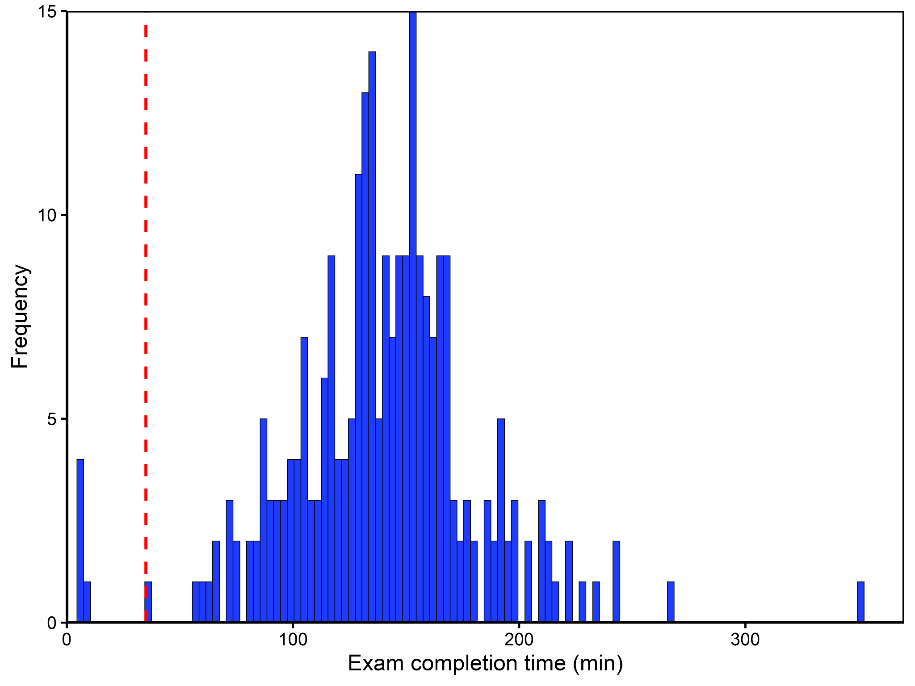
Figure S1. Histogram showing the distribution of exam completion times (minutes) among all participants who submitted responses (N = 258) prior to applying exclusion criteria. The vertical dashed red line indicates the pre-specified 35-minute exclusion threshold for insufficient engagement (5 mins for pre- and post-exam survey and 30 mins for exam completion time). Mean completion time was 139.7 ± 42.8 minutes. The 35-minute threshold excluded six participants with extremely short completion times, consistent with random responding or lack of meaningful engagement with the examination.

Figure S2. Time required per MCQ by exam generation protocol.
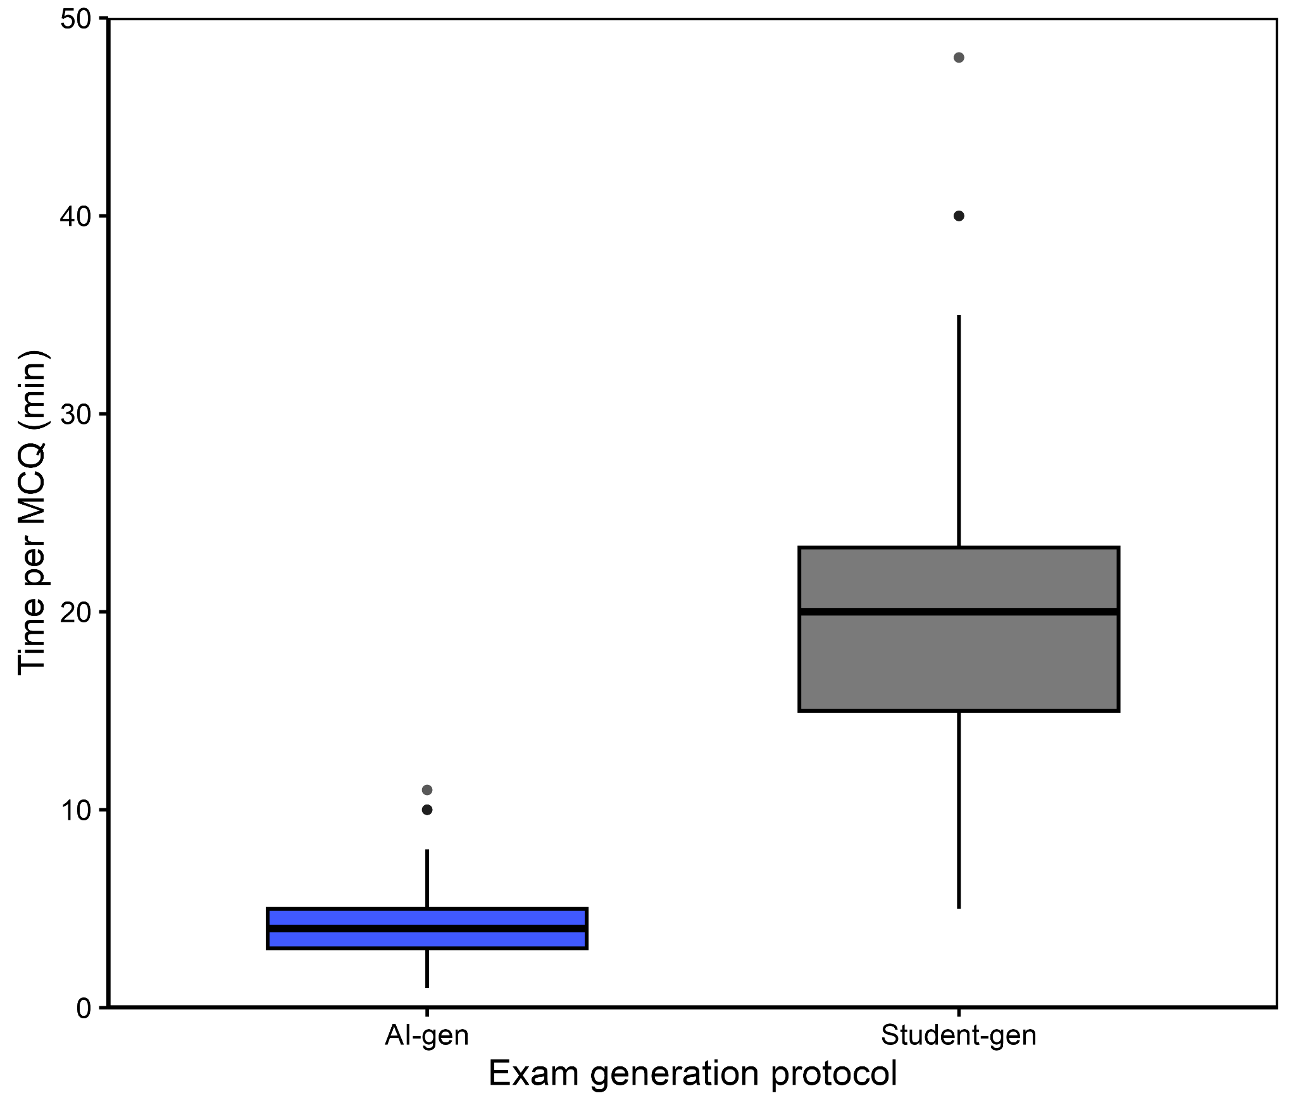
Figure S2. Boxplots comparing the time required to produce individual MCQs for the AI- and Student-gen exam. The box midline represents the median time; box limits indicate the interquartile range (IQR, 25th–75th percentile); and whiskers extend to the most extreme data points within 1.5 × IQR of the quartiles. Data points beyond this range are plotted individually.

Figure S3. Distribution of item discrimination index (DI) values by exam generation protocol in the PP population.
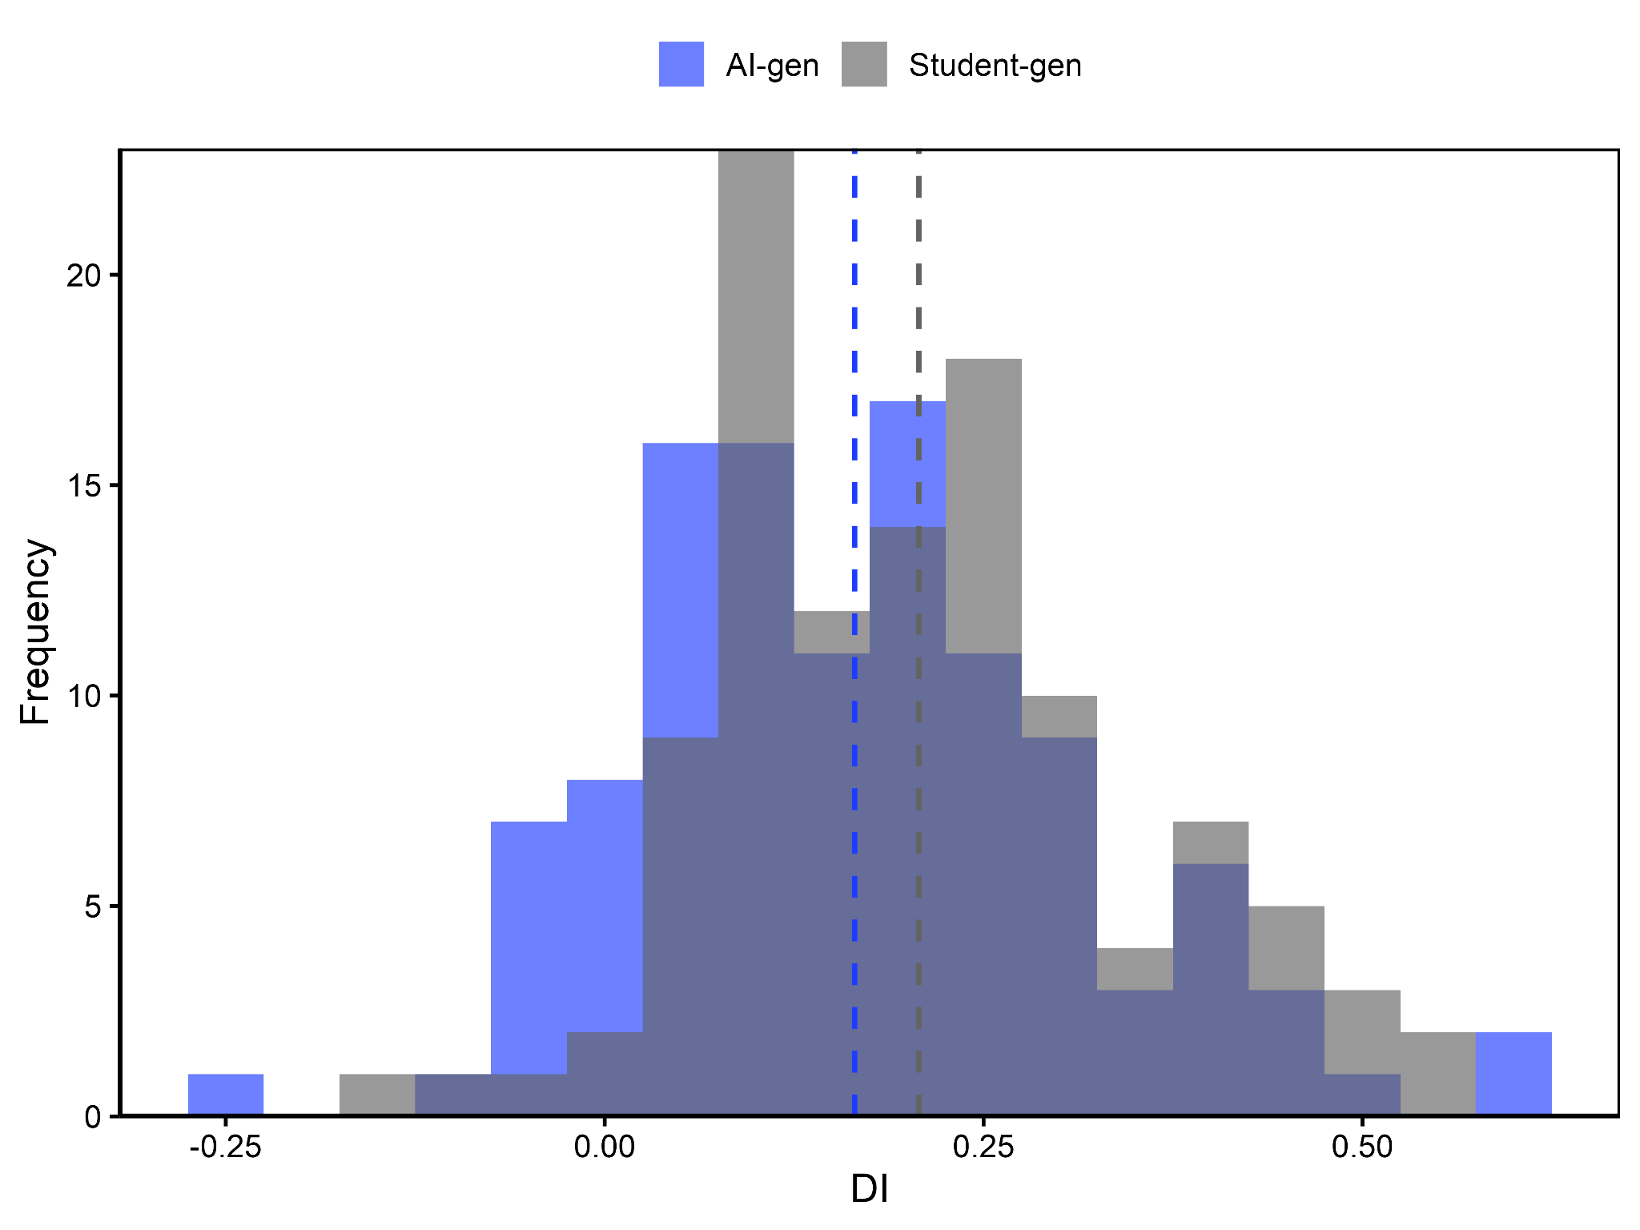
Figure S3. Histogram showing the distribution of item-level DI values for AI- and Student-gen MCQs. The distribution for Student-gen items is shifted to the right relative to AI-generated items, indicating a higher frequency of items with higher discriminatory power. Dashed blue and grey vertical lines represent the mean DI values for the AI-generated and Student-generated exams, respectively.

Figure S4. Distribution of distractor efficiency (DE) values by exam generation protocol in the PP population.
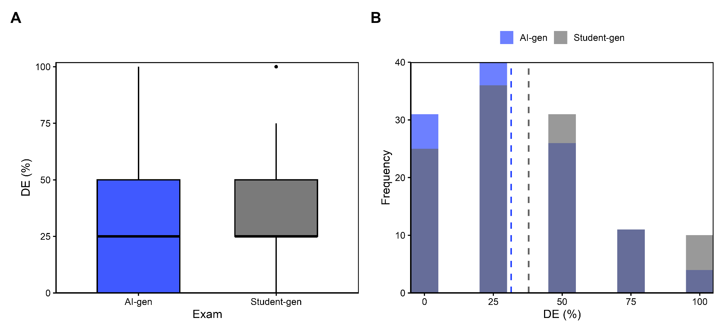
Figure S4. (A) Boxplots comparing DE values for the AI- and Student-gen exams in the PP population. The box midline represents the median DE; box limits indicate the interquartile range (IQR); and whiskers extend to 1.5 × IQR. Data points beyond this range are plotted individually. (B) Distribution of DE values for AI-generated (blue) and Student-generated (grey) MCQs. Dashed vertical lines indicate the mean DE for each exam (AI-gen in blue; Student-gen in grey).

Figure S5. Distribution of student performance by exam generation protocol in the PP population.
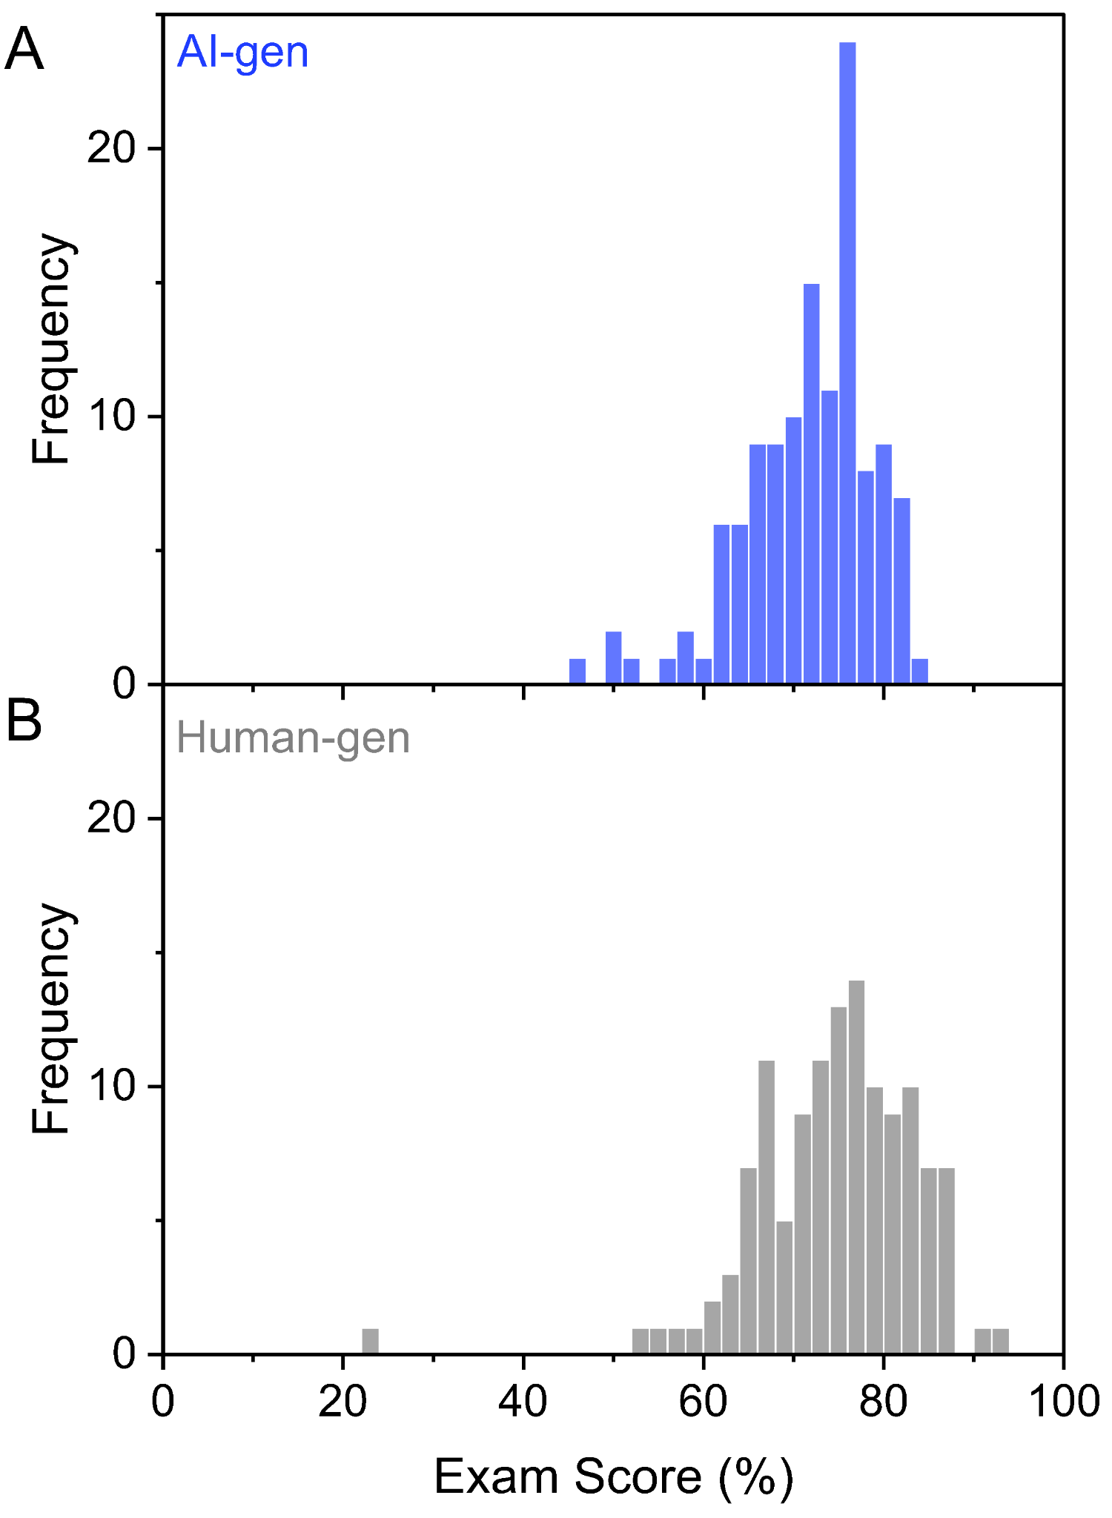
Figure S5. Histograms showing the distribution of student exam scores (% correct) for the (A) AI-gen and (B) Student-gen examinations in the per-protocol population.

Figure S6.1. Performance by undergraduate academic background in the PP population.
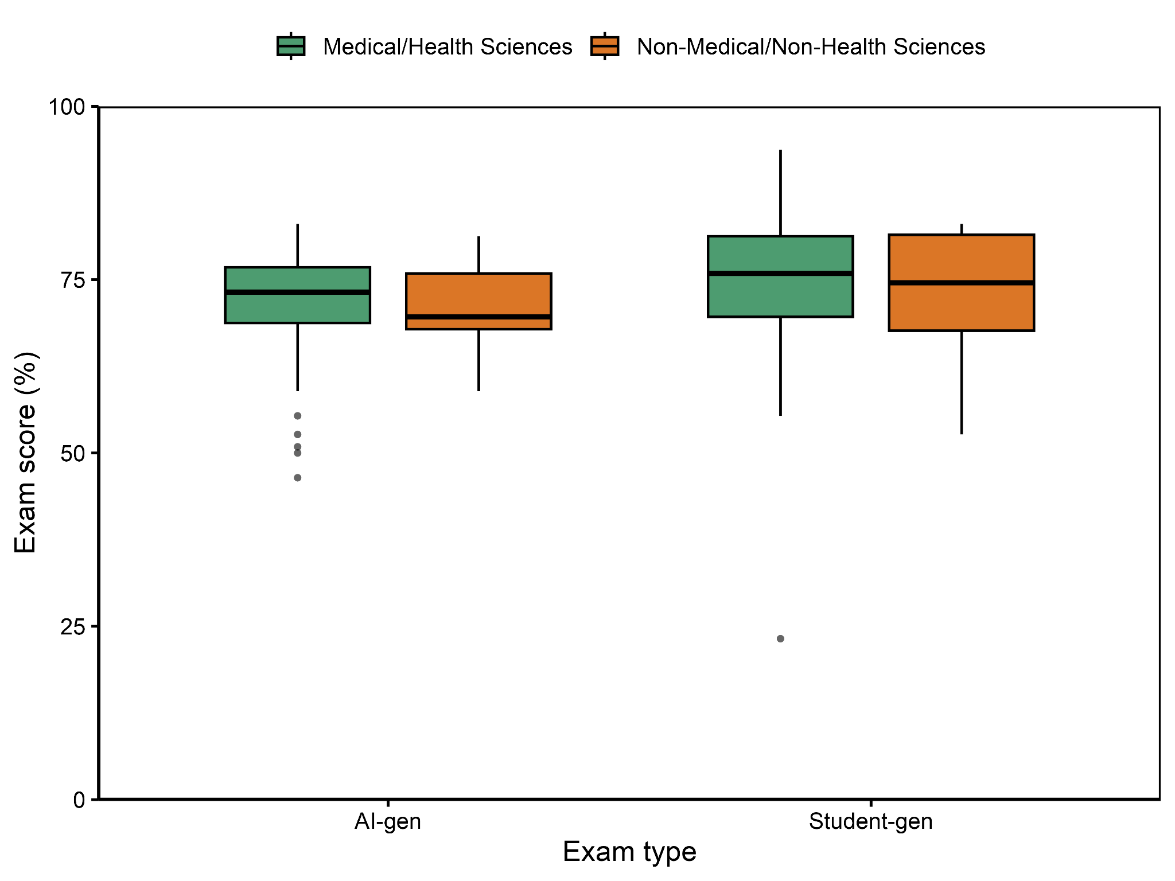
Figure S6.1. Boxplots of exam performance (%) in the per-protocol population stratified by undergraduate academic background. The x-axis shows exam type (left: AI-gen exam; right: Student-gen exam). Within each exam, green boxes represent students with a medical/health sciences background and orange boxes represent students with a non-medical/non-health sciences background.

Figure S6.2. Performance by undergraduate academic background in the ITT population.
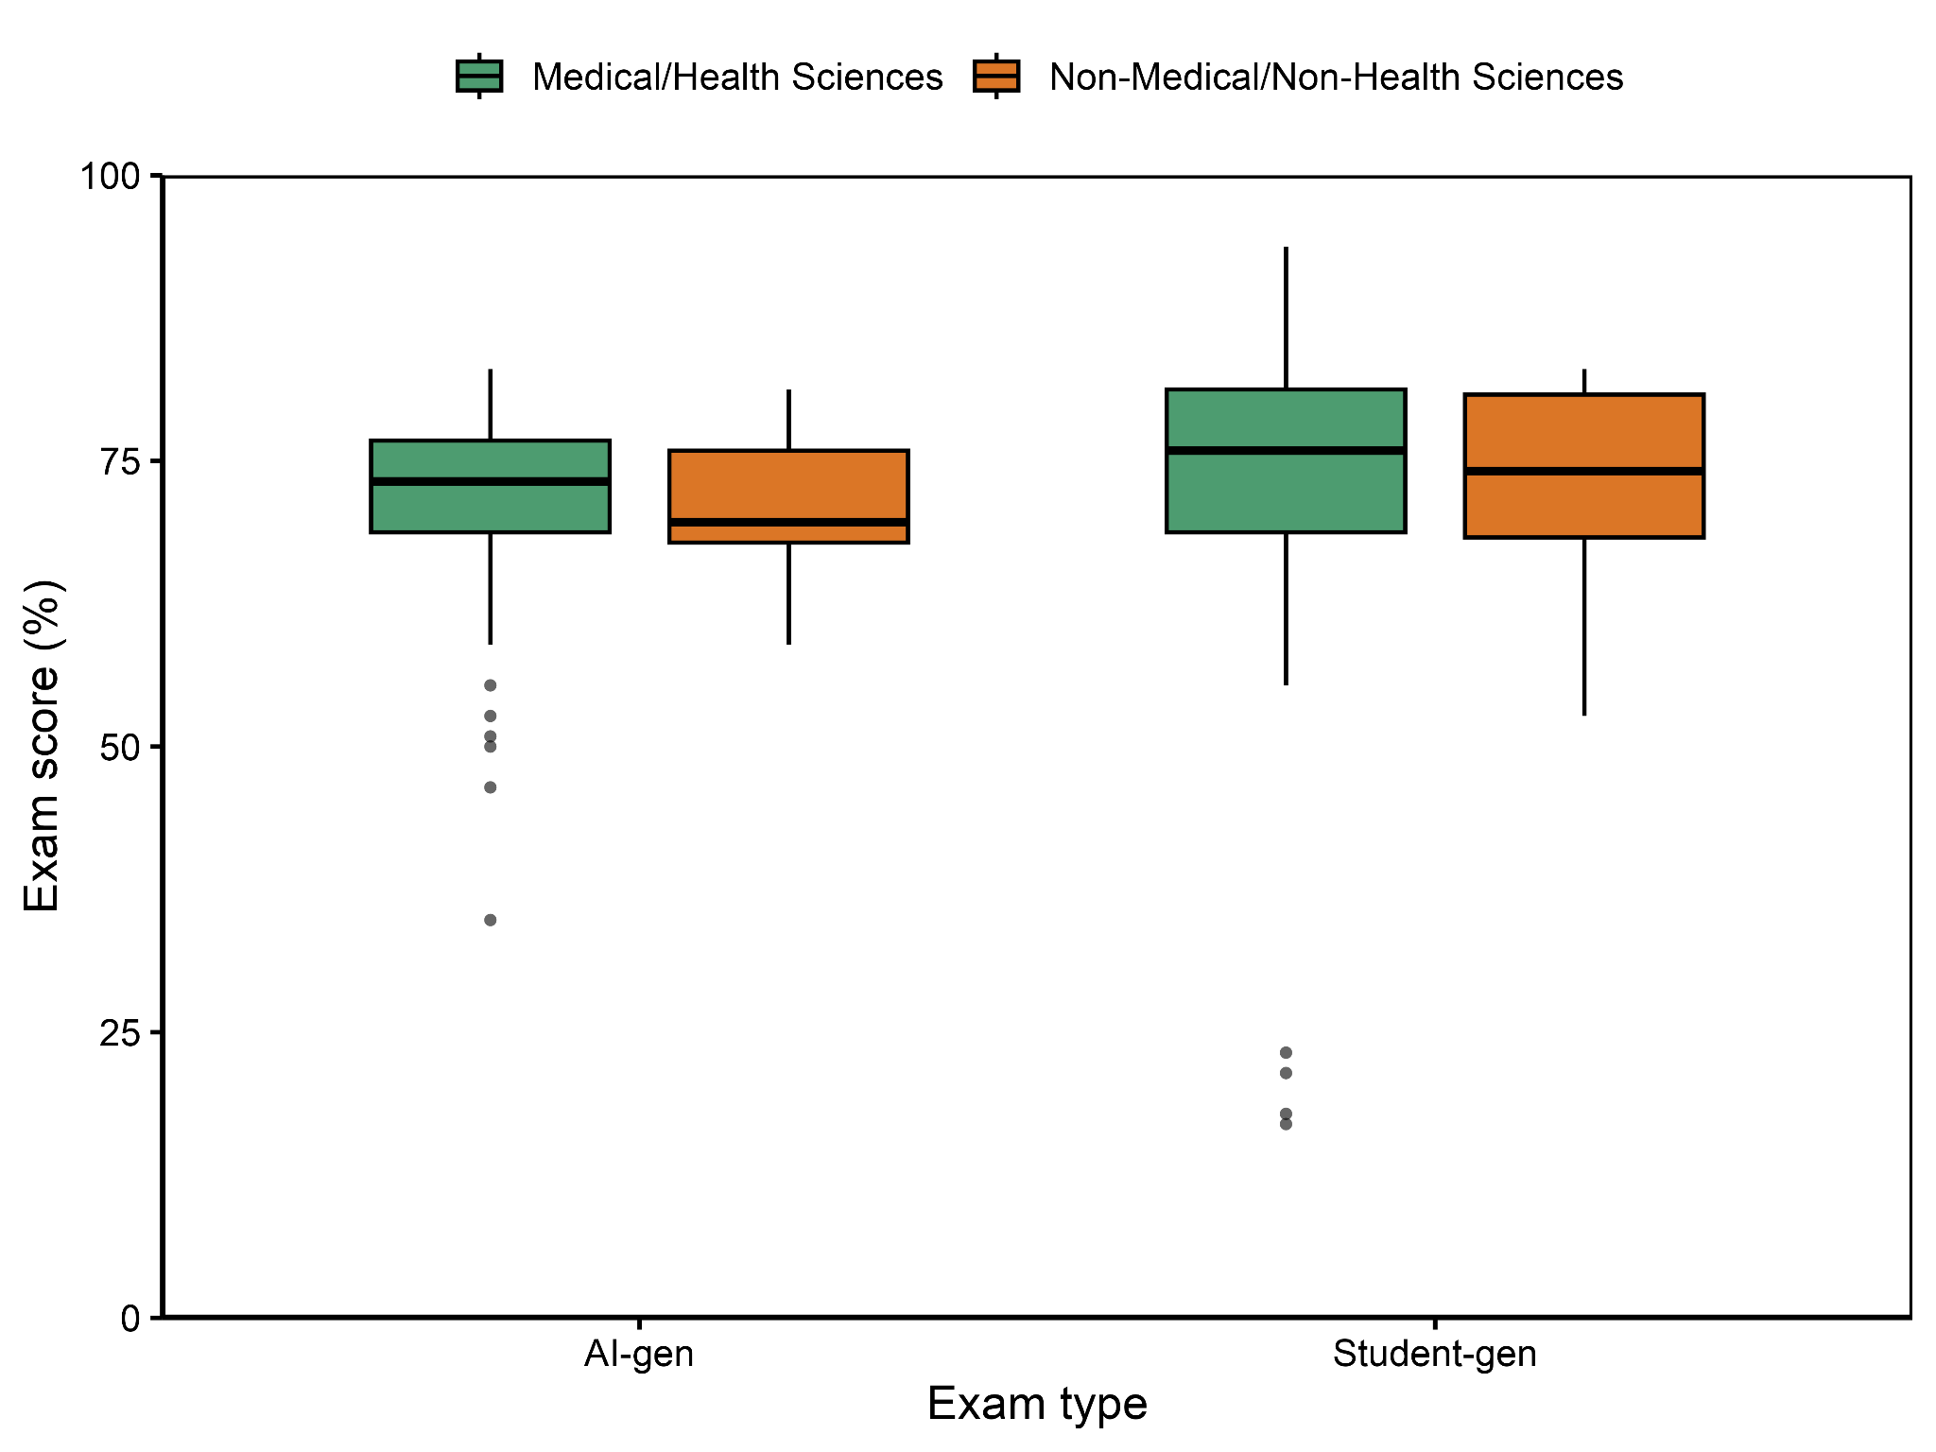
Figure S6.2. Boxplots of exam performance (%) in the ITT population stratified by undergraduate academic background. The x-axis shows exam type (left: AI-gen exam; right: Student-gen exam). Within each exam, green boxes represent students with a medical/health sciences background and orange boxes represent students with a non-medical/non-health sciences background.

Figure S7.1. Performance by curricular theme in the PP population.

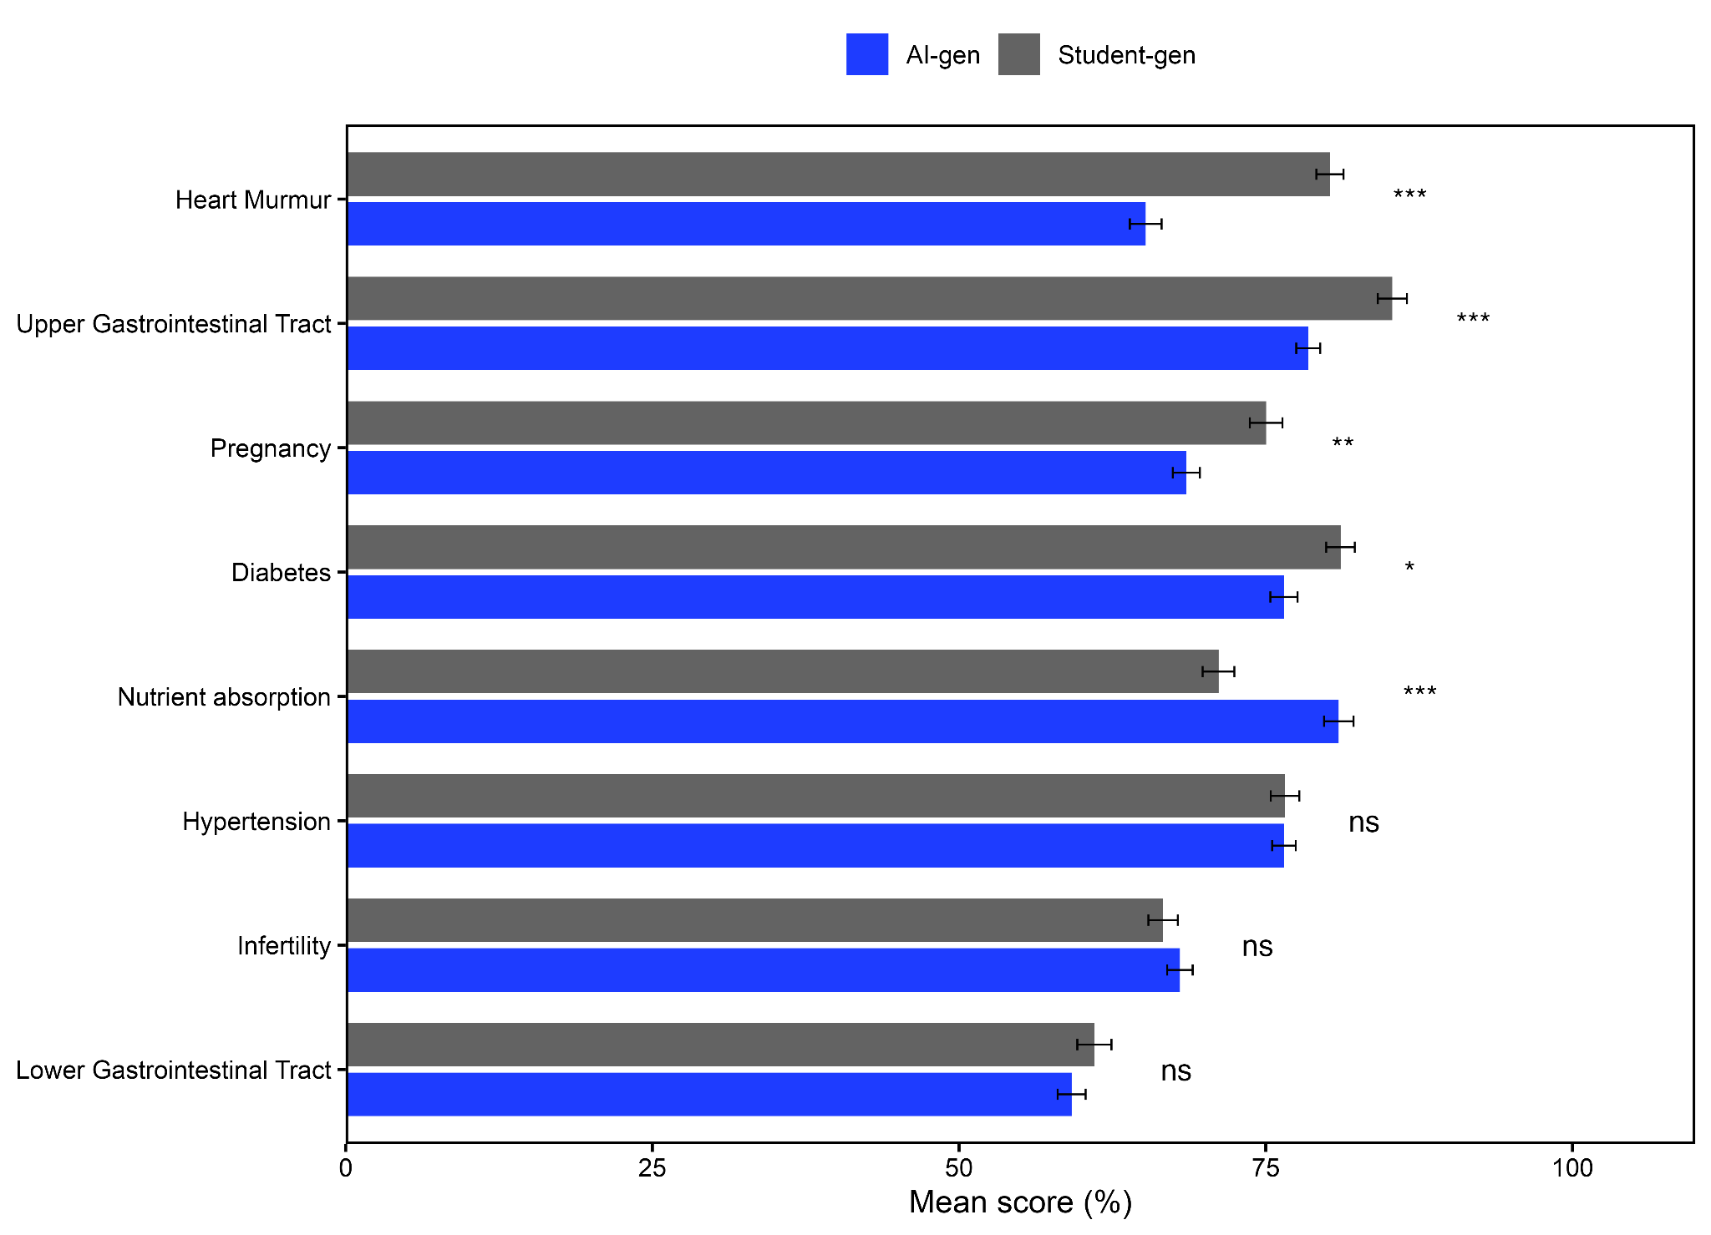
Figure S7.1. Bar plot showing mean score (%) ± standard error (SE) for each curricular theme, stratified by exam type (AI-gen versus Student-gen) in the PP population. Bars represent the mean theme score for students in each examination arm, and error bars indicate ±1 SE. Significance labels beside each theme denote Bonferroni-corrected p-values from independent-samples t-tests comparing student-level theme scores between AI-gen and Student-gen examination arms

Figure S7.2. Performance by curricular theme in the ITT population.
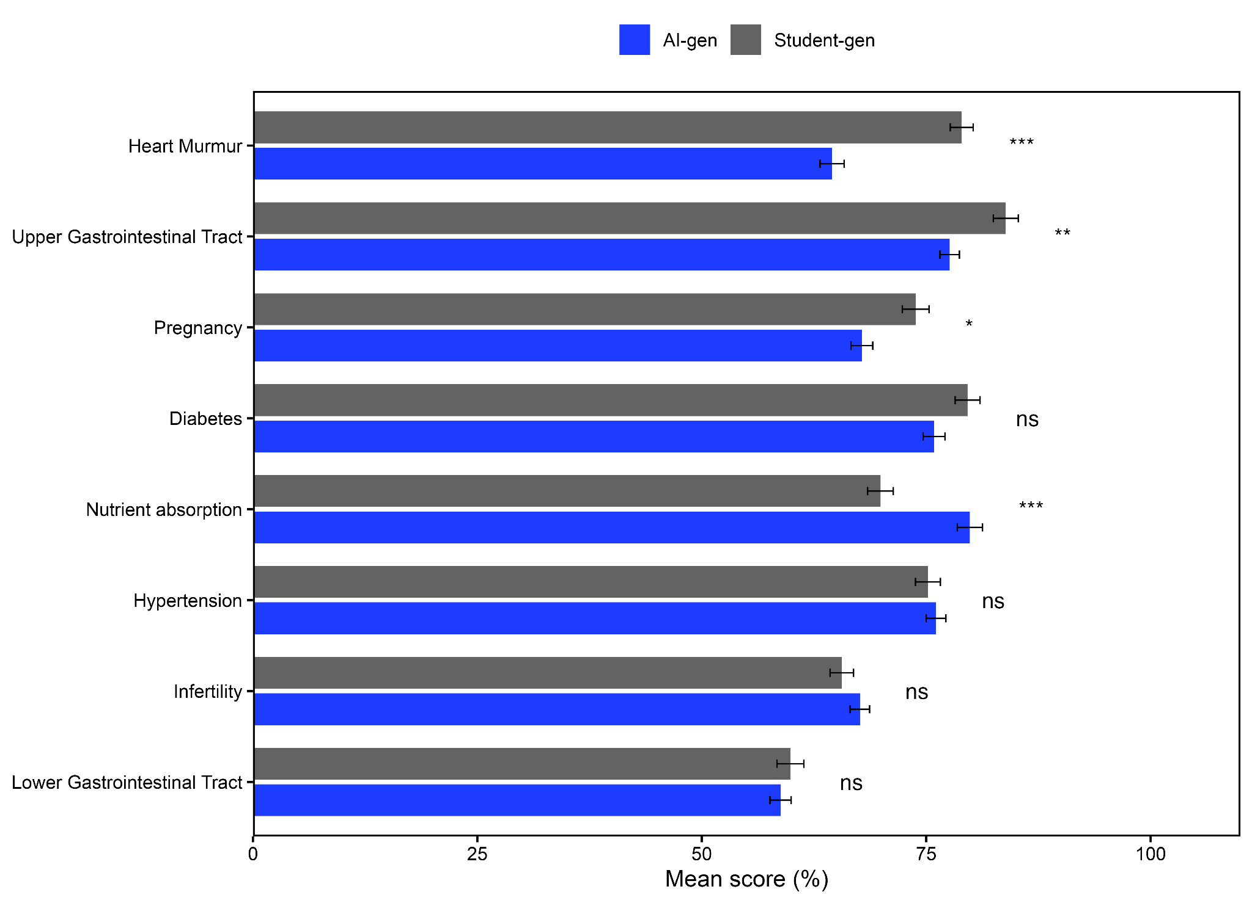
Figure S7.2 Bar plot showing mean score (%) ± standard error (SE) for each curricular theme, stratified by exam type (AI-gen versus Student-gen) in the ITT population. Bars represent the mean theme score for students in each examination arm, and error bars indicate ±1 SE. Significance labels beside each theme denote Bonferroni-corrected p-values from independent-samples t-tests comparing student-level theme scores between AI-gen and Student-gen examination arms

Figure S8.1. Performance by gender in the PP population.
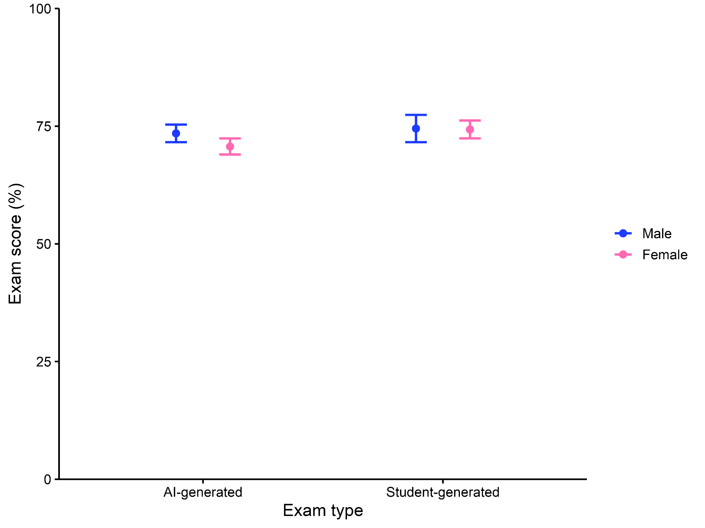
Figure S8.1. Mean exam scores (±95% confidence intervals) are shown for male (blue) and female (pink) students in the AI- and Student-gen examinations within the per-protocol (PP) population. Points represent group means, and error bars represent 95% confidence intervals.

Figure S8.2. Performance by gender in the ITT population.

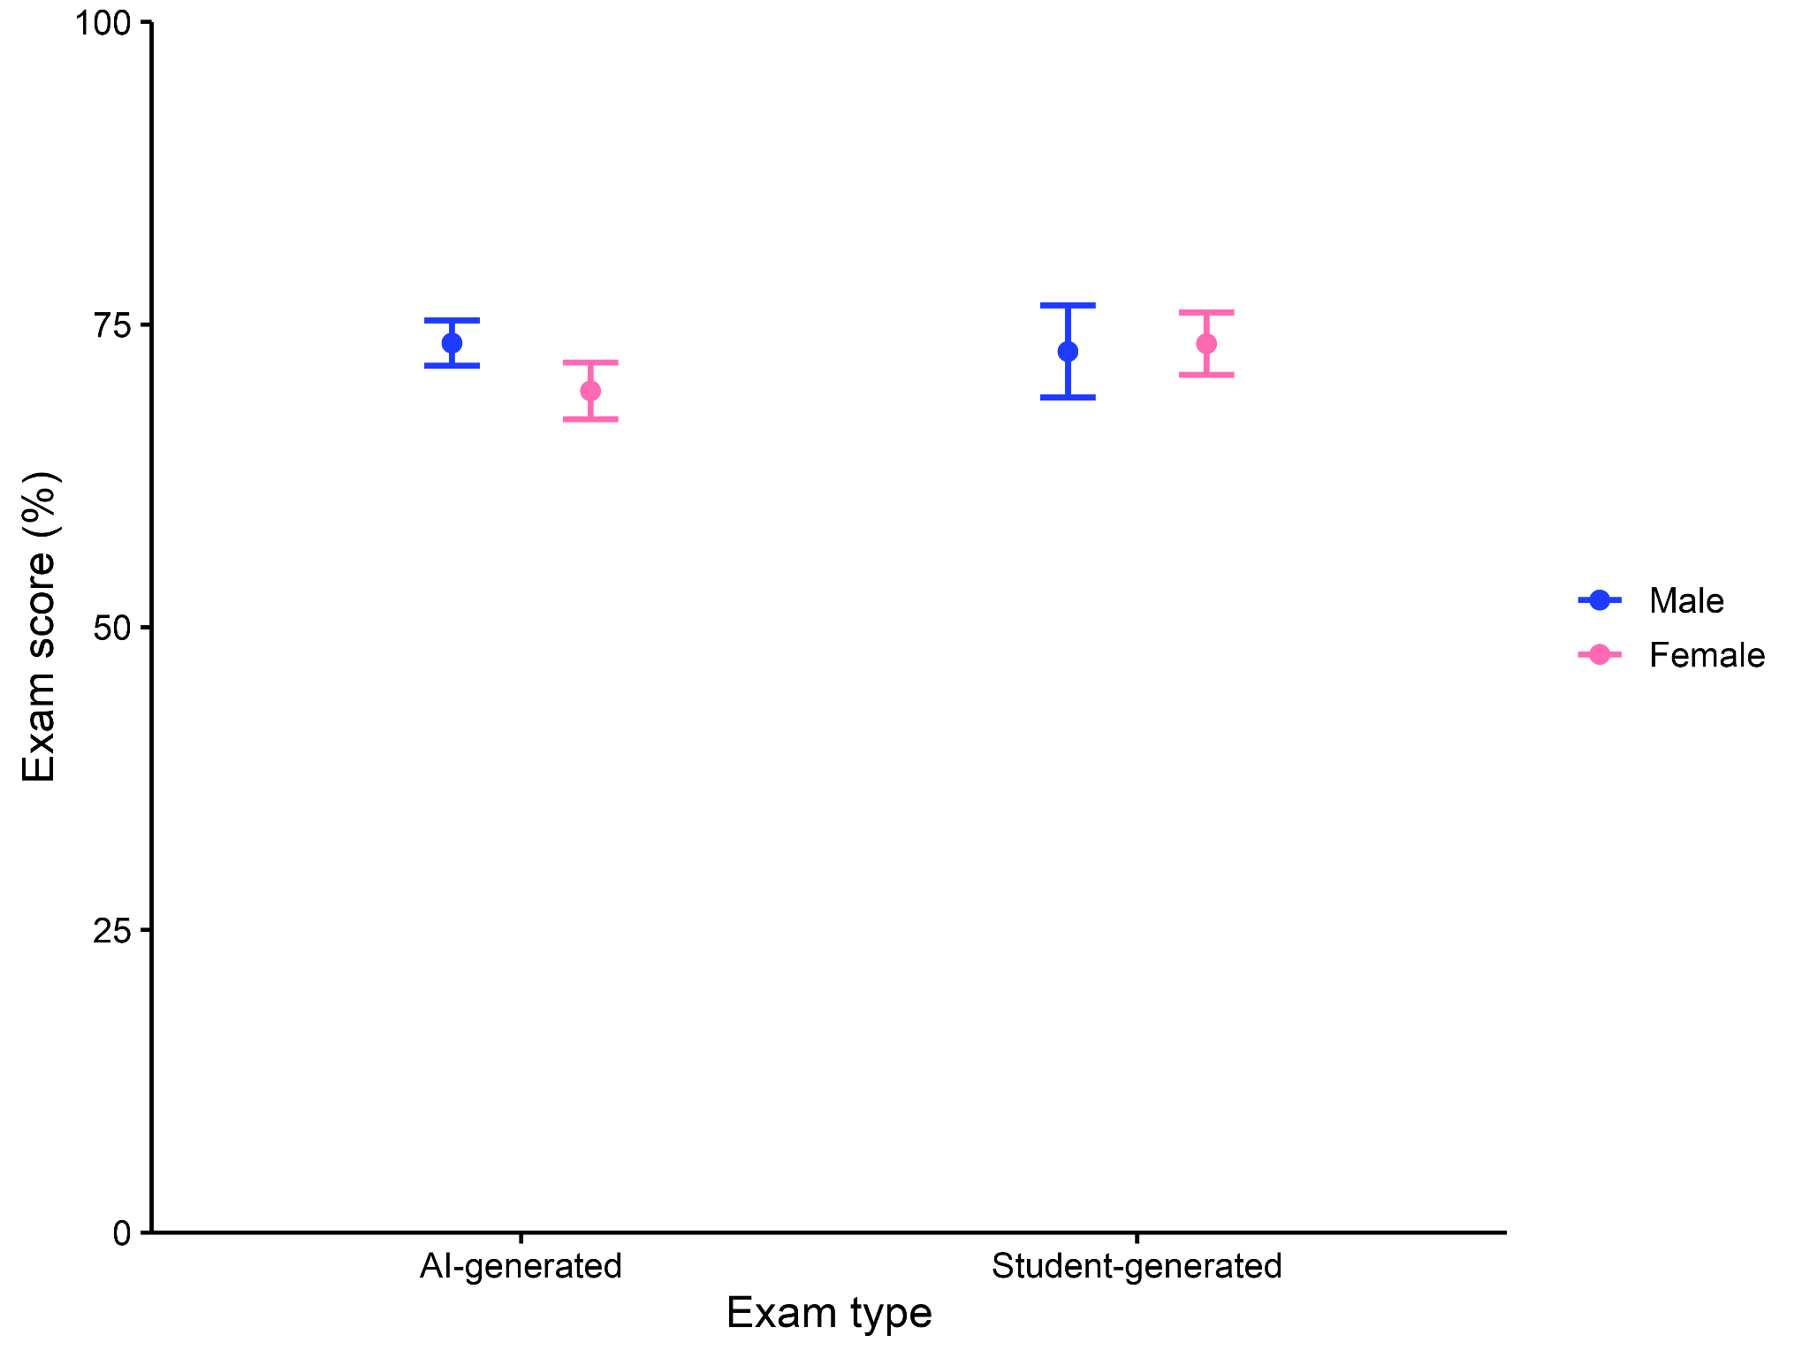
Figure S8.2. Mean exam scores (±95% confidence intervals) are shown for male (blue) and female (pink) students in the AI-gen and Student-gen exams within the intention-to-treat (ITT) population. Points represent group means, and error bars represent 95% confidence intervals.

Figure S9. Comparison of PP and ITT DI distributions.
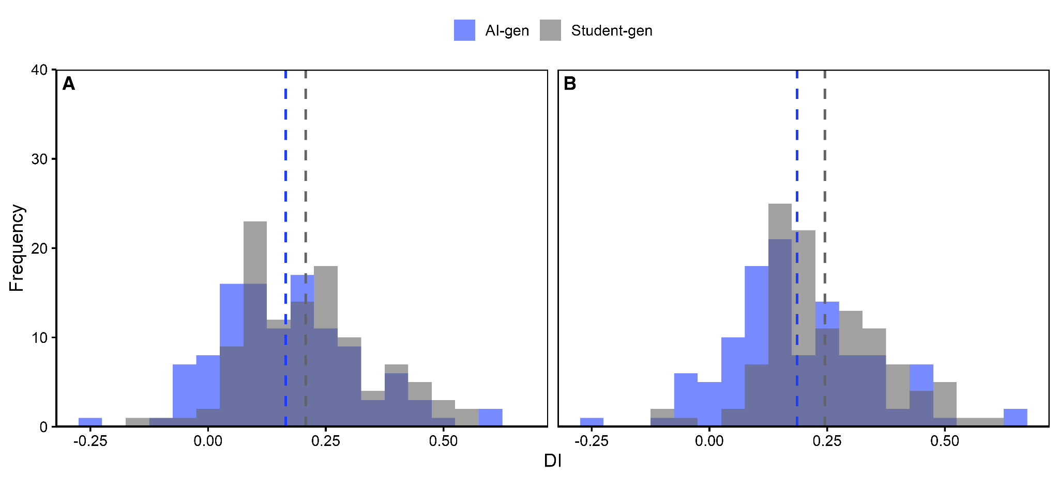
Figure S9. Comparison of the DI distributions for AI-gen (blue) and Student-gen (grey) MCQs in the (A) PP and (B) ITT analyses. Dashed vertical lines represent group DI means.

Figure S10. Comparison of DI for PP and ITT populations.
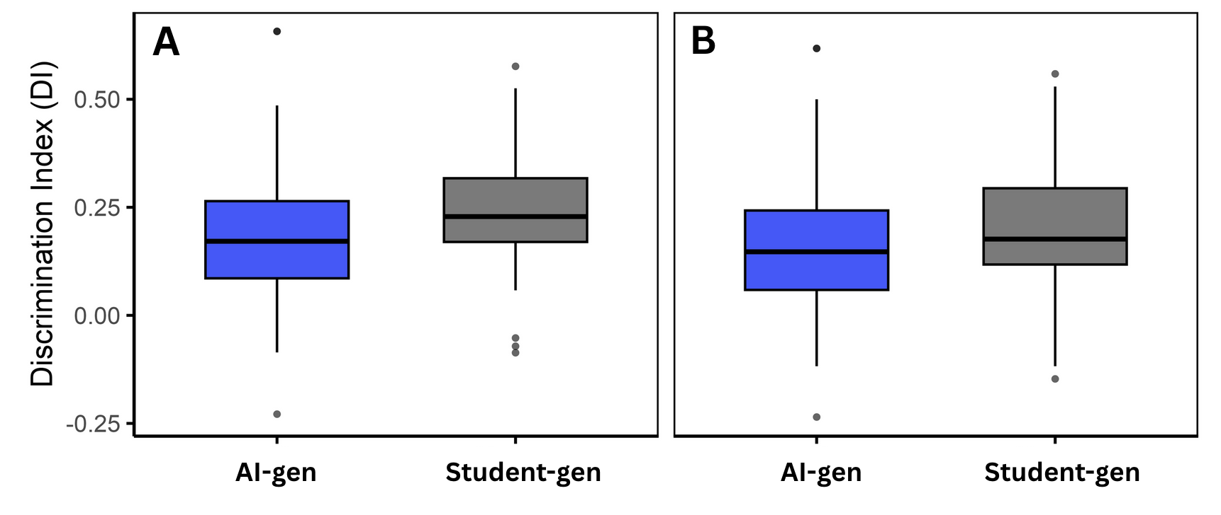
Figure S10. Boxplots comparing the DI values of the AI- and Student-gen exams in the (A) ITT and (B) PP analyses. For each boxplot, the center line represents the median, the box limits indicate the interquartile range (IQR), and whiskers extend to 1.5 X IQR. Data points lying outside this range are plotted individually.

Figure S11. Acceptability metrics for PP population.
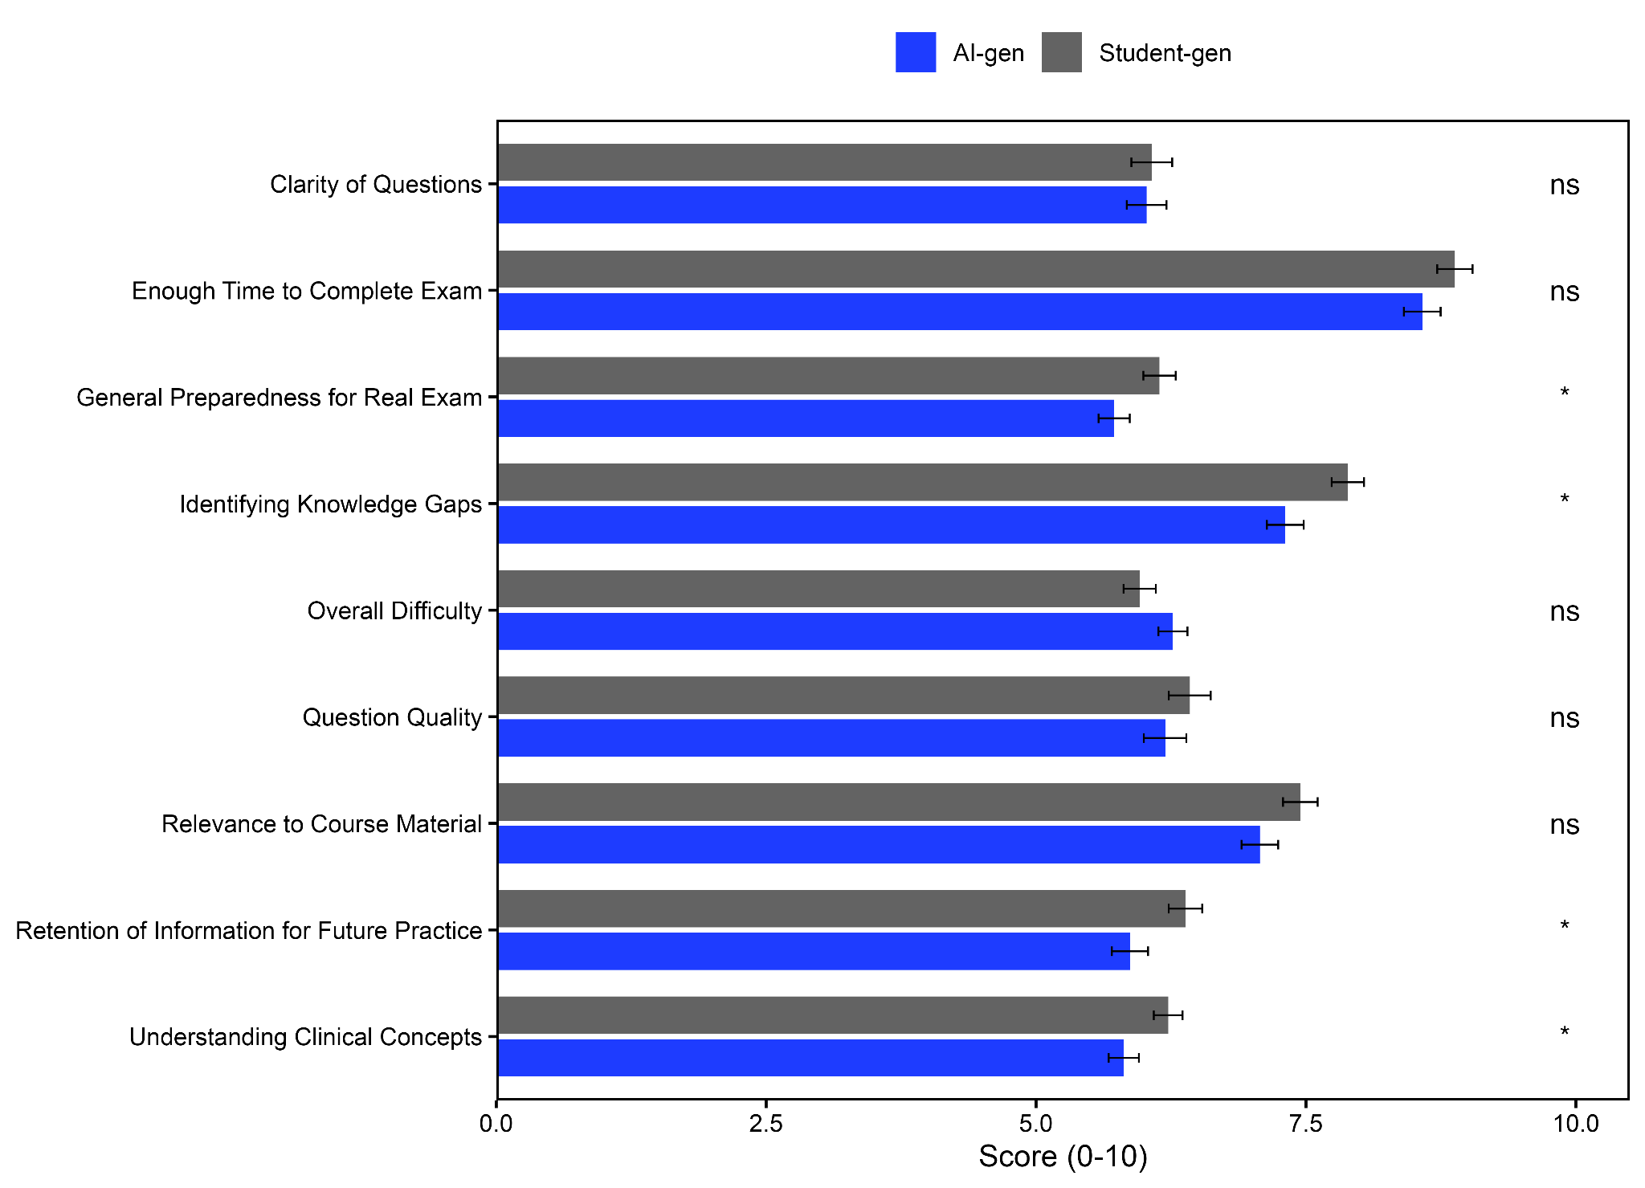
Figure S11. Student-reported perceptions of AI- and Student-gen exams in the PP population. Bars represent mean scores on a 10-point Likert scale, with error bars indicating standard error (N = 123 for AI-gen, N = 125 for Student-gen). Statistical comparisons were conducted using Welch's t-test with Bonferroni correction applied across nine acceptability domains; "ns" indicates non-significance after correction (all Bonferroni-adjusted p ≥ 0.10).

6. Sample Paired AI-Gen and Student-gen MCQs
A randomly selected subset of 30 paired AI-generated and Student-generated multiple-choice questions (MCQs) is made publicly available in an open data repository. For each selected objective, the dataset includes: the shared weekly learning objective used to generate both versions (listed under the column 'Common Weekly objectives for each MCQ, the same objective was used to generate Student-gen and AI-gen MCQs'), the AI-generated and Student-generated MCQ versions presented side by side, the correct answer key, and item-level discrimination indices derived from the per-protocol (PP) analysis. The inclusion of the shared objective for each pair enables direct verification of content alignment between generation protocols. These items are provided solely as illustrative research artefacts. They were not analyzed independently for psychometric inference beyond the full 112-item analyses reported in the main manuscript and are not validated for summative assessment.
The dataset is publicly available at Zenodo (DOI: 10.5281/zenodo.18284890).

7. Supplementary References
1. Rezigalla AA, Eleragi AMESA, Elhussein AB, Alfaifi J, ALGhamdi MA, Al Ameer AY, et al. Item analysis: the impact of distractor efficiency on the difficulty index and discrimination power of multiple-choice items. BMC Med Educ. 2024;24:445. https://doi.org/10.1186/s12909-024-05433-y.
2. Dhanvijay AKD, Dhokane N, Balgote S, Kumari A, Juhi A, Mondal H, et al. The Effect of a One-Day Workshop on the Quality of Framing Multiple Choice Questions in Physiology in a Medical College in India. Cureus. 2023. https://doi.org/10.7759/cureus.44049.

