Supplementary material
Figure S1: Sample AI OSPE station.
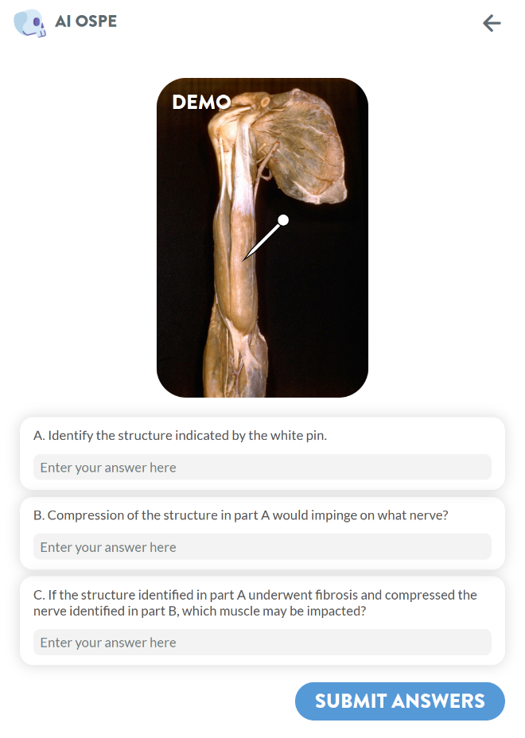
Images in the AI OSPE database are from the Bassett Collection of Stereoscopic Images of Human Anatomy, under a CC Attribution-Share-Alike 4.0 International license; and the Virtual Microscopy Database (VMD), under a CC Attribution-NonCommercial-ShareAlike 4.0 International license. The AI OSPE tool can be found online https://aiospe.mcmaster.ca/info/. Details on the construction and validation of AI OSPE are outlined by Bernard et al, 2024.

Table S1: AI OSPE score results presented as percentages. The median, quartiles, p-value and effect sizes are reported. Significant scores changes are highlighted in green.
Topic | Pre-test median | Q1 | Q3 | Post-test median | Q1 | Q3 | p | ES
INTEG | 33.3% | 0.0% | 75.0% | 66.7% | 33.3% | 66.7% | 0.36 | 0.19
NEURO | 66.7% | 33.3% | 75.0% | 100.0% | 66.7% | 100.0% | <0.01 | 0.53
ENDO | 33.3% | 33.3% | 75.0% | 66.7% | 33.3% | 100.0% | 0.26 | 0.26
RESP | 100.0% | 66.7% | 100.0% | 100.0% | 66.7% | 100.0% | 0.29 | 0.25
GI | 33.3% | 33.3% | 66.7% | 50.0% | 33.3% | 66.7% | 0.23 | 0.26
REPRO | 0.0% | 0.0% | 41.7% | 66.7% | 33.3% | 66.7% | <0.01 | 0.66
RENAL | 33.3% | 0.0% | 33.3% | 33.3% | 33.3% | 33.3% | 0.14 | 0.31
B. PLEX | 0.0% | 0.0% | 33.3% | 0.0% | 0.0% | 66.7% | 0.12 | 0.33
CARDIO | 66.7% | 33.3% | 100.0% | 100.0% | 66.7% | 100.0% | 0.13 | 0.34
MSK | 66.7% | 0.0% | 100.0% | 66.7% | 33.3% | 100.0% | 0.40 | 0.18
TOTAL | 45.0% | 35.8% | 63.3% | 60.0% | 45.8% | 70.8% | <0.01 | 0.57
Abbreviations: B. PLEX – brachial plexus; CARDIO – cardiovascular; ENDO – endocrine; ES – effect size; GI – gastrointestinal; INTEG – integumentary; MSK – musculoskeletal; NEURO – neuroanatomy; REPRO – reproductive; RESP – respiratory.

