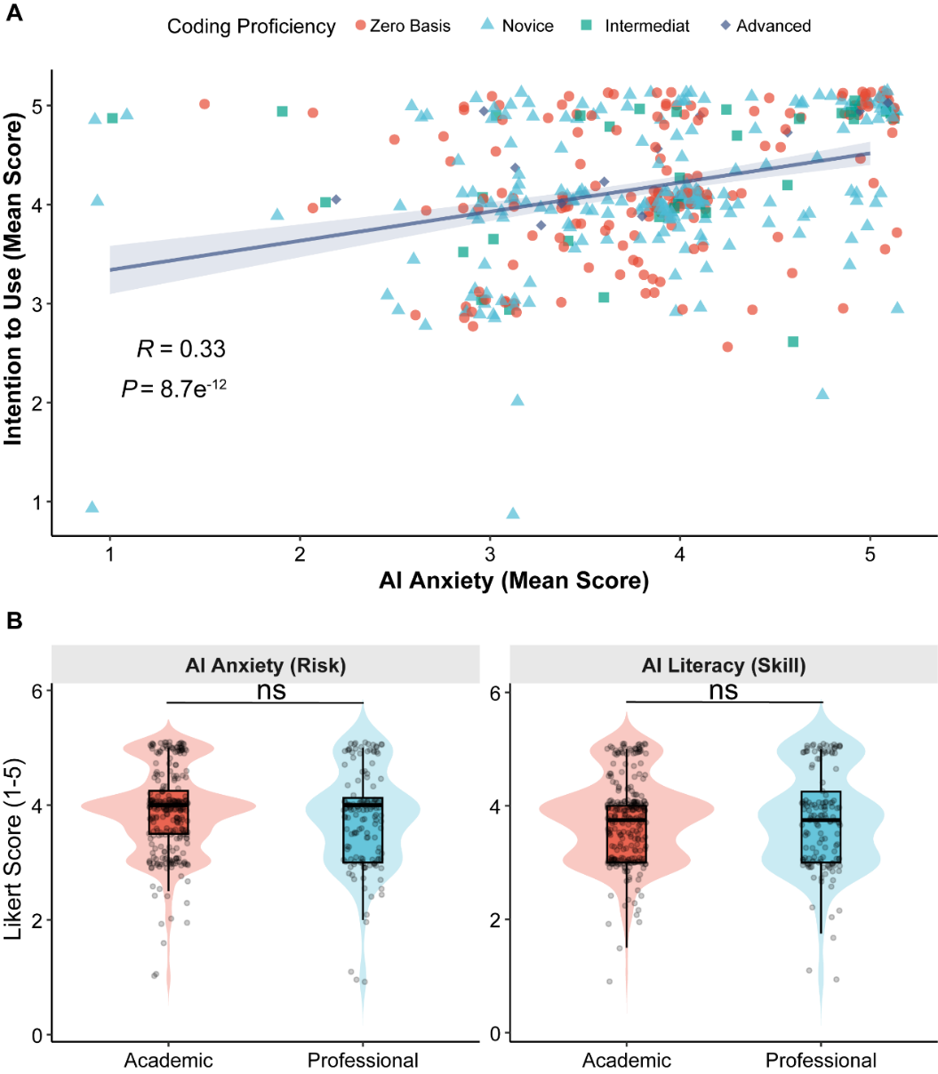
Supplementary Figure S1. The Paradox of Defensive Adoption and Demographic Disparities. (A) Scatter plot illustrating the "Defensive Adoption" mechanism. The X-axis represents AI anxiety, and the Y-axis represents Intention to use. Points are colored and shaped by Coding Proficiency. The blue regression line indicates a significant positive correlation (Pearson’s = 0.33, P < 0.001). (B) Comparison of AI profiles between Academic and Professional degrees. Violin plots overlaid with box plots show the distribution of AI literacy (left panel) and AI anxiety (right panel) across degree types. The internal box plots indicate the median and interquartile range. Statistical significance was determined using Student's -test (ns: non-significant, P > 0.05).
Supplementary Figure S2. Forest Plot of Predictors for the Agentic Innovators Profile. Results from a multinomial logistic regression analysis identifying factors associated with membership in the Agentic Innovators class (Class 1), using the Detached Users (Class 3) as the reference group. The plot displays OR and 95% CI.

