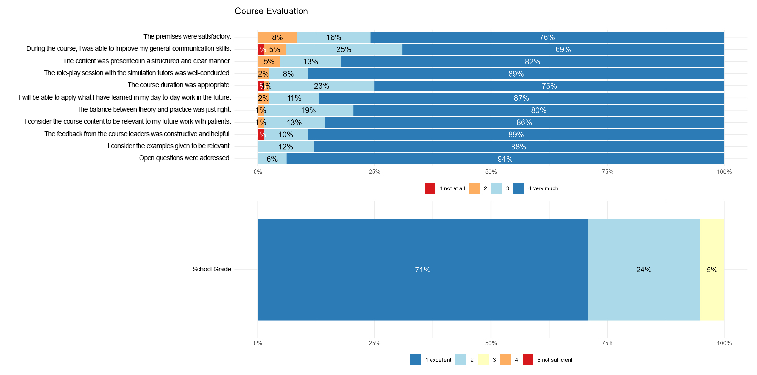
Supplementary Figure F1: Overall course evaluation

