Supplementary Table 1: Hierarchical multiple regression analyses examining the associations of workload-related, psychophysiological, sleep, and physical activity variables with kyphotic angle.

Outcome | Model | Predictors  entered | B | 95% CI of B | $$β$$ | p | VIF | $$R^{2}$$ | Model p | $$∆R^{2}$$ | F change | Sig. F Change
Kyphotic  Angle | Model 1 | Constant | 85.616 | [40.781; 130.452] |  | 0.000 |  | 0.144 | 0.006 | 0.144 | 3.242 | 0.006
Kyphotic  Angle | Model 1 | Class Group | -6.684 | [-12.168; -1.2] | -0.379 | 0.017 | 3.346
Kyphotic  Angle | Model 1 | Age | 0.047 | [-1.088; 1.182] | 0.008 | 0.935 | 1.327
Kyphotic  Angle | Model 1 | Weight | 0.220 | [0.091; 0.349] | 0.348 | 0.001 | 1.428
Kyphotic  Angle | Model 1 | Height | -0.183 | [-0.414; 0.048] | -0.16 | 0.120 | 1.416
Kyphotic  Angle | Model 1 | SStand | 0.010 | [-0.011; 0.031] | 0.122 | 0.327 | 2.094
Kyphotic  Angle | Model 1 | SSitting | -0.012 | [-0.034; 0.009] | -0.142 | 0.264 | 2.18
Kyphotic  Angle | Model 2 | Constant | 72.173 | [17.4; 126.946] |  | 0.010 |  | 0.177 | 0.021 | 0.033 | 0.887 | 0.492
Kyphotic  Angle | Model 2 | Class Group | -6.903 | [-14.235; 0.43] | -0.392 | 0.065 | 5.948
Kyphotic  Angle | Model 2 | Age | 0.129 | [-1.05; 1.309] | 0.022 | 0.828 | 1.425
Kyphotic  Angle | Model 2 | Weight | 0.235 | [0.104; 0.367] | 0.372 | 0.001 | 1.492
Kyphotic  Angle | Model 2 | Height | -0.194 | [-0.438; 0.05] | -0.17 | 0.117 | 1.56
Kyphotic  Angle | Model 2 | SStand | 0.009 | [-0.013; 0.03] | 0.101 | 0.426 | 2.139
Kyphotic  Angle | Model 2 | SSitting | -0.012 | [-0.034; 0.01] | -0.142 | 0.275 | 2.268
Kyphotic  Angle | Model 2 | +STAI_State | 0.193 | [-0.133; 0.519] | 0.114 | 0.244 | 1.271
Kyphotic  Angle | Model 2 | +STAI_Trait | 0.114 | [-0.212; 0.44] | 0.069 | 0.490 | 1.353
Kyphotic  Angle | Model 2 | +MBI_EE | 0.105 | [-0.216; 0.425] | 0.085 | 0.518 | 2.327
Kyphotic  Angle | Model 2 | +MBI_D | -0.400 | [-1.031; 0.23] | -0.167 | 0.211 | 2.382
Kyphotic  Angle | Model 2 | +MBI_PA | 0.029 | [-0.306; 0.363] | 0.021 | 0.865 | 2.126
Kyphotic  Angle | Model 3 | Constant | 72.459 | [17.371; 127.547] |  | 0.010 |  | 0.177 | 0.034 | 0.000 | 0.041 | 0.840
Kyphotic  Angle | Model 3 | Class Group | -6.889 | [-14.255; 0.477] | -0.391 | 0.067 | 5.95
Kyphotic  Angle | Model 3 | Age | 0.107 | [-1.099; 1.312] | 0.018 | 0.861 | 1.475
Kyphotic  Angle | Model 3 | Weight | 0.236 | [0.104; 0.369] | 0.374 | 0.001 | 1.499
Kyphotic  Angle | Model 3 | Height | -0.195 | [-0.44; 0.05] | -0.171 | 0.117 | 1.564
Kyphotic  Angle | Model 3 | SStand | 0.009 | [-0.013; 0.03] | 0.101 | 0.428 | 2.139
Kyphotic  Angle | Model 3 | SSitting | -0.012 | [-0.034; 0.01] | -0.141 | 0.283 | 2.276
Kyphotic  Angle | Model 3 | STAI_State | 0.199 | [-0.134; 0.531] | 0.117 | 0.239 | 1.309
Kyphotic  Angle | Model 3 | STAI_Trait | 0.109 | [-0.223; 0.44] | 0.066 | 0.518 | 1.389
Kyphotic  Angle | Model 3 | MBI_EE | 0.094 | [-0.247; 0.434] | 0.076 | 0.587 | 2.599
Kyphotic  Angle | Model 3 | MBI_D | -0.401 | [-1.034; 0.233] | -0.167 | 0.212 | 2.382
Kyphotic  Angle | Model 3 | MBI_PA | 0.031 | [-0.306; 0.368] | 0.023 | 0.856 | 2.134
Kyphotic  Angle | Model 3 | +PSQI_Global | 0.072 | [-0.63; 0.773] | 0.021 | 0.840 | 1.398
Kyphotic  Angle | Model 4 | Constant | 61.829 | [6.103; 117.555] |  | 0.030 |  | 0.201 | 0.019 | 0.024 | 3.334 | 0.070
Kyphotic  Angle | Model 4 | Class Group | -5.767 | [-13.158; 1.624] | -0.327 | 0.125 | 6.116
Kyphotic  Angle | Model 4 | Age | 0.111 | [-1.082; 1.304] | 0.019 | 0.854 | 1.475
Kyphotic  Angle | Model 4 | Weight | 0.252 | [0.119; 0.384] | 0.398 | 0.000 | 1.523
Kyphotic  Angle | Model 4 | Height | -0.146 | [-0.395; 0.102] | -0.128 | 0.246 | 1.64
Kyphotic  Angle | Model 4 | SStand | 0.009 | [-0.012; 0.030] | 0.106 | 0.397 | 2.141
Kyphotic  Angle | Model 4 | SSitting | -0.012 | [-0.034; 0.010] | -0.144 | 0.269 | 2.276
Kyphotic  Angle | Model 4 | STAI_State | 0.174 | [-0.156; 0.504] | 0.103 | 0.299 | 1.318
Kyphotic  Angle | Model 4 | STAI_Trait | 0.097 | [-0.232; 0.425] | 0.059 | 0.561 | 1.391
Kyphotic  Angle | Model 4 | MBI_EE | 0.112 | [-0.225; 0.449] | 0.091 | 0.512 | 2.608
Kyphotic  Angle | Model 4 | MBI_D | -0.350 | [-0.979; 0.279] | -0.146 | 0.273 | 2.4
Kyphotic  Angle | Model 4 | MBI_PA | 0.066 | [-0.269; 0.401] | 0.049 | 0.697 | 2.162
Kyphotic  Angle | Model 4 | PSQI_Global | 0.004 | [-0.695; 0.702] | 0.001 | 0.992 | 1.414
Kyphotic  Angle | Model 4 | +IPAQ_Total | -0.001 | [-0.002; 0.000] | -0.176 | 0.071 | 1.265

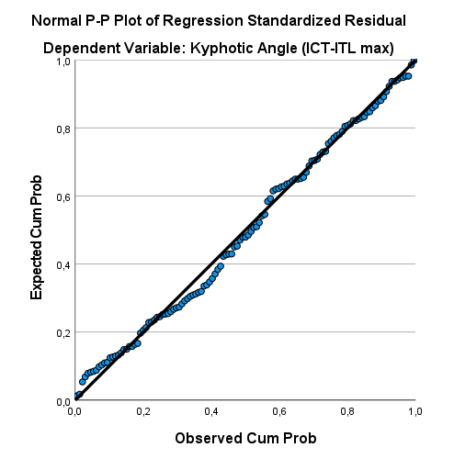 | 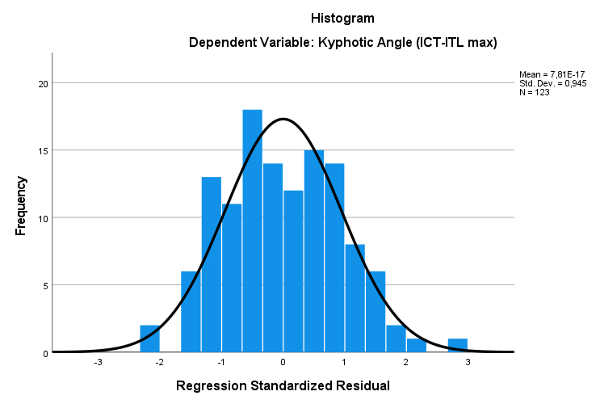
(a) Normal P–P plot of standardized residuals | (b) Histogram of standardized residuals
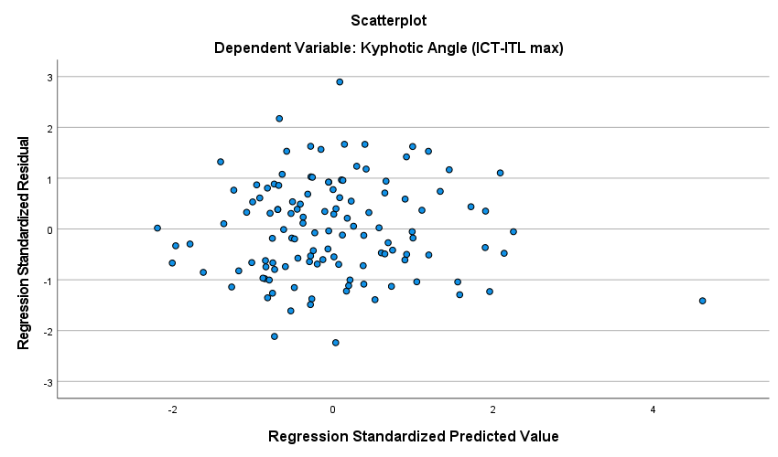

(c) Scatterplot of standardized residuals versus standardized predicted values

Supp. Figure 1: Diagnostic plots for the hierarchical regression model predicting kyphotic angle (ICT-ITL max). (a) Normal probability (P–P) plot of standardized residuals demonstrating an approximately normal distribution of residuals. (b) Histogram of standardized residuals showing that the residuals were approximately normally distributed. (c) Scatterplot of standardized residuals versus standardized predicted values, showing no clear systematic pattern or funnel-shaped distribution, supporting the assumptions of linearity and homoscedasticity. Together, these diagnostic plots support the assumptions of normality, linearity, and homoscedasticity for the regression model.

Supplementary Table 2: Hierarchical multiple regression analyses examining the associations of workload-related, psychophysiological, sleep, and physical activity variables with lordotic angle.

Outcome | Model | Predictors  entered | B | 95% CI of B | $$β$$ | p | VIF | $$R^{2}$$ | $$∆R^{2}$$ | Model  p | F change | Sig. F Change
Lordotic Angle | Model 1 | Constant | 120.283 | [80.507; 160.06] |  | 0.000 |  | 0.281 | 0.281 | <0.001 | 7.566 | <0.001
Lordotic Angle | Model 1 | Class Group | -3.372 | [-8.237; 1.494] | -0.198 | 0.173 | 3.346
Lordotic Angle | Model 1 | Age | 1.197 | [0.19; 2.204] | 0.213 | 0.020 | 1.327
Lordotic Angle | Model 1 | Weight | 0.14 | [0.026; 0.254] | 0.229 | 0.017 | 1.428
Lordotic Angle | Model 1 | Height | -0.635 | [-0.841; -0.43] | -0.574 | 0.000 | 1.416
Lordotic Angle | Model 1 | SStand | 0.008 | [-0.011; 0.026] | 0.092 | 0.419 | 2.094
Lordotic Angle | Model 1 | SSitting | 0.001 | [-0.018; 0.02] | 0.012 | 0.920 | 2.18
Lordotic Angle | Model 2 | Constant | 126.383 | [78.241; 174.526] |  | 0.000 |  | 0.322 | 0.040 | <0.001 | 1.321 | 0.260
Lordotic Angle | Model 2 | Class Group | -5.262 | [-11.707; 1.183] | -0.308 | 0.109 | 5.948
Lordotic Angle | Model 2 | Age | 1.297 | [0.261; 2.334] | 0.231 | 0.015 | 1.425
Lordotic Angle | Model 2 | Weight | 0.144 | [0.028; 0.26] | 0.235 | 0.015 | 1.492
Lordotic Angle | Model 2 | Height | -0.650 | [-0.864; -0.436] | -0.587 | 0.000 | 1.56
Lordotic Angle | Model 2 | SStand | 0.007 | [-0.011; 0.026] | 0.089 | 0.437 | 2.139
Lordotic Angle | Model 2 | SSitting | -0.002 | [-0.021; 0.018] | -0.019 | 0.873 | 2.268
Lordotic Angle | Model 2 | +STAI_State | 0.176 | [-0.111; 0.462] | 0.107 | 0.227 | 1.271
Lordotic Angle | Model 2 | +STAI_Trait | -0.116 | [-0.403; 0.17] | -0.073 | 0.423 | 1.353
Lordotic Angle | Model 2 | +MBI_EE | -0.107 | [-0.389; 0.174] | -0.09 | 0.452 | 2.327
Lordotic Angle | Model 2 | +MBI_D | -0.246 | [-0.8; 0.309] | -0.106 | 0.382 | 2.382
Lordotic Angle | Model 2 | +MBI_PA | 0.097 | [-0.197; 0.391] | 0.074 | 0.515 | 2.126
Lordotic Angle | Model 3 | Constant | 126.673 | [78.256; 175.089] |  | 0.000 |  | 0.322 | 0.000 | <0.001 | 0.054 | 0.816
Lordotic Angle | Model 3 | Class Group | -5.249 | [-11.723; 1.226] | -0.308 | 0.111 | 5.95
Lordotic Angle | Model 3 | Age | 1.274 | [0.215; 2.334] | 0.227 | 0.019 | 1.475
Lordotic Angle | Model 3 | Weight | 0.145 | [0.028; 0.262] | 0.237 | 0.015 | 1.499
Lordotic Angle | Model 3 | Height | -0.651 | [-0.867; -0.436] | -0.589 | 0.000 | 1.564
Lordotic Angle | Model 3 | SStand | 0.007 | [-0.011; 0.026] | 0.089 | 0.439 | 2.139
Lordotic Angle | Model 3 | SSitting | -0.001 | [-0.021; 0.018] | -0.017 | 0.884 | 2.276
Lordotic Angle | Model 3 | STAI_State | 0.181 | [-0.111;0.473] | 0.111 | 0.221 | 1.309
Lordotic Angle | Model 3 | STAI_Trait | -0.122 | [-0.413;0.17] | -0.077 | 0.410 | 1.389
Lordotic Angle | Model 3 | MBI_EE | -0.119 | [-0.418;0.18] | -0.099 | 0.434 | 2.599
Lordotic Angle | Model 3 | MBI_D | -0.246 | [-0.803;0.31] | -0.106 | 0.383 | 2.382
Lordotic Angle | Model 3 | MBI_PA | 0.099 | [-0.197;0.395] | 0.076 | 0.508 | 2.134
Lordotic Angle | Model 3 | +PSQI_Global | 0.072 | [-0.544;0.689] | 0.022 | 0.816 | 1.398
Lordotic Angle | Model 4 | Constant | 120.597 | [71.189;170.004] |  | 0.000 |  | 0.330 | 0.009 | <0.001 | 1.386 | 0.242
Lordotic Angle | Model 4 | Class Group | -4.607 | [-11.16;1.946] | -0.27 | 0.166 | 6.116
Lordotic Angle | Model 4 | Age | 1.277 | [0.219;2.335] | 0.228 | 0.018 | 1.475
Lordotic Angle | Model 4 | Weight | 0.154 | [0.036;0.271] | 0.251 | 0.011 | 1.523
Lordotic Angle | Model 4 | Height | -0.623 | [-0.844;-0.403] | -0.563 | 0.000 | 1.64
Lordotic Angle | Model 4 | SStand | 0.008 | [-0.011;0.026] | 0.093 | 0.420 | 2.141
Lordotic Angle | Model 4 | SSitting | -0.002 | [-0.021;0.018] | -0.019 | 0.873 | 2.276
Lordotic Angle | Model 4 | STAI_State | 0.167 | [-0.125;0.46] | 0.102 | 0.260 | 1.318
Lordotic Angle | Model 4 | STAI_Trait | -0.129 | [-0.42;0.163] | -0.081 | 0.384 | 1.391
Lordotic Angle | Model 4 | MBI_EE | -0.108 | [-0.407;0.191] | -0.091 | 0.475 | 2.608
Lordotic Angle | Model 4 | MBI_D | -0.217 | [-0.775;0.341] | -0.094 | 0.442 | 2.4
Lordotic Angle | Model 4 | MBI_PA | 0.119 | [-0.178;0.416] | 0.092 | 0.429 | 2.162
Lordotic Angle | Model 4 | PSQI_Global | 0.034 | [-0.585;0.653] | 0.01 | 0.914 | 1.414
Lordotic Angle | Model 4 | +IPAQ_Total | 0.000 | [-0.001;0] | -0.104 | 0.242 | 1.265

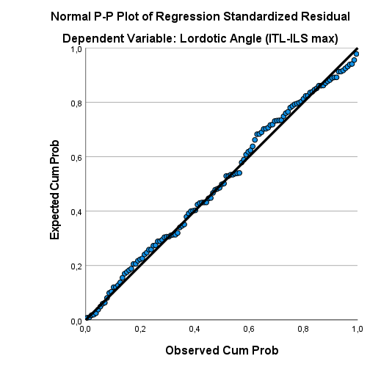 | 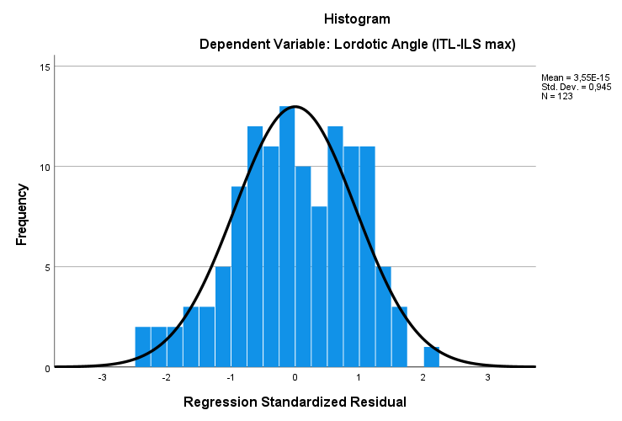
(a) Normal P–P plot of standardized residuals | (b) Histogram of standardized residuals
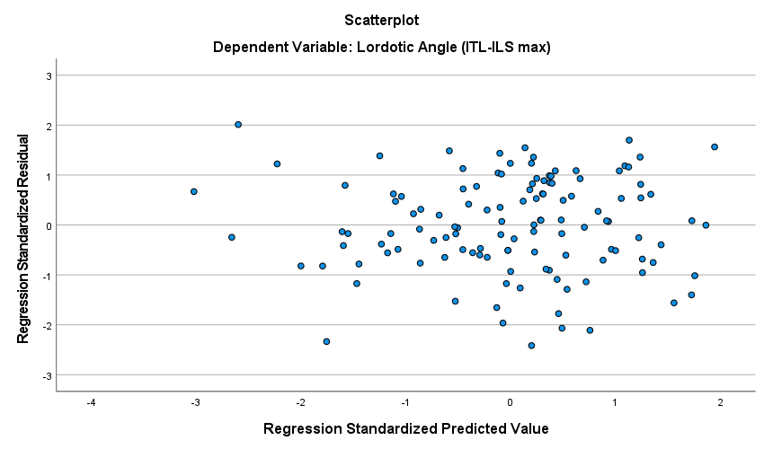
(c) Scatterplot of standardized residuals versus standardized predicted values

Supp. Fig 2: Diagnostic plots for the hierarchical regression model predicting lordotic angle (ITL-ILS max). (a) Normal probability (P–P) plot of standardized residuals demonstrating an approximately normal distribution of residuals. (b) Histogram of standardized residuals showing that the residuals were approximately normally distributed. (c) Scatterplot of standardized residuals versus standardized predicted values, showing no clear systematic pattern or funnel-shaped distribution, supporting the assumptions of linearity and homoscedasticity. Together, these diagnostic plots support the assumptions of normality, linearity, and homoscedasticity for the regression model.

