Supplementary materials

Details about the literature review
The literature searches were based on a similar study on undergraduate medical programs [1]. They were adjusted to nurse education and to programmes with outcome measures that included place of work (rural/non-rural) after graduation. This informed the choice of search terms.
In collaboration with a university librarian, we searched in the Cinahl (Ebsco), Eric (Ebsco), Medline (Ovid) and PsycInfo (Ovid) databases using 'rural', 'remote', 'workforce', 'nurse', 'recruitment' and 'retention' as search terms.
As an example, we used the following search string in Medline:
(((exp Students, Nursing/ OR nursing student*.ti,ab,kw.) AND (training or teaching or education* program* or curriculum).ti,ab,kw) OR ((exp Schools, Nursing/ OR exp Education, Nursing/)))
AND
(decentraliz* or decentralis* or distributed or community-based or community-engaged or off-campus or extramural or rural or remote).ti,ab,kw.
AND
limit 12 to yr="2005 -Current"
The main search was concluded in February 2025. It was restricted to articles in English language published in peer-reviewed journals in the period January 2005 – February 2025. After removing duplicates, we were left with 4 258 hits. The articles were first assessed for relevance in light of their title and summary. Rayyan, an electronic tool that permits two or more persons to review the references blinded and independently of each other in light of specific inclusion and exclusion criteria, was used in the selection. Three of the authors (MHL, BA and IPO) participated in this phase. We started with a blinded assessment of a set of 200 articles in order to calibrate a shared assessment approach. The remaining articles were evenly distributed for selection. We also included one article from our own literature archive and three from an umbrella review retrieved from our search. The 64 articles that were chosen were divided evenly among MHL, BA and IPO and read in full-text versions. Subsequently, BA reviewed the articles assessed by IPO, IPO reviewed the articles assessed by MHL, while MHL reviewed the articles assessed by BA. Finally, 6 articles were included. We included all articles that met the following criteria: they included study programs designed to educate nurses for work in rural areas, a study population consisting of nurses, and outcome measures including place of work (rural/non-rural) after graduation.
A follow up search was conducted in April 2026 using the same data bases and search strings to include articles published in the period February 2025 - April 2026. After removing duplicates, we were left with 610 hits. BA assessed their relevance in light of their title and summary using the Rayyan-tool. No articles were included from the follow up search.
We used narrative synthesis as our method of analysis (see 2. Literature review in the main article text).

The Northern Norwegian admission quota
At UiT The Arctic University of Norway (UiT), certain study programs allocate admission quotas specifically for applicants from Northern Norway, encompassing the counties of Nordland, Troms, and Finnmark. This initiative, which has been in place since UiT welcomed its first students in 1972, aims to improve access to higher education for young people in Northern Norway and to ensure a well-qualified workforce in the region. The underlying assumption is that students are more likely to remain in the area if they have the opportunity to pursue their education close to where they grew up.
The nursing program is one such example, with a preferential admission quota reserving 80% of study placements for applicants from Northern Norway. To qualify for this quota, applicants must demonstrate a connection to the region by fulfilling at least three of the following criteria:
- Proof of residence in Northern Norway
- Completion of upper secondary education in one of the three counties in Northern Norway
- A lower secondary school diploma from a municipality in Northern Norway
- Residency in Northern Norway for a minimum of ten years
- A parent currently residing in, or having resided in, Northern Norway within the past ten years
- The applicant's mother residing in Northern Norway at the time of the applicant's birth
This policy reflects UiT's commitment to fostering regional development and addressing the unique challenges of Northern Norway.

Norther, Southern, urban and rural municipalities in Norway
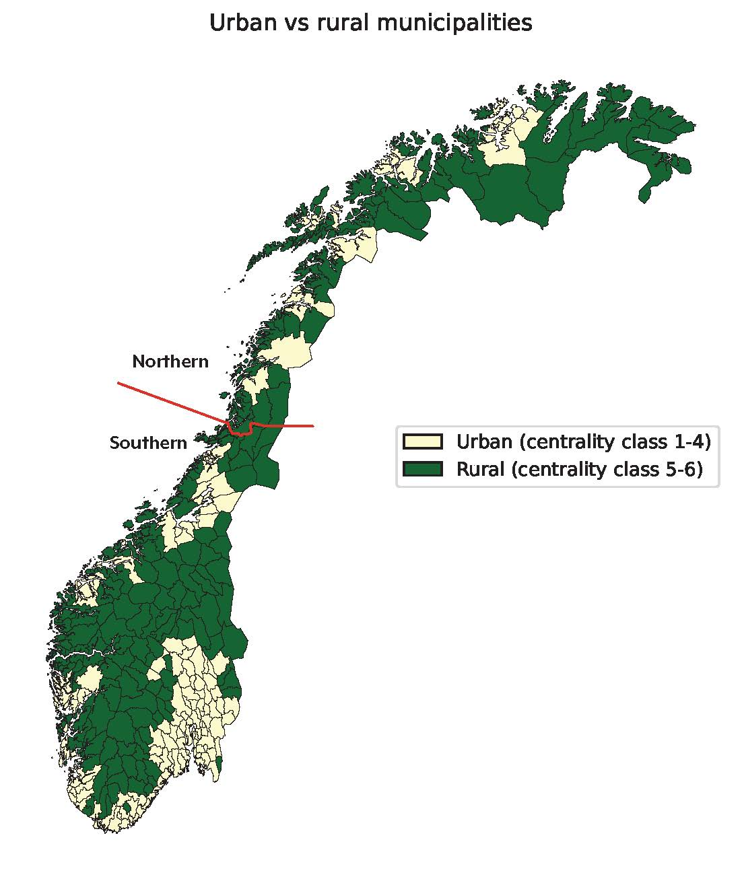
Figure S1: Map of Northern (Finnmark, Troms and Nordland county), Southern (other counties), urban (centrality classes 1–4), and rural (centrality classes 5–6) municipalities in Norway

Nurse-relevant jobs – specific occupations and occupation codes
Styrk-08 code | Styrk-08 title | Major unit group title
1114 | Senior officials of special-interest organisations | Management
1120 | Managing directors and chief executives | Management
1219 | Business services and administration managers not elsewhere classified | Management
1341 | Childcare services managers | Management
1342 | Health services managers | Management
1343 | Aged care services managers | Management
1344 | Social welfare managers | Management
1345 | Education managers | Management
2221 | Nursing professionals | Health professionals
2222 | Midwifery professionals | Health professionals
2223 | Nurses | Health professionals
2263 | Environmental and occupational health and hygiene professionals | Health professionals
3258 | Ambulance workers | Health professionals
2310 | University and higher education teachers | Teaching professionals
2320 | Vocational education teachers | Teaching professionals
2330 | Secondary education teachers | Teaching professionals
2421 | Management and organisation analysts | Administration professionals
2422 | Policy administration professionals | Administration professionals
Note: Styrk-08 is Statistics Norway’s classification of occupations, based on the International Standard Classification of Occupations – ISCO-08, prepared by the International Labour Organization (ILO), see https://www.ssb.no/klass/klassifikasjoner/7/koder

Supplementary table and figures
Table S1: Descriptive characteristics according to study programme type and career path (cluster)
 |  | Flexible study programmes |  |  |  |  |  | Full-time study programmes
 |  | Nurses in urban north |  | Nurses in rural north |  | Nurses in urban south |  | Nurses in urban north |  | Nurses in rural north |  | Nurses in urban south
 |  | %/Mean (SD) | N | %/Mean (SD) | N | %/Mean (SD) | N | %/Mean (SD) | N | %/Mean (SD) | N | %/Mean (SD) | N
Gender | Females | 89.1 | 29 | 94.1 | 336 | 80.0 | 52 | 86.4 | 1,362 | 93.9 | 412 | 84.5 | 353
Gender | Males | 10.9 | 238 | 5.9 | 21 | 20.0 | 13 | 13.6 | 214 | 6.2 | 27 | 15.6 | 65
Age (years) |  | 35.2 (8.1) | 267 | 36.0 (8.0) | 357 | 32.4 (7.6) | 65 | 29.3 (7.7) | 1,576 | 29.6 (8.3) | 439 | 26.6 (5.4) | 418
Northern background | Yes | 94.8 | 236 | 96.7 | 317 | 69.8 | 44 | 93.4 | 1,399 | 95.3 | 385 | 54.2 | 207
Northern background | No | 5.2 | 13 | 3.4 | 11 | 30.2 | 19 | 6.6 | 99 | 4.7 | 19 | 45.8 | 175
Rural background | Urban (centrality class 1-4) | 63.5 | 158 | 14.6 | 48 | 60.3 | 38 | 66.5 | 996 | 15.4 | 62 | 54.0 | 277
Rural background | Rural (centrality class 5-6) | 36.6 | 91 | 85.4 | 280 | 39.7 | 25 | 33.5 | 502 | 84.7 | 342 | 72.5 | 105
Marital status at the time of graduation | Unmarried/divorced/separated | 65.5 | 175 | 55.7 | 199 | 73.9 | 48 | 82.0 | 1,293 | 80.4 | 353 | 90.2 | 377
Marital status at the time of graduation | Married | 34.1 | 91 | 38.9 | 139 | 23.1 | 15 | 16.1 | 253 | 17.5 | 77 | 8.1 | 34
Marital status at the time of graduation | Not registered | 0.4 | 1 | 5.3 | 19 | 3.1 | 2 | 1.9 | 30 | 2.1 | 9 | 1.7 | 7
No. of children at the time of graduation | None | 25.1 | 67 | 22.7 | 81 | 43.1 | 28 | 44.5 | 701 | 41.0 | 180 | 65.8 | 275
No. of children at the time of graduation | One or more | 53.9 | 144 | 61.9 | 221 | 38.5 | 25 | 37.6 | 593 | 38.5 | 169 | 20.3 | 85
No. of children at the time of graduation | Not registered | 21.0 | 56 | 15.4 | 55 | 18.5 | 12 | 17.9 | 282 | 20.5 | 90 | 13.9 | 58
Graduation period | Early: 2003-2008 | 50.6 | 135 | 41.5 | 148 | 49.2 | 32 | 50.8 | 801 | 49.9 | 219 | 41.2 | 172
Graduation period | Late: 2009-2016 | 49.4 | 132 | 58.5 | 209 | 50.8 | 33 | 49.2 | 775 | 50.1 | 220 | 58.9 | 246
Note: SD = standard deviation
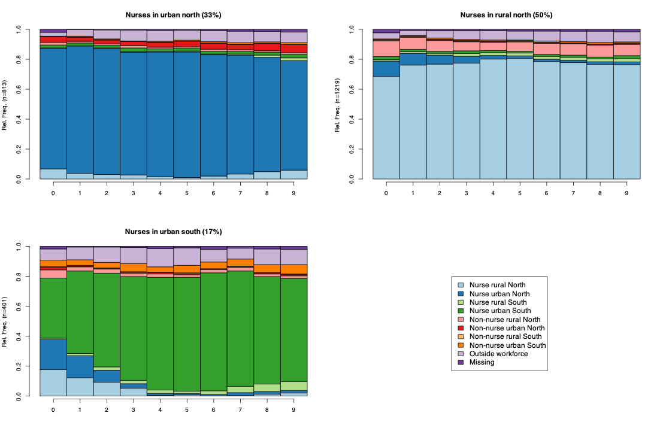
Figure S1a: State distribution plot representing the cross-sectional state frequencies for each year for those who attended a full-time study programme, rural workplace municipality defined as centrality classes 4-6
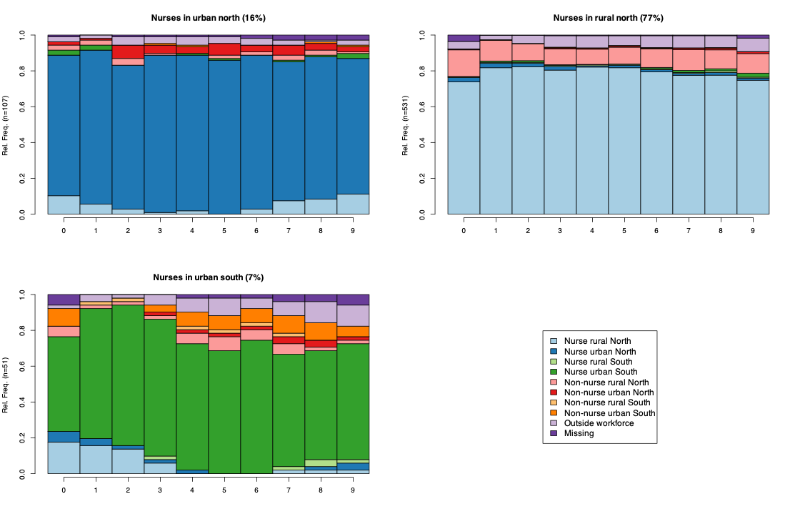
Figure S1b: State distribution plot representing the cross-sectional state frequencies for each year for those who attended a flexible study programme, rural workplace municipality defined as centrality classes 4-6
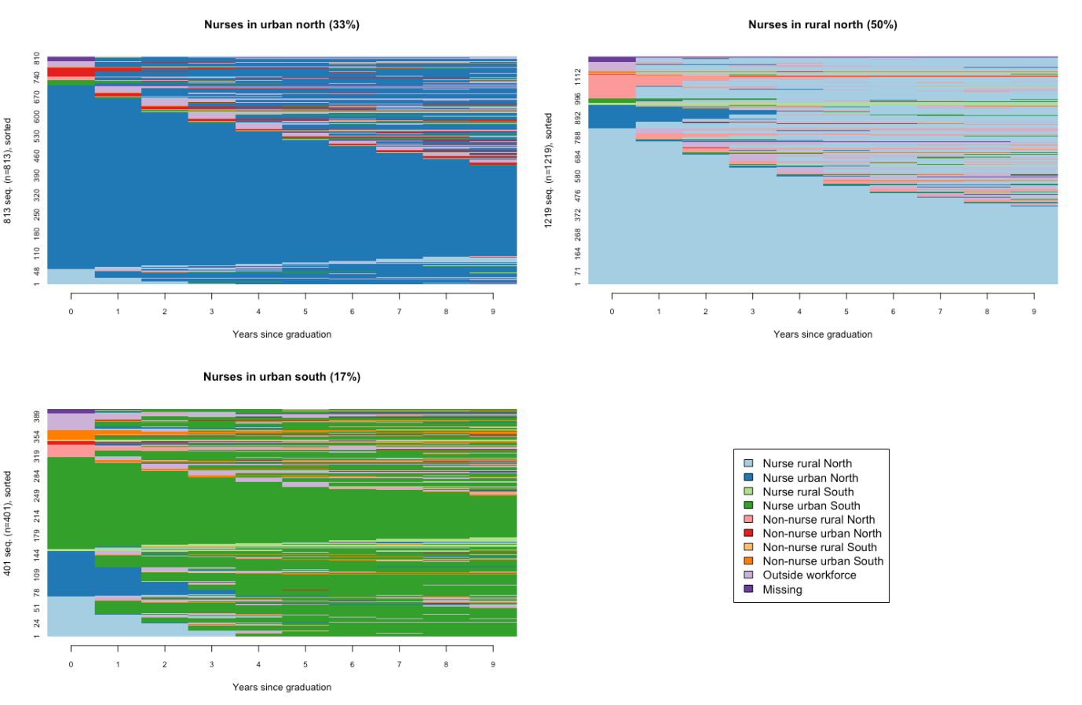
Figure S2a: Sequence index plot in which individual sequences are shown as horizontally stacked bars depicting the states over time for those who completed a full-time study programme, rural workplace municipality defined as centrality classes 4-6
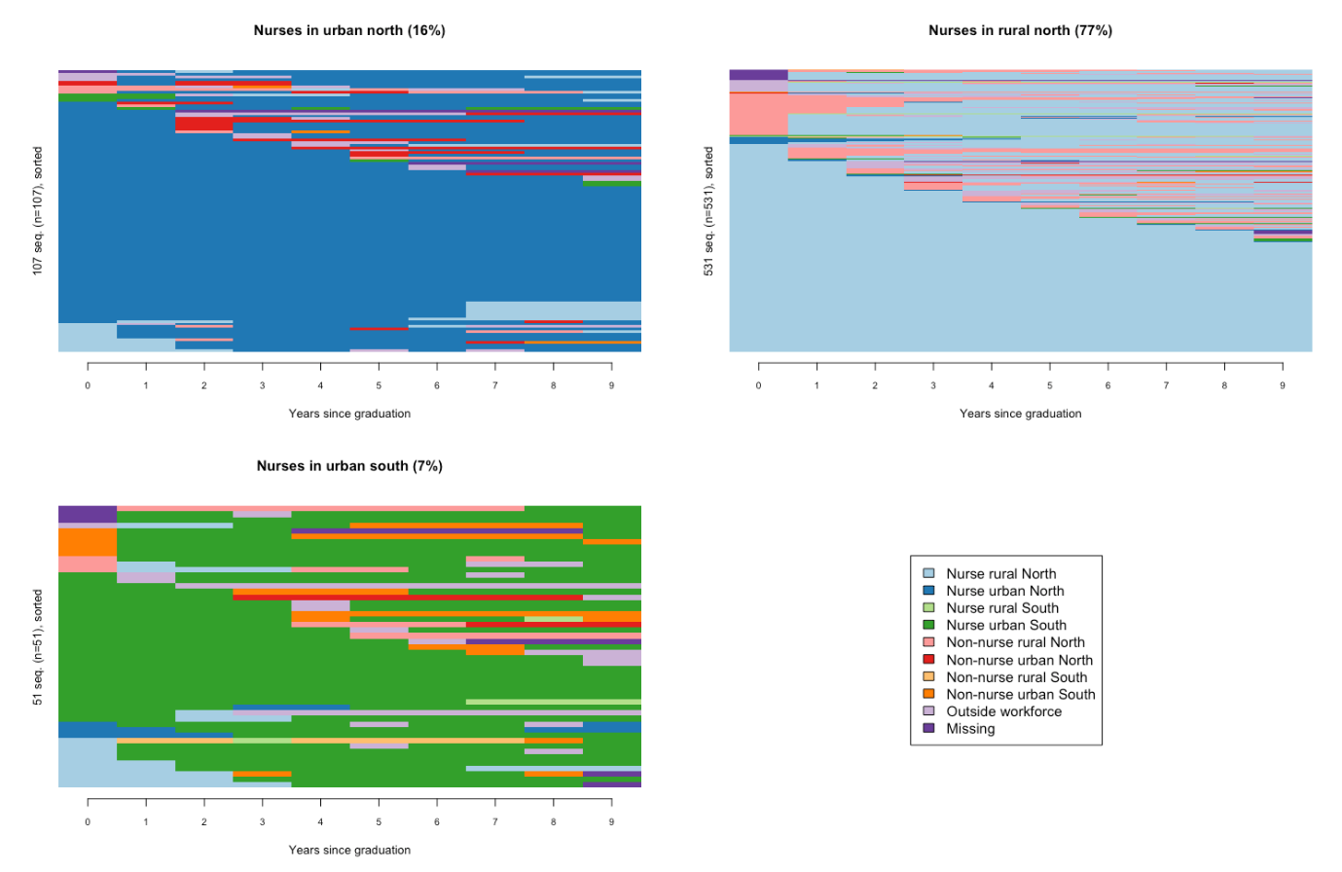
Figure S2b: Sequence index plot in which individual sequences are shown as horizontally stacked bars depicting the states over time for those who completed a flexible study programme, rural workplace municipality defined as centrality classes 4-6

References
1. Abelsen, B., et al., Educational interventions to ensure provision of doctors in rural areas - a systematic review. Tidsskr Nor Laegeforen, 2022. 142(1).

