Supplement 1. Online questionnaire to assess strengths, weaknesses, and necessary modifications for each scenario
Expert Review Questionnaire for Educational Escape Room Design
Thank you for participating in this research project. Your expert opinion is highly valuable in evaluating the design of this educational escape room. Please review the overall structure and each scenario carefully. Your feedback will help improve the educational quality and appropriateness of the escape room.
Please indicate your response for each item and provide comments or suggestions whenever appropriate.

Part I. Overall Escape Room Design

1. Overall Escape Room Structure
The proposed escape room design (single room / multiple connected rooms) is appropriate for the educational objectives.
☐ Yes ☐ No
Comments:

2. Number of Scenarios
The proposed number of scenarios (five scenarios) is appropriate.
☐ Yes ☐ No
Comments:

3. Location
The proposed location (University Clinical Skills Laboratory) is appropriate for implementing the educational escape room.
☐ Yes ☐ No
Comments:

4. Scenario Topics
The selected scenario topics are appropriate for the educational objectives.
Topics include:
- Cardiac Arrest and Resuscitation
- Airway Management
- Trauma (ATLS)
- Anaphylaxis
- Poisoning
☐ Yes ☐ No
Comments:

Part II. Scenario Evaluation

Scenario 1: Cardiac Arrest and Resuscitation

1. The written scenario is appropriate and aligns with the educational objectives discussed during the planning meetings.
☐ Yes ☐ No
Comments:
2. The puzzles are appropriate and support the intended learning objectives.
Yes ☐ No
Comments:

3. The difficulty level of the scenario and puzzles is appropriate for the residents and consistent with the educational objectives.
☐ Yes ☐ No
Comments:

4. Strengths of the scenario

5. Weaknesses of the scenario
6. Suggested modifications

Scenario 2: Airway Management and Anaphylaxis

1. The written scenario is appropriate and aligns with the educational objectives discussed during the planning meetings.
☐ Yes ☐ No
Comments:

2. The puzzles are appropriate and support the intended learning objectives.
☐ Yes ☐ No
Comments:

3. The difficulty level of the scenario and puzzles is appropriate for the residents and consistent with the educational objectives.
☐ Yes ☐ No
Comments:
4. Strengths of the scenario
5. Weaknesses of the scenario
6. Suggested modifications

Scenario 3: Trauma (ATLS)

1. The written scenario is appropriate and aligns with the educational objectives discussed during the planning meetings.
☐ Yes ☐ No
Comments:

2. The puzzles are appropriate and support the intended learning objectives.
☐ Yes ☐ No
Comments:
3. The difficulty level of the scenario and puzzles is appropriate for the residents and consistent with the educational objectives.
☐ Yes ☐ No
Comments:

4. Strengths of the scenario

5. Weaknesses of the scenario

6. Suggested modifications

Scenario 4: Poisoning

1. The written scenario is appropriate and aligns with the educational objectives discussed during the planning meetings.
☐ Yes ☐ No
Comments
2. The puzzles are appropriate and support the intended learning objectives.
☐ Yes ☐ No
Comments:

3. The difficulty level of the scenario and puzzles is appropriate for the residents and consistent with the educational objectives.
☐ Yes ☐ No
Comments
4. Strengths of the scenario
5. Weaknesses of the scenario

6. Suggested modifications

Scenario 5: Poisoning

1. The written scenario is appropriate and aligns with the educational objectives discussed during the planning meetings.
☐ Yes ☐ No
Comments
2. The puzzles are appropriate and support the intended learning objectives.
☐ Yes ☐ No
Comments:

3. The difficulty level of the scenario and puzzles is appropriate for the residents and consistent with the educational objectives.
☐ Yes ☐ No
Comments
4. Strengths of the scenario
5. Weaknesses of the scenario

6. Suggested modifications

Overall Comments
Please provide any additional comments or recommendations regarding the educational escape room design.

Thank you for your valuable time and expert feedback.

Supplement 2. Questionnaire for Evaluating an Escape Room (Summative Evaluation)
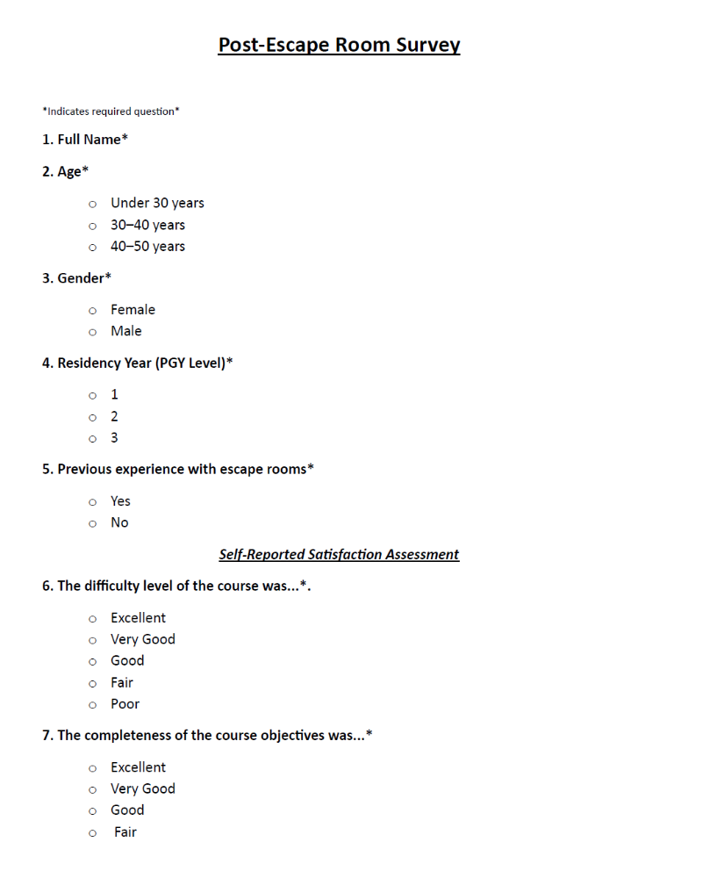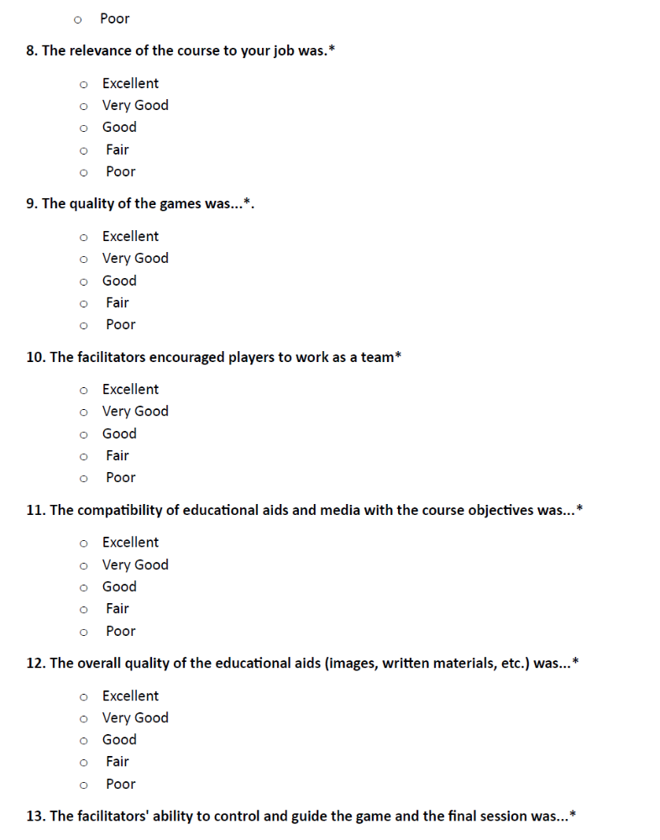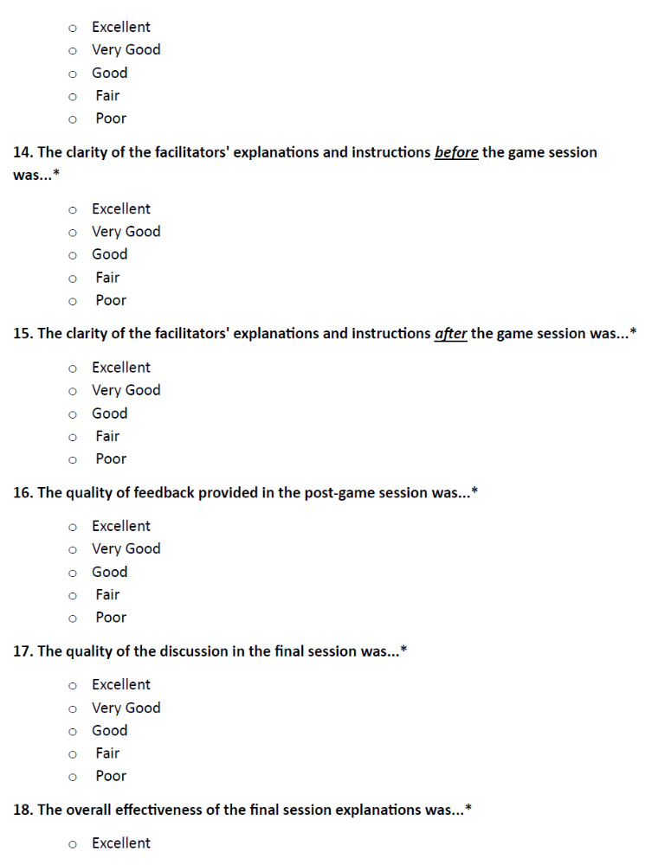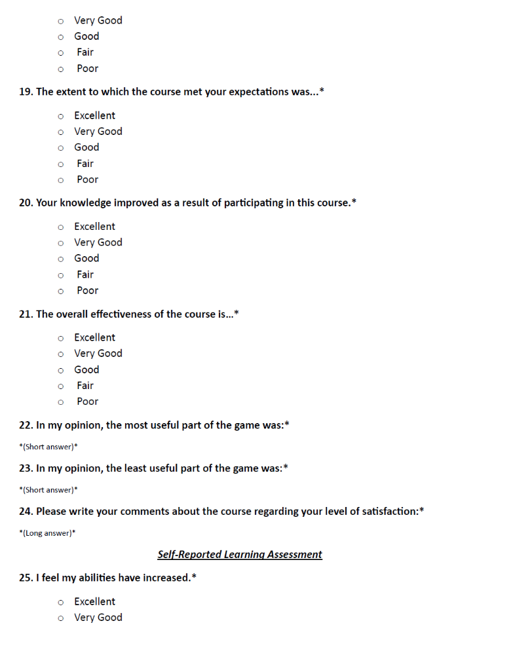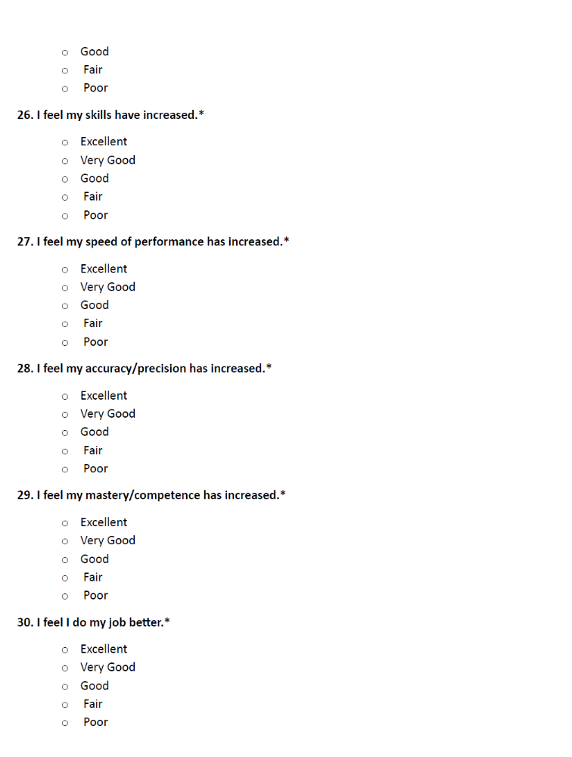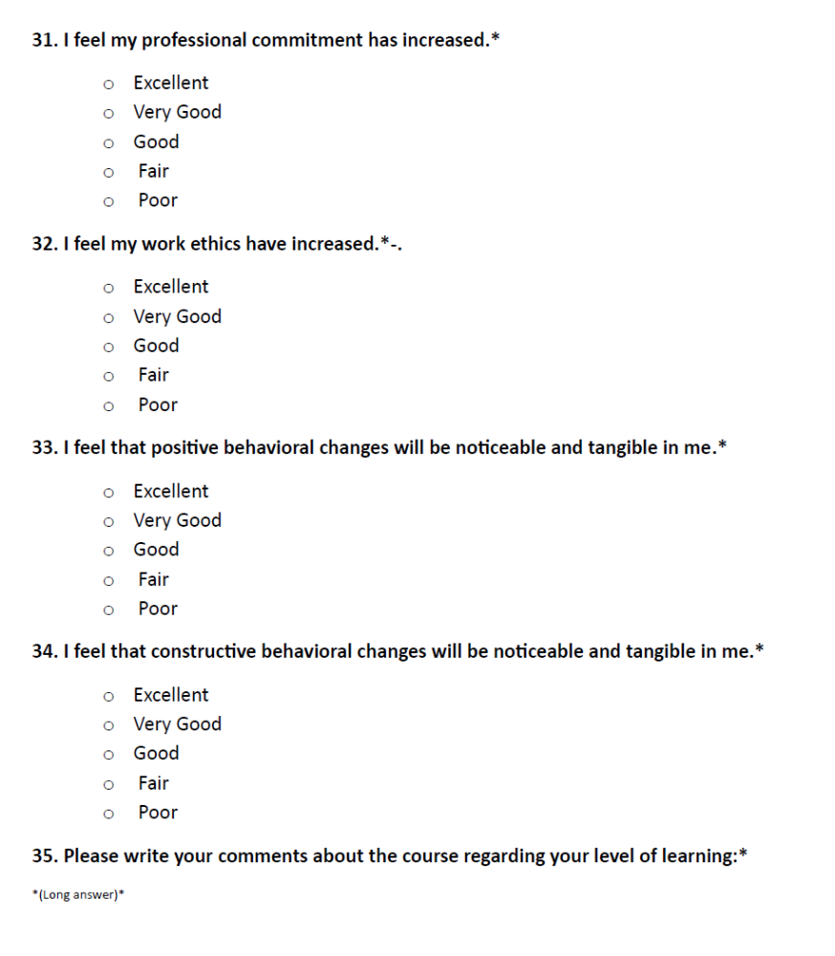

Supplement 3. Open-ended questions used to obtain qualitative information
Questions
What is your opinion regarding the puzzles?
What are the easiest and hardest puzzles in your opinion?
Name the challenging points in the game.
Mention the positive and negative points of the entire game.

Supplement 4. Distribution of Participant Responses to Individual Satisfaction and Perceived-Learning Questionnaire Items in Final intervention group (n=6)
Questions | Excellent  n(%) | Very Good  n(%) | Good  n(%) | Fair  n(%) | Poor n(%)
Self-Reported Satisfaction Assessment
6. The difficulty level of the course was… | 1(16.70) | 2(33.30) | 3(50) | 0 | 0
7. The completeness of the course objectives was... | 2(33.33) | 2(33.33) | 2(33.33) | 0 | 0
8. The relevance of the course to your job was… | 5(83.30) | 1(16.70) | 0 | 0 | 0
9. The quality of the games was… | 3(50) | 2(33.30) | 1(16.70) | 0 | 0
10. The facilitators encouraged players to work as a team. | 4(66.70) | 2(33.30) | 0 | 0 | 0
11. The compatibility of educational aids and media with the course objectives was… | 2(33.30) | 3(50) | 1(16.70) | 0 | 0
12. The overall quality of the educational aids (images, written materials, etc.) was… | 1(16.70) | 2(33.30) | 3(50) | 0 | 0
13. The facilitators' ability to control and guide the game and the final session was... | 1(16.70) | 4(66.60) | 1(16.70) | 0 | 0
14. The clarity of the facilitators' explanations and instructions before the game session was... | 2(33.30) | 1(16.70) | 2(33.30) | 1(16.70) | 0
15. The clarity of the facilitators' explanations and instructions after the game session was... | 5(83.30) | 1(16.70) | 0 | 0 | 0
16. The quality of feedback provided in the post-game session was... | 5(83.30) | 1(16.70) | 0 | 0 | 0
17. The quality of the discussion in the final session was... | 4(66.70) | 2(33.30) | 0 | 0 | 0
18. The overall effectiveness of the final session explanations was... | 4(66.70) | 2(33.30) | 0 | 0 | 0
19. The extent to which the course met your expectations was… | 2(33.30) | 4(66.70) | 0 | 0 | 0
20. Your knowledge improved as a result of participating in this course. | 3(50) | 2(33.30) | 1(16.70) | 0 | 0
21. The overall effectiveness of the course is… | 5(83.30) | 1(16.70) | 0 | 0 | 0
Perceived Learning Assessment
25. I feel my abilities have increased. | 3(50) | 2(33.30) | 1(16.70) | 0 | 0
26. I feel my skills have increased. | 2(33.30) | 3(50) | 1(16.70) | 0 | 0
27. I feel my speed of performance has increased. | 3(50) | 2(33.30) | 1(16.70) | 0 | 0
28. I feel my accuracy/precision has increased. | 2(33.30) | 4(66.70) | 0 | 0 | 0
29. I feel my mastery/competence has increased. | 2(33.30) | 4(66.70) | 0 | 0 | 0
30. I feel I do my job better. | 2(33.30) | 4(66.70) | 0 | 0 | 0
31. I feel my professional commitment has increased. | 2(33.30) | 4(66.70) | 0 | 0 | 0
32. I feel my work ethics have increased. | 2(33.30) | 3(50) | 1(16.70) | 0 | 0
33. I feel that positive behavioral changes will be noticeable and tangible in me. | 2(33.30) | 4(66.70) | 0 | 0 | 0
34. I feel that constructive behavioral changes will be noticeable and tangible in me. | 2(33.30) | 4(66.70) | 0 | 0 | 0

Supplement 5- Distribution of Participant Responses to Individual Satisfaction and Perceived-Learning Questionnaire Items in Pilot group (n=3)
Questions | Excellent  n(%) | Very Good  n(%) | Good  n(%) | Fair  n(%) | Poor n(%)
Self-Reported Satisfaction Assessment
6. The difficulty level of the course was… | 0 | 3(100) | 0 | 0 | 0
7. The completeness of the course objectives was... | 0 | 3(100) | 0 | 0 | 0
8. The relevance of the course to your job was… | 2(66.70) | 1(33.30) | 0 | 0 | 0
9. The quality of the games was… | 1(33.30) | 2(66.70) | 0 | 0 | 0
10. The facilitators encouraged players to work as a team. | 1(33.30) | 2(66.70) | 0 | 0 | 0
11. The compatibility of educational aids and media with the course objectives was… | 1(33.30) | 2(66.70) | 0 | 0 | 0
12. The overall quality of the educational aids (images, written materials, etc.) was… | 1(33.30) | 2(66.70) | 0 | 0 | 0
13. The facilitators' ability to control and guide the game and the final session was... | 0 | 2(66.70) | 1(33.30) | 0 | 0
14. The clarity of the facilitators' explanations and instructions before the game session was... | 1(33.33) | 1(33.33) | 1(33.33) | 0 | 0
15. The clarity of the facilitators' explanations and instructions after the game session was... | 0 | 1(33.30) | 2(66.70) | 0 | 0
16. The quality of feedback provided in the post-game session was... | 2(66.70) | 0 | 1(33.30) | 0 | 0
17. The quality of the discussion in the final session was... | 2(66.70) | 0 | 1(33.30) | 0 | 0
18. The overall effectiveness of the final session explanations was... | 2(66.70) | 0 | 1(33.30) | 0 | 0
19. The extent to which the course met your expectations was… | 0 | 2(66.70) | 1(33.30) | 0 | 0
20. Your knowledge improved as a result of participating in this course. | 1(33.30) | 2(66.70) | 0 | 0 | 0
21. The overall effectiveness of the course is… | 1(33.30) | 2(66.70) | 0 | 0 | 0
Perceived Learning Assessment
25. I feel my abilities have increased. | 1(33.33) | 1(33.33) | 1(33.33) | 0 | 0
26. I feel my skills have increased. | 1(33.33) | 1(33.33) | 0 | 1(33.33) | 0
27. I feel my speed of performance has increased. | 0 | 2(66.70) | 0 | 1(33.33) | 0
28. I feel my accuracy/precision has increased. | 0 | 2(66.70) | 1(33.30) | 0 | 0
29. I feel my mastery/competence has increased. | 0 | 2(66.70) | 0 | 1(33.30) | 0
30. I feel I do my job better. | 0 | 2(66.70) | 0 | 1(33.30) | 0
31. I feel my professional commitment has increased. | 0 | 2(66.70) | 0 | 1(33.30) | 0
32. I feel my work ethics have increased. | 0 | 1(33.33) | 1(33.33) | 1(33.33) | 0
33. I feel that positive behavioral changes will be noticeable and tangible in me. | 0 | 1(33.33) | 1(33.33) | 1(33.33) | 0
34. I feel that constructive behavioral changes will be noticeable and tangible in me. | 0 | 1(33.33) | 1(33.33) | 1(33.33) | 0

