Additional file 1. Additional methodology information

Additional Table S1.1. Focus groups’ composition
Focus Group | Education* | Language | Location | Participants | Age range | Gender
1 | No HSD | French | Sherbrooke | 7 | 30 – 67 | M: 6  F: 1
2 | ≥ HSD | French | Sherbrooke | 11 | 20 – 70 | M: 4  F: 7
3 | No HSD | English | Montreal | 6 | 30 – 58 | M: 4  F: 2
4 | ≥ HSD | English | Montreal | 8 | 34 – 60 | M: 3  F: 5
5 | No HSD | French | Rimouski | 8 | 27 – 66 | M: 4  F: 4
6 | ≥ HSD | French | Rimouski | 8 | 27 – 66 | M: 3  F: 5
7 | No HSD | French | Quebec City | 8 | 31 – 70 | M: 3  F: 5
8 | ≥ HSD | French | Quebec City | 7 | 24 – 66 | M: 5  F: 3
HSD: High School Diploma.
*No HSD: participants who have no high school diploma nor equivalent; ≥ HSD: participants who have at least a high school diploma or equivalent (including a diploma of collegial studies, a university diploma or equivalent).

Additional Table S1.2. Meta-consent model: Set of data content characteristics {X}
Data identification character |  | Genetic data usage
With direct identifiers | Without direct identifiers | With genetic information | Without genetic information
The data include at least one direct identifier. | The data exclude any direct identifier. | The data include at least one genetic information. | The data exclude any type of genetic information.
Examples of direct identifier: the name, the personal health plan number, the social insurance number (1). | Examples of non-direct identifier: the first three digits of the postal code, year of birth. | Genetic data results from the analysis of specific genes obtained from a biological sample (blood, hair, skin, etc.) (2).  Genetic data can reveal information about susceptibility to diseases and physical conditions (3) and can help to understand hereditary diseases as well as the response of an individual to drugs and treatments (2). | Example of non-genetic data: weight, blood pressure measurement, lung X-ray.

Additional Table S1.3. Meta-consent model: Set of contextual characteristics {Y}
Type of organisation who has access to the data |  | Where could the data be used
Academic or public organisation | Private organisation with commercial goals | Only within Canadian borders | International
A public or academic organisation has access to the data. | A private organisation with commercial goals has access to the data. | Data are being used at a national scale only (within Canadian jurisdiction). | Data are being used at an international scale (within Canadian jurisdiction and those of at least another country).
A public organisation refers to an organisation or a company that is under the jurisdiction of the state or public authorities (4).  An academic organisation refers to an educational institution dedicated to higher education and research, which grants academic degrees (4).  For example, data are accessed by governments, hospitals, universities, research institutes, research centers, or non-profit organisations like foundations. | A private organisation with commercial goals refers to an organisation or a company that belong to private individuals or legal entities rather than the state or public authorities, and for which there are commercial goals.  For example, data are accessed by a pharmaceutical company who specializes in the development of new drugs or by a company who develops medical devices. | For example, data are being used by researchers from two Canadiens universities (e.g. McGill University and The University of British Columbia). | For example, data are being used in collaboration by researchers from a university in Canada and by researchers from a university in Japan.

Additional Table S1.4. Meta-consent model: Set of consent choices {Z}
Broad approval | Specific opt-out | Specific opt-in | Broad refusal
For a given category of research projects, I authorize the use of my health data for all research projects from this category. | For a given category of research projects, I want to be asked for my consent for each new research project from this category that would like to use my data.  From the moment I am informed of the new research project, I have a given period of time (e.g. 3 months) to refuse access to my data for this project. If I have not taken action by the end of this period, my data will be used for the said project. | For a given category of research projects, I want to be asked for my consent for each new research project from this category that would like to use my data.  From the moment I am informed of the new research project, I have a given period of time (e.g. 3 months) to authorize access to my data for this project. If I have not taken action by the end of this period, my data will not be used for the said project. | For a given category of research projects, I refuse the use of my health data for all research projects from this category.

Additional Table S1.5. Characteristics defining categories of research projects in our meta-consent model as presented to the focus group participants
Data identification character
With direct identifiers      e.g., first and last name, personal  health plan number,  cell phone number. |   Without direct identifiers  e.g., year of birth, postal code.
Genetic data usage
With genetic information  e.g., analysis of genes responsible  for ​hereditary diseases from a  blood sample. | 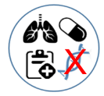  Without genetic information  e.g., ​ weight, blood pressure  measure, lung X-ray.
Type of organisation who has access to the data
Academic or public organisation​    e.g., universities, hospitals. |   Private organisation with commercial goals  e.g., a pharmaceutical company  developing a new medication or  medical device.
Where could the data be used
Only within Canadian borders    e.g., researchers from two Canadian  universities (McGill University and  The University of British Colombia). |   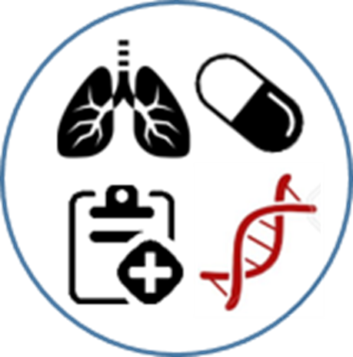  International    e.g., researchers from a university  in Canada and from a university  in Japan.

Additional Table S1.6. Example of predefining categories of research projects for which focus group participants had to express their meta-consent preferences
Category A | Category B | Category C
 |  | 
 | 
 |  | 
 | 
Consent choice? | Consent choice? | Consent choice?

Consent choices (using stickers):
Broad approval | Specific opt-out
Specific opt-in | Broad refusal

References
1. Instituts de recherche en santé du Canada, Conseil de recherches en sciences humaines du Canada, Conseil de recherches en sciences naturelles et en génie du Canada. EPTC 2 points saillants des modifications. 2014.
2. World Health Organization, éditeur. Genomics and world health: report of the Advisory Committee on Health Research. Geneva: World Health Organization; 2002. 241 p.
3. Anderson NB, Bulatao RA, Cohen B, National Research Council (US) Panel on Race E. Genetic Factors in Ethnic Disparities in Health [Internet]. Critical Perspectives on Racial and Ethnic Differences in Health in Late Life. National Academies Press (US); 2004 [cité 29 oct 2020]. Disponible sur: https://www.ncbi.nlm.nih.gov/books/NBK25517/
4. Gouvernement du Québec. Thésaurus de l’activité gouvernementale [Internet]. 2020 [cité 29 oct 2020]. Disponible sur: http://www.thesaurus.gouv.qc.ca/tag/accueil.do;jsessionid=0AA5C2E9BF3B12C3E0DFDE038FAFB893

