Appendix A: Items of own questionnaire to assess students’ level of intercultural knowledge and in interculturality regarding Muslim patients before and after the course.
Component | Item No | Sample Item
Level of intercultural knowledge | IK1 | How do you assess your ability in intercultural communication?
Level of intercultural knowledge | IK2 | How do you assess your level of knowledge regarding conflict resolution strategies in the context of misunderstandings in intercultural settings with patients?
Level of intercultural knowledge | IK3 | How confident do you feel in conducting a culturally sensitive physical examination?
Level of intercultural knowledge | IK4 | How confident do you feel in dealing with culturally sensitive patient information and counseling?
Level of intercultural knowledge | IK5 | How competent do you feel in working with interpreters in the medical context?
Level of knowledge in interculturality regarding Muslim patients | IM1 | How do you assess your level of knowledge regarding sensitization to culturally specific aspects of Muslim patients?

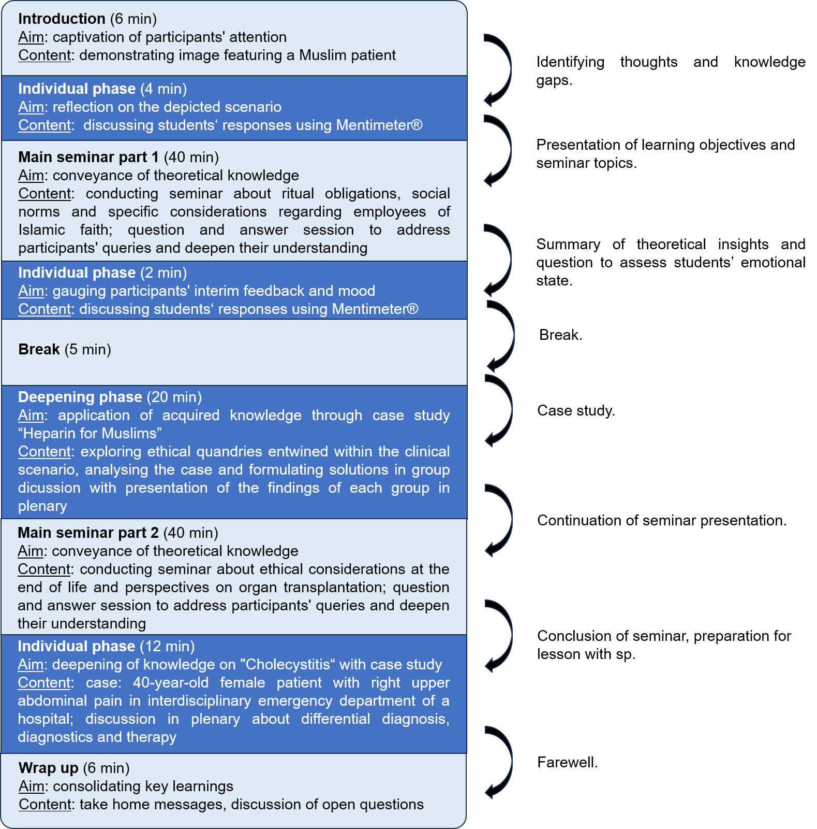
Appendix B: Teaching concept as sandwich approach [16]. Mentimeter®: interactive presentation and polling tool. Case “Heparin for Muslims”[24]: administration of porcine-derived heparin to a Muslim patient, potentially conflicting with Islamic beliefs when alternatives are available. Sp: simulated patient.

