Additional Files 1

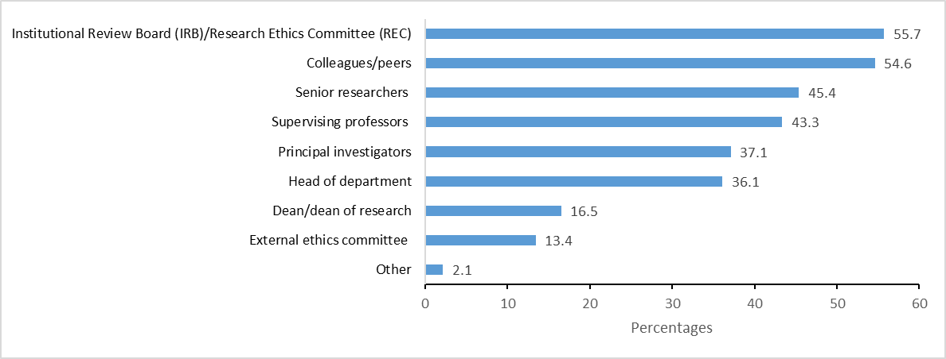
S1 Figure: Sources of Guidance for Ethical Dilemmas and Applied Ethics Queries

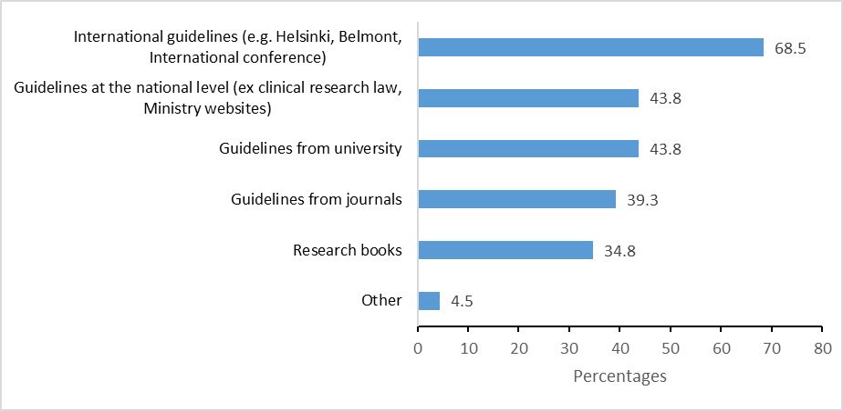
S2 Figure : Resource-Based Guidance for Ethical Dilemmas and Applied Ethics Queries

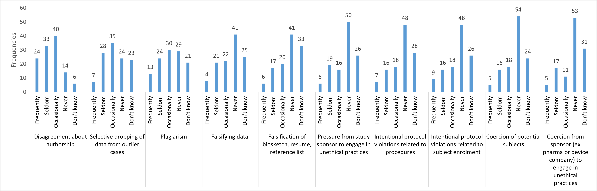
S3 Figure: Perceived prevalence of scientific misconduct in the workplace

S1 Table: Research methodology Training Capacity
 | n | (%)
Have you ever received training in research methodology?
No | 10 | (8.5)
Yes | 107 | (91.5)
What is your level of satisfaction with the content of the research methodology training
Very satisfied | 36 | (33.6)
Satisfied | 51 | (47.7)
Neutral | 19 | (17.8)
Dissatisfied | 1 | (0.9)
If yes, what is the modality of the last training?
Internet based/ online certificate | 18 | (16.8)
Workshop/conference | 26 | (24.3)
Course | 40 | (37.4)
Diploma training | 7 | (6.5)
On-the-job training | 14 | (13.1)
Other | 2 | (1.9)
If yes, what is the modality of the last training?
Undergraduate studies | 2 | (1.9)
Graduate studies | 24 | (22.4)
Postgraduate studies | 56 | (52.3)
Tenure at university | 16 | (15.0)
Other | 9 | (8.4)
Are you interested in attending training workshops on research methodology in the future?
No | 20 | (17.1)
Yes | 97 | (82.9)
If yes, suggest some topics:
Qualitative study / analyses | 17 | (17.5)
Biostatistics | 14 | (14.4)
Public health topics | 11 | (11.3)
Research methodologies | 8 | (8.2)
Advance quantitative research / analysis | 6 | (6.2)
Systematic reviews / Meta-analysis | 6 | (6.2)
Study design | 5 | (5.2)
Advanced Statistical Software Sessions | 4 | (4.1)
Randomized Controlled trials | 4 | (4.1)
Ethics of research and publications | 4 | (4.1)
Artificial intelligence | 2 | (2.1)
Epidemiology | 2 | (2.1)
Sampling / sample size | 2 | (2.1)
Mixed methods | 2 | (2.1)
writing manuscripts, grant writing | 2 | (2.1)
Other | 15 | (15.5)
If yes, what is the modality of the suggested training? (tick all that apply)
Hands-on-practice
No | 12 | (12.4)
Yes | 85 | (87.6)
Virtual workshop
No | 47 | (48.5)
Yes | 50 | (51.5)
Self-paced
No | 73 | (75.3)
Yes | 24 | (24.7)

S2 Table: Research Ethics Training Capacity
 | n | (%)
Have you ever received training in research ethics?
No | 38 | (32.5)
Yes | 79 | (67.5)
If yes, what is your level of satisfaction with the content of research ethics
Very satisfied | 23 | (29.1)
Satisfied | 44 | (55.7)
Neutral | 10 | (12.7)
Dissatisfied | 2 | (2.5)
If yes, where did you receive the last training?
Egypt | 11 | (13.9)
Jordan | 9 | (11.4)
Lebanon | 6 | (7.6)
Oman | 10 | (12.7)
United Arab Emirates | 10 | (12.7)
United States | 15 | (19.0)
Others (Australia, Austria, Ghana, India, Italy, Kuwait, Morroco, New Zealand, Palestine, Philippines, South Africa, United Kingdom) | 18 | (22.7)
If yes, when did you receive the last training in research ethics?
Undergraduate studies | 5 | (6.3)
Graduate studies | 7 | (8.9)
Postgraduate studies | 29 | (36.7)
While working in my current job | 31 | (39.2)
Other | 7 | (8.9)
If yes, what is the modality of the last research ethics training that you recei
Internet-based/online certificate | 23 | (29.1)
Workshop/conference | 19 | (24.1)
Course | 29 | (36.7)
Part of a research study | 7 | (8.9)
Other | 1 | (1.3)
Are you interested in receiving research ethics training in the future?
No | 34 | (29.1)
Yes | 83 | (70.9)
If yes, suggest some topics:
General topic / refresher / updates | 24 | (28.9)
Resolve ethical dilemmas | 7 | (8.4)
Others (e.g. research ethics with children, artificial intelligence, clinical trials, bioethics, conflict of interest) | 42 | (9.6)
If yes, what is the modality of the suggested training? (tick all that apply)
Hands-on-practice
No | 18 | (21.7)
Yes | 65 | (78.3)
Virtual workshop
No | 35 | (42.2)
Yes | 48 | (57.8)
Self-paced
No | 64 | (77.1)
Yes | 19 | (22.9)

S3 Table: Financial Resources Available to Conduct Research
 | Total |  | Education level |  |  |  |  | Gender
 |  |  | PhD |  | Non PhD |  | P-Value | Women |  | Men |  | P-Value
 | n | (%) | n | (%) | n | (%) | P-Value | n | (%) | n | (%) | P-Value
University internal funding
No | 70 | (59.8) | 31 | (47.7) | 39 | (75.0) | 0.003 | 49 | (65.3) | 21 | (50.0) | 0.105
Yes | 47 | (40.2) | 34 | (52.3) | 13 | (25.0) | 0.003 | 26 | (34.7) | 21 | (50.0) | 0.105
Government/National research funds
No | 61 | (52.1) | 30 | (46.2) | 31 | (59.6) | 0.148 | 40 | (53.3) | 21 | (50.0) | 0.729
Yes | 56 | (47.9) | 35 | (53.8) | 21 | (40.4) | 0.148 | 35 | (46.7) | 21 | (50.0) | 0.729
Private sector companies
No | 103 | (88.0) | 55 | (84.6) | 48 | (92.3) | 0.203 | 68 | (90.7) | 35 | (83.3) | 0.241
Yes | 14 | (12.0) | 10 | (15.4) | 4 | (7.7) | 0.203 | 7 | (9.3) | 7 | (16.7) | 0.241
Multilateral and bilateral donor funding
No | 100 | (85.5) | 53 | (81.5) | 47 | (90.4) | 0.177 | 65 | (86.7) | 35 | (83.3) | 0.624
Yes | 17 | (14.5) | 12 | (18.5) | 5 | (9.6) | 0.177 | 10 | (13.3) | 7 | (16.7) | 0.624
Local NGOs
No | 105 | (89.7) | 60 | (92.3) | 45 | (86.5) | 0.307 | 71 | (94.7) | 34 | (81.0) | 0.019
Yes | 12 | (10.3) | 5 | (7.7) | 7 | (13.5) | 0.307 | 4 | (5.3) | 8 | (19.0) | 0.019
International NGOs
No | 88 | (75.2) | 49 | (75.4) | 39 | (75.0) | 0.962 | 58 | (77.3) | 30 | (71.4) | 0.478
Yes | 29 | (24.8) | 16 | (24.6) | 13 | (25.0) | 0.962 | 17 | (22.7) | 12 | (28.6) | 0.478
Out of pocket
No | 77 | (65.8) | 43 | (66.2) | 34 | (65.4) | 0.931 | 48 | (64.0) | 29 | (69.0) | 0.581
Yes | 40 | (34.2) | 22 | (33.8) | 18 | (34.6) | 0.931 | 27 | (36.0) | 13 | (31.0) | 0.581
Other
No | 113 | (96.6) | 65 | (100.0) | 48 | (92.3) | 0.037 | 73 | (97.3) | 40 | (95.2) | 0.617
Yes | 4 | (3.4) | 0 | (0.0) | 4 | (7.7) | 0.037 | 2 | (2.7) | 2 | (4.8) | 0.617
Other international funding
No | 97 | (82.9) | 50 | (76.9) | 47 | (90.4) | 0.055 | 59 | (78.7) | 38 | (90.5) | 0.104
Yes | 20 | (17.1) | 15 | (23.1) | 5 | (9.6) | 0.055 | 16 | (21.3) | 4 | (9.5) | 0.104

S4 Table: Non-Financial Resources Available to Conduct Research
 |  |  |  |  | Education level |  |  |  |  | Gender
 | Total |  | PhD |  | Non-PhD |  | P-value | Women |  | Men |  | P-Value
 | n | (%) | n | (%) | n | (%) |  | n | (%) | n | (%)
Supportive infrastructure (for example, library resources, research office, adequate equipment)
No | 58 | (49.6) | 31 | (47.7) | 27 | (51.9) | 0.649 | 39 | (52.0) | 19 | (45.2) | 0.483
Yes | 59 | (50.4) | 34 | (52.3) | 25 | (48.1) | 0.649 | 36 | (48.0) | 23 | (54.8) | 0.483
Technical and staff support (for example, research assistants)
No | 59 | (50.4) | 32 | (49.2) | 27 | (51.9) | 0.772 | 38 | (50.7) | 21 | (50.0) | 0.945
Yes | 58 | (49.6) | 33 | (50.8) | 25 | (48.1) | 0.772 | 37 | (49.3) | 21 | (50.0) | 0.945
Access to international peer review journals
No | 56 | (47.9) | 25 | (38.5) | 31 | (59.6) | 0.023 | 37 | (49.3) | 19 | (45.2) | 0.671
Yes | 61 | (52.1) | 40 | (61.5) | 21 | (40.4) | 0.023 | 38 | (50.7) | 23 | (54.8) | 0.671
Training for scientific research
No | 79 | (67.5) | 44 | (67.7) | 35 | (67.3) | 0.965 | 53 | (70.7) | 26 | (61.9) | 0.332
Yes | 38 | (32.5) | 21 | (32.3) | 17 | (32.7) | 0.965 | 22 | (29.3) | 16 | (38.1) | 0.332
Sufficient time to conduct research
No | 90 | (76.9) | 49 | (75.4) | 41 | (78.8) | 0.659 | 58 | (77.3) | 32 | (76.2) | 0.888
Yes | 27 | (23.1) | 16 | (24.6) | 11 | (21.2) | 0.659 | 17 | (22.7) | 10 | (23.8) | 0.888
Clear and accessible policies for guiding research
No | 96 | (82.1) | 56 | (86.2) | 40 | (76.9) | 0.196 | 61 | (81.3) | 35 | (83.3) | 0.787
Yes | 21 | (17.9) | 9 | (13.8) | 12 | (23.1) | 0.196 | 14 | (18.7) | 7 | (16.7) | 0.787
Accessible research ethics committee information
No | 79 | (67.5) | 40 | (61.5) | 39 | (75.0) | 0.122 | 49 | (65.3) | 30 | (71.4) | 0.499
Yes | 38 | (32.5) | 25 | (38.5) | 13 | (25.0) | 0.122 | 26 | (34.7) | 12 | (28.6) | 0.499
Active research networks and research collaborations
No | 74 | (63.2) | 37 | (56.9) | 37 | (71.2) | 0.113 | 43 | (57.3) | 31 | (73.8) | 0.076
Yes | 43 | (36.8) | 28 | (43.1) | 15 | (28.8) | 0.113 | 32 | (42.7) | 11 | (26.2) | 0.076
Incentives for research (recognition for researchers, financial incentives, promotion guidelines)
No | 97 | (82.9) | 49 | (75.4) | 48 | (92.3) | 0.024 | 65 | (86.7) | 32 | (76.2) | 0.149
Yes | 20 | (17.1) | 16 | (24.6) | 4 | (7.7) | 0.024 | 10 | (13.3) | 10 | (23.8) | 0.149

S5 Table: Implications for Practice
 | Total |  | Education level |  |  |  |  | Gender
 |  |  | PhD |  | Non PhD |  | P-Value | Women |  | Men |  | P-value
 | n | (%) | n | (%) | n | (%) |  | n | (%) | n | (%)
Which of the below are needed to improve the research experience in your country? (tick all that apply)
Link research outcomes to policies
No | 24 | (20.5) | 8 | (12.3) | 16 | (30.8) | 0.014 | 16 | (21.3) | 8 | (19.0) | 0.769
Yes | 93 | (79.5) | 57 | (87.7) | 36 | (69.2) | 0.014 | 59 | (78.7) | 34 | (81.0) | 0.769
Increase collaboration within institutions (multidisciplinary teams)
No | 30 | (25.6) | 12 | (18.5) | 18 | (34.6) | 0.047 | 20 | (26.7) | 10 | (23.8) | 0.734
Yes | 87 | (74.4) | 53 | (81.5) | 34 | (65.4) | 0.047 | 55 | (73.3) | 32 | (76.2) | 0.734
Increase collaboration between institutions to avoid research waste
No | 31 | (26.5) | 16 | (24.6) | 15 | (28.8) | 0.606 | 20 | (26.7) | 11 | (26.2) | 0.955
Yes | 86 | (73.5) | 49 | (75.4) | 37 | (71.2) | 0.606 | 55 | (73.3) | 31 | (73.8) | 0.955
Allow more time for academics to conduct research
No | 38 | (32.5) | 21 | (32.3) | 17 | (32.7) | 0.965 | 24 | (32.0) | 14 | (33.3) | 0.883
Yes | 79 | (67.5) | 44 | (67.7) | 35 | (67.3) | 0.965 | 51 | (68.0) | 28 | (66.7) | 0.883
Increase awareness of general public about research
No | 44 | (37.6) | 24 | (36.9) | 20 | (38.5) | 0.864 | 24 | (32.0) | 20 | (47.6) | 0.094
Yes | 73 | (62.4) | 41 | (63.1) | 32 | (61.5) | 0.864 | 51 | (68.0) | 22 | (52.4) | 0.094
Supportive political atmosphere at country level
No | 67 | (57.3) | 38 | (58.5) | 29 | (55.8) | 0.770 | 42 | (56.0) | 25 | (59.5) | 0.712
Yes | 50 | (42.7) | 27 | (41.5) | 23 | (44.2) | 0.770 | 33 | (44.0) | 17 | (40.5) | 0.712
Increase researcher awareness of the importance of research
No | 64 | (54.7) | 38 | (58.5) | 26 | (50.0) | 0.361 | 42 | (56.0) | 22 | (52.4) | 0.706
Yes | 53 | (45.3) | 27 | (41.5) | 26 | (50.0) | 0.361 | 33 | (44.0) | 20 | (47.6) | 0.706
Increase collaboration with industry partners
No | 65 | (55.6) | 38 | (58.5) | 27 | (51.9) | 0.479 | 42 | (56.0) | 23 | (54.8) | 0.897
Yes | 52 | (44.4) | 27 | (41.5) | 25 | (48.1) | 0.479 | 33 | (44.0) | 19 | (45.2) | 0.897
Create independent research centers not affiliated to government
No | 59 | (50.4) | 36 | (55.4) | 23 | (44.2) | 0.231 | 35 | (46.7) | 24 | (57.1) | 0.277
Yes | 58 | (49.6) | 29 | (44.6) | 29 | (55.8) | 0.231 | 40 | (53.3) | 18 | (42.9) | 0.277
Increase funding to conduct social science research
No | 39 | (33.3) | 21 | (32.3) | 18 | (34.6) | 0.792 | 20 | (26.7) | 19 | (45.2) | 0.041
Yes | 78 | (66.7) | 44 | (67.7) | 34 | (65.4) | 0.792 | 55 | (73.3) | 23 | (54.8) | 0.041
Engage with local communities to develop research studies that meet their needs
No | 42 | (35.9) | 26 | (40.0) | 16 | (30.8) | 0.301 | 23 | (30.7) | 19 | (45.2) | 0.115
Yes | 75 | (64.1) | 39 | (60.0) | 36 | (69.2) | 0.301 | 52 | (69.3) | 23 | (54.8) | 0.115
Other
No | 109 | (93.2) | 60 | (92.3) | 49 | (94.2) | 0.731 | 69 | (92.0) | 40 | (95.2) | 0.709
Yes | 8 | (6.8) | 5 | (7.7) | 3 | (5.8) | 0.731 | 6 | (8.0) | 2 | (4.8) | 0.709

