Supplemental Materials

Supplement 1. Data Collection Events.

Data Collection Event | Participant Role | # of Participants
1 | Provider | 2
2 | Provider | 1
3 | Provider | 2
4 | Provider | 1
5 | Autistic Adult | 2
6 | Autistic Adult | 1
7 | Autistic Adult | 2
8 (written) | Autistic Adult | 1
9 | Provider | 1
10 | Caregiver | 1
11 | Caregiver | 1
12 | Provider | 2
13 | Caregiver | 2
14 | Caregiver | 1
15 | Caregiver | 1
16 | Provider | 1
17 | Adult | 1
18 | Caregiver | 1
19 | Adult | 1
20 | Caregiver | 1

Supplement 2. Focus Group Guide.

Introduction

Consent
(5 minutes)

Thank you so much for speaking with me today! I’m [name], with [entity 1 – methodological team]. Accompanying me is my colleague [name]. I will be conducting this focus group today, and [name] will be taking notes.

Before we begin, I want to remind you what we are doing here today and why. Much of this is the same information you received when you consented to participate, but we want to reiterate a few things to be sure we are all on the same page. This will be a bit of me talking at you, so please bear with me.

We are partnering with the [entity 2 - autism research center] to explore different methods of autism screening for young children, and we are particularly interested in the use of a machine learning based clinical prediction model, the specifics of which we will explain in a bit. There are important ethical questions of how to best use these methods to foster shared decision making and to help providers and families work together to make the best health care decisions. Through our research, we aim to develop a set of practice-oriented guidelines on how to best use these screening methods.

To do this, we are gathering information for three key groups, including
- Caregivers of autistic children
- Autistic adults
- Clinical providers who may screen for autism, diagnose autism, or work with autistic children and their caregivers

We are asking to speak to you in a focus group, or a moderated group discussion, for approximately 90 minutes. What you share will contribute to our guidance and recommendations.

We will be recording our focus group today and all recording will be stored on a secure network drive. As you read or heard when you consented to participate, we will make every effort to keep your information confidential, however this cannot be guaranteed given the group nature of this discussion. We ask that all of you respect each other’s privacy and keep what is said today to yourself. What we can assure you is that your identity and the confidential information you discuss will not be directly disclosed in any publications which might come out of this research.

Your participation in this focus group is voluntary. You can skip any question you would like. If you want to stop taking part after the focus group has begun, just let me know; you can exit at any time. There are no direct benefits to you for joining this study; however, the information you provide can help inform and improve autism screening.

The format of this focus group is fairly informal. I do have specific areas to discuss, but there is no need to keep to a strict question-and-answer format. You may share your thoughts in whatever way makes you comfortable, such as by raising your hand, commenting in the chat, or simply coming off mute.

With all of this information, are you still comfortable participating today? [Yes/no; go around group and for verbal consent from all]

And are you OK with us recording this focus group? [Yes/no; go around group and for verbal consent from all]

START RECORDING

Thank you so much for your time and cooperation. We truly value your input.

Before we begin, I also want to note that [notetaker] and I are not the data scientists building these models, nor are we autism experts. We are collaborating with those individuals to collect your opinions and expertise. We will use some technical language throughout, but we aim to keep that to a minimum.

Do you have any questions for me before we begin?

Part 1: Broad perspective on clinical prediction tools/models for autism

View of Current Method
(10 minutes)

We’d like to start today by getting your thoughts on an autism screening tool for toddlers.
Currently, when a child goes to the doctor for their 18-24 month well child visit, it is recommended by the American Academy of Pediatrics that their caregiver completes a questionnaire. This questionnaire, called M-CHAT, asks caregivers to consider autism-related behaviors their child may or may not be exhibiting. The results of the questionnaire show if the child has a low or high likelihood of being diagnosed with autism or another developmental condition. Those results may then trigger additional screenings and referral for an autism diagnostic evaluation.
- Does this screening process generally make sense? [address if questions]
- What do you think about using this particular tool, a caregiver questionnaire called the M-CHAT, for autism screening?
  - What do you think the benefits are of screening using a caregiver questionnaire?
  - How much would or do you trust screenings made using a caregiver questionnaire? Why?
  - What concerns would or do you have about screenings made using a caregiver questionnaire?
  - Probe: personal experience with this or similar screening tools
- [if not bought up organically] Do you have any questions about this screening questionnaire?

View of New Method
(10 minutes)

Great, thanks. Now, let’s talk about the new method that researchers are currently developing. To make things easier, I am going to share an image that explains this process.

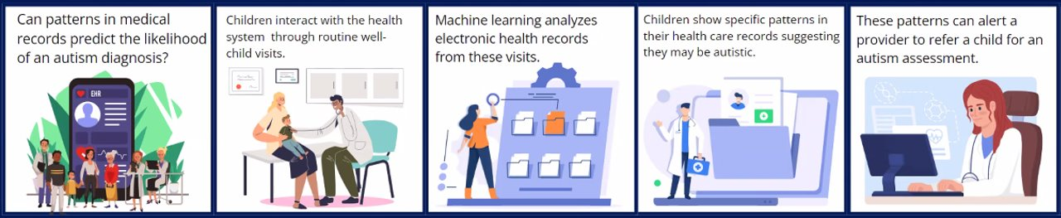

Rather than rely just on the caregiver perspective and clinician judgement, the new method uses machine-learning to search for patterns in patient health data included in electronic health records where the outcome is known – that is, we know whether they were diagnosed with autism or not. Then, the machine-learning model uses these identified patterns to make a prediction for other children where the outcome is not known.. The results of the machine-learning model will show if the child has a low, medium or high likelihood of being diagnosed with autism if they were to complete a clinical evaluation.

- Does this generally make sense? [address if questions]
- What do you think about screenings done using machine-learning to identify patterns in patients’ data? Why?
  - What do you think the benefits are of screening using machine learning?
  - How much would you trust screenings made using machine learning? Why?
  - What concerns do you have about screenings made using machine learning?
- [if not bought up organically] Do you have any questions about the machine learning process? We can answer if you do, to the best of our ability.

Comparison
(15 minutes)

Now, let’s think about the two methods together. Recall that in the current method, a caregiver completes a screening questionnaire that reveals their child’s likelihood of being diagnosed with autism if they receive a clinical evaluation. In the new method, machine-learning is used to look at patient health data that is part of electronic health records and then predicts a child’s likelihood of being diagnosed with autism if they receive a clinical evaluation.
- Do you think one method is better than the other? Why?
  - Would you have a preference? Why?
  - Would you trust one more than the other? Why?

Now I am going to talk about a few different things to see if they change or do not change your preference between the two methods and your level of trust in the two methods.
- First, would your preference between the two methods change if we were discussing screening for something OTHER than autism, such as heart disease risk? Why or why not?
- Second, one advantage of using machine-learning is that it may make connections that people might not think of. However, it may find patterns that exist in the dataset but are not meaningful in reality. [example if needed: “being left handed is associated with being smarter”]
  - Does knowing this change your preference between the two methods?
  - Does it change your level of trust in either screening method?
- Third, the machine learning method may involve automatically using available health data to screen for autism, which means that caregivers would not specifically consent to their child being screened. The caregiver themselves may also not have any concerns about their child’s development.
  - Does knowing this change your preference between the two methods?
  - Does it change your level of trust in either screening method?
  - [if yes for either] how would you prefer for consent to be collected? [can probe here for “opting-in” (i.e. giving permission to use data for ML) or “opting-out”]
- Finally, I want to discuss timing. As a reminder, the current method using the M-CHAT can screen for autism when a child is 18-24 months old. The new machine-learning method could screen for autism when a child is 1 month old though there are currently no diagnostic tools or interventions available at this age.
  - Does knowing this change your preference between the two methods?
  - Does knowing this change your level of trust in either screening method?

Use in Shared Decision Making
(15 minutes)

Let’s turn now to shared decision-making, which refers to a process in which both the patient, or caregiver in this case, and the physician contribute to medical decision-making. In some processes of medical decision-making, caregivers do not participate in treatment decisions. Instead, physicians tell caregivers what to do from a position of authority. In shared decision-making, a medical provider explains the treatment options; caregivers tell the providers what their preferences, goals, and beliefs are; and then they work together to find the best match. [definition to be put in the chat]

- In general, what shared decisions do you think could or should be made after autism screening?
- In what ways, if any, may using machine-learning in autism screening affect any of these shared decision-making processes or conversations?
  - [If yes] What specific decisions do you think would be affected? Why?
- In what ways, if any, would screenings done at 1 month (versus 18-24 months) affect any of these shared decision-making processes or conversations? As a reminder, there are currently no diagnostic tools or interventions available at this age.
  - [If yes] What specific decisions do you think would be affected? Why?

Now I am going to ask you to imagine a few situations in which machine learning is being used to screen for autism…
- If the machine learning screening result is different from what a provider thinks is true based on their clinical experience, what should they tell the patients when trying to make decisions together? Why? [If respondents asks if they should be thinking about ML results from 1 month vs. 1 year, probe on if/why that information would make a difference in their response]
  - Is this similar or different than what providers would do if they disagreed with MCHAT results?
- When sharing the results of the screener, how important do you think it is, if at all, to share with caregivers that the screener used machine-learning or artificial intelligence?
- When sharing the results of the screener, how important do you think it is, if at all, to explain the factors, or data, used to inform the machine learning model?
  - [if important] How do you think the factors the model is using to determine the prediction should be shared with the caregiver?
  - [if not important] Do you think it’s important for providers to know/understand the factors that inform the model? Why or why not?
- Are there any other factors you would consider when presenting or discussing the results of the autism screener?
  - Do these factors differ based on the method of screening?

Part 2. Response to specific example scenarios
(30 minutes)

Next, we would like your feedback on some specific example scenarios.

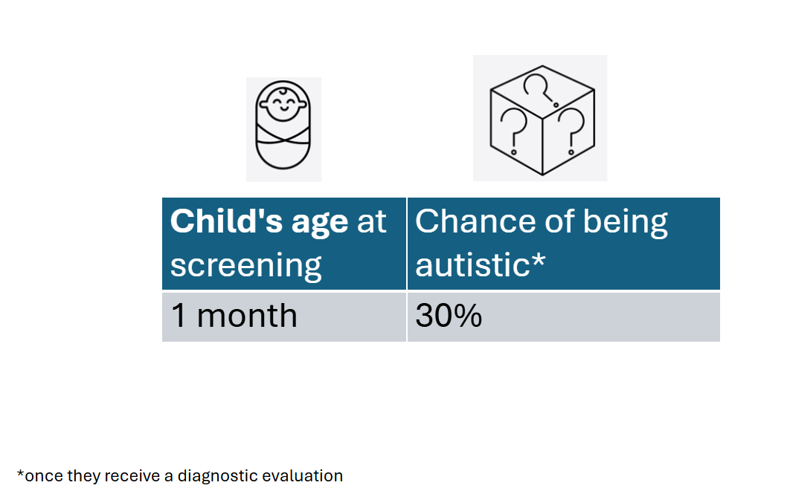

[Share Slide 2] Imagine a caregiver and their child are at their 1 month well-child visit. Their doctor tells them there is a new machine-learning model available to screen for likelihood of autism based on patient data. The doctor says that based on this model, there is a 30% chance that their child is autistic
- How would you interpret the results of this screening?
- What questions would you have?
- Is this result useful/helpful for decision-making? Why or why not?
- What questions would you have about next steps?

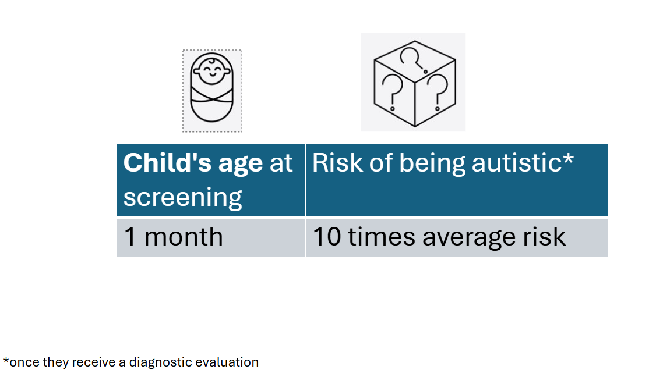

[Slide 3] Now, what if the doctor instead told the caregiver that their child had 10x the average risk of autism. Please note that this is same as having a 30% change of being autistic. [if needed, the prevalence or general “risk” or being autistic is 3%]
- Does this wording change how you would interpret the result of this screening?
  - [probe, if time] how do you feel about the word “risk” being used?
- Would you have any additional questions?
- Do you have a preference in what way the results are shared? [facilitator can flip back and forth between slides]

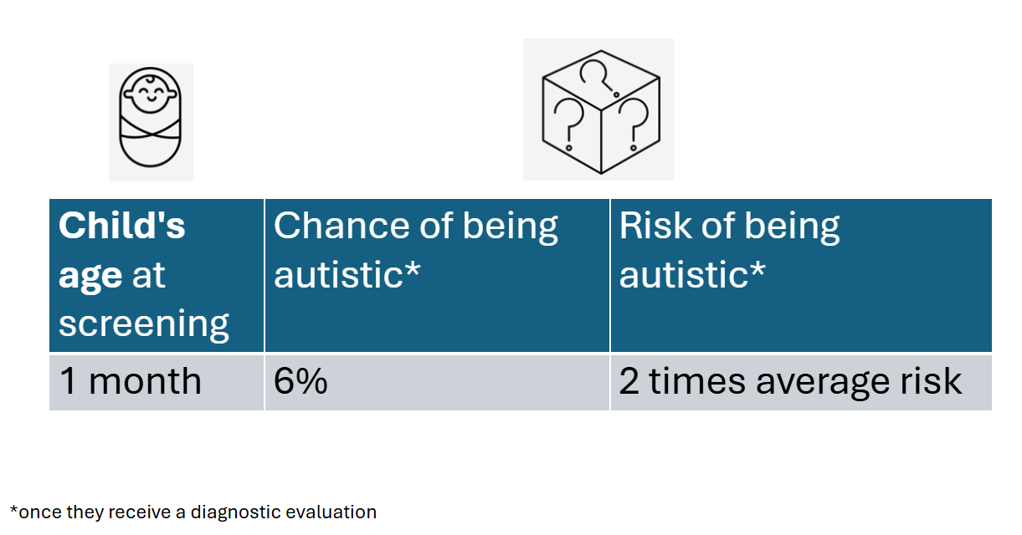

[Slide 4] Now, what if the doctor instead told the caregiver that their child had a 6% chance of being autistic or 2x the average risk of being autistic?
- How would you interpret the results of this screening?
- Is this result useful/helpful for decision-making? Why or why not?
- Is there a threshold at which you would not even want to know the results of the screening?

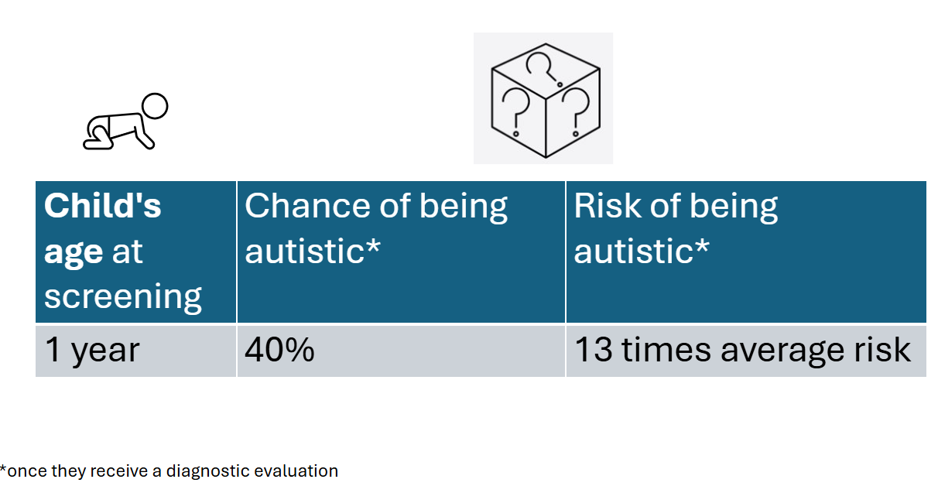

[Slide 5] I now want to introduce a slightly different scenario. A caregiver and their child are at their 1-year well child visit – not the 1-month visit. Their doctor tells them there is a new machine-learning model available to screen for likelihood of autism based on patient data. The doctor says that based on this model, there is a 40% chance that their child is autistic or 13 times the average risk.
- How do you interpret the results of this screening?
- What questions would you have?
- Is this result useful/helpful for decision-making? Why or why not?
- Is this result, at 1 year, more or less useful than that a 1 month?

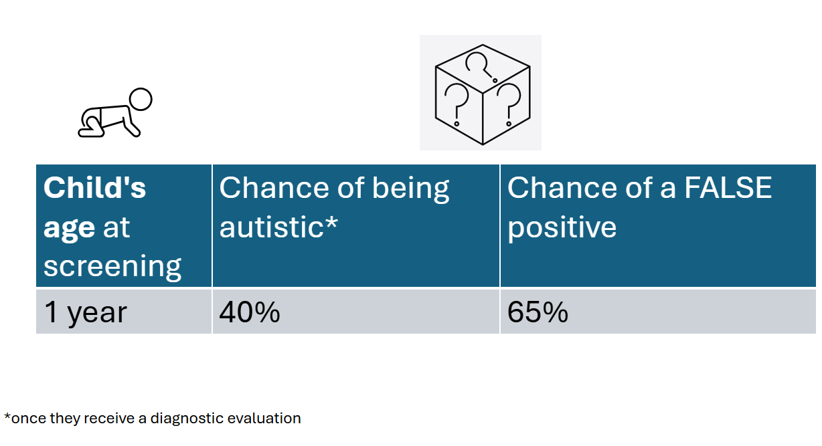

[Slide 6] Now, I want to introduce one more component to this scenario. What if the doctor told the caregiver that, according to the machine-learning model, their child had a 40% chance of being autistic, but a 60% chance of a false positive. This means, that there is a 60% chance that their child would screen positive for autism when, in reality, they do not have autism.
- Does this make sense?
- Does knowing this information change how you would interpret the results of this screening?
- Does knowing this information change how useful these results are for decision-making?

Ending
(5 minutes)
Is there anything else you’d like to say, before we finish? Or is there anything we haven’t covered that you think is important to consider, regarding autism screening, machine learning or shared decision-making? Anything else, you’d like to add.

Thank you so much for your time. It was so helpful to speak with you. As a thank you, we will be giving you $50 via ClinCard. Partners of ours email you a form to complete to receive this payment.

Thank you again.

Supplement 3. Coding Schema.

Parent Code | Child Code (if applicable) | Grandchild Code (if applicable) | Great-Grandchild Code (if applicable) | Description | Use (if applicable; if clarification on use deemed valuable in early coding process)
Tool |  |  |  | references the tool/method of screening | Only code here when it is unclear what type of screening method participants are referring to or if they are specifically referring to screening without reference to a specific method
Tool | MCHAT |  |  | mentions of MCHAT | Code whenever someone is talking about MCHAT; will always be co-coded with a thematic code.
Tool | ML |  |  | mentions of ML autism screening tool | Code whenever someone is talking about ML tool; will always be co-coded with a thematic code. Do not need to code in scenario section.
Perception of Tool |  |  |  | how participants respond to the tools/methods/screenings in general | DO NOT CODE
Perception of Tool | Trust |  |  | participants discussing their trust in the tool | Use 1) When facilitator specifically probes/asks about trust (in general and if levels of trust change), 2) Whenever participants specifically use the word "trust." For the former, will always be co-coded with a Quantification code. If there are examples where it really seems like the participant is talking about trust, but the reference does not meet the coding criteria described here, code to Coding Questions
Perception of Tool | Benefits |  |  | any references to the benefits, value, or utility of the tool | Use when 1) When facilitator specifically probes about benefits, 2) when facilitator probes for "general thoughts on Mchat or ML" and participants are talking about benefits, 3) participants use words/phrases like "benefit," "value," "good," "helpful," etc. in reference to either tool. In general, it is better to overcode than undercode this
Perception of Tool | Concerns |  |  | refers to any concerns or perceived barriers participants discuss | Use when 1) When facilitator specifically probes about concerns, 2) when facilitator probes for "general thoughts on Mchat or ML" and participants are talking about concerns, 3) participants use words/phrases like "concern," "challenge" or "barrier" etc. in reference to either tool. In general, it is better to overcode than undercode this
Perception of Tool | Questions |  |  | refers to any questions that participants ask about the different tools and how they might work | Use when 1) facilitator asks if there are any questions that participants would have about the tool or results (ex: in scenarios), 2) when participants naturally bring up questions about the tools or results
Tool Characteristics |  |  |  | refers to the characteristics of the tool in question, either ML or MCHAT | DO NOT CODE
Tool Characteristics | Accuracy |  |  | references concerning the accuracy of the tool and its results | Use 1) whenever someone specifically says "accuracy," 2) whenever someone discusses synonyms for accuracy or how well the tool works at actually screening for autism "correctly". Only code here when grand child codes are not relevant
Tool Characteristics | Accuracy | Data Source |  | references to any data used to inform the results of the ML algorithm or the MCHAT. | Use whenever there is discussion of the data that informs the Mchat or ML results. This could include: behavioral data/observations, EHR data, number of appointments, etc. Also code here when participants discussing wanting to know what data would go into a result; in that instance, co-code with questions.
Tool Characteristics | Accuracy | Data Source | Parent | any references to parents/caregivers role in providing data to inform autism screenings | examples: parents know their kids best, parents may not fill out the Mchat honestly because of stigma; parents may not understand Mchat questions
 |  |  | Provider | any references to providers/healthcare workers' role in providing data to inform autism screenings | examples: how providers input HER data that will then be used in a ML screening
Tool Characteristics | Accuracy | Correlations |  | references to erroneous correlations that the ML algorithm may find | will likely only be coded in the section where facilitators specifically ask about this
Tool Characteristics | Accuracy | False Positives |  | references to false positives (or false negatives) | will likely be coded the most in the final scenario in which this is probed
Tool Characteristics | Presentation |  |  | references to how the tool and its results will or should be presented to providers and families. Consider how results are communicated verbally and visually, and what information is included or not included. | Better to over-code this one then to under-code. Don't need to code this for every thing in the scenario section; only when relevant to how data is presented
Tool Characteristics | Presentation | Provider View Different |  | Any references to a provider's opinion on the results of a screener. This was specifically asked in the guide, but may also be referenced more broadly, esp. in relation to potential provider "bias"
Tool Characteristics | Presentation | Risk |  | references to how results are worded specifically within the Scenario section
Tool Characteristics | Ease of Use |  |  | references to how easy/difficult the tool is to engage with | similar to Presentation, but more of a focus on providers
Tool Characteristics | Equity |  |  | references to any discussion of equity or inequity, i.e. considerations of who the tool may or may not benefit and whether it will operate in an equitable/fair way. Think of things like "this tool may miss a lot of children" or "this tool will catch more children" | references will likely be about who the ML tool can diagnose vs. MCHAT (example: ML will help diagnose girls whereas the MCHAT typically underdiagnoses girls).
Tool Characteristics | Consent |  |  | any references to the consent process
Tool Characteristics | Timing |  |  | references to when screenings do/will take place | code here when participants are not specifically referencing the timepoints below
Tool Characteristics | Timing | 1 month |  | references to screenings done at 1 month | do not need to automatically code in scenario section; just code when timing is relevant
Tool Characteristics | Timing | 1 year |  | references to screenings done at 1 year or beyond | do not need to automatically code in scenario section; just code when timing is relevant
Decisions |  |  |  | references to the decisions, uses, or next-steps after receiving a screening result | can code here if unsure what child code to use
Decisions | Follow Up Screening |  |  | references to getting additional screenings after original MCHAT or ML screening
Decisions | Formal Diagnosis |  |  | references to getting diagnosed with autism
Decisions | Services |  |  | references to getting referrals to services/interventions/resources, etc. Can be formal or informal resources.
Decisions | Education/Awareness |  |  | references to awareness or education around autism; typically described as a potential value of screenings
Decisions | Shared |  |  | any references to SHARED decision making only | co-code with other decisions
Decisions | Early |  |  | any references to when decisions can be made earlier, typically described as a potential value of ML screenings specifically
Decisions | Next Steps |  |  | any references to participants asking about next steps or what's next
Topics | Stigma |  |  | references to the stigma or other potentially negative viewpoints associated with autism
Topics | Overwhelm |  |  | related to overwhelm that caregivers may feel upon receiving an autism screening or diagnosis; this most often comes up in relation to screenings being done at 1 month
Topics | Personal Experiences |  |  | code here for anytime participants discuss how their personal experiences with autism screening are influencing their opinions | use code here so that we can provide rich context
Scenario |  |  |  | organizational codes to quickly differentiate between scenarios; DO NOT CODE
Scenario | 1 |  |  | scenario of 30% chance at 1 month
Scenario | 2 |  |  | scenario of 10x risk at 1 month
Scenario | 3 |  |  | scenario of 2x risk or 6% chance at 1 month
Scenario | 4 |  |  | scenario of 30% chance at 1 year
Scenario | 5 |  |  | scenario of false positives
Coding Questions |  |  |  | code here when you have questions about what code to use. | We will discuss as a duo (SQ/EH) or as a full team
Memorable Quotes |  |  |  | code here for any particularly good quotes that you think we could use in our final paper
Identifiabillity Concerns |  |  |  | code here for anything that would break confidentiality or identify participants if we were to share
New Codes |  |  |  | a place-holder for new codes that you think would be useful | DO NOT CODE. Just add whatever new code as a child code. This will not affect project merging
Quantification Codes |  |  |  | anything coded to here will be reviewed and quantified using the excel doc on the next sheet | for all, better to overcode
 | 1_TrustMChat |  |  | "How much would or do you trust screenings made using a caregiver questionnaire?"
 | 2_TrustML |  |  | "How much would you trust screenings made using machine learning? "
 | 3_Preference_ML or MCHAT |  |  | "Do you think one method is better than the other? Would you have a preference?"
 | 4_Trust_ML or MCHAT |  |  | "Would you trust one more than the other?"
 | 5_Pref_Change_Heart Disease |  |  | "would your preference between the two methods change if we were discussing screening for something OTHER than autism, such as heart disease risk?"
 | 6_Trust_Change_Heart Disease |  |  | "would your trust between the two methods change if we were discussing screening for something OTHER than autism, such as heart disease risk?"
 | 7_Pref_Change_Timing |  |  | "I want to discuss timing…does knowing this change your preference between the two methods?"
 | 8_Trust_Change_Timing |  |  | "I want to discuss timing…does knowing this change your trust in either screening method?"
 | 9_Importance_Sharing ML |  |  | "In your opinion, when a medical provider is sharing the results of the screener, how important is it for them state that the screener used machine-learning or artificial intelligence?"
 | 10_Importance_Sharing Factors |  |  | "How important is it for the doctor to explain the factors, or data, used to inform the machine learning model?"
 | 11_Pref_Scenario 1 or 2 |  |  | "do you have a preference in which way results are shared? [scenario 2]"
 | 12_Useful_Scenario 1 |  |  | "is this result useful for decision making?" [scenario]
 | 13_Useful_Scenario 2 |  |  | "is this result useful for decision making?" [scenario]
 | 14_Useful_Scenario 3 |  |  | "is this result useful for decision making?" [scenario]
 | 15_Useful_Scenario 4 |  |  | "is this result useful for decision making?" [scenario]
 | 16_Useful_Scenario 5 |  |  | "is this result useful for decision making?" [scenario]

Coding Schema – Additional

Key ID (same color if from same focus group) |  | Participant Key ID 1 | Participant Key ID 2 | Participant Key ID 3 | cont.
NVIVO Code | Options
Trust in Mchat | Low, Mid, High, Depends, Unclear/Unknown
Trust in ML | Low, Mid, High, Depends, Unclear/Unknown
Preference between ML and MChat | ML, Mchat, Combo, Unclear/Unknown
Trust ML or Mchat more? | ML, Mchat, the same, Unclear/Unknown
Preference between ML and Mchat, if measuring something other than autism | ML, Mchat, Combo, Unclear/Unknown
Trust ML or Mchat more, if measuring something other than autism | ML, Mchat, the same, Unclear/Unknown
Preference between ML and Mchat, if screenings done at 1 month | ML, Mchat, Combo, Unclear/Unknown
Trust ML or Mchat more, if screenings done at 1 month | ML, Mchat, the same, Unclear/Unknown
Importance of Sharing Factors | Low, Mid, High, Depends, Unclear/Unknown
Importance of Sharing ML | Low, Mid, High, Depends, Unclear/Unknown
Preference between Scenario 1 and Scenario 2 | Scenario 1, Scenario 2, Combo, Unclear/Unknown
Scenario 1, results useful for decision making? | Yes, Maybe, No, Depends, Unclear/Unknown
Scenario 2, results useful for decision making? | Yes, Maybe, No, Depends, Unclear/Unknown
Scenario 3, results useful for decision making? | Yes, Maybe, No, Depends, Unclear/Unknown
Scenario 4, results useful for decision making? | Yes, Maybe, No, Depends, Unclear/Unknown
Scenario 5, results useful for decision making? | Yes, Maybe, No, Depends, Unclear/Unknown

Supplement 3. Adapted COnsolidated criteria for REporting Qualitative research (COREQ) checklist

Topic | Item No. | Guide Questions/Description | Addressed in manuscript
Domain 1: Research team and reﬂexivity
Personal characteristics
Interviewer/facilitator | 1 | Which author/s conducted the interview or focus group? | No (facilitators are paper co-authors; specific co-authors conducting focus groups is not referenced)
Credentials | 2 | What were the researcher’s credentials? | Yes
Occupation | 3 | What was their occupation at the time of the study? | No
Gender | 4 | Was the researcher male or female? | No
Experience and training | 5 | What experience or training did the researcher have? | No
Relationship with participants
Relationship established | 6 | Was a relationship established prior to study commencement? | No
Participant knowledge of  the interviewer | 7 | What did the participants know about the researcher? | No
Interviewer characteristics | 8 | What characteristics were reported about the interviewer/facilitator? | No
Domain 2: Study design
Theoretical framework
Methodological orientation and Theory | 9 | What methodological orientation was stated to underpin the study? | Yes
Participant Selection
Sampling | 10 | How were participants selected? | Yes
Method of approach | 11 | How were participants approached? | Yes
Sample size | 12 | How many participants were in the study? | Yes
Non-participation | 13 | How many people refused to participate or dropped out? Reasons? | No
Setting
Setting of data collection | 14 | Where was the data collected? | Yes
Presence of non-participants | 15 | Was anyone else present besides the participants and researchers? | Yes
Description of sample | 16 | What are the important characteristics of the sample? | Yes
Data collection
Interview guide | 17 | Were questions, prompts, guides provided by the authors? Was it pilot  tested? | Yes
Repeat interviews | 18 | Were repeat interviews carried out? If yes, how many? | Yes
Audio/visual recording | 19 | Did the research use audio or visual recording to collect the data? | Yes
Field notes | 20 | Were ﬁeld notes made during and/or after the interview or focus group? | No
Duration | 21 | What was the duration of the interviews or focus group? | Yes
Data saturation | 22 | Was data saturation discussed? | Yes
Transcripts returned | 23 | Were transcripts returned to participants for comment and/or correction? | No
Domain 3: analysis and findings
Data analysis
Number of data coders | 24 | How many data coders coded the data? | Yes
Description of the coding  tree | 25 | Did authors provide a description of the coding tree? | Yes (coding schema provided)
Derivation of themes | 26 | Were themes identiﬁed in advance or derived from the data? | Yes
Software | 27 | What software, if applicable, was used to manage the data? | Yes
Participant checking | 28 | Did participants provide feedback on the ﬁndings? | No
Reporting
Quotations presented | 29 | Were participant quotations presented to illustrate the themes/ﬁndings?  Was each quotation identiﬁed? | Yes
Data and ﬁndings consistent | 30 | Was there consistency between the data presented and the ﬁndings? | Yes
Clarity of major themes | 31 | Were major themes clearly presented in the ﬁndings? | Yes
Clarity of minor themes | 32 | Is there a description of diverse cases or discussion of minor themes? | Yes

