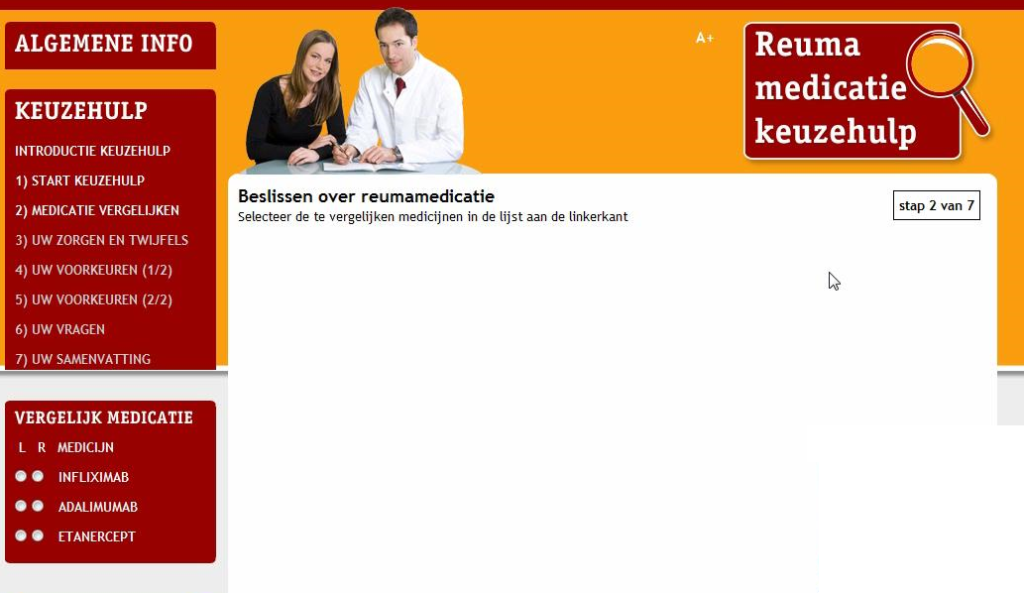
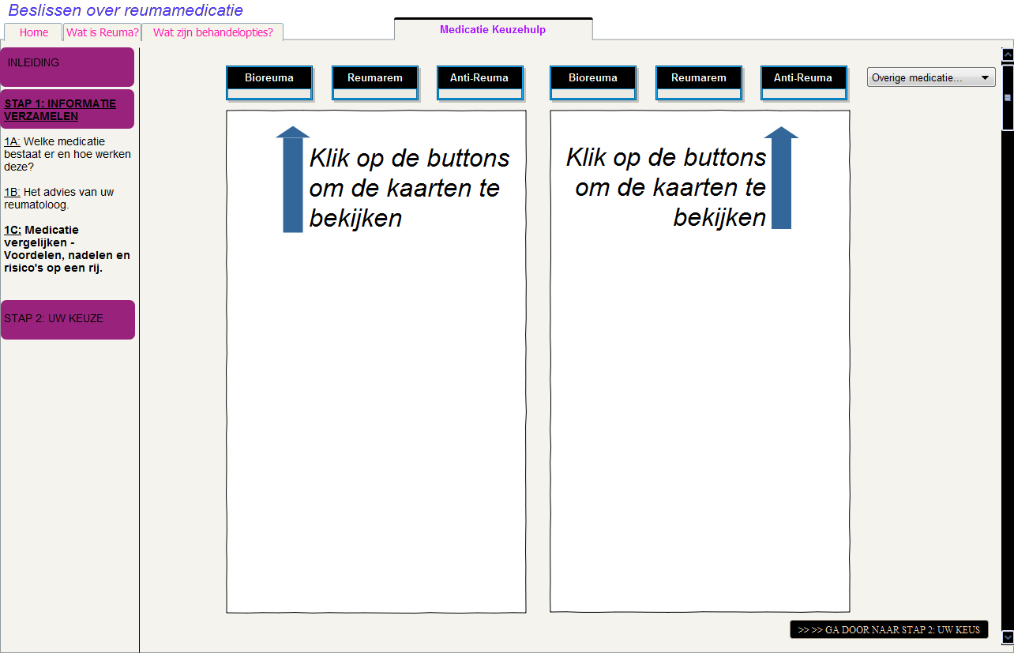
Screenshot 1: First draft (paper prototype) of the screen used during the needs assessment. This screen enabled patients to compare medications. The fictional medication names “Bioreuma,” “Reumarum” and “Anti-Reuma” were used to avoid providing incorrect information to patients.
Screenshot 2: The working prototype of the screen used in the usability study. This screen enabled patients to compare medications. The study revealed that the placement of two medicines side-by-side was not intuitive or easy to use. (See the left-hand corner box titled “Vergelijk Medicatie” with the buttons L, R and Medicijn.)
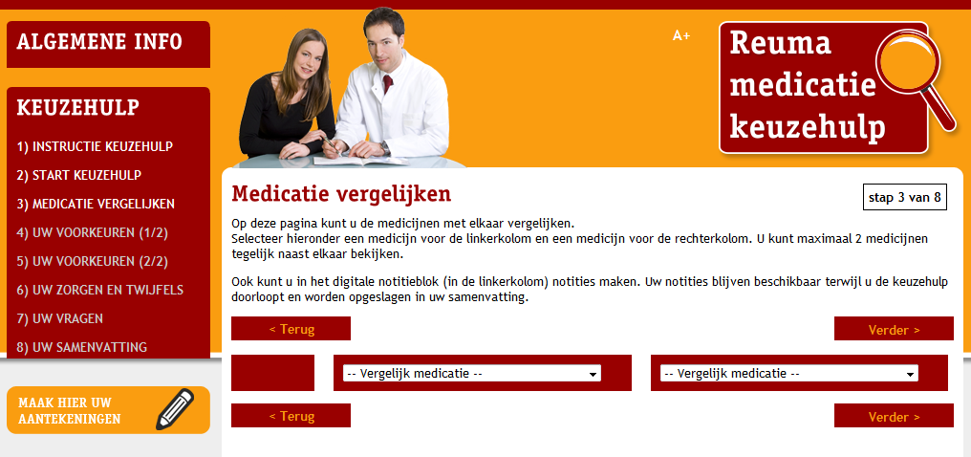Screenshot 3: Final version of the screen that enabled patients to compare medications. User navigation was adjusted based on results of the usability study.

