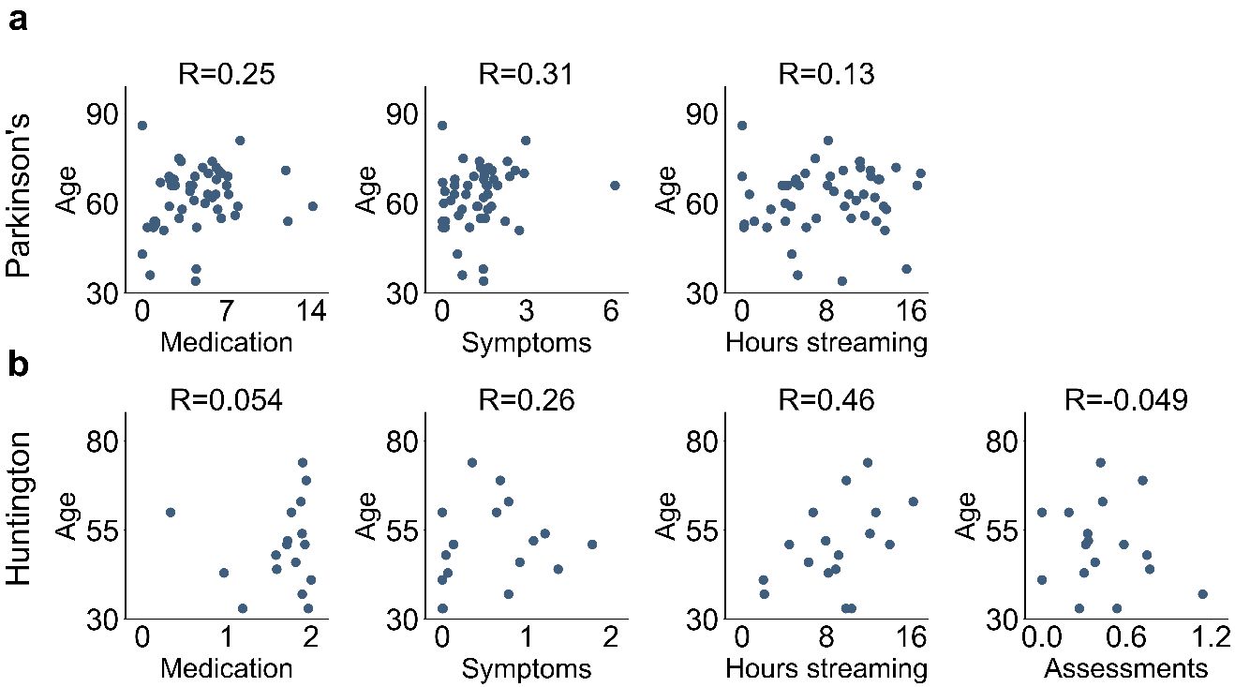
Supplementary Fig. 3 Compliance patterns by age for the PD and HD studies. Scatter plots portray compliance patterns for all three remote compliance metrics studied in the PD study and the four metrics studied in the HD study. The R values in the plot are Spearman’s rank-order correlations.

