Additional file 1
Neuro team
Home visits

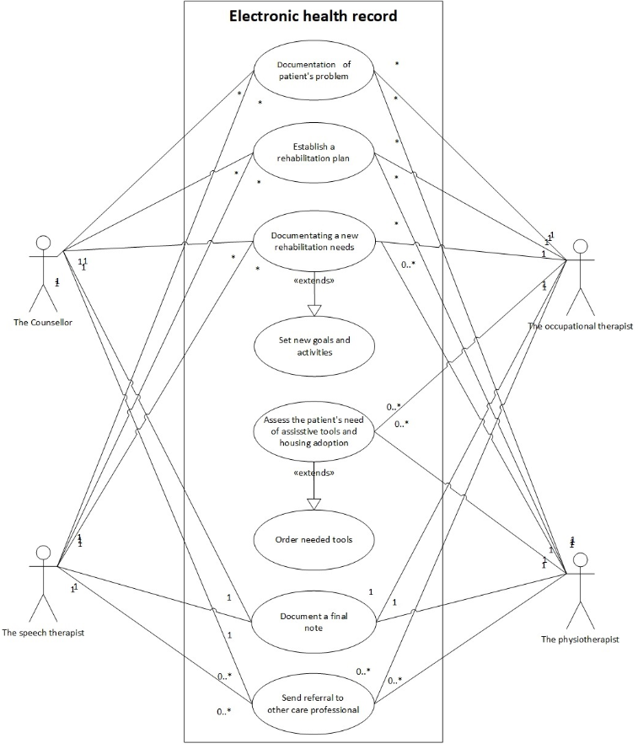

Care and rehabilitation planning tool, eHealth service for citizens
Patient
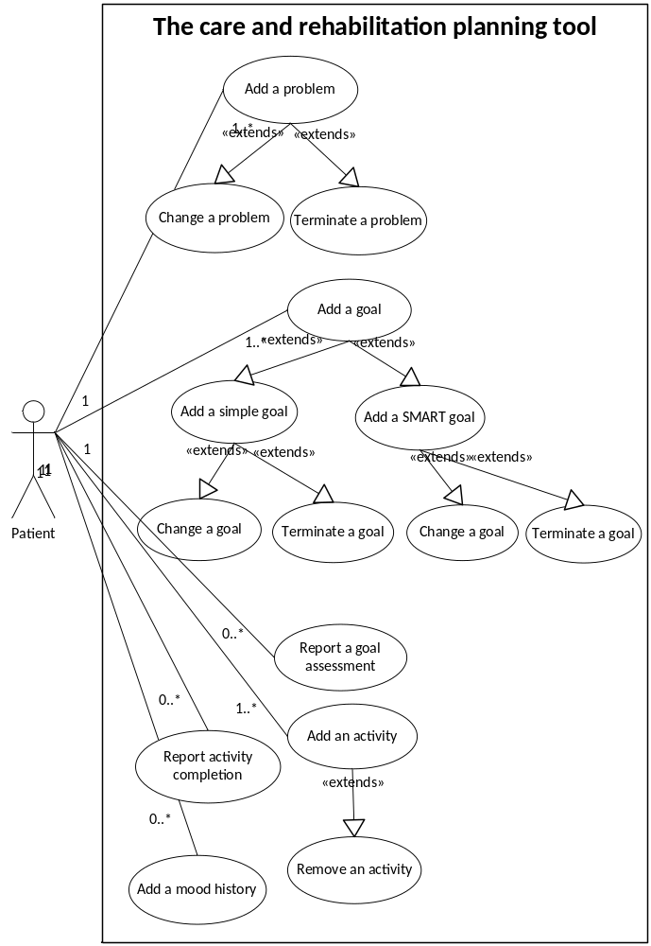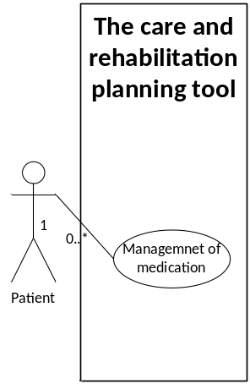

Physician & district nurse
Electronic Health Record
