APPENDIX 2. DT classifier results
Table A2.1 – DT performance results
maximal depth | 2 | 4 | 8 | 16
Series replaced with the last values; missing values filtered out
Precision | 0.6139 | 0.6276 | 0.6264 | 0.5803
Recall | 0.5929 | 0.6312 | 0.6265 | 0.5917
F1-score | 0.6018 | 0.6280 | 0.6258 | 0.5857
Accuracy | 0.6589 | 0.6750 | 0.6737 | 0.6351
Series replaced with the last values; missing values filled in from medians
Precision | 0.7236 | 0.7244 | 0.6967 | 0.6397
Recall | 0.6319 | 0.6407 | 0.6575 | 0.6566
F1-score | 0.6745 | 0.6794 | 0.6761 | 0.6478
Accuracy | 0.7368 | 0.7391 | 0.7282 | 0.6920
Series replaced with the set of statistical characteristics; missing values filtered out
Precision | 0.6720 | 0.6977 | 0.6537 | 0.6016
Recall | 0.5232 | 0.6036 | 0.6307 | 0.6238
F1-score | 0.5867 | 0.6465 | 0.6414 | 0.6122
Accuracy | 0.6798 | 0.7125 | 0.6927 | 0.6556
Series replaced with the set of statistical characteristics; missing values filled in from medians
Precision | 0.6431 | 0.7203 | 0.6923 | 0.6452
Recall | 0.5697 | 0.6142 | 0.6693 | 0.6623
F1-score | 0.5986 | 0.6618 | 0.6801 | 0.6534
Accuracy | 0.6747 | 0.7296 | 0.7285 | 0.6969
Series replaced with maximums; missing values filtered out
Precision | 0.7356 | 0.7016 | 0.6641 | 0.5949
Recall | 0.4643 | 0.6070 | 0.6230 | 0.6122
F1-score | 0.5688 | 0.6500 | 0.6423 | 0.6031
Accuracy | 0.6933 | 0.7153 | 0.6976 | 0.6489
Series replaced with maximums; missing values filled in from medians
Precision | 0.6989 | 0.6997 | 0.6850 | 0.6358
Recall | 0.5106 | 0.6144 | 0.6610 | 0.6458
F1-score | 0.5844 | 0.6528 | 0.6722 | 0.6417
Accuracy | 0.6905 | 0.7187 | 0.7220 | 0.6877

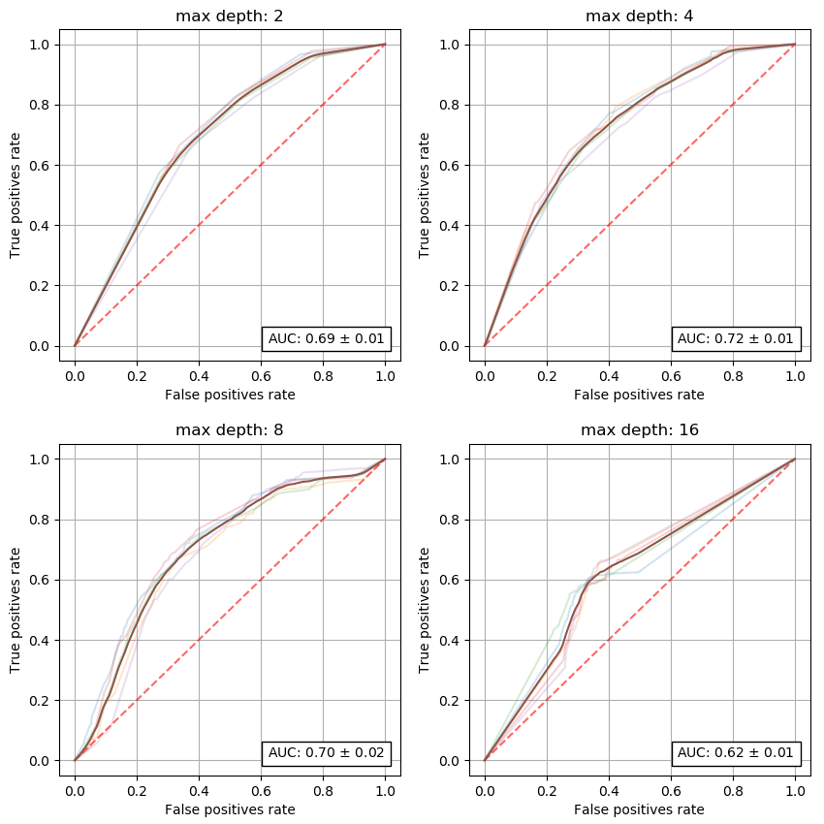 | 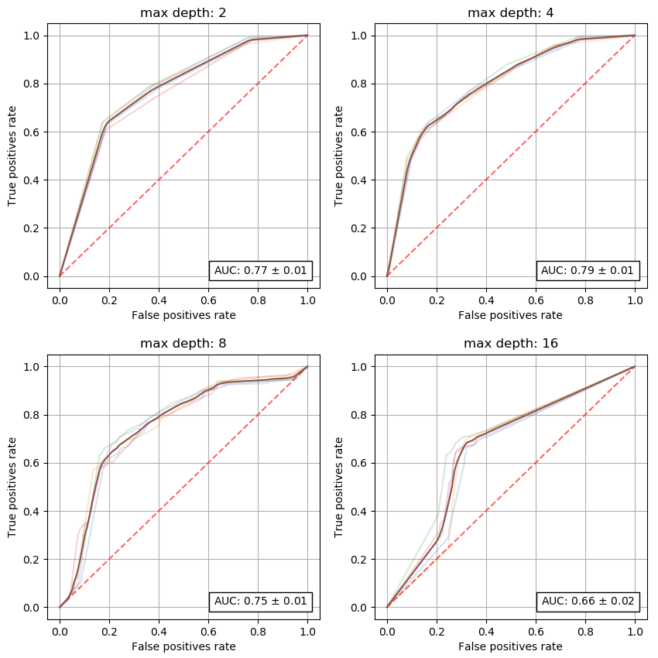
Figure A2.1 – DT ROC for file with series replaced with last values, missing data filtered out | Figure A2.2 – DT ROC for file with series replaced with last values, missing data filled in
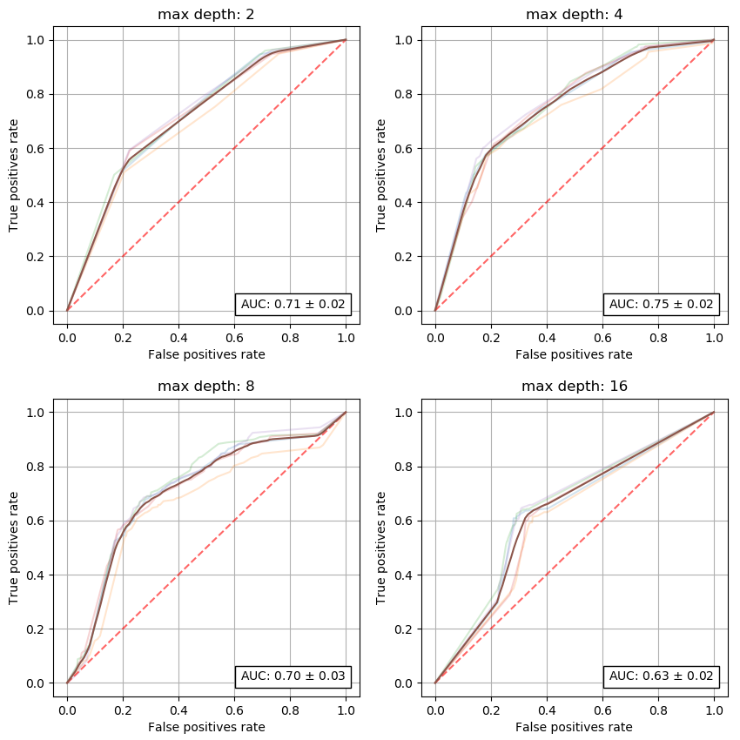 | 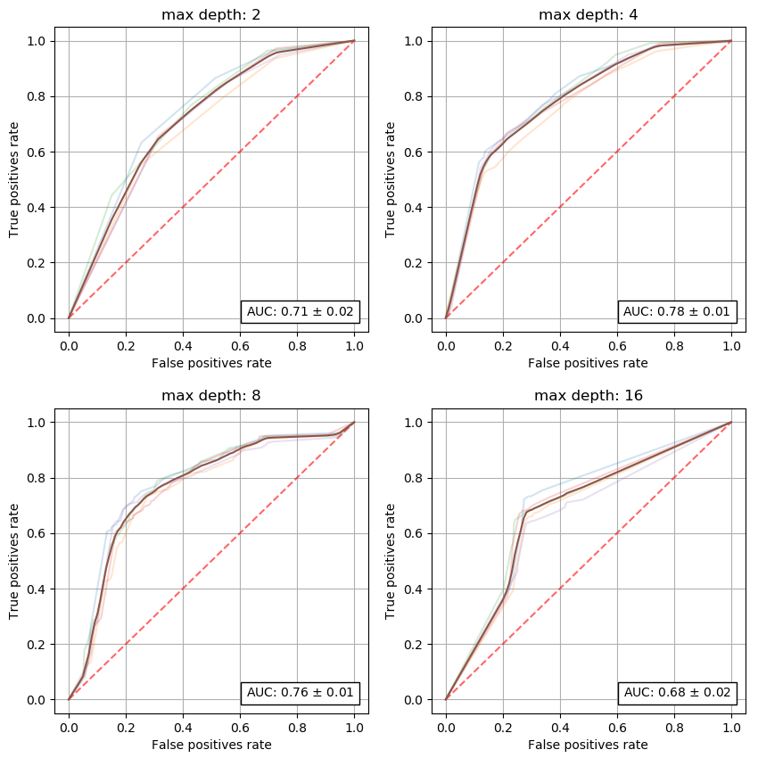
Figure A2.3 – DT ROC for file with series replaced with stats, missing data filtered out | Figure A2.4 – DT ROC for file with series replaced with stats, missing data filled in
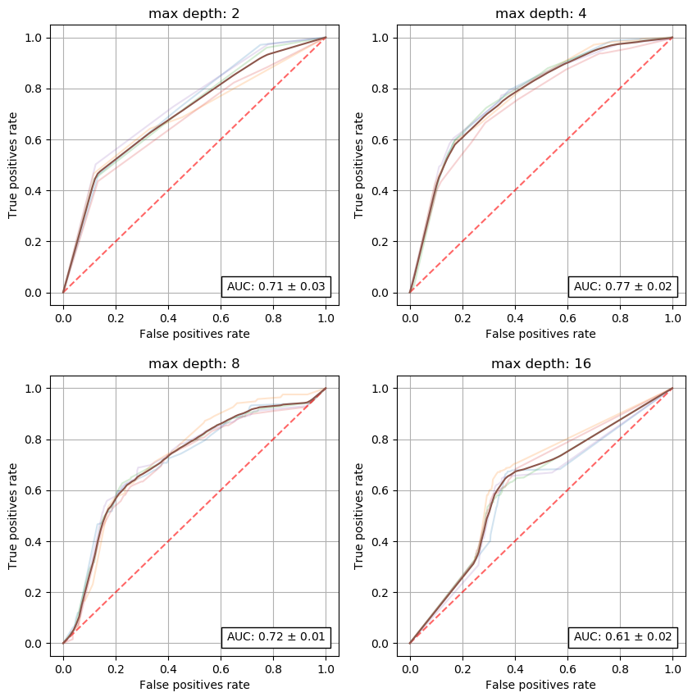 | 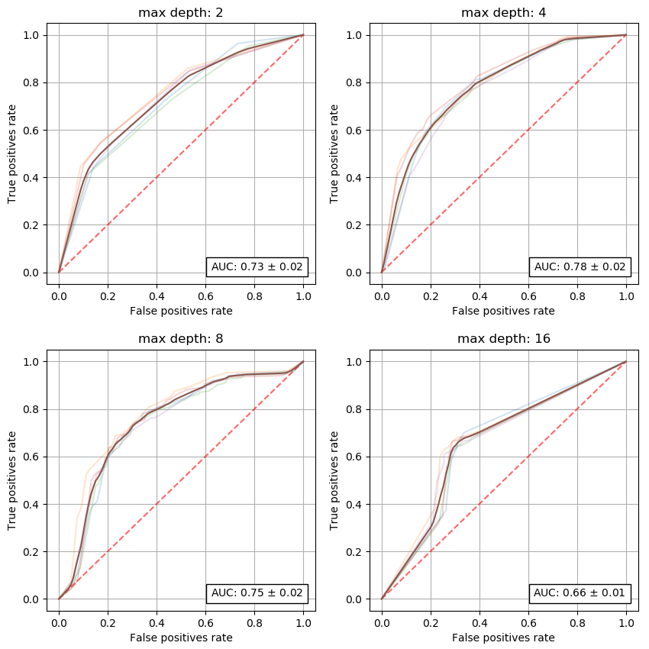
Figure A2.5 – DT ROC for file with series replaced with maximums, missing data filtered out | Figure A2.6 – DT ROC for file with series replaced with maximums, missing data filled in

