APPENDIX 5. Logistic regression classifier results
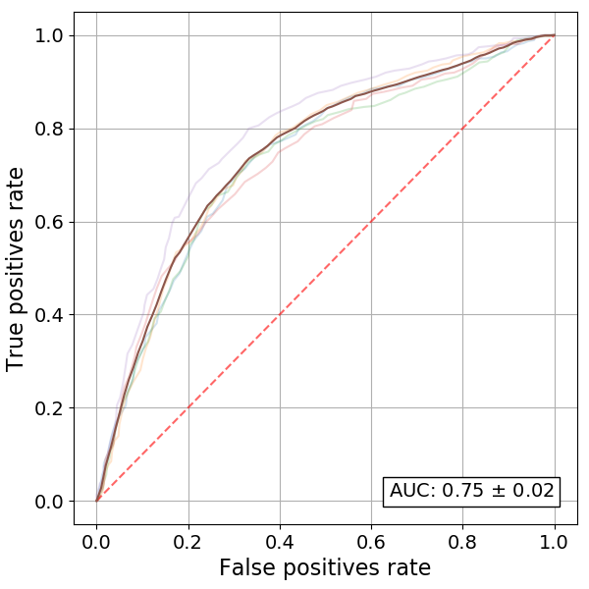 |  |  | 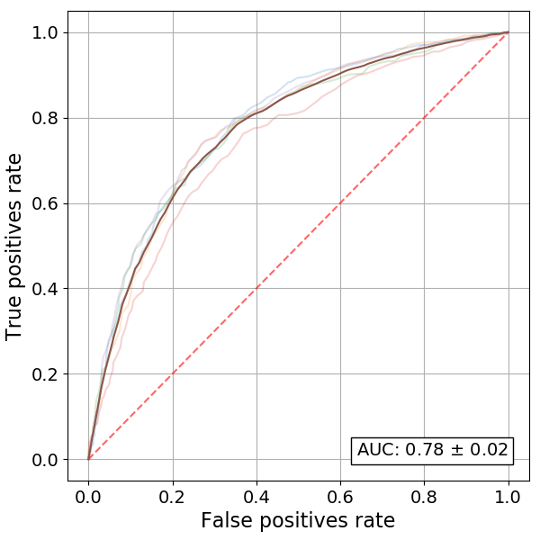
 | Figure A5.1 – Log. R. ROC for file with series replaced with last values, missing data filtered out |  |  | Figure A5.2 – Log. R. ROC for file with series replaced with last values, missing data filled in
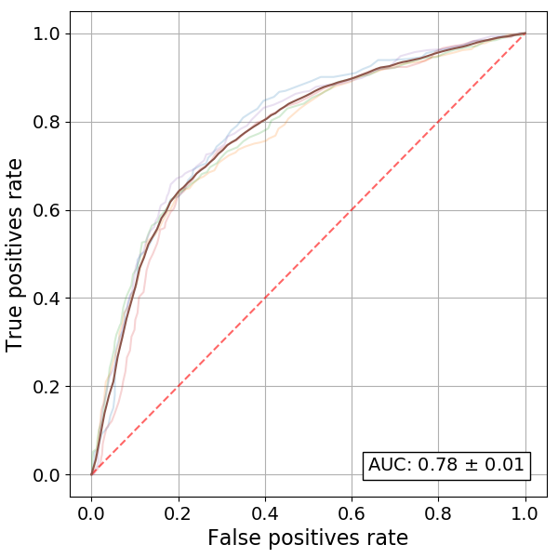 |  |  | 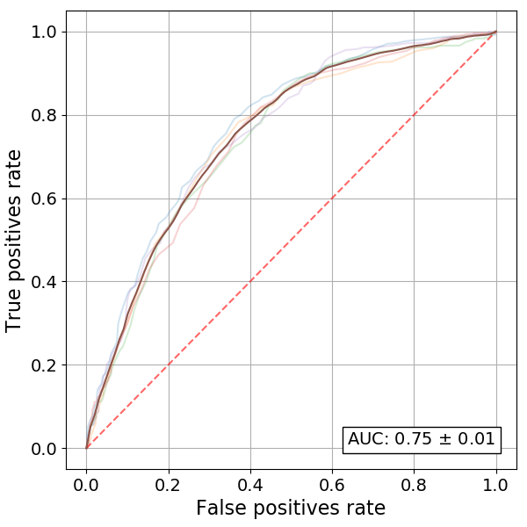
 | Figure A5.3 – Log. R. ROC for file with series replaced with the stats, missing data filtered out |  |  | Figure A5.4 – Log. R. ROC for file with series replaced with the stats, missing data filled in
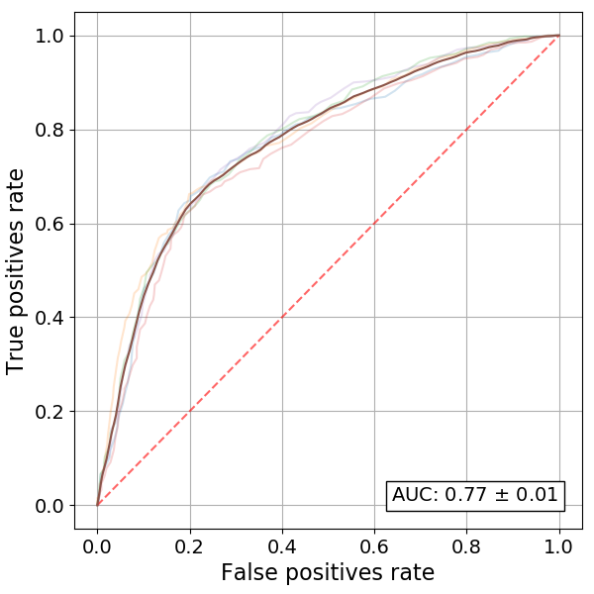 |  |  | 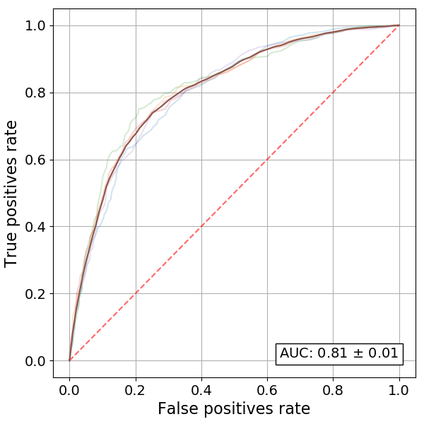
 | Figure A5.5 – Log. R. ROC for file with series replaced with maximums, missing data filtered out |  |  | Figure A5.6 – Log. R. ROC for file with series replaced with maximums, missing data filled in

