Supplementary Materials:

Figure S1 Example of Basic structure of Radiology Report

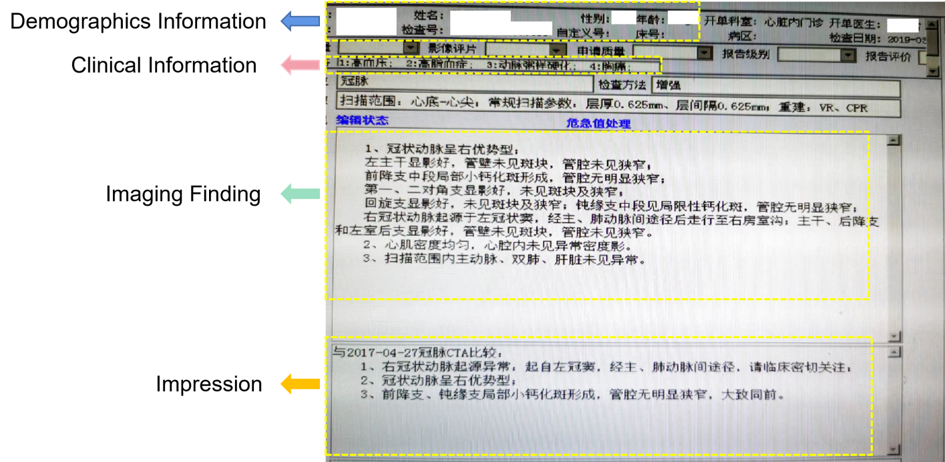

Table S1: Kappa results of labelers (n=300)
Labeler 1  Labeler 2 | Normal Finding | Unrelated Finding | Related Finding | Total
Normal Finding | 92 | 5 | 0 | 97
Unrelated Finding | 10 | 88 | 6 | 104
Related Finding | 1 | 19 | 79 | 99
Total | 103 | 112 | 85 | 300

Pe = (103*97+112*104+85*99)/300*300=0.333
Pa =（92+88+79）300=0.863
Kappa =（Pa-Pe）/（1-Pe）=0.795

Eqs2:Equation for performance metrics

Table S2: Word2Vec Parameters
Parameters | Value
Sg | 1（skip-gram）
Size | 100
Alpha | 0.025
Sample | 1e-3
Max_vocab_size | None
Min_Alpha | 0.0001
Iter | 5
Batch_Words | 10000

Table S3: BERT Parameters
Model | Size | Hidden_Size | Num_Attention_Heads | Num_Hidden_Layers | Learning  Rate | Epoch | Batch_Size
Bert-base-chinese | 393MB | 768 | 12 | 12 | 2e-5 | 10 | 8
Chinese-Bert-Wwm-Ext | 390MB | 768 | 12 | 12 | 2e-5 | 10 | 8
Chinese-Roberta-Wwm-Ext | 390MB | 768 | 12 | 12 | 2e-5 | 10 | 8
Mengzi-Bert-Base | 196MB | 768 | 12 | 12 | 2e-5 | 10 | 8

Table S4: Statistics Of Token Length

Count | Mean | Std | Min | 5% | 25% | 50% | 75% | 80% | 95% | Max
5864 | 186.02 | 71.22 | 16.00 | 58.00 | 133.00 | 247.00 | 306.00 | 328.00 | 468.00 | 512

Table S5 Confusion Matrix
