Explanatory Data Analysis of Low birth Weight in Ethiopia based on EDHS 2016
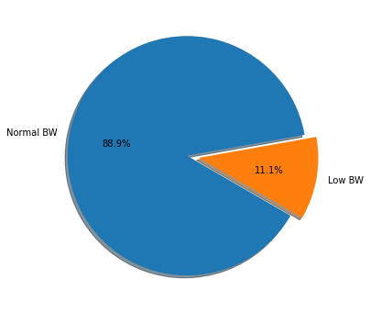
Figure S1 Pie-chart for Birth Weight Normal and Low birth weight
The Target Variable seems imbalanced.
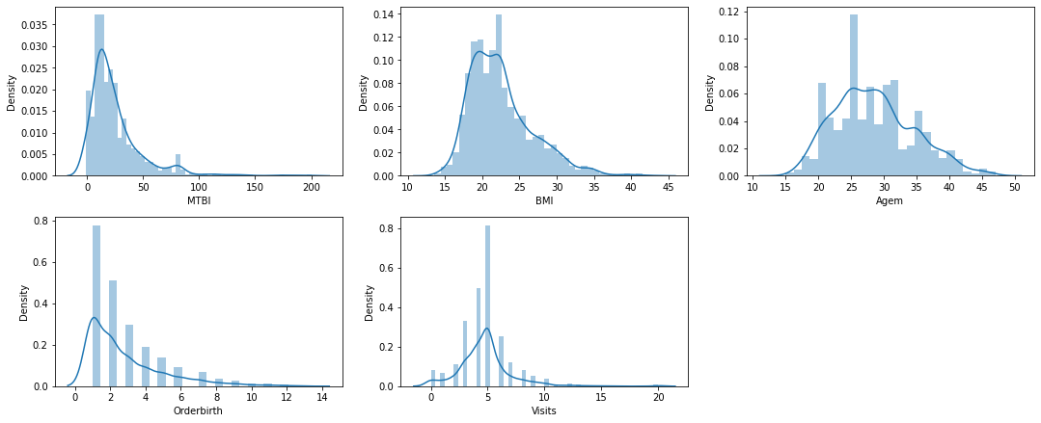
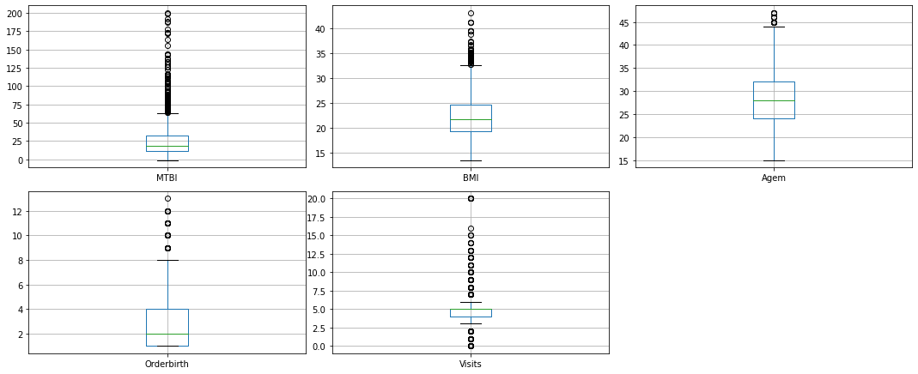
Figure S2 Continuous features: density and box plots
The continuous features are somewhat normally distributed, and there are many outliers present. Preprocessing on the data conducted to remove the irregularities.
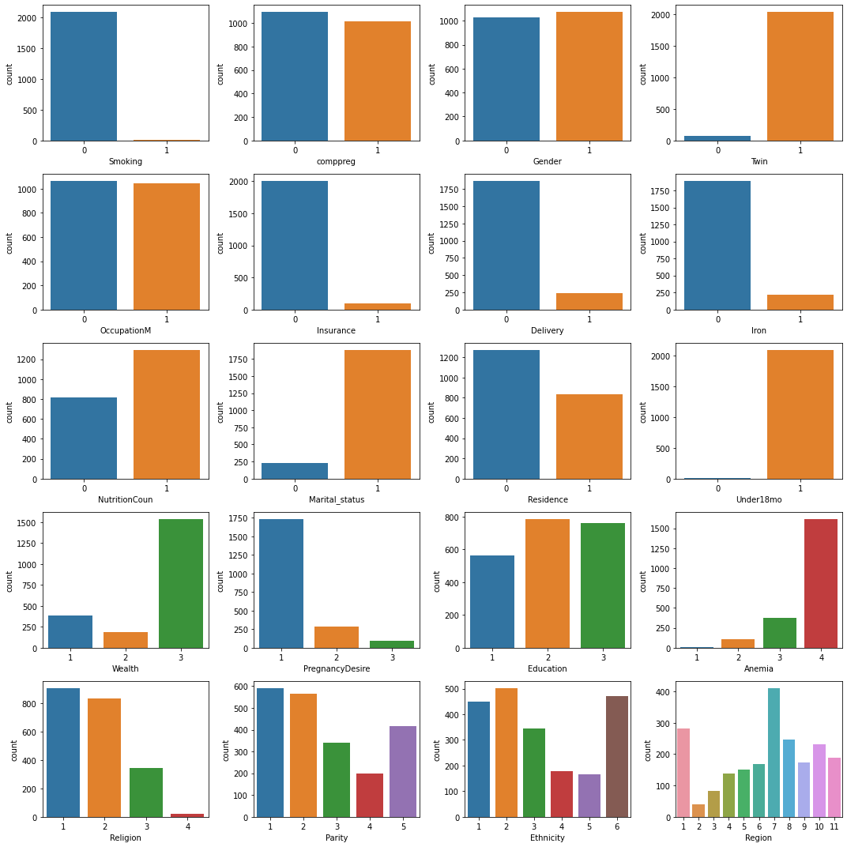
Figure S3 Categorical features bar plots
One-Hot Encoding on features conducted for the binary categorical features: Smoking, comppreg, Gender, Twin, OccupationM, Insurance, Delivery, Iron, NutritionCoun, Marital_status, Residence, Under18mo
Dummy Encoding on features employed for more than two categorical features: Wealth, PregnancyDesire, Education, Anemia , Religion, Parity, Ethnicity, and Region
There are 2110 instances and 25 features and then the encoded features became 49.

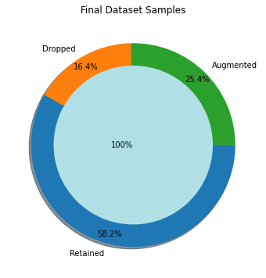
Figure S4 Final (Processed) Dataset Plots
- After removal of outliers, the dataset now has 1406 samples.
- The Target Variable seems imbalanced. The imbalance fixed using SMOTE Technique.
- The final dataset after cleanup has 2492 samples and 49 columns.
- Splitting the data intro training & testing sets
Original set ---> (2492, 48) (2492,)
Training set ---> (1993, 48) (1993,)
Testing set ---> (499, 48) (499,)
- Feature Scaling (Standardization) by StandardScaler()
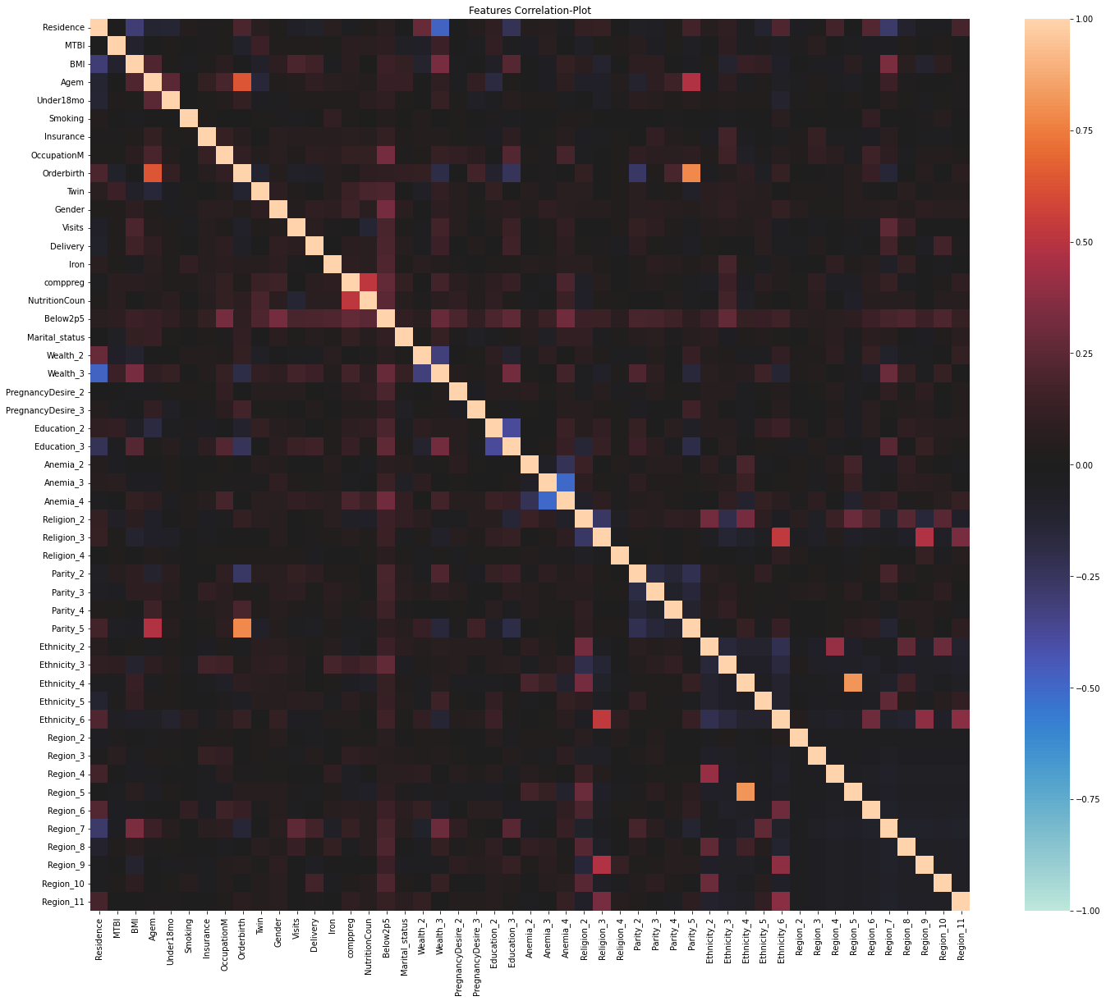
Figure S5 Features Correlation Heat Plot

 | Birth Weight </>= 2.5kg
 | Low BW % | Norma BW % | Total
 | % | % | %
delivery by caesarean section
no | 13.5 | 86.5 | 100
yes | 9.5 | 90.5 | 100
Total | 13.2 | 86.8 | 100
RECODE of v106 (highest educational level)
no education | 18.3 | 81.7 | 100
primary | 11 | 89 | 100
secondary or above | 11.3 | 88.7 | 100
Total | 13.2 | 86.8 | 100
taking iron pills, sprinkles or syrup
no | 14.2 | 85.8 | 100
yes | 5.8 | 94.2 | 100
Total | 13.2 | 86.8 | 100
respondent's occupation (grouped)
not working | 13.3 | 86.7 | 100
professional/technical/managerial | 13.1 | 86.9 | 100
Total | 13.2 | 86.8 | 100
type of place of residence
urban | 10.9 | 89.1 | 100
rural | 15.4 | 84.6 | 100
Total | 13.2 | 86.8 | 100
smokes cigarettes
no | 13.2 | 86.8 | 100
yes | 9.6 | 90.4 | 100
Total | 13.2 | 86.8 | 100
sex of child
male | 10.9 | 89.1 | 100
female | 15.6 | 84.4 | 100
Total | 13.2 | 86.8 | 100
child is twin
single birth | 12.3 | 87.7 | 100
1st of multiple | 39.9 | 60.1 | 100
Total | 13.2 | 86.8 | 100
RECODE of v190 (wealth index combined)
poor | 15.7 | 84.3 | 100
middle | 17.3 | 82.7 | 100
rich | 11.7 | 88.3 | 100
Total | 13.2 | 86.8 | 100
ethnicity
amhara | 15.8 | 84.2 | 100
oromo | 16.3 | 83.7 | 100
tigrie | 6.5 | 93.5 | 100
somalie | 10 | 90 | 100
guragie | 16.7 | 83.3 | 100
other | 10.4 | 89.6 | 100
Total | 13.2 | 86.8 | 100
covered by health insurance
no | 13.2 | 86.8 | 100
yes | 13.8 | 86.2 | 100
Total | 13.2 | 86.8 | 100
under age 18 (from household questionnaire)
under age 18 | 44.9 | 55.1 | 100
age 18 or older | 13 | 87 | 100
Total | 13.2 | 86.8 | 100
anemia level
severe | 53.9 | 46.1 | 100
moderate | 13.6 | 86.4 | 100
mild | 16.7 | 83.3 | 100
not anemic | 12.4 | 87.6 | 100
Total | 13.2 | 86.8 | 100
Paritylab
1 | 9.8 | 90.2 | 100
2 | 13.1 | 86.9 | 100
3 | 17.5 | 82.5 | 100
4 | 18.7 | 81.3 | 100
5+ | 12.4 | 87.6 | 100
Total | 13.2 | 86.8 | 100
RECODE of v501 (current marital status)
Not married | 10.8 | 89.2 | 100
Married | 13.4 | 86.6 | 100
Total | 13.2 | 86.8 | 100
RECODE of v130 (religion)
orthodox | 13.4 | 86.6 | 100
muslim | 15.8 | 84.2 | 100
protestant | 9.6 | 90.4 | 100
others | 1.6 | 98.4 | 100
Total | 13.2 | 86.8 | 100
region
tigray | 7.6 | 92.4 | 100
afar | 26.2 | 73.8 | 100
amhara | 22.2 | 77.8 | 100
oromia | 13.1 | 86.9 | 100
somali | 11.1 | 88.9 | 100
benishangul | 9.9 | 90.1 | 100
snnpr | 13.1 | 86.9 | 100
gambela | 11.9 | 88.1 | 100
harari | 4.4 | 95.6 | 100
addis adaba | 11.5 | 88.5 | 100
dire dawa | 9.2 | 90.8 | 100
Total | 13.2 | 86.8 | 100
wanted pregnancy when became pregnant
then | 14 | 86 | 100
later | 9.9 | 90.1 | 100
no more | 8.7 | 91.3 | 100
Total | 13.2 | 86.8 | 100
during (any of) your antenatal care visit(s), were you told about the signs of p
no | 13.9 | 86.1 | 100
yes | 12.5 | 87.5 | 100
Total | 13.2 | 86.8 | 100
did any health worker give you nutritional counseling?
no | 15.1 | 84.9 | 100
yes | 12.1 | 87.9 | 100
Total | 13.2 | 86.8 | 100

