Supplementary file 1. The validation of structure learning. The posterior classification error of HC and Tabu algorithms for all nodes according to different score functions.

 | HC |  |  |  |  |  | Tabu
State | AIC | BDE | BDS | BIC | K2 | loglikelihood | AIC | BDE | BDS | BIC | K2 | loglikelihood
N1 | 0.115 (0.017) | 0.120 (0.017) | 0.115 (0.017) | 0.121 (0.023) | 0.106 (0.020) | 0.102 (0.021) | 0.118 (0.019) | 0.112 (0.015) | 0.120 (0.030) | 0.109 (0.018) | 0.117 (0.020) | 0.106 (0.017)
N2 | 0.183 (0.033) | 0.167 (0.021) | 0.180 (0.015) | 0.167 (0.023) | 0.187 (0.021) | 0.193 (0.052) | 0.183 (0.027) | 0.185 (0.022) | 0.191 (0.015) | 0.154 (0.017) | 0.167 (0.032) | 0.184 (0.025)
N3 | 0.075 (0.019) | 0.082 (0.017) | 0.080 (0.011) | 0.076 (0.012) | 0.074 (0.016) | 0.092 (0.020) | 0.085 (0.027) | 0.080 (0.014) | 0.076 (0.020) | 0.077 (0.011) | 0.071 (0.019) | 0.078 (0.018)
N4 | 0.071 (0.017) | 0.056 (0.015) | 0.062 (0.021) | 0.060 (0.015) | 0.054 (0.010) | 0.028 (0.014) | 0.061 (0.014) | 0.067 (0.016) | 0.064 (0.024) | 0.054 (0.013) | 0.056 (0.014) | 0.027 (0.020)
N5 | 0.025 (0.012) | 0.029 (0.011) | 0.028 (0.010) | 0.019 (0.011) | 0.025 (0.007) | 0.018 (0.014) | 0.027 (0.012) | 0.027 (0.012) | 0.033 (0.013) | 0.018 (0.008) | 0.025 (0.011) | 0.011 (0.010)
N6 | 0.008 (0.004) | 0.011 (0.004) | 0.011 (0.007) | 0.010 (0.004) | 0.012 (0.008) | 0.000 (0.000) | 0.009 (0.005) | 0.012 (0.006) | 0.006 (0.002) | 0.009 (0.004) | 0.009 (0.008) | 0.000 (0.000)
N7 | 0.010 (0.006) | 0.010 (0.008) | 0.010 (0.008) | 0.009 (0.006) | 0.010 (0.004) | 0.013 (0.011) | 0.012 (0.006) | 0.012 (0.004) | 0.012 (0.005) | 0.011 (0.007) | 0.012 (0.004) | 0.008 (0.010)
N8 | 0.0034 (0.0032) | 0.0068 (0.0048) | 0.0041 (0.0026) | 0.0058 (0.0030) | 0.0023 (0.0045) | 0.0000 (0.0000) | 0.0033 (0.0032) | 0.0055 (0.0036) | 0.0055 (0.0048) | 0.0053 (0.0068) | 0.0050 (0.0045) | 0.0000 (0.0000)
N9 | 0.007 (0.005) | 0.006 (0.005) | 0.004 (0.004) | 0.004 (0.004) | 0.007 (0.004) | 0.000 (0.000) | 0.0066 (0.0052) | 0.0037 (0.0047) | 0.0032 (0.0031) | 0.0026 (0.0031) | 0.0047 (0.0033) | 0.0000 (0.0000)
N10 | 0.008 (0.005) | 0.005 (0.003) | 0.011 (0.007) | 0.008 (0.007) | 0.007 (0.007) | 0.002 (0.008) | 0.005 (0.006) | 0.005 (0.005) | 0.005 (0.005) | 0.006 (0.005) | 0.008 (0.007) | 0.001 (0.005)
N11 | 0.0042 (0.0041) | 0.0027 (0.0038) | 0.0018 (0.0032) | 0.0027 (0.0031) | 0.0023 (0.0038) | 0.0000 (0.0000) | 0.0024 (0.0025) | 0.0014 (0.0022) | 0.0032 (0.0038) | 0.0013 (0.0030) | 0.0030 (0.0043) | 0.0000 (0.0000)
N12 | 0.0014 (0.0023) | 0.0032 (0.0031) | 0.0023 (0.0024) | 0.0027 (0.0038) | 0.0027 (0.0038) | 0.0000 (0.0000) | 0.0010 (0.0020) | 0.0014 (0.0022) | 0.0019 (0.0040) | 0.0013 (0.0021) | 0.0019 (0.0024) | 0.0000 (0.0000)
N13 | 0.0037 (0.0029) | 0.0019 (0.0024) | 0.0041 (0.0026) | 0.0027 (0.0023) | 0.0018 (0.0023) | 0.0000 (0.0000) | 0.0023 (0.0025) | 0.0023 (0.0024) | 0.0027 (0.0023) | 0.0035 (0.0028) | 0.0024 (0.0025) | 0.0000 (0.0000)
N14 | 0.0019 (0.0024) | 0.0023 (0.0024) | 0.0027 (0.0038) | 0.0022 (0.0023) | 0.0023 (0.0024) | 0.0000 (0.0000) | 0.0010 (0.0020) | 0.0005 (0.0014) | 0.0014 (0.0022) | 0.0022 (0.0023) | 0.0018 (0.0023) | 0.0000 (0.0000)
Q1 | 0.114 (0.017) | 0.115 (0.017) | 0.113 (0.023) | 0.116 (0.023) | 0.112 (0.014) | 0.124 (0.032) | 0.119 (0.020) | 0.116 (0.021) | 0.115 (0.013) | 0.115 (0.019) | 0.108 (0.022) | 0.104 (0.018)
Q2 | 0.191 (0.020) | 0.199 (0.047) | 0.184 (0.016) | 0.174 (0.015) | 0.179 (0.023) | 0.174 (0.031) | 0.186 (0.018) | 0.180 (0.025) | 0.199 (0.031) | 0.164 (0.019) | 0.182 (0.027) | 0.173 (0.032)
Q3 | 0.081 (0.017) | 0.092 (0.021) | 0.083 (0.016) | 0.064 (0.013) | 0.076 (0.018) | 0.073 (0.026) | 0.089 (0.020) | 0.094 (0.027) | 0.086 (0.016) | 0.072 (0.021) | 0.092 (0.013) | 0.088 (0.015)
Q4 | 0.064 (0.009) | 0.060 (0.015) | 0.064 (0.016) | 0.051 (0.013) | 0.049 (0.014) | 0.025 (0.012) | 0.066 (0.015) | 0.059 (0.013) | 0.066 (0.015) | 0.064 (0.019) | 0.063 (0.012) | 0.019 (0.006)
Q5 | 0.023 (0.009) | 0.028 (0.011) | 0.025 (0.007) | 0.024 (0.008) | 0.022 (0.008) | 0.018 (0.012) | 0.027 (0.011) | 0.030 (0.007) | 0.021 (0.010) | 0.024 (0.008) | 0.016 (0.006) | 0.016 (0.008)
Q6 | 0.015 (0.006) | 0.008 (0.004) | 0.008 (0.003) | 0.010 (0.004) | 0.011 (0.007) | 0.000 (0.000) | 0.012 (0.006) | 0.017 (0.014) | 0.013 (0.006) | 0.009 (0.007) | 0.010 (0.006) | 0.000 (0.000)
Q7 | 0.011 (0.004) | 0.010 (0.006) | 0.010 (0.006) | 0.012 (0.008) | 0.009 (0.007) | 0.009 (0.011) | 0.013 (0.008) | 0.010 (0.003) | 0.014 (0.010) | 0.012 (0.005) | 0.011 (0.008) | 0.005 (0.006)
Q8 | 0.0047 (0.0044) | 0.0032 (0.0022) | 0.0054 (0.0046) | 0.0049 (0.0039) | 0.0040 (0.0040) | 0.0000 (0.0000) | 0.006 (0.004) | 0.009 (0.003) | 0.007 (0.005) | 0.004 (0.002) | 0.004 (0.003) | 0.000 (0.000)
Q9 | 0.007 (0.007) | 0.004 (0.004) | 0.005 (0.004) | 0.004 (0.004) | 0.008 (0.005) | 0.000 (0.000) | 0.006 (0.007) | 0.006 (0.006) | 0.006 (0.007) | 0.007 (0.004) | 0.005 (0.005) | 0.000 (0.000)
Q10 | 0.004 (0.002) | 0.006 (0.003) | 0.006 (0.004) | 0.008 (0.005) | 0.007 (0.004) | 0.000 (0.000) | 0.008 (0.006) | 0.007 (0.007) | 0.006 (0.006) | 0.008 (0.006) | 0.006 (0.005) | 0.001 (0.004)
Q11 | 0.0042 (0.0042) | 0.0022 (0.0032) | 0.0018 (0.0023) | 0.0022 (0.0031) | 0.0023 (0.0044) | 0.0000 (0.0000) | 0.0014 (0.0023) | 0.0055 (0.0036) | 0.0036 (0.0036) | 0.0013 (0.0030) | 0.0033 (0.0031) | 0.0000 (0.0000)
Q12 | 0.0020 (0.0034) | 0.0014 (0.0022) | 0.0005 (0.0015) | 0.0031 (0.0036) | 0.0013 (0.0030) | 0.0000 (0.0000) | 0.0009 (0.0029) | 0.0027 (0.0038) | 0.0013 (0.0030) | 0.0009 (0.0019) | 0.0019 (0.0024) | 0.0000 (0.0000)
Q13 | 0.0028 (0.0024) | 0.0032 (0.0022) | 0.0041 (0.0026) | 0.0026 (0.0023) | 0.0038 (0.0020) | 0.0000 (0.0000) | 0.0038 (0.0037) | 0.0022 (0.0032) | 0.0045 (0.0021) | 0.0035 (0.0019) | 0.0023 (0.0025) | 0.0000 (0.0000)
Q14 | 0.0015 (0.0023) | 0.0014 (0.0022) | 0.0028 (0.0024) | 0.0018 (0.0031) | 0.0047 (0.0032) | 0.0000 (0.0000) | 0.0009 (0.0020) | 0.0014 (0.0031) | 0.0009 (0.0019) | 0.0022 (0.0023) | 0.0015 (0.0025) | 0.0000 (0.0000)
Total N | 0.0368 (0.0020) | 0.0359 (0.0020) | 0.0368 (0.0035) | 0.0350 (0.0024) | 0.0352 (0.0024) | 0.0321 (0.0030) | 0.037 (0.004) | 0.037 (0.003) | 0.038 (0.005) | 0.032 (0.003) | 0.034 (0.003) | 0.030 (0.002)
Total Q | 0.038 (0.002) | 0.038 (0.004) | 0.037 (0.003) | 0.034 (0.003) | 0.035 (0.003) | 0.030 (0.005) | 0.039 (0.003) | 0.038 (0.003) | 0.039 (0.004) | 0.035 (0.003) | 0.036 (0.002) | 0.029 (0.003)
Total | 0.0372 (0.0015) | 0.0370 (0.0024) | 0.0367 (0.0024) | 0.0346 (0.0024) | 0.0351 (0.0023) | 0.0312 (0.0017) | 0.038 (0.003) | 0.038 (0.002) | 0.038 (0.004) | 0.034 (0.002) | 0.035 (0.002) | 0.029 (0.002)
¹Mean (SD)

Supplementary file 2. Conditional probability distribution of time stationary variables in the model.

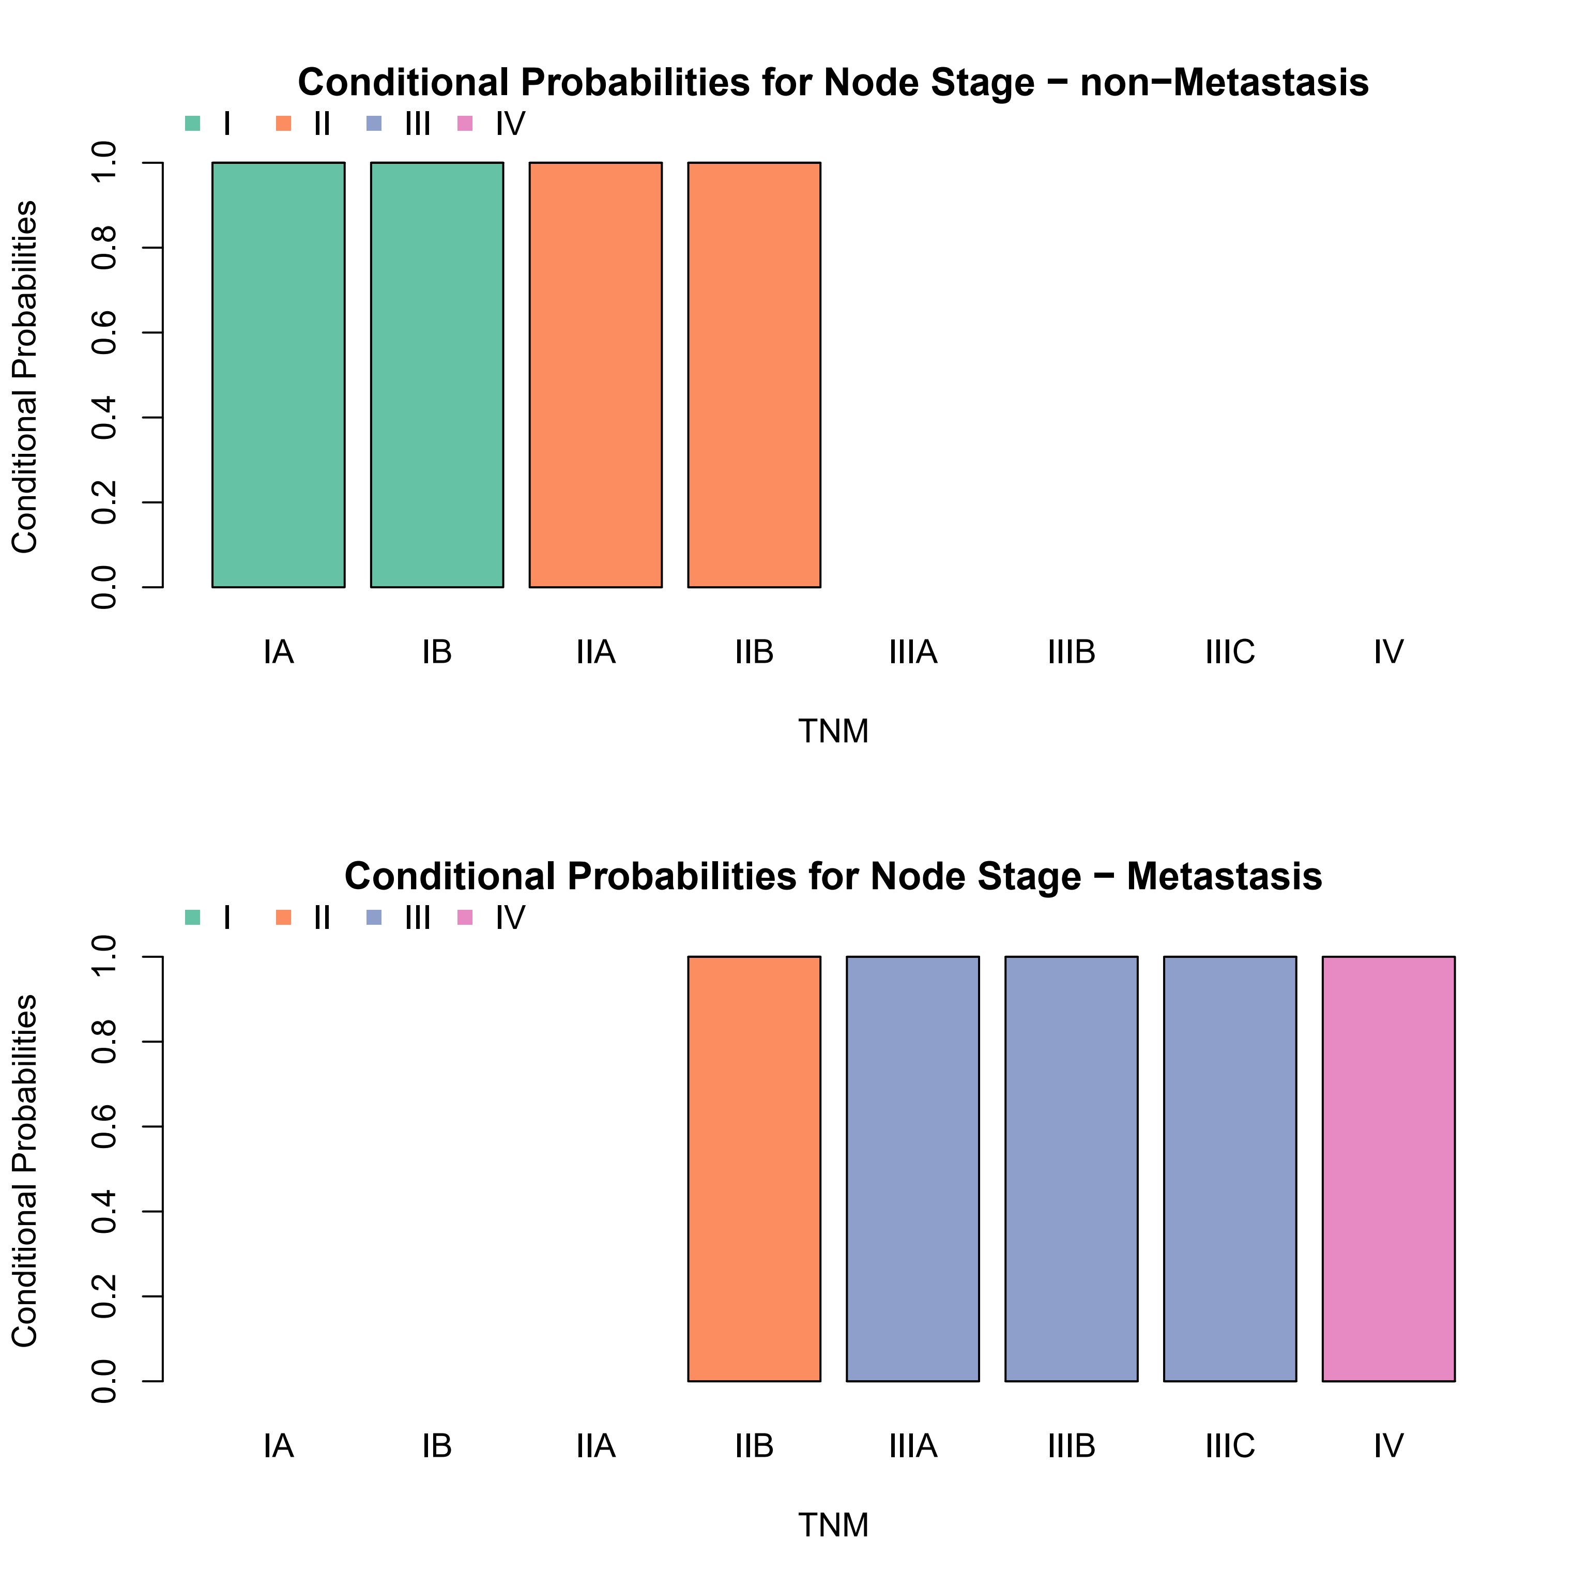
Supplementary figure 1. Conditional probability distribution of node stage given the different levels of its parents (Metastasis and TNM)

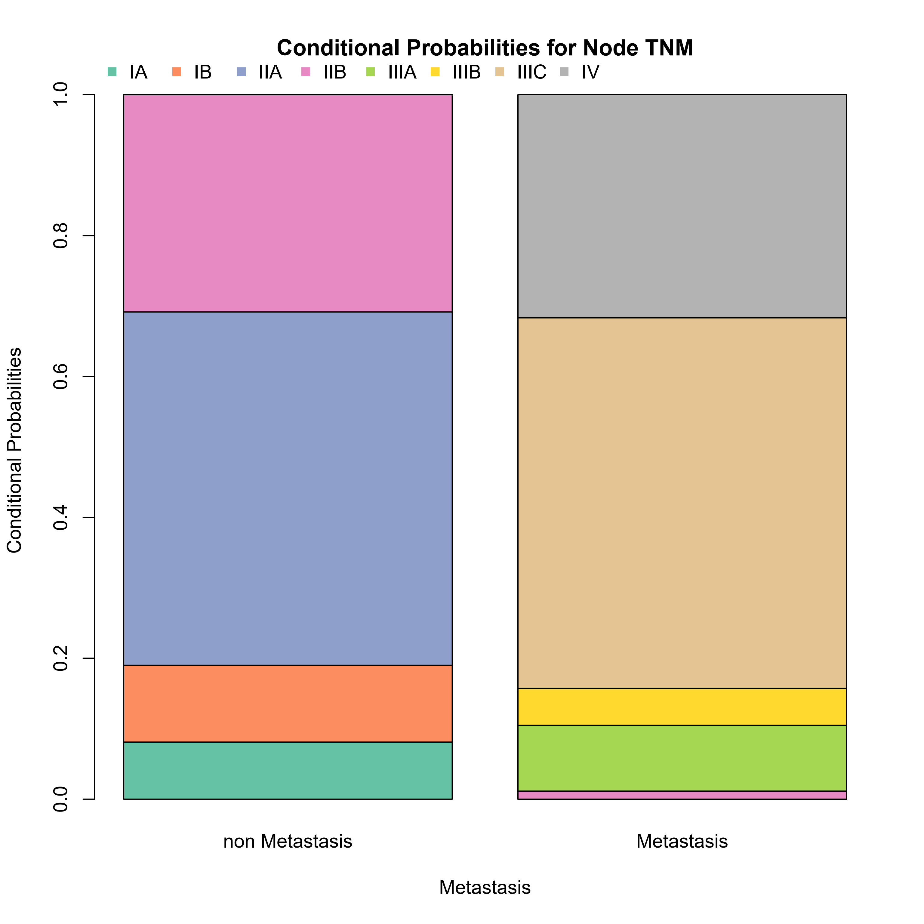
Supplementary figure 2. Conditional probability distribution of node TNM given the different levels of its parent (Metastasis)

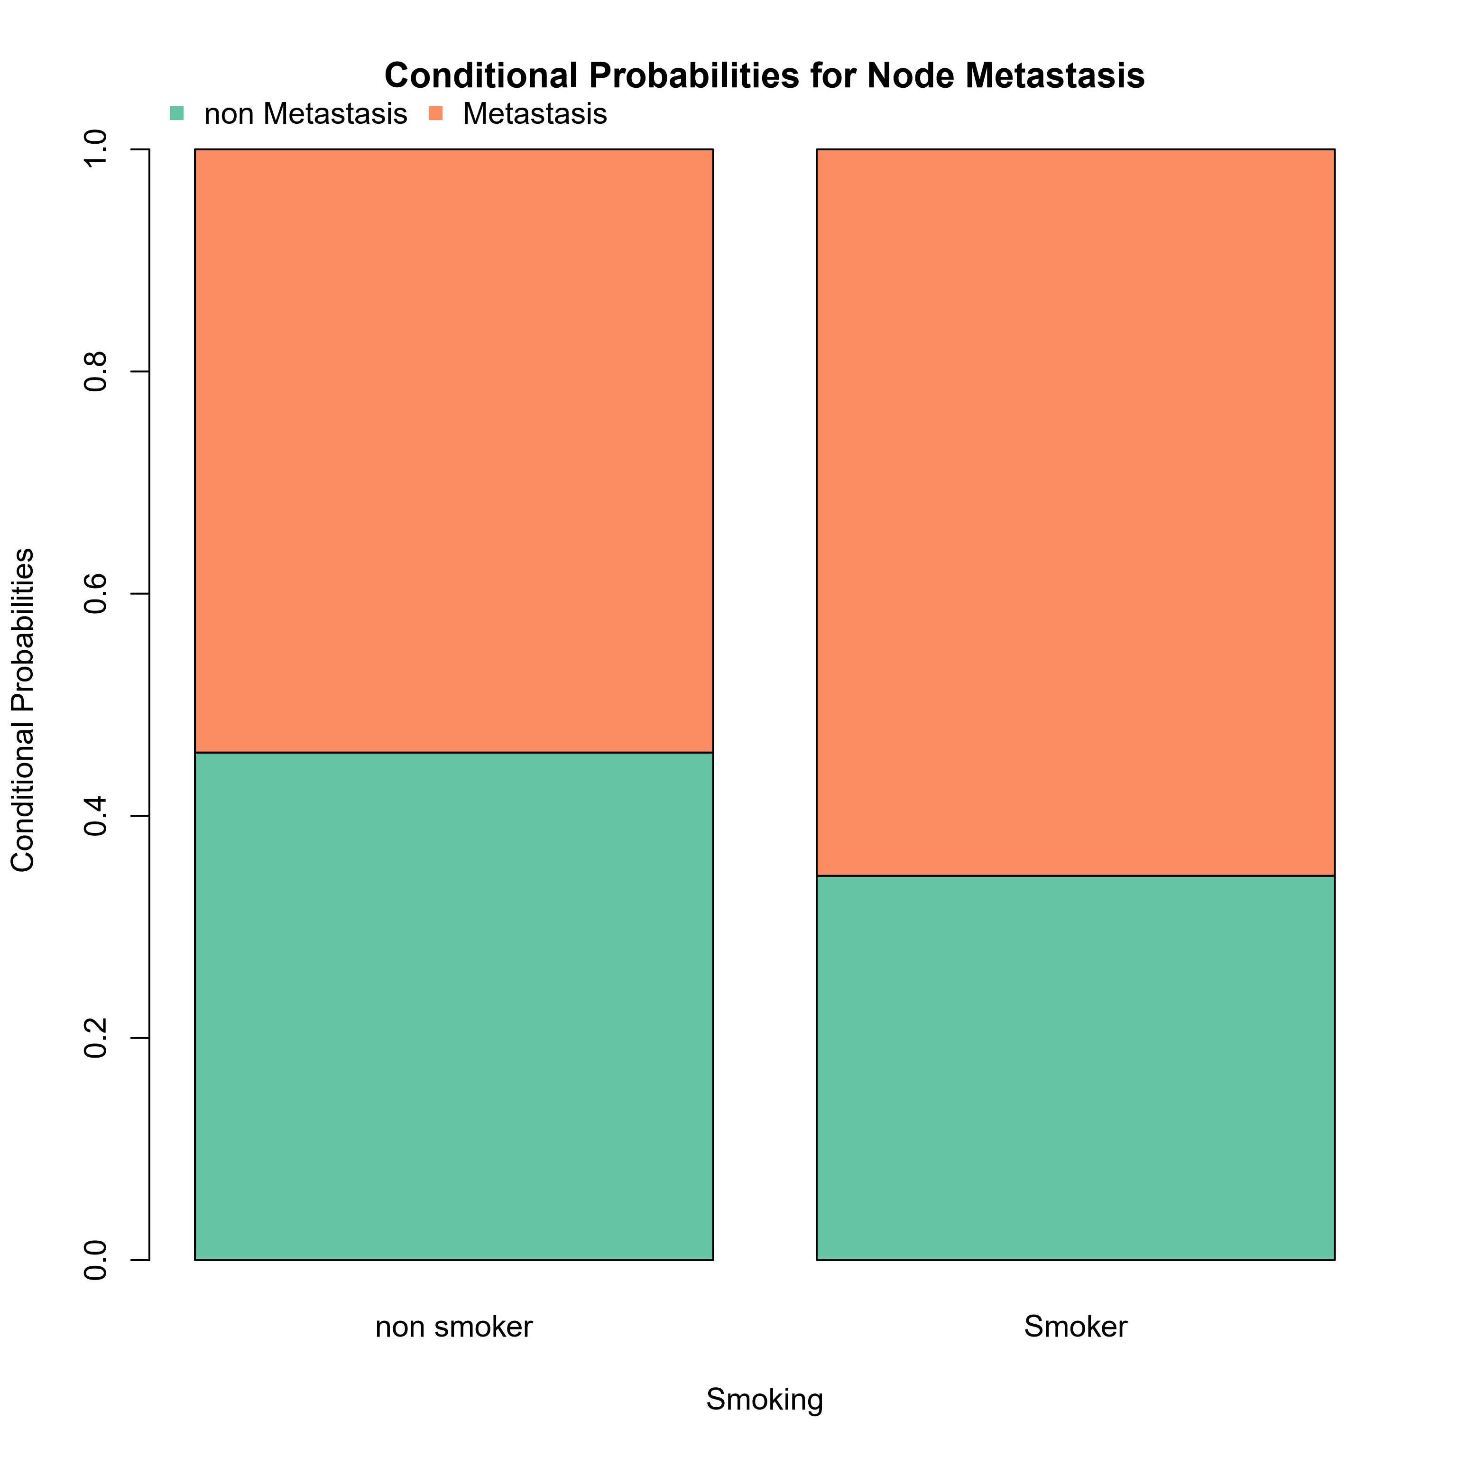
Supplementary figure 3. Conditional probability distribution of node metastasis given the different levels of its parent (Smoking)

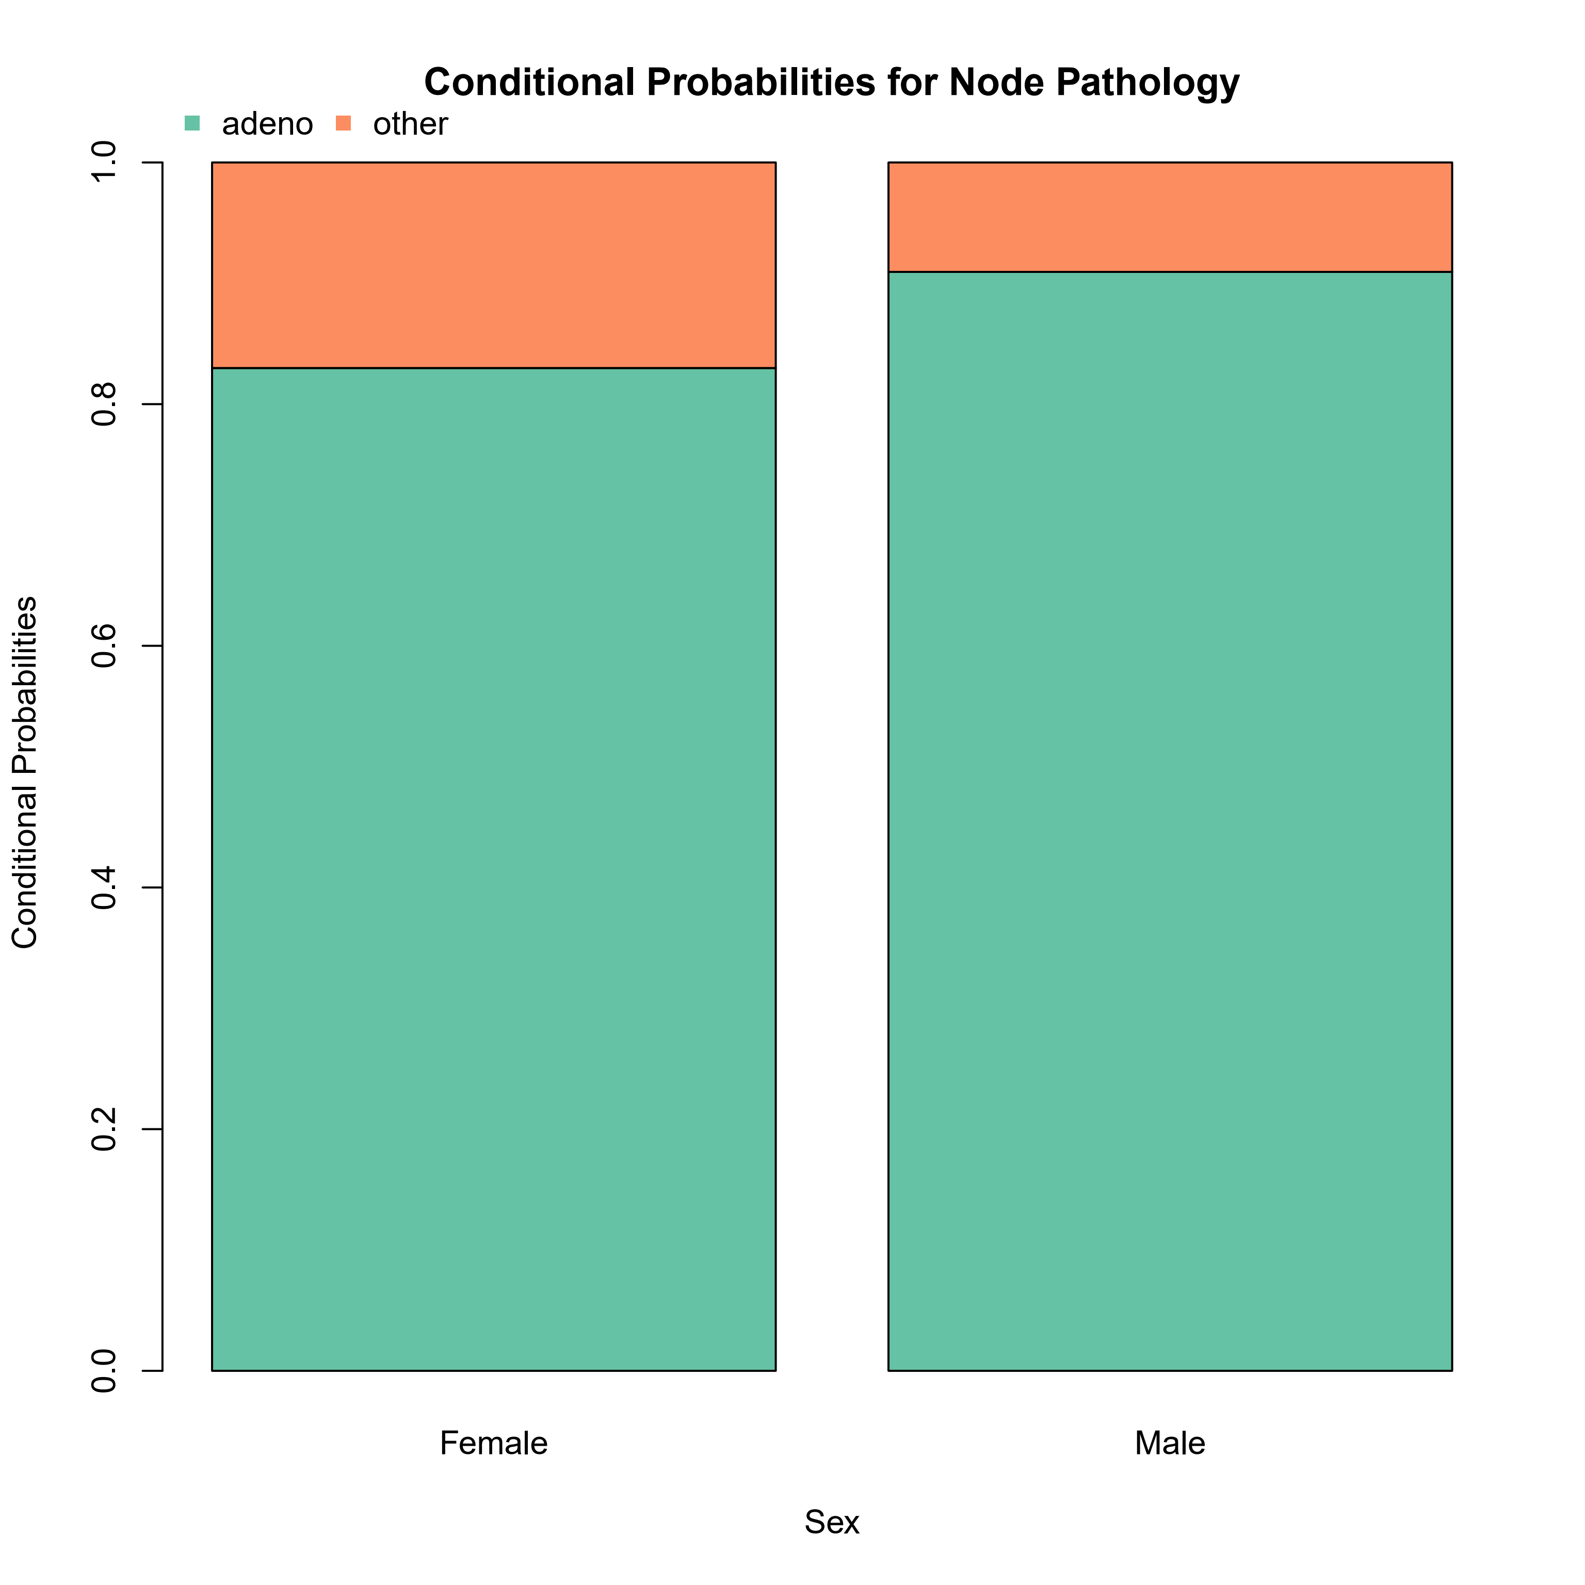
Supplementary figure 4. Conditional probability distribution of node pathology given the different levels of its parent (Sex)

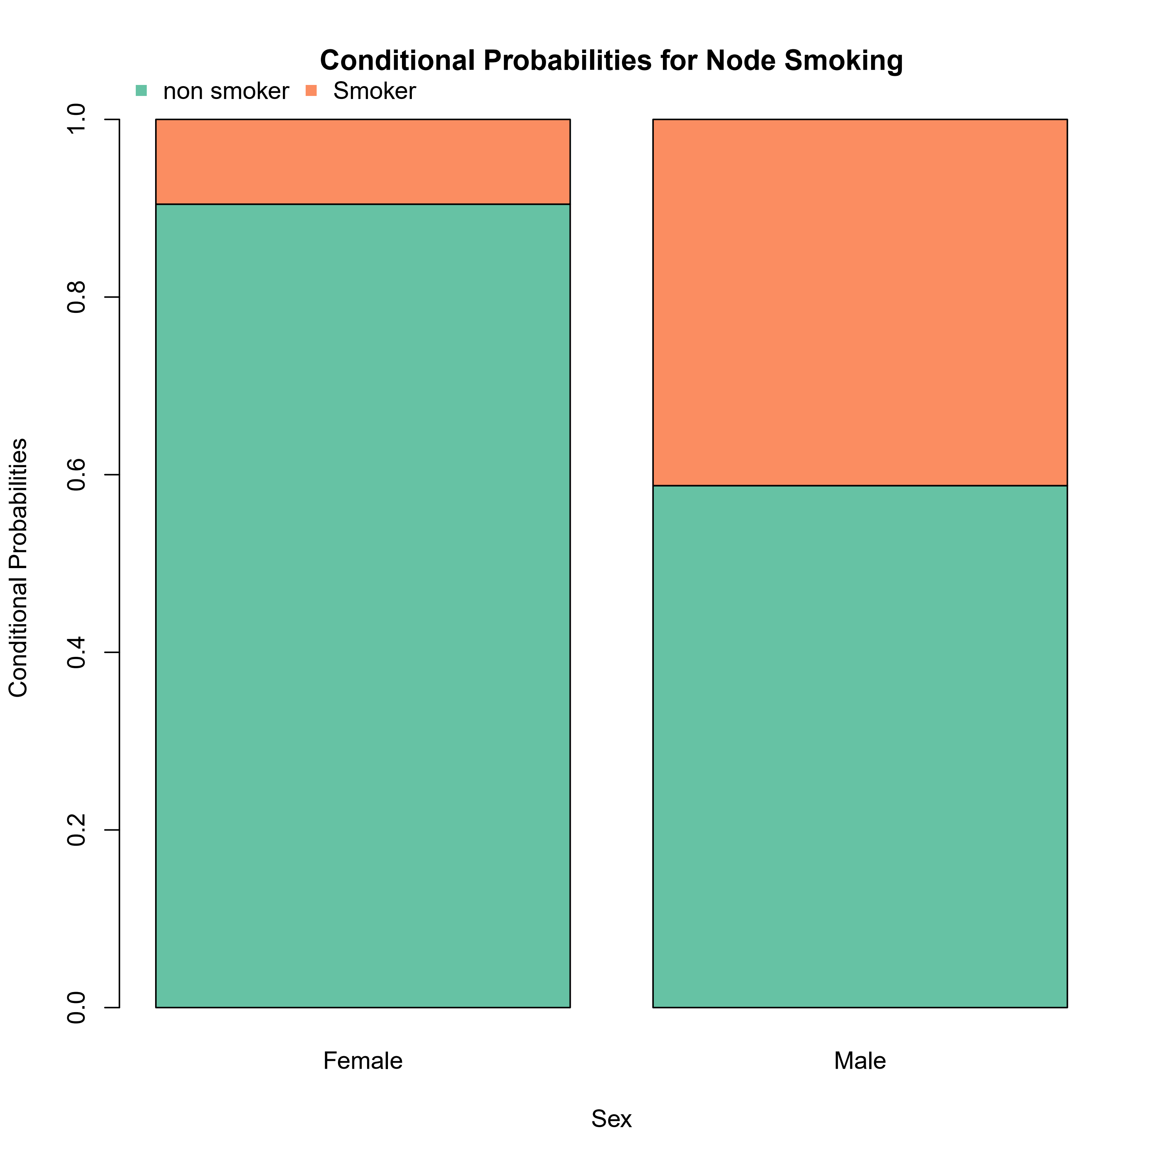
Supplementary figure 5. Conditional probability distribution of node smoking given the different levels of its parent (Sex)

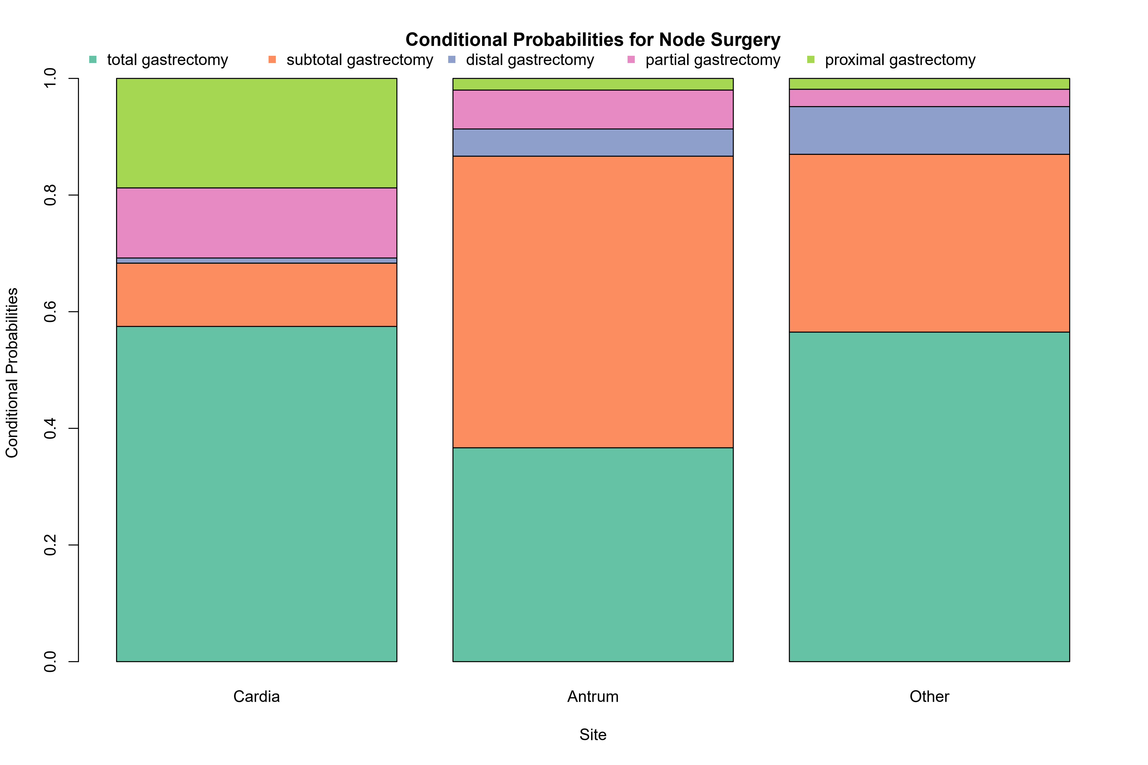
Supplementary figure 6. Conditional probability distribution of node surgery given the different levels of its parent (Site)

