Appendix A: Demographic of executive and stakeholder group members
Variables |  | Group members (N=11)
Decade of birth | 1950's | 2 | 18%
Decade of birth | 1960's | 3 | 27%
Decade of birth | 1970's | 3 | 27%
Decade of birth | 1980's | 2 | 18%
Decade of birth | 1990’s | 1 | 9%
Sex at birth | Female | 10 | 91%
Sex at birth | Male | 1 | 9%
Gender | Woman | 10 | 91%
Gender | Man | 1 | 9%
Gender | Trans, fluid, or non-binary | 0 | 0%
Country | Australia | 2 | 18%
Country | Canada | 4 | 36%
Country | Other (China, Denmark, Germany, Japan, Norway) | 5 | 45%
Current level of education | Masters | 2 | 18%
Current level of education | PhD | 5 | 45%
Current level of education | Post doctorate | 4 | 36%
Primary language | English | 6 | 55%
Primary language | Other (Chinese, Danish, German, Japanese, Not specified) | 5 | 45%
Experience(s) with decision coaching | Beginning to learn about decision coaching | 2 | 18%
Experience(s) with decision coaching | Received decision coaching as an intervention | 2 | 18%
Experience(s) with decision coaching | Gave decision coaching to someone making a decision | 8 | 73%
Experience(s) with decision coaching | Was trained to use decision coaching | 7 | 64%
Experience(s) with decision coaching | Provided training in decision coaching to others | 7 | 64%
Experience(s) with decision coaching | Developed decision coaching interventions | 8 | 73%
Experience(s) with decision coaching | Conducted research to evaluate decision coaching | 9 | 82%
Experience(s) with decision coaching | Developed and/or promoted health policy that supports decision coaching | 3 | 27%
Experience(s) with decision coaching | Synthesized evidence on decision coaching | 8 | 73%

Appendix B: Initial program theory
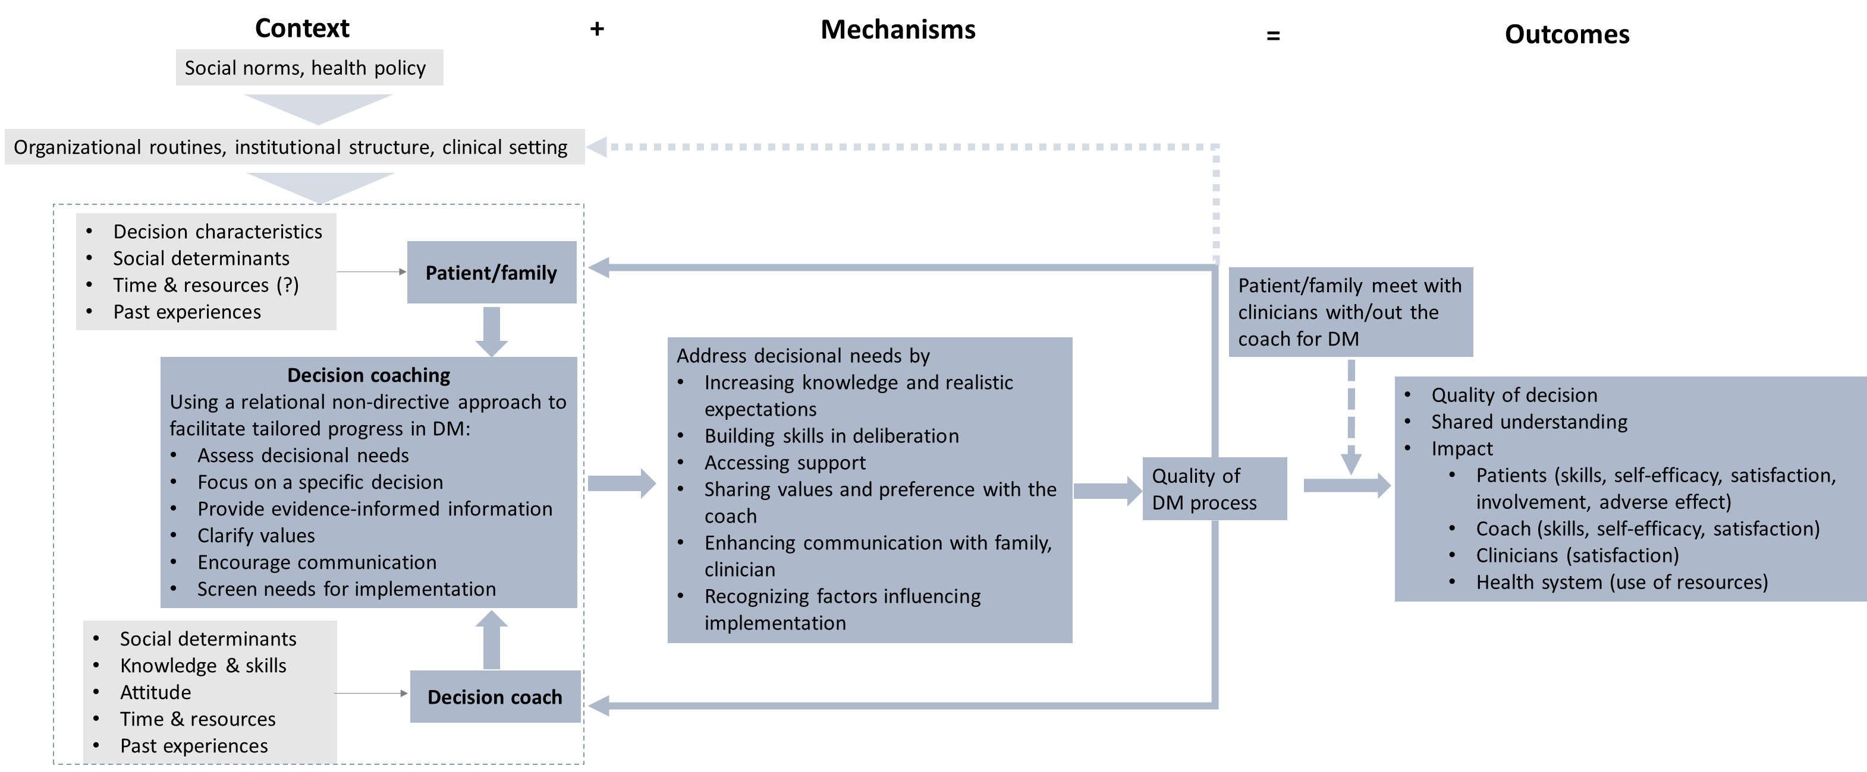

Appendix C: Relevance rating checklist
Level of relevance criteria
Overall relevance (level 0-3) (level 3 precedes over level 2, level 1 and level 0)
Level 3: the mechanism is rated level 3.
Level 2: the mechanism is rated level 2; or the context rated level 3.
Level 1: the mechanism is rated level 1; or the context rated level 2;
Level 0: the mechanism is rated level 0; or the context rated level 1 or 0; or cannot be excluded based on the eligibility criteria.
Mechanisms (level 0-3)
Level 3: the paper provides rich information on the mechanism: it directly answers the review question, i.e.: how/why/why not decision coaching works for people making healthcare decisions from patients’ or HCPs’ perspective; or is intervention studies on decision coaching with explicit theory (which has an explanatory focus) support; or investigates the experiences, perceptions of patients / people / HCPs / decision coaches on decision coaching; or investigates the barriers and/or facilitators to implementing decision coaching; or investigates the development/implementation process of decision coaching intervention.
Level 2: the paper provides some information on the mechanism: it investigates the reasons why decision coaching leads (or fails to lead) to certain outcomes (eg: improved quality of decision), or is intervention studies on decision coaching without explicit theory support.
Level 1: the paper provides a little information on the mechanism: it does not address the question on mechanism in the study, but only infers how decision coaching works in the discussion section.
Level 0: the paper provides no information on the mechanism: neither does the paper address the question on mechanism, nor does it discuss the mechanism.
Context (level 0-3)
Level 3: the paper provides rich information on the context based on the IPT: it investigates or explains the impact of different level contexts on decision coaching.
Level 2: the paper provides some information on the context based on the IPT: it investigates or explains the impact of certain level context (eg: individual context) on decision coaching.
Level 1: the paper provides a little information on the context based on the IPT: it only describes the decision coaching context in the method and/or results section.
Level 0: the paper provides no information on the context based on the IPT.
Outcomes (level 0-3)
Level 3: the paper reports different level outcomes based on the IPT.
Level 2: the paper reports certain level, or several outcomes based on the IPT.
Level 1: the paper focus on one specific outcome based on the IPT.
Level 0: the paper does not report any outcome based on the IPT.

Appendix D: Data extraction form
Basic characteristics
Author year | Country | Aim of study | conclusion | Study design
Mechanism |  |  |  |  |  |  |  |  |  | STOP?
Guiding theory | How does theory inform the study | research rationale/hypothesis, perceptions/experience of Interventions, explanations for success/failure, Barriers/facilitators for implementation | Increasing knowledge and realistic expectations | Building skills in deliberation | Accessing support | Sharing values and preference with the coach | Enhancing communication with family, clinician | Recognizing factors influencing implementation | Other potential mechanisms | Is Mechanism well described? If no, then stop here
Decision coaching intervention
Setting | providers (+ # No.) | consumers (+ # No.) | Decision Type | Intervention components | Development process | how decision coaching is used | Patient meets with clinician? | Length of time to follow-up | Other information
Context
Individual-patient | Individual-decision coach | Organizational | System | Notes
Outcomes
Quality of DM process
Patient involvement in decision making | Decision conflict | other outcomes
Quality of decision
Preparation for decision making | Decision self‐efficacy | Decision regret | Stage of decision making | other outcomes
Impact-patient
knowledge | satisfaction with decision coaching | Satisfaction with care | other outcomes
Impact-coach
Impact-clinician
Health system: Length of consultation, Cost to health system
Your comments (optional): reflections on the potential relationships among intervention, mechanism, context, outcome

