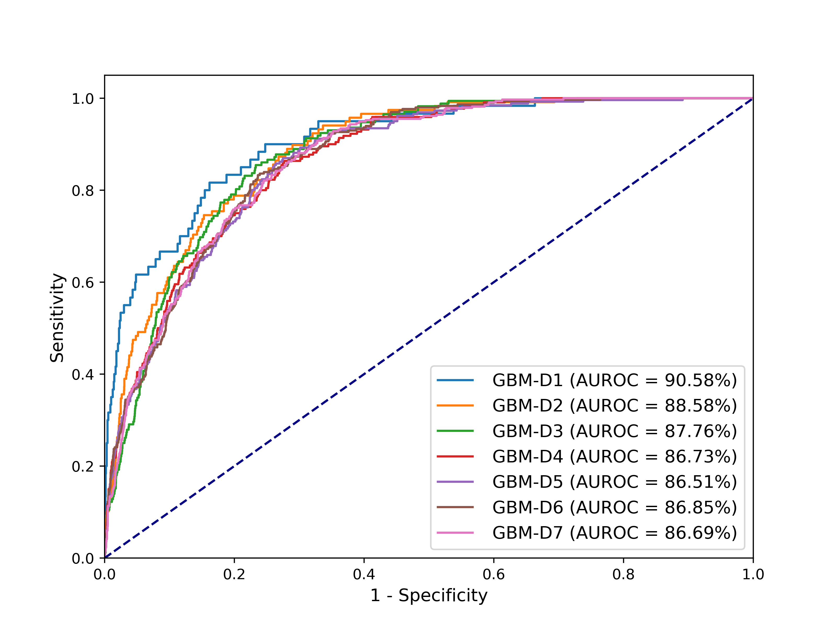
Figure S2: AUCs of GBM-D1 to GBM-D7 for the data comprised of one positive sample and one negative sample randomly selected from each patient.
。

