Additional file 1
Supplementary material for the article entitled “Explainable prediction of daily hospitalizations for cerebrovascular disease using stacked ensemble learning”.

Table S1 The performances of eight candidates of base learners on the valid set.
Model Types | Models | MAE | RMSE | MAPE | R²
Tree | RF | 12.359 | 16.850 | 0.148 | 0.746
Tree | GBDT | 12.465 | 16.551 | 0.149 | 0.755
Tree | XGBoost | 14.809 | 19.978 | 0.165 | 0.643
Tree | Adaboost | 17.901 | 21.706 | 0.234 | 0.579
Linear | Lasso | 17.280 | 21.091 | 0.271 | 0.602
Linear | Ridge | 14.351 | 19.097 | 0.193 | 0.674
Linear | Elastic Net | 16.885 | 20.747 | 0.261 | 0.615
Network | ANN | 14.802 | 19.043 | 0.211 | 0.676

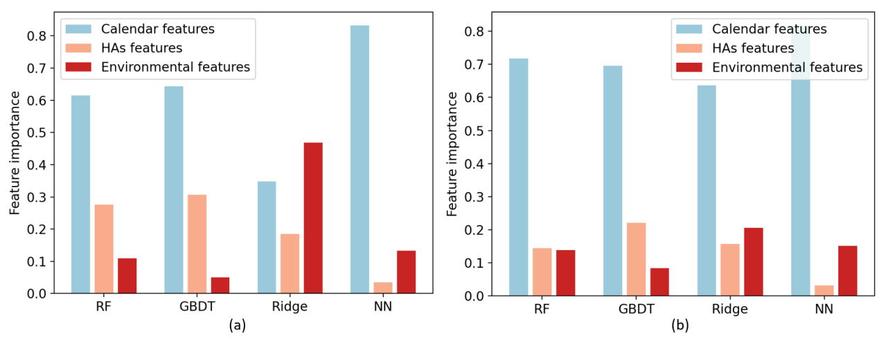
Figure S1 The feature importance in base models on two datasets: (a) CD and (b) stroke. The feature importance in tree-based model, Ridge and ANN was calculated from impurity, regression coefficients and SHAP values, respectively. For each base learner and both datasets, historical HAs and calendar features accounted for less than 20% of the number of features, but more than 50% of the feature importance, therefore we defined them as the key features which would be reused by meta learner in the stacking model.

Table S2 The range of grid search and the best hyper-parameter combinations in the stacking model and benchmarks.
Model | Hyper-parameter name | The range of grid search | Best hyper-parameters (CD) | Best hyper-parameters (stroke)
RF | max depth | [10, 20, 30, 40, None] | 20 | 30
RF | max features | [auto, sqrt, log2, None] | auto | auto
RF | n estimators | [20, 30, 40, 50] | 40 | 40
GBDT | learning rate | [0.05, 0.1, 0.15, 0.2] | 0.1 | 0.15
GBDT | max depth | [3, 6, 9, 12] | 3 | 3
GBDT | max features | [auto, sqrt, log2, None] | None | auto
GBDT | n estimators | [80, 90, 100, 110] | 100 | 100
Ridge | alpha | [0.90, 0.91,0.92, … , 1.10] | 1.09 | 1.09
ANN | Number of layers | Increase until the performance in the valid set is no longer optimized | 2 | 2
ANN | Units of the first layer | [16, 32, 48, 64, 80] | 48 | 32
ANN | Units of the second layer | [8, 16, 24, 32] | 16 | 16
ANN | Activation function | [Tanh, ReLU, Sigmoid] | ReLU | ReLU
ANN | Learning rate | [0.0005, 0.001, 0.005, 0.01] | 0.001 | 0.001
ANN | Loss function | [MSE, MAE] | MSE | MSE
ANN | Optimizer | [Adam, SGD, RMSprop] | Adam | Adam
ANN | Batch size | [8, 16, 32, 64, 128] | 64 | 32
ANN | Training epochs | [250, 500, 1000, 1500] | 1000 | 500
Elastic Net | alpha | [0.01, 0.02,0.03, … , 0.10] | 0.02 | 0.03
Elastic Net | l1 ratio | [0.1, 0.2, … , 1] | 0.9 | 0.9
LSTM | Number of hidden layers | Increase until performance in the valid set is no longer optimized | 1 | 1
LSTM | Units of the hidden layer | [16, 32, 64, 128] | 64 | 64
LSTM | Number of fully connected layers | Increase until the performance in the valid set is no longer optimized | 1 | 1
LSTM | Learning rate | [0.0005, 0.001, 0.005, 0.01] | 0.001 | 0.001
LSTM | Loss function | [MSE, MAE] | MSE | MSE
LSTM | Optimizer | [Adam, SGD, RMSprop] | Adam | Adam
LSTM | Batch size | [8, 16, 32, 64, 128] | 32 | 16
LSTM | Training epochs | [100, 250, 500, 1000] | 500 | 250
* Hyper-parameters not listed in the table are default values in scikit-learn 0.24.2 and Tensorflow 2.4.1.
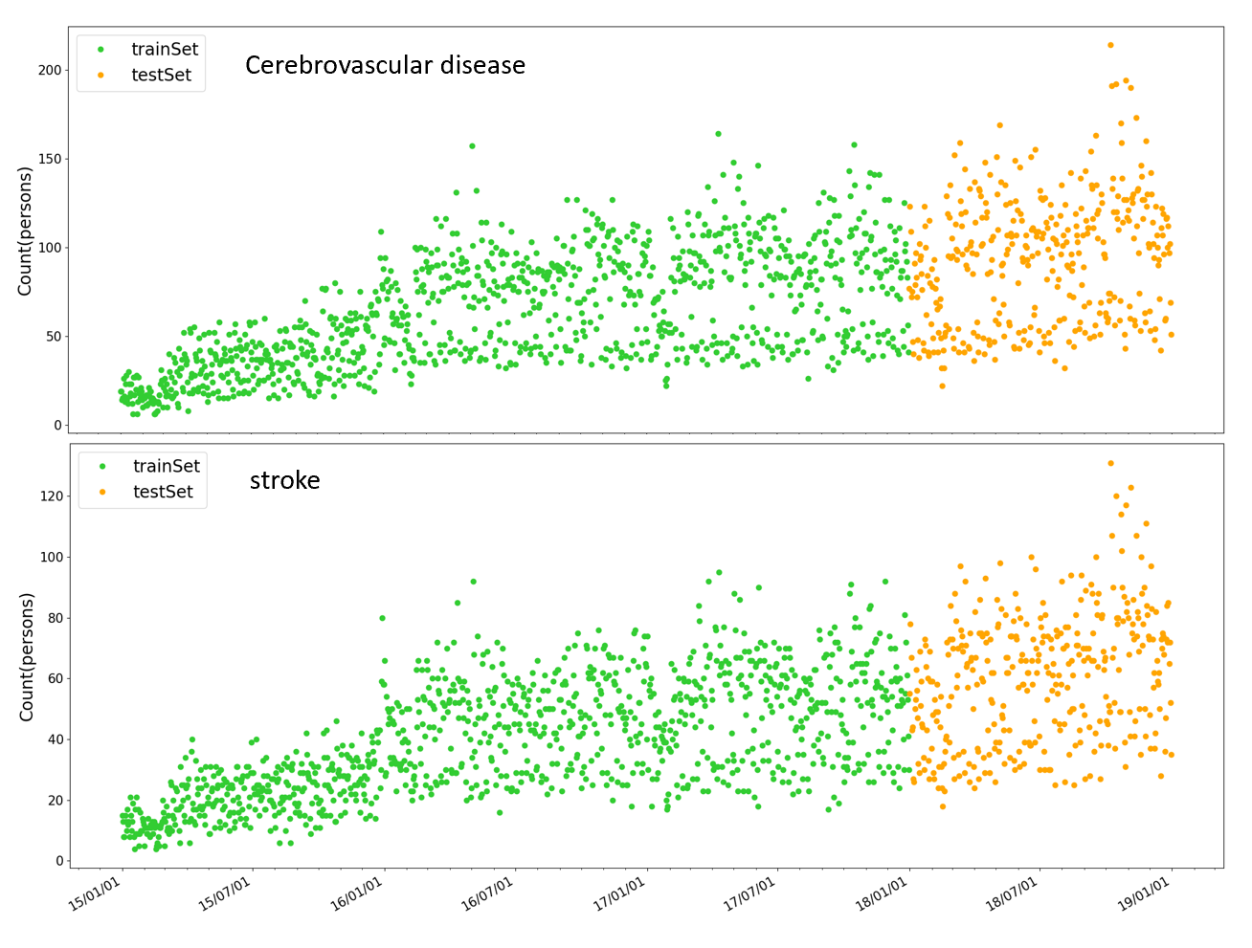
Figure S2 Temporal variations of HAs for CD and stroke during 2015/1/1 through 2018/12/31 in Chengdu, China.

Table S3 Pearson correlations between environmental exposure variables.
 | AQI | PM₁₀ | PM_{c} | PM_{2.5} | SO₂ | NO₂ | CO | O₃ | TEM | RH
AQI | 1.00
PM₁₀ | 0.98* | 1.00
PM_{c} | 0.81* | 0.90* | 1.00
PM_{2.5} | 0.99* | 0.96* | 0.75* | 1.00
SO₂ | 0.59* | 0.61* | 0.56* | 0.59* | 1.00
NO₂ | 0.75* | 0.77* | 0.69* | 0.74* | 0.62 * | 1.00
CO | 0.80* | 0.80* | 0.63* | 0.82* | 0.64* | 0.72* | 1.00
O₃ | -0.20* | -0.22* | -0.11* | -0.27* | -0.04 | -0.07* | -0.27* | 1.00
TEM | -0.45* | -0.45* | -0.32* | -0.48* | -0.15* | -0.28* | -0.41* | 0.71* | 1.00
RH | -0.07* | -0.09* | -0.20* | 0.00 | -0.15* | -0.12* | 0.07* | -0.46* | -0.03 | 1.00
Note: *two-tailed test of significance is used (P-value<0.05).

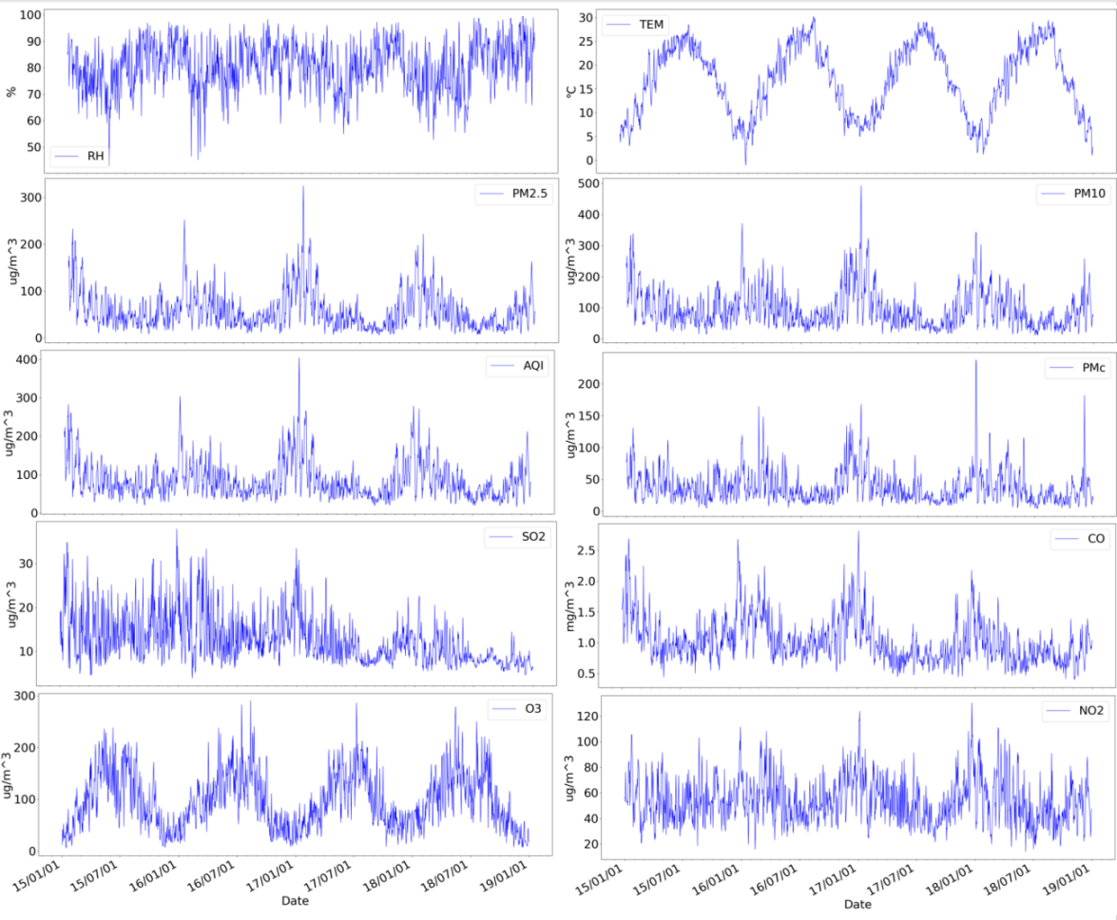
Figure S3 Temporal variations of environmental exposure data during 2015/1/1 through 2018/12/31 in Chengdu, China.
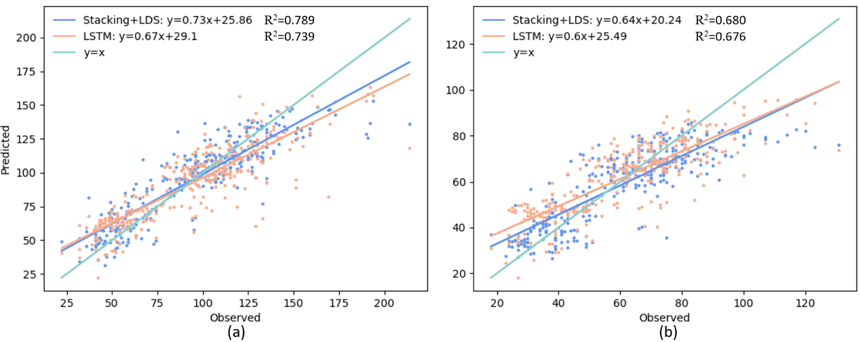
Figure S4 The scatter plots to compare the R² of the stacking model and the R² of the best individual model (LSTM) on two datasets: (a) CD and (b) stroke.

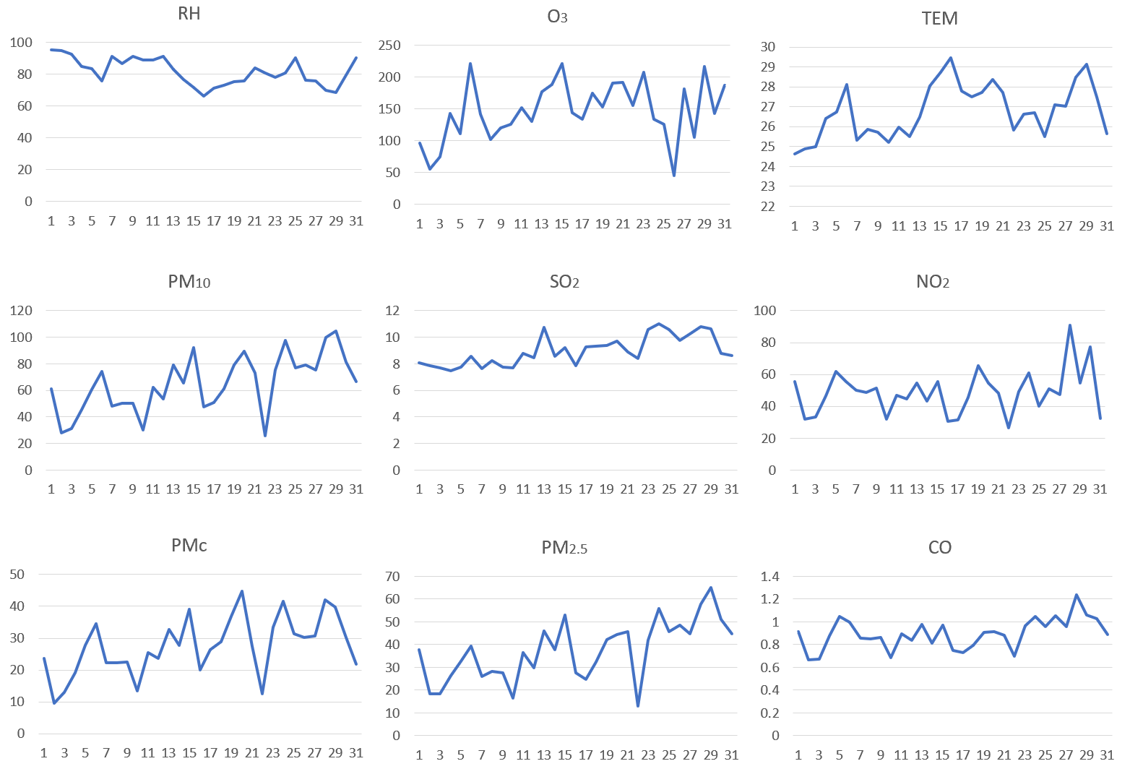
Figure S5 Temporal variations of environmental factors during August 2018. The units of TEM, RH and CO are ℃, % and mg/m³, respectively. The units of other factors are µg/m³.

