(A-F) Screenshots of the decision support application

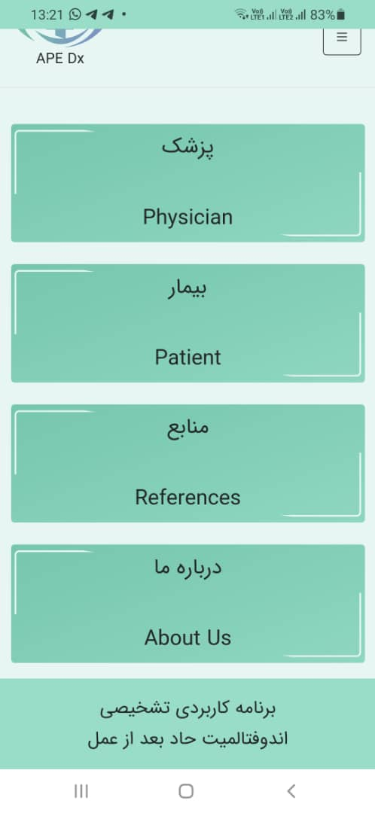
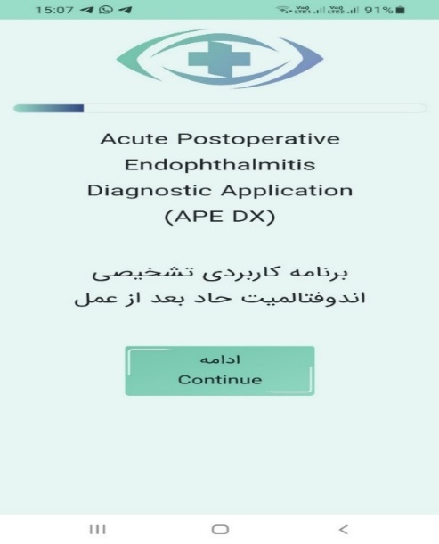

A. Login page B. Home page

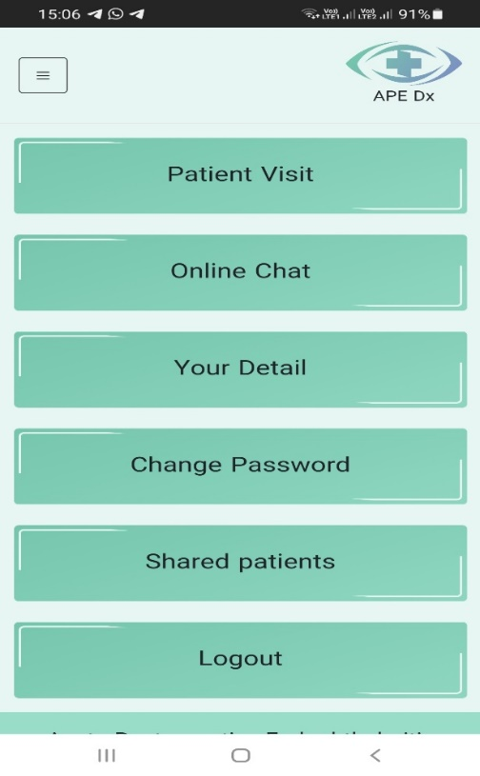
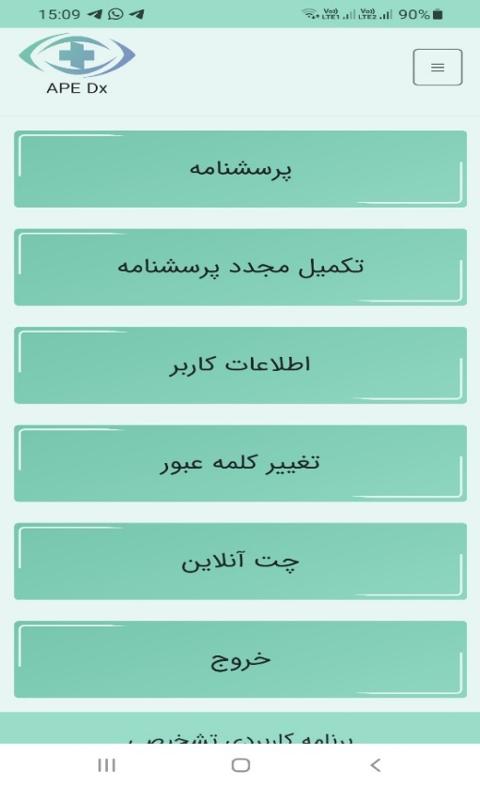 C. Physician user interface D. Patient user interface

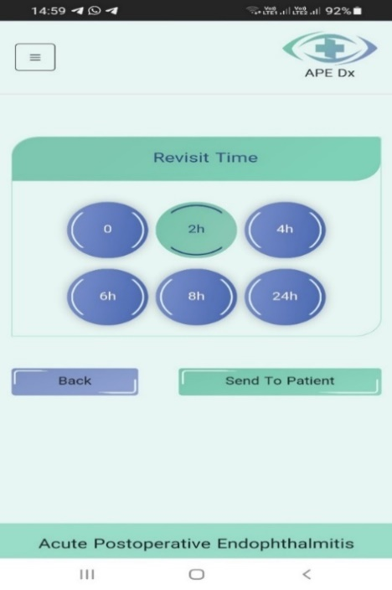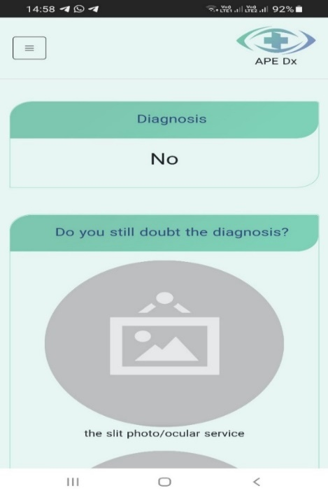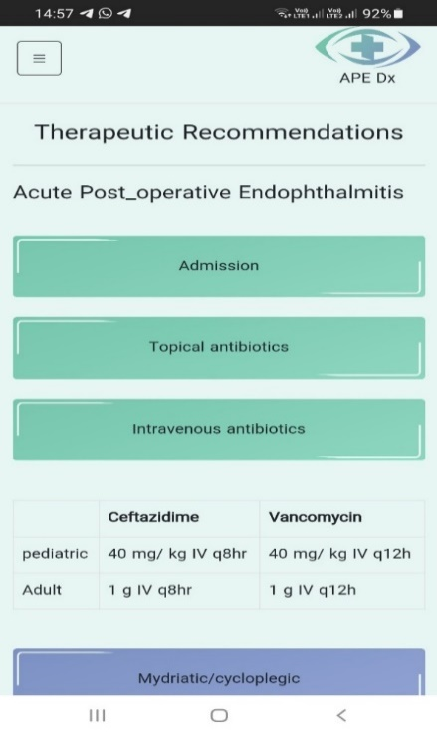
E1
E2
E3
E. Sample screenshots from physician user interface, E1) therapeutic recommendation, E2) diagnosis, E3) revisit time/ fill out the questionnaire

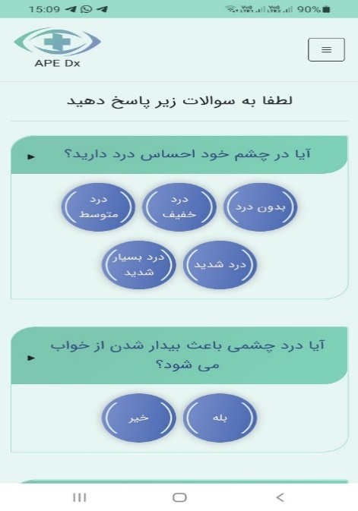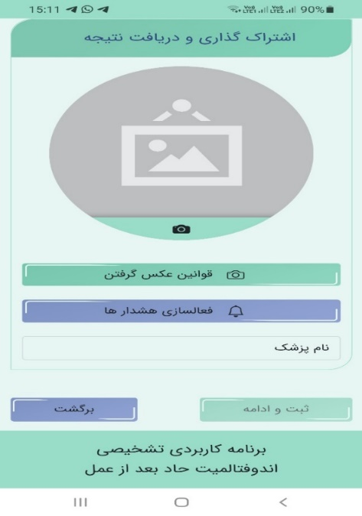
F2
F1
F. Sample screenshots from patient user interface, F1) Patient questionnaire, F2) Information sharing

