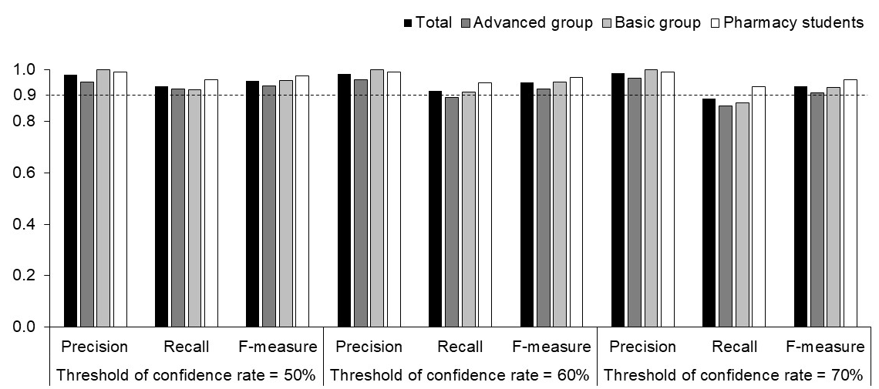
Supplementary Figure. 1 Precision, Recall, and F-measure by threshold of confidence rate
Advanced group Pharmacists with advanced knowledge and experience of Kampo medicines; Basic group Pharmacists with basic knowledge and experience of Kampo medicines

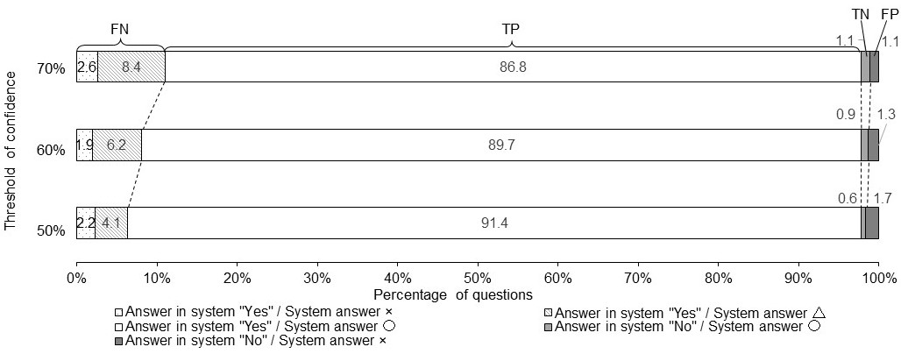

Supplementary Figure 2 The results of the system by the threshold of confidence rate

〇 means the system answers is the expected one. △ means the system answers were "I do not have an answer." × means the system answers were unexpected.
TP True positive; FN False negative; TN True negative; FN False negative

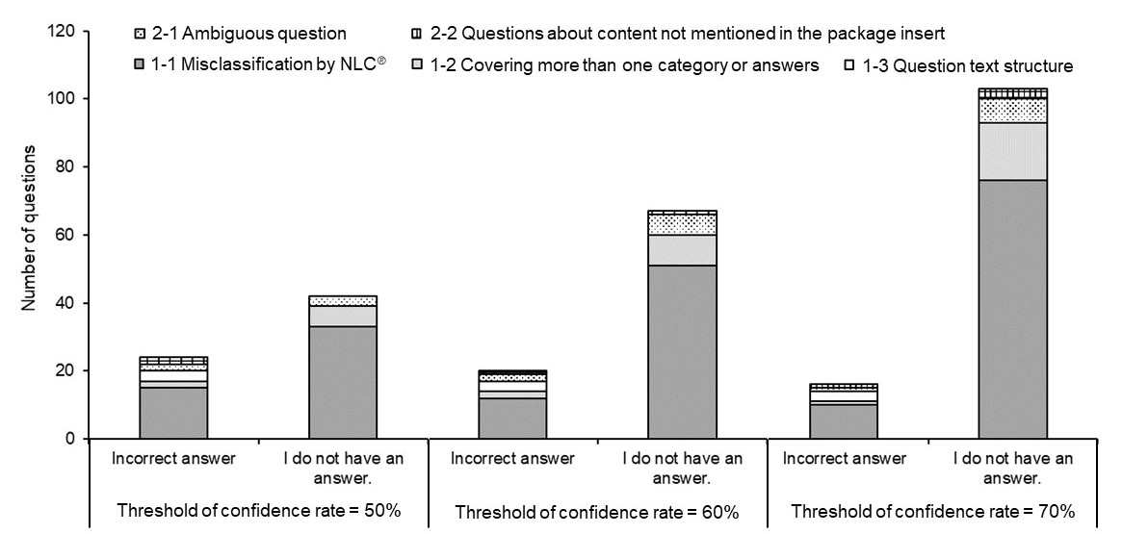
Supplementary Figure 3: Number of questions with correct answers listed in the system by threshold of confidence rate of why the question did not lead to the correct answer

