Expectation of clinical decision support systems: Survey study among nephrologist end-users

SUPPLEMENTAL FIGURES

Fruzsina Kotsis^{1,2*}, Helena Bächle^{1*}, Michael Altenbuchinger³, Jürgen Dönitz^{3,4}, Yacoub Abelard Njipouombe Nsangou⁴, Heike Meiselbach⁵, Robin Kosch³, Sabine Salloch⁶, Tanja Bratan⁷, Helena U. Zacharias⁸, Ulla T. Schultheiss^{1,2}

¹Institute of Genetic Epidemiology, Faculty of Medicine and Medical Center - University of Freiburg, Freiburg, Germany
²Department of Medicine IV – Nephrology and Primary Care, Faculty of Medicine and Medical Center - University of Freiburg, Germany
³Department of Medical Bioinformatics, University Medical Center Göttingen, Göttingen, Germany
⁴Institute of Computational Biology, Helmholtz Zentrum München, Germany ⁵Department of Nephrology and Hypertension, University Hospital Erlangen, Friedrich-Alexander-Universität Erlangen-Nürnberg, Erlangen, Germany
⁶Institute for Ethics, History and Philosophy of Medicine, Hanover Medical School, Hanover, Germany
⁷https://www.isi.fraunhofer.de/, Karlsruhe, Germany
⁸Peter L. Reichertz Institute for Medical Informatics of TU Braunschweig and Hannover Medical School, Hannover, Germany.

*the first authors contributed equally to this project

Table of Contents

SupplementaL Figures 3-6
Supplemental Figure 1: CKDNapp survey analysis set and number of missingness per participant across all Questions 3

Supplemental Figure 2: Scatterplots of participants concerning their work experience 4

Supplemental Figure 3 Expectations of a clinical decision support software in general of module 2 – details on questions M2.1 to M2.4. 5

Supplemental Figure 4: Preferred device for querying a CDSS. 6

Supplemental Figure 1: CKDNapp survey analysis set and number of missingness per participant across all questions.
B
A
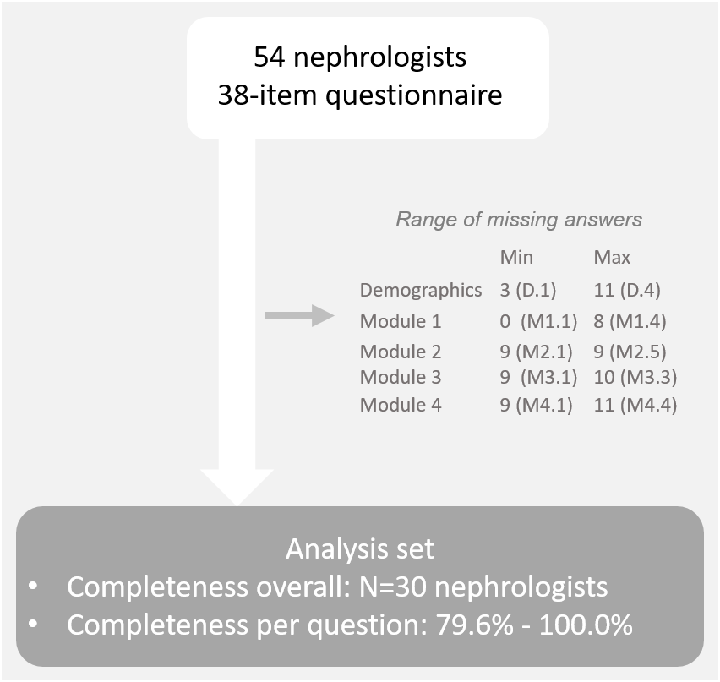
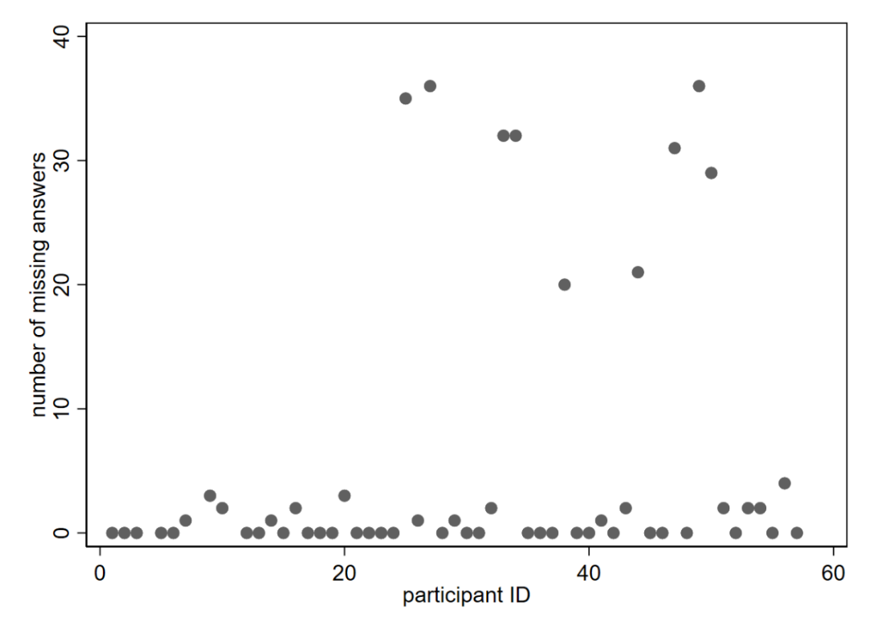

Legend:
A: analysis set with number of missingness per module. B: Scatterplot of number of missingness values per participant across all questions.
Supplemental Figure 2: Scatterplots of participants concerning their work experience
A: years spent treating out-patients
B: years being a consultant
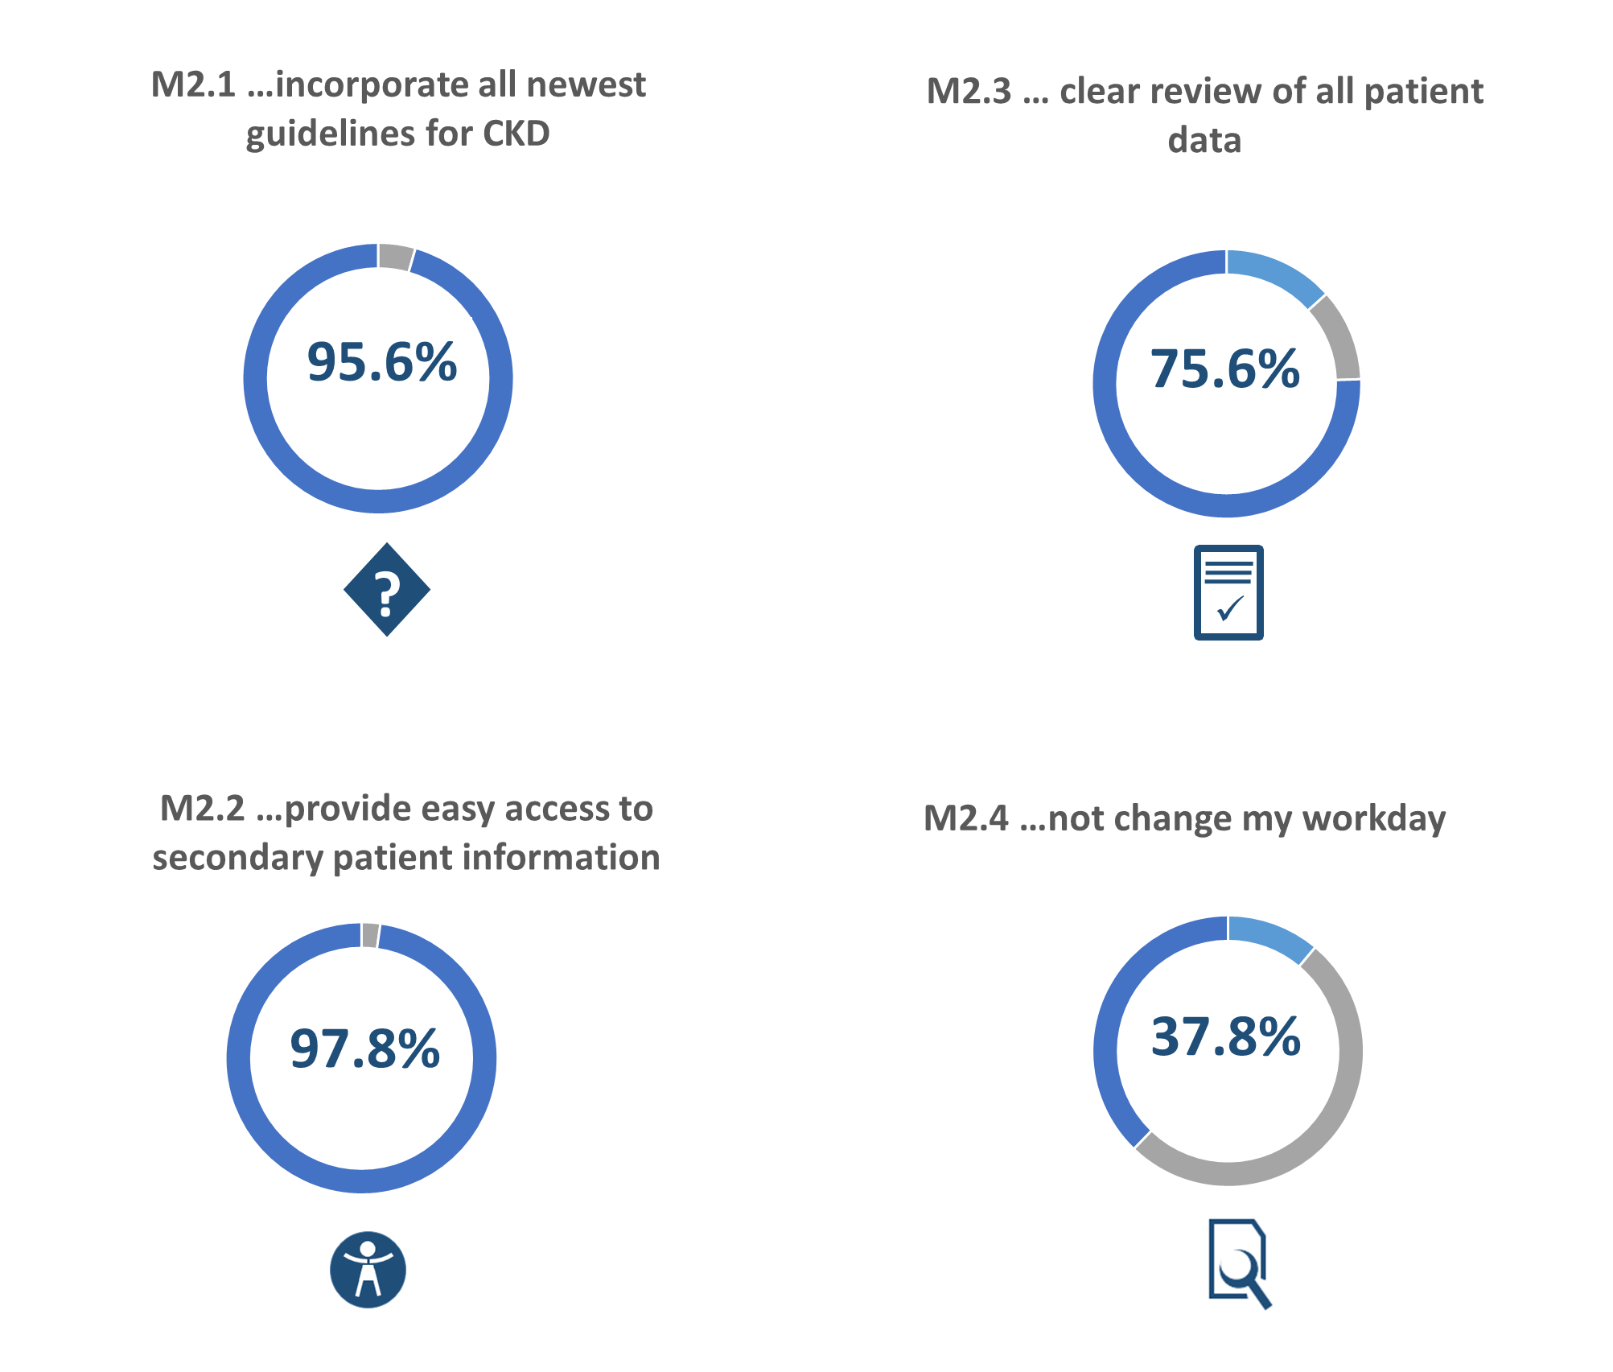
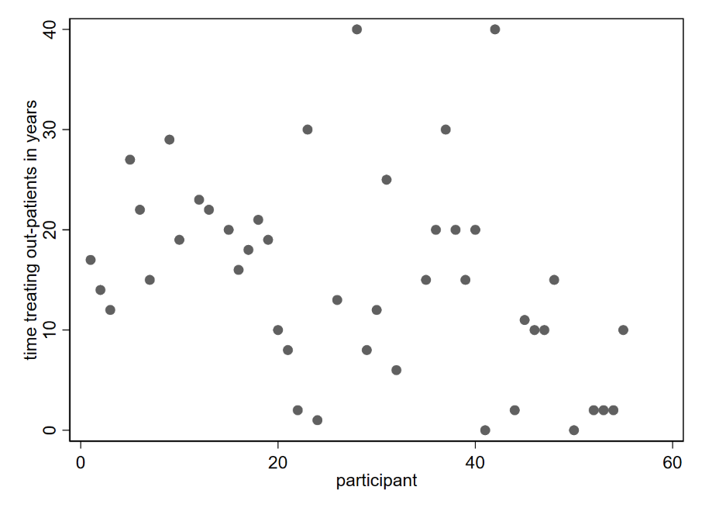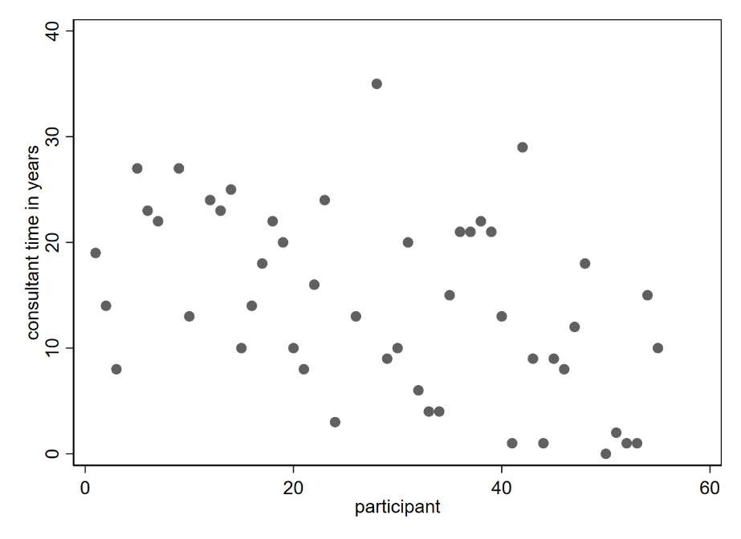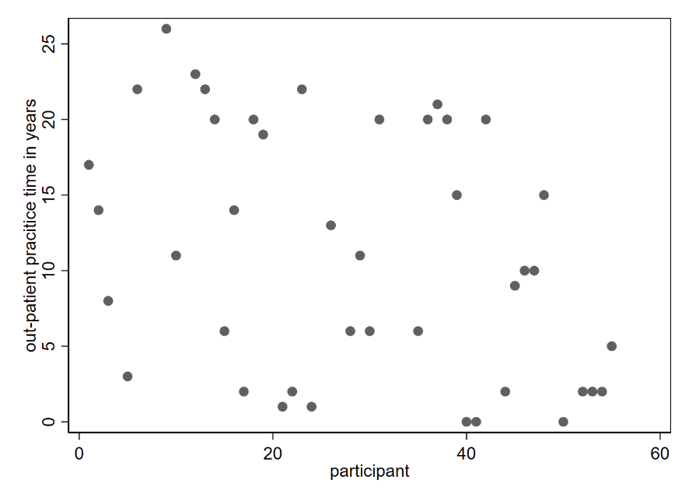
Supplemental Figure 3: Expectations of a clinical decision support software in general of module 2 – details on questions M2.1 to M2.4.
C: years spent in an out-patient practice
An optimal CDSS should…

Legend: percentages refer to the summary of percentages given for answer possibilities: mostly and completely correct. For M2.1 to M2.4: N_{missing}=9, N_{notspecified}=0, N_{answers}=45. Percentages for all answers can be found in Supplemental Table 3, Additional file 1.
Supplemental Figure 4: Preferred device for querying a CDSS.

